COURSE PROJECT REPORT
HYBRID DEEP LEARNING NETWORK INTRUSION DETECTION SYSTEM
Benign-Only Anomaly Detection, Latent Clustering, and Day-Specific Attack Classification on CICIDS2017
Course: BCSE209L - Machine Learning
Submitted by
Sushant Kumar (23BDS0128)
Soumyadeep Dasgupta (23BDS0134)
Udit Vashisht (23BDS0172)
Faculty: Dega Nagaraju
Academic Year 2026-27
CONTENTS
Abstract
Chapter 1 Introduction
Chapter 2 Literature Review
Chapter 3 Dataset and Methodology
Chapter 4 Results and Discussion
Chapter 5 Conclusion and Future Work
References
Appendix A Project Artifacts, Feature List and Repository Layout

ABSTRACT
Most intrusion detection systems that people build for coursework are supervised classifiers: show the model labelled attacks, and it learns to spot those same attacks later. The weakness is obvious once you think about it. A classifier has no label for something it has never seen, so a brand-new attack usually gets filed under "benign" without any warning. In this project we try to deal with that problem by combining three different ideas into one hybrid network intrusion detection system (NIDS), built and tested on the CICIDS2017 flow dataset.
Engine A is an FT-Transformer autoencoder trained only on benign Monday traffic. It learns what "normal" looks like and flags any flow it cannot reconstruct well. Engine B takes the flows that Engine A flags, pulls out their 64-dimensional bottleneck embeddings, and groups them with K-Means and HDBSCAN without ever looking at labels. Engine C is a set of day-specific supervised classifiers that join a feature-tokenizer Transformer with a temporal convolutional network (TCN) to name the known attacks. Before any of this, we cleaned the raw data carefully: we removed identifier columns, repaired timestamp and blank-row problems in the CSV files, handled infinite and missing values, and kept the preprocessing statistics fitted on training data only.
Our saved results are mixed, and we report them that way. The clustering stage separates DDoS and PortScan traffic quite well (silhouette 0.594), and the Tuesday, Wednesday and Friday specialists reach roughly 96-98.5% weighted F1 on random within-day splits. On the other hand, Engine A's recall depends heavily on the threshold percentile, rare classes such as Heartbleed, Bot and SQL Injection are almost never detected, the Thursday specialist was trained on a 5,000-window subsample, and the chronological experiment gives irregular numbers that need more auditing. Overall the project is a working hybrid prototype and a useful set of experiments, not a deployment-ready detector. Systematic hyperparameter tuning, full-data retraining of all specialists and a proper fusion policy for the three engines are left as future work.
Keywords: network intrusion detection, CICIDS2017, FT-Transformer, autoencoder, anomaly detection, clustering, TCN, concept drift, hyperparameter tuning

CHAPTER 1 INTRODUCTION

1.1 Background
A network intrusion detection system watches traffic and raises an alert when something looks like an attack on the confidentiality, integrity or availability of a system. Classical signature-based tools are fast and precise for attacks they already know, but they need someone to write a new rule every time attackers change their approach. Machine learning promised a way around this, and a lot of recent work trains classifiers on labelled flow records and reports accuracies above 99%. Those numbers look great on paper, yet they often come from random train/test splits where the test flows are practically neighbours of the training flows.
The other family of methods is anomaly detection. Instead of learning attacks, the model learns normal traffic and raises an alarm when a flow does not fit. This can catch things nobody has labelled, but it comes with its own problems: false alarms eat analyst time, and the threshold that decides "too different" has a huge effect on what the system actually detects.
CICIDS2017 is one of the most widely used benchmarks for this kind of work [1], [2]. It contains five working days of traffic with a mix of benign activity and attacks such as brute-force logins, DoS, Heartbleed, web attacks, infiltration, botnet activity, DDoS and port scanning. Because the attacks are spread across days, the dataset lets us ask two different questions. First, how well can a model recognise attacks it was trained on? Second, what happens when it meets attacks, or traffic conditions, that it never saw?

1.2 Motivation
Our starting point was a simple experiment we ran early on. We trained a FT-Transformer and a TCN classifier on Monday to Wednesday traffic (benign plus eight known classes) and then tested them on Friday, which holds DDoS, PortScan and Bot traffic that the models never saw. Even the better model caught only about a third of the Friday attack flows at its chosen threshold, and it almost completely missed Bot and PortScan. That result is the whole motivation of this project in one sentence: supervised models trained on yesterday's attacks quietly fail on tomorrow's.
We therefore wanted a design where (a) something learns "normal" without needing attack labels, (b) something helps a human understand what the flagged traffic looks like, and (c) the known attacks are still identified precisely with a strong supervised model. That is the three-engine structure of this report.

1.3 Problem Statement
The project tries to answer five concrete questions:
- Can normal network behaviour be learned from benign-only traffic?
- Can traffic from days the model never trained on be flagged as anomalous without using its attack labels?
- Can the flagged flows be grouped into behavioural clusters that mean something to an analyst?
- Can known attacks still be classified accurately by specialist supervised models?
- How much does performance change when the test traffic comes later in time than the training traffic?

1.4 Objectives
- Audit CICIDS2017 and fix the data-quality problems we found in the raw CSV files.
- Build a leakage-conscious preprocessing pipeline: remove identifiers, split before fitting anything, and fit imputation, scaling and feature ranking on training data only.
- Select a compact set of flow features using Random Forest importance combined with mutual information.
- Train a benign-only FT-Transformer autoencoder and calibrate its anomaly thresholds on a benign validation split.
- Cluster the anomaly embeddings without labels and audit the clusters afterwards.
- Train one FT-Transformer + TCN specialist for each of Tuesday, Wednesday, Thursday and Friday.
- Compare random and chronological evaluation to study concept drift.
- Package the saved models, reports and plots into a dashboard for inspection.

1.5 Scope and Contributions
This is an offline research prototype that works on CICIDS2017 flow features. We do not claim a deployed system, and we do not report a single end-to-end number for all three engines, because we have not defined a validated rule for combining them. Engine A and Engine B are evaluated as an anomaly detection and profiling path; Engine C is evaluated as a separate known-class classification path.
Our main contributions are the following:
- A cleaned and documented version of CICIDS2017, including fixes for the blank trailing rows in the Thursday web-attack file, the day-first timestamp format and the 12-hour clock without AM/PM, and a bug in our own caching code that overwrote multi-file days.
- A flow-level FT-Transformer autoencoder with top-k reconstruction-error scores, motivated by an earlier window-based version that diluted short attacks.
- A latent-space clustering stage whose clusters can be audited against labels after the fact.
- Four day-specific FT-Transformer + TCN specialists with train-fold-only feature selection and scaling.
- A side-by-side look at random versus chronological evaluation, plus a supervised-baseline experiment showing how classifiers behave on attack families they never saw.

1.6 Report Organisation
Chapter 2 reviews the related literature. Chapter 3 describes the dataset, preprocessing, model architectures and evaluation design. Chapter 4 presents and discusses the saved results together with their limitations. Chapter 5 concludes and lays out future work, including a hyperparameter tuning plan. The appendix lists the artifacts, the selected features and the repository layout.

CHAPTER 2 LITERATURE REVIEW

2.1 Network Intrusion Detection and Benchmarking
Machine-learning-based intrusion detection covers binary detection, multiclass attack recognition, anomaly detection and hybrids of these. Survey papers describe how broad the field is and how hard it is to compare systems when datasets, class mixes and evaluation protocols differ [3]-[5]. Early deep-learning work showed that recurrent and autoencoder-based models could beat shallow classifiers on benchmark data [9], [12]. CICIDS2017 was released as a more modern replacement for older datasets, with realistic benign traffic and a wider set of attacks described by flow-level features [1], [2].
Later analyses are a bit less flattering to the dataset. Researchers found labelling errors, duplicated records, flow-construction problems and leakage-prone features, and showed that cleaning these changes the reported scores [6]-[8]. For us this has a practical consequence: we need to describe our splits clearly, fit every transformation on training data only, and avoid relying on accuracy alone.

2.2 Autoencoders and Unsupervised Anomaly Detection
An autoencoder compresses its input into a small representation and then tries to rebuild it. When it is trained only on normal data, the reconstruction error can act as an anomaly score, because abnormal inputs are reconstructed worse. Robust autoencoders [13] and representation-learning approaches [9] have been applied to anomaly detection, and Kitsune [10] showed an ensemble of small autoencoders working online on network traffic. These ideas motivated Engine A. But the practical performance depends on two things: how well the normal training data represents real deployment traffic, and where the threshold is set. A percentile threshold is simply a calibration rule; it does not guarantee the same false-positive rate on a different day.

2.3 Feature Learning and Temporal Models
Feature selection removes redundant or noisy columns and can cut training cost. Prior intrusion detection studies use information gain and related ranking methods on CICIDS2017 [11], and Random Forest importance is a standard ranking tool [28], [29]. For modelling feature interactions, the Transformer architecture made self-attention a general-purpose mechanism [14]. It was later adapted to tabular data by TabTransformer [16] and the FT-Transformer of Gorishniy et al. [15], which embeds each numeric feature as its own token. For sequences, temporal convolutional networks use causal, dilated convolutions to cover long contexts cheaply [17], and Transformer-based frameworks have also been proposed for multivariate time series [18]. Engine C joins a feature-tokenizer encoder with TCN blocks over short flow windows so the model can see both within-flow feature interactions and local temporal patterns.

2.4 Class Imbalance, Metrics and Concept Drift
Intrusion data is heavily imbalanced; in CICIDS2017 some attacks have hundreds of thousands of flows while others have only a handful. Cost-sensitive learning and class weighting raise the influence of rare classes [21], [22], and oversampling methods such as SMOTE offer alternatives [25]-[27], but very small supports still give unstable estimates. Precision-recall analysis is more informative than ROC when positives are rare [23], [24], so accuracy and ROC-AUC should always be read next to attack recall, precision, F1 and the benign false-positive rate.
Real traffic also changes with time. Surveys on concept drift stress that models must be evaluated as the data evolves [19], [20]. A random within-day split measures how well a model interpolates inside a single distribution, whereas a chronological split asks whether a model trained earlier can handle later traffic. These are different questions and should not be mixed up.
Clustering literature also shaped the design of Engine B. DBSCAN [30] and HDBSCAN [31] find density-based groups and treat isolated points as noise, and the silhouette coefficient [32] is a standard way to judge cluster separation. Finally, work on KDD Cup 99 and UNSW-NB15 [33]-[35] reminds us that conclusions from one dataset do not automatically carry over to another.

2.5 Research Gap and Project Position
A lot of published work either focuses on one task or reports one headline score. This project explores a modular combination instead: normal-only anomaly learning, unsupervised grouping of the anomalies, and day-wise supervised classification. The saved results also expose the limits of that combination. Thresholds change what is detected, unsupervised clusters can contain benign flows, rare labels give very little evidence, and random-split performance does not necessarily carry over to later traffic. We therefore position the work as an empirical study of complementary methods and not as a claim that zero-day detection is solved.

CHAPTER 3 DATASET AND METHODOLOGY

3.1 The CICIDS2017 Dataset
CICIDS2017 was created by the Canadian Institute for Cybersecurity. Traffic was captured over five working days (3 to 7 July 2017) on a testbed with victim machines and a separate attacker network, and CICFlowMeter was used to convert the packet captures into bidirectional flow records. We worked with the "GeneratedLabelledFlows" release, which consists of eight CSV files: one each for Monday, Tuesday and Wednesday, two for Friday afternoon plus one for Friday morning, and two for Thursday (a morning web-attack file and an afternoon infiltration file). Together these contain 2,830,743 real flows after removing blank rows. Each flow has about 78 columns, including source and destination addresses, ports, protocol, timestamp, around 76 numeric statistics (durations, packet counts, byte rates, inter-arrival times, flag counts, window sizes and so on) and a label.
The day-by-day structure is central to our design. Monday contains benign traffic only, which makes it a natural training set for the anomaly detector. Tuesday and Wednesday contain attacks that act as "known" classes for supervised models. Thursday and Friday contain attack families that do not appear on earlier days, so they act as unseen attacks for Engine A.
Table 3.1. Flows and labels per day after cleaning.
Day | Flows | Labels and counts
Monday | 529,918 | BENIGN 529,918
Tuesday | 445,909 | BENIGN 432,074; FTP-Patator 7,938; SSH-Patator 5,897
Wednesday | 692,703 | BENIGN 440,031; DoS Hulk 231,073; DoS GoldenEye 10,293; DoS slowloris 5,796; DoS Slowhttptest 5,499; Heartbleed 11
Thursday | 458,968 | BENIGN 456,752; Web Attack Brute Force 1,507; Web Attack XSS 652; Infiltration 36; Web Attack SQL Injection 21
Friday | 703,245 | BENIGN 414,322; PortScan 158,930; DDoS 128,027; Bot 1,966

Two things stand out in this table. First, the imbalance is extreme: Heartbleed has 11 flows in the whole dataset and SQL Injection has 21, while DoS Hulk has more than 231,000. Second, Thursday is almost entirely benign (over 99.5%), so any attack-recall number on that day is based on very few flows.

Data-quality problems we found
- Blank trailing rows. The Thursday web-attack file contains 288,602 fully blank rows at the end. Left in place, they inflate missing value counts and the duplicate count. Dropping them gives the true 170,366 rows for that file.
- Timestamp format. Timestamps are day-first (for example 5/7/2017 is 5 July) and use a 12-hour clock without AM/PM, so afternoon hours appear as 1 to 5. We parse them day-first and shift hours below 8 by twelve hours so chronological sorting is correct. Our first audit assumed month-first dates, which is why it kept failing the date check.
- Duplicate and malformed columns. A duplicated "Fwd Header Length.1" column is removed, column names are whitespace-normalised, and the label text "Web Attack – XSS" (which arrives with a broken character) is normalised to plain ASCII.
- Infinite and missing values. Columns such as Flow Bytes/s and Flow Packets/s contain infinite values caused by zero durations. We convert infinities to missing values and impute them later using training medians.
- A caching bug of our own. Our first cache builder wrote one parquet file per CSV, so for days with several CSVs the later file silently overwrote the earlier one. Thursday ended up with only 288,602 flows and lost classes such as Infiltration. We rewrote the builder to concatenate all files of a day before saving and rebuilt every cache.

3.2 Preprocessing Pipeline
- Read each CSV, normalise column names, drop blank rows and the duplicated header-length column.
- Remove identifier and metadata columns (Flow ID, source and destination IP, ports, protocol, timestamp, label) from the model inputs. This leaves 76 behavioural features.
- Convert fields to numeric values, replace infinities with missing values and store everything as float32 to keep memory use manageable.
- Parse and correct timestamps, sort flows chronologically inside each day and save one parquet file per day.
- Split before fitting anything. For feature selection we used Monday to Wednesday as the fitting data; Thursday and Friday were held out.
- Fit medians, constant-feature removal, correlation pruning (|r| > 0.95), Random Forest and mutual-information ranking, and the scaler on the fitting data only.
- Apply a signed log transform, sign(x)·log(1+|x|), to tame heavy-tailed features, then standardise and clip values to [-5, 5].
- Cache the final arrays as NumPy files so every later experiment reads exactly the same inputs.
This ordering matters. If scaling or feature ranking were fitted on the full dataset before splitting, information from validation or test traffic would leak into training and make every later result look better than it really is.

3.3 Feature Selection
After dropping constant and highly correlated columns, we rank the remaining features with two complementary scores. A Random Forest (200 trees, class-balanced) trained on a class-capped sample gives an importance value, and mutual information with the binary attack/benign target gives a second ranking. The two ranks are averaged and the top 32 features are kept. Class-capped sampling (up to 80,000 flows per class for the forest and 15,000 for mutual information) keeps the ranking from being dominated by the benign majority.
The 32 selected features cover packet-length statistics, inter-arrival times, flow rates, header lengths, initial window sizes, active-time statistics and the FIN flag count (full list in Appendix A). The specialists repeat the same ranking procedure inside each day using only the training fold, so each day gets its own feature list and scaler.
We also tried selecting the number of features k by validation-day average precision in an earlier experiment (candidates 10 to 44). The results were noisy, ranging from AP 0.007 at k=10 to 0.34 at k=40, which told us that feature count interacts strongly with the unseen-day shift. For the production pipeline we fixed k=32, which gave a good balance between model size and information.

3.4 Overall System Architecture
The workflow starts with flow-level records and a shared preprocessing stage. The prepared features then feed two analysis tracks. Engine A learns benign traffic and scores each flow by reconstruction error, and Engine B groups the suspicious latent representations for post-hoc inspection. In parallel, Engine C trains a supervised specialist for each attack day. Engine C is not a downstream classifier of Engine A's flags; it is a separate classification path, so we report its results independently.
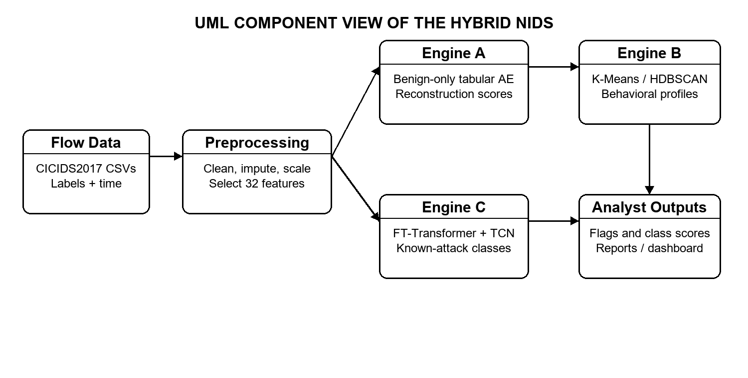
Figure 1. UML component view of the implemented NIDS modules and their data products.

3.5 Shared Building Blocks

Feature tokenizer
Following the FT-Transformer idea [15], each scalar feature xj is turned into a d-dimensional token as xj · wj + bj, where wj and bj are learned per feature. A learned [CLS] token is prepended, and its final representation summarises the whole flow.

FT-Transformer block
Each block applies layer normalisation, multi-head self-attention and a residual connection, followed by a second normalisation and a GELU feed-forward network with another residual connection. Attention lets the model learn which features should be looked at together; for example, packet-rate features and inter-arrival features often matter jointly for DoS-type attacks.

Temporal convolutional network
The TCN stacks residual blocks of causal 1-D convolutions with dilation rates 1, 2, 4 and 8, layer normalisation, ReLU and spatial dropout. Causal padding means a prediction never depends on future flows, and the dilations let a short window of ten flows be covered by few layers.

3.6 Engine A: Benign-Only Autoencoder
Engine A is a flow-level tabular FT-Transformer autoencoder. Each numeric feature is tokenised, the self-attention blocks build a latent representation, a 64-dimensional bottleneck compresses it, and a dense decoder reconstructs the 32 input features. Training uses benign Monday flows only, with an 80/20 split for training and validation (roughly 424,000 and 106,000 flows). The validation loss settles at about 0.0025.
For scoring, we compute the squared reconstruction error of each feature and summarise it three ways: the mean over all features, the mean of the three largest feature errors ("top-3 MSE") and the maximum single-feature error. The top 3 score matters because an attack that only disturbs one or two features gets averaged away by the 30 normal-looking features in the mean score. Thresholds are taken as percentiles (p90, p95, p97, p99, p99.5) of these scores on the Monday benign validation split; the p95 top 3 threshold is 0.04595 and the p99 threshold is 0.12192. A flow is flagged when its score exceeds the chosen threshold. Labels are never used to train the model or to set the Monday thresholds; they are used only to evaluate the scores afterwards.

Why we moved from windows to single flows
Our first autoencoder looked at windows of ten consecutive flows and combined an FT-Transformer with a TCN. It performed poorly on unseen days: on Thursday it reached ROC-AUC 0.687 and recall of only 1.1% at its p99 threshold, and on Friday ROC-AUC 0.629 and recall 1.9%. Our explanation is "temporal dilution". Web attacks and infiltration often show up in one or two flows, so averaging the error over a window of ten mostly benign flows hides them. Switching to a pure flow-level model with top-k error scores improved the separation substantially (Chapter 4). We also tried raising the threshold budget by calibrating on Tuesday (allowing up to 5% benign false positives), but recall stayed low (2.0% on Thursday, 3.6% on Friday), which supported the view that the window design itself was the bottleneck.
Table 3.2. Production hyperparameters of Engine A.
Hyperparameter | Engine A value
Input features | 32
Token dimension | 48
Attention heads / FT blocks | 4 / 2
Bottleneck dimension | 64
Dropout | 0.05
Learning rate | 0.0007
Weight decay | 0.00001
Batch size | 1024
Max epochs / patience | 12 / 4
Optimizer / loss | AdamW / MSE
Seed | 42

3.7 Engine B: Clustering Anomalous Embeddings
Engine B takes the flows flagged by Engine A and extracts the 64-dimensional bottleneck embedding of each. K-Means then splits them into a fixed number of groups (five in the saved run), while HDBSCAN discovers density-based groups and labels isolated points as noise. We summarise cluster geometry with the silhouette, Calinski-Harabasz and Davies-Bouldin indices. Attack labels play no part in fitting; they are used afterwards only to see what each cluster is made of. Two-dimensional PCA projections are provided as a visual aid and are not a substitute for analysis in the full embedding space.
Table 3.3. Engine B settings.
Setting | Value
K-Means clusters / n_init | 5 / 10
HDBSCAN min cluster size / min samples | 50 / 15
Maximum clustered samples | 25,000
Random state | 42

3.8 Engine C: Day-Specific Supervised Specialists
Engine C trains a separate multiclass classifier for each of Tuesday, Wednesday, Thursday and Friday. Giving every day its own model avoids forcing one network to learn four different traffic distributions at once. Each specialist tokenises the selected features with an FT-Transformer encoder, applies it to every flow in a window of ten consecutive flows, passes the sequence through TCN blocks, pools it and uses a dense softmax head that outputs probabilities for that day's labels.
Within each day we use a stratified 70/30 split. Rare classes that appear only once are merged into a "rare attack" stratum for splitting purposes. Medians, the Random Forest and mutual-information ranking, and the scaler are all fitted on the 70% training fold only. Class weights are computed from the training windows as n / (k · count) and capped at 250 so that very rare classes do not produce exploding gradients. Early stopping watches validation loss and the best checkpoint is restored.
Table 3.4. Production hyperparameters of Engine C.
Hyperparameter | Engine C value
Lookback window | 10 flows
Selected features | 32 (per-day, train fold)
Token dimension / heads / FT blocks | 48 / 4 / 2
TCN filters / kernel / dilations | 96 / 3 / 1, 2, 4, 8
Dropout | 0.1
Learning rate / weight decay | 0.0005 / 0.0001
Batch size | 512
Max epochs / patience | 20 / 5
Max class weight | 250
Optimizer / loss | AdamW / sparse categorical cross-entropy
Split / seed | Stratified 70/30 / 42

One important practical note: the saved Thursday and Friday specialist result files contain only 5,000 training windows and 5,000 test windows each, which means those runs came from a smoke (subsampled) configuration. Tuesday and Wednesday used the full splits. We discuss the consequences in Chapter 4.

3.9 Random versus Chronological Evaluation
The specialist metrics come from stratified random splits, which tell us how well a model handles the same day's distribution. To study drift, we also ran a second experiment where each day is sorted by timestamp, the first 70% (the morning) is used for training and the last 30% (the afternoon) is used for testing. The gap between the two numbers is our measure of concept drift. This experiment is especially important for days like Wednesday and Friday, where the traffic regime changes during the day.

3.10 Evaluation Design
Engine A is judged by ROC-AUC, average precision, recall at calibrated thresholds and the benign false-positive rate. Engine B is judged by internal clustering indices and by post-hoc dominant-label composition. Engine C is judged by per-class precision, recall and F1, weighted and macro averages, accuracy, and attack-versus-benign average precision and ROC-AUC. Confusion matrices and ROC/PR curves are saved for each specialist. For the temporal experiment we also check class presence in the test window before reading any metric.
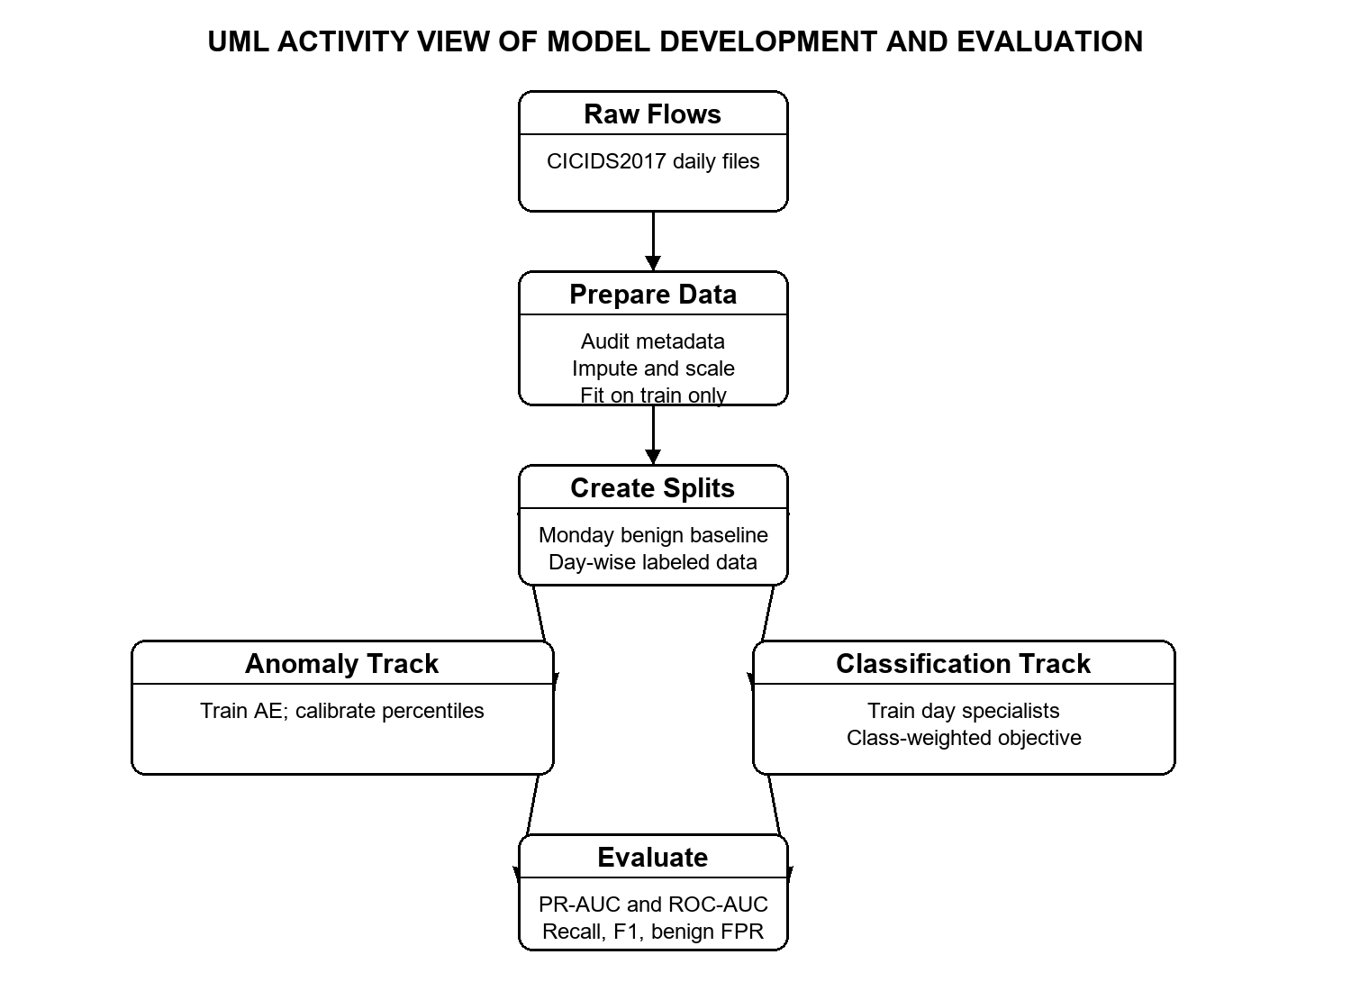
Figure 2. UML activity view of data preparation, model training, and evaluation paths.

3.11 Implementation Environment
The pipeline is written in Python with TensorFlow/Keras 2.21, scikit-learn, Pandas, NumPy, PyArrow (parquet), Matplotlib and Seaborn. The Colab notebooks ran on a T4 GPU with all intermediate artifacts stored on Google Drive so a disconnected runtime could be resumed. The same logic is packaged as Python modules (engine_a_flow_autoencoder.py, engine_b_clustering.py, engine_c_specialists.py and section5_temporal_generalization.py) with a single launcher script, run_hybrid_nids.py. A separate script, tune_hyperparameters.py, implements a random-search tuning extension that does not touch the production models. Native Windows TensorFlow at this version runs on CPU only, so GPU training needs Colab or WSL2.

3.12 Dashboard
We built a Streamlit dashboard that reads the saved artifacts without retraining anything. Its pages cover an overview, CSV scoring with Engine A, anomaly visualisation, Engine B clusters and projections, Engine C Day-wise metrics and plots, and the tuning tables. It is an offline inspection tool rather than a live packet-capture system.

CHAPTER 4 RESULTS AND DISCUSSION

4.1 Motivating Experiment: Supervised Models on Unseen Attacks
Before presenting the hybrid system, here is the experiment that motivated it. We trained a FT-Transformer and a TCN from Monday to Wednesday (benign plus eight known classes), chose a decision threshold on Thursday by maximum F1 and applied it unchanged to Friday, which contains three families the models never saw. Attack score was 1 − P(BENIGN).
Table 4.1. Supervised baselines evaluated on Friday (unseen families).
Model | Test AP | Test ROC-AUC | Attack recall | Benign FPR | DDoS / PortScan / Bot recall
FT-Transformer | 0.806 | 0.890 | 0.379 | 0.0785 | 22.8% / 50.6% / 0.1%
TCN | 0.809 | 0.851 | 0.332 | 0.0059 | 74.6% / 0.2% / 1.0%

The numbers tell a consistent story. Ranking quality (AP around 0.81) looks respectable, but at a usable threshold only about a third of the attack flows are caught, and which family gets caught depends on the model: the TCN spots DDoS but nearly misses PortScan, and the FT-Transformer does the opposite. Bot flows are almost invisible to both. This confirms that a classifier trained on known labels cannot be trusted alone against new attack families. (The combined FT-Transformer + TCN baseline run was interrupted before finishing, so we do not report it.)

4.2 Engine A: Thresholds and Anomaly Results
The Monday benign calibration gives a top 3 MSE p95 threshold of 0.04595 and a p99 threshold of 0.12192. Table 4.2 compares the median top 3 error of each Thursday and Friday attack family with the p95 cutoff. It is a descriptive comparison: a group median above the cutoff suggests that many flows in that family would be flagged, but it cannot by itself give recall or count flagged flows.
Table 4.2. Median top 3 reconstruction error per family versus the p95 threshold.
Day and label | Attack flows in evaluated sample | Median top-3 MSE | Compared with p95 = 0.04595
Thursday Infiltration | 3 | 0.17031 | Above
Thursday Web Brute Force | 156 | 0.05449 | Above
Thursday SQL Injection | 1 | 0.02530 | Below
Thursday XSS | 73 | 0.05335 | Above
Friday Bot | 206 | 0.01551 | Below
Friday DDoS | 12,658 | 0.11834 | Above
Friday PortScan | 15,702 | 0.05567 | Above

At the p99 operating point, the top-3 score gives 4.72% overall attack recall on the evaluated Thursday sample and 20.89% on Friday, with benign false-positive rates of 1.10% and 7.57%. By family, recall is 100% for the three Infiltration flows, 3.85% for Web Brute Force, 0% for the single SQL Injection flow and 2.74% for XSS on Thursday; on Friday it is 0.97% for Bot, 47.02% for DDoS and 0.09% for PortScan. The rare-class percentages rest on one to three flows and are therefore very uncertain.
Two lessons come out of this. First, Engine A is clearly better at volumetric attacks like DDoS, whose statistics are far from normal, than at attacks that look like ordinary web or scan traffic. Second, the threshold matters a lot: exact p95 recall needs the cutoff applied to every saved flow-level score, and a good operating point should be chosen from a validation sweep over percentiles and reported with both recall and false-positive rate. Lowering the threshold raises recall but also raises the number of alerts an analyst has to read.

4.3 Engine B: Clustering Results
The saved clustering evaluation covers 21,158 flows. The K-Means run with five clusters has a silhouette score of 0.594, Calinski-Harabasz index 12,578.5 and Davies-Bouldin index 0.991. HDBSCAN finds 74 clusters and labels 19.30% of the flows as noise. Table 4.3 shows the post-hoc audit.
Table 4.3. K-Means cluster composition (labels used only for audit).
Cluster | Size | Dominant behaviour | Purity | Comment
0 | 7,651 | PortScan | 85.73% | Some benign flows mixed in
1 | 4,166 | DDoS | 98.44% | Very clean
2 | 1,945 | Web Attack Brute Force / XSS family | 61.85% | Web attack classes overlap
3 | 2,875 | DDoS burst variant | 91.69% | Second DDoS pattern
4 | 4,521 | Benign / residual boundary | 62.20% benign | Also contains DDoS

The clustering shows both the value and the limit of the approach. Without ever seeing a label, the embedding separates two kinds of DDoS traffic and a PortScan group quite cleanly. But cluster identity is not a class prediction: the web-attack cluster is only about 62% Brute Force, and cluster 4 is mostly benign boundary traffic that crossed the threshold. This is expected, since Engine B can only be as good as the pool Engine A hands to it.
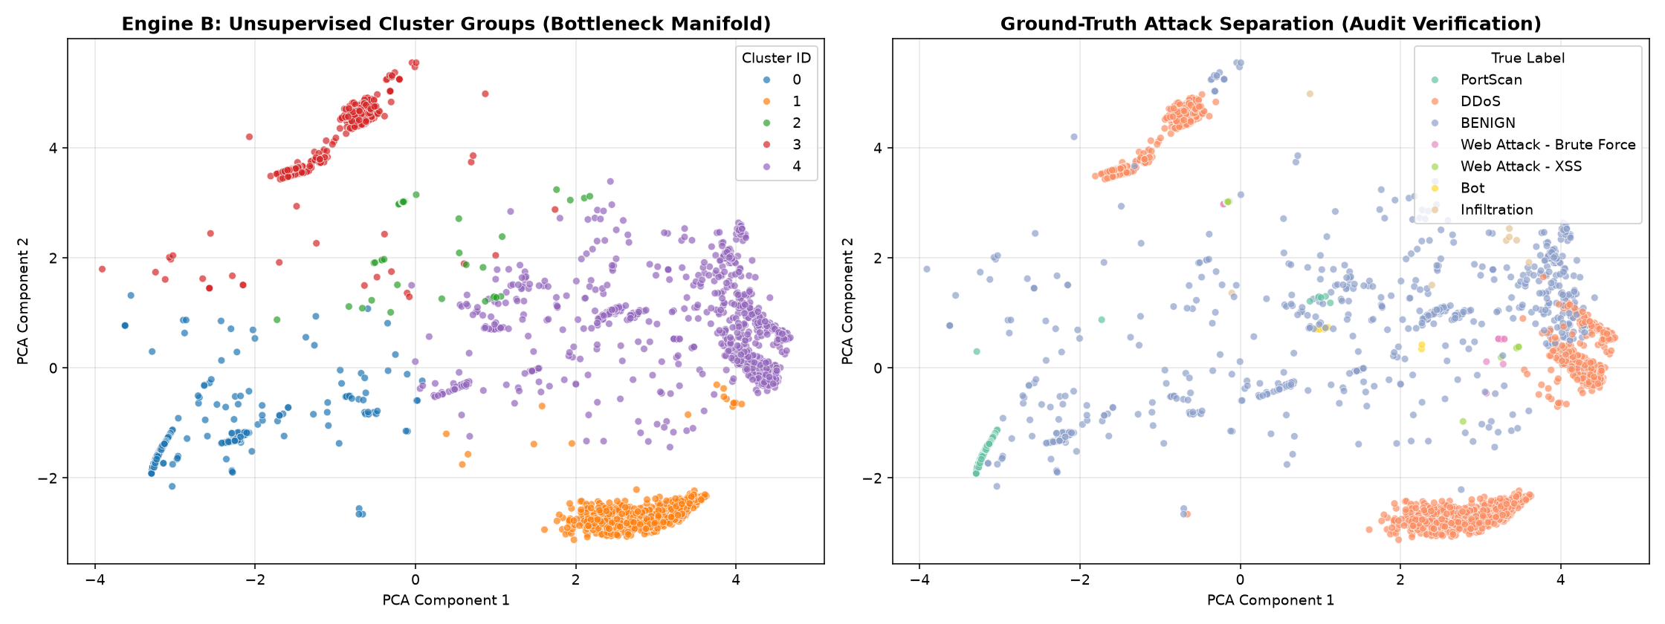
Figure 3. Engine B PCA projection of the K-Means groups and a separate label audit. Labels in the right panel are post-hoc evaluation only.

4.4 Engine C: Specialist Results
Table 4.4. Engine C specialist summary from the saved reports.
Day | Classes | Train windows | Test windows | Weighted F1 | Note
Tuesday | 3 | 312,127 | 133,764 | 0.985 | Full split
Wednesday | 6 | 484,883 | 207,802 | 0.981 | Full split
Thursday | 5 | 5,000 | 5,000 | 0.343 | Subsampled run
Friday | 4 | 5,000 | 5,000 | 0.963 | Subsampled run

Tuesday's specialist reaches 98.34% accuracy and 0.985 weighted F1. FTP-Patator recall is 99.83% and SSH-Patator recall is 95.93%, but precision is only 67.62% and 62.48%, so many predicted attack windows are false positives even though almost no attacks are missed. This is the expected effect of a class-weighted loss: it pushes the model towards recall at the cost of precision. Wednesday reaches 97.93% accuracy and 0.981 weighted F1. The common DoS classes have high recall, but all three Heartbleed test examples were missed, so no dependable Heartbleed conclusion can be drawn.
Friday's 5,000-window test reports 96.02% accuracy and 0.963 weighted F1, with DDoS recall 98.77% and PortScan recall 98.39%. The test held only 13 Bot windows and the model missed all of them. Thursday's 5,000-window test reports 21.06% accuracy and 0.343 weighted F1; it holds only 17 Brute Force and 8 XSS attack examples, has no test support for Infiltration or SQL Injection, and the confusion matrix shows the attack examples all predicted as Brute Force. These Thursday results are not evidence of successful multiclass detection, and the Thursday and Friday rows should be redone on the full data before being quoted anywhere else.
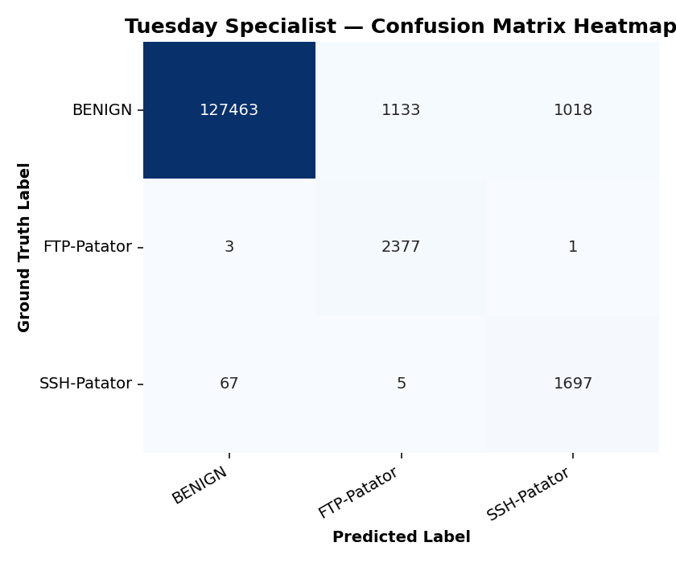
Figure 4. Tuesday specialist confusion matrix. The model detects most FTP-Patator and SSH-Patator windows, while attack precision is lower than recall.
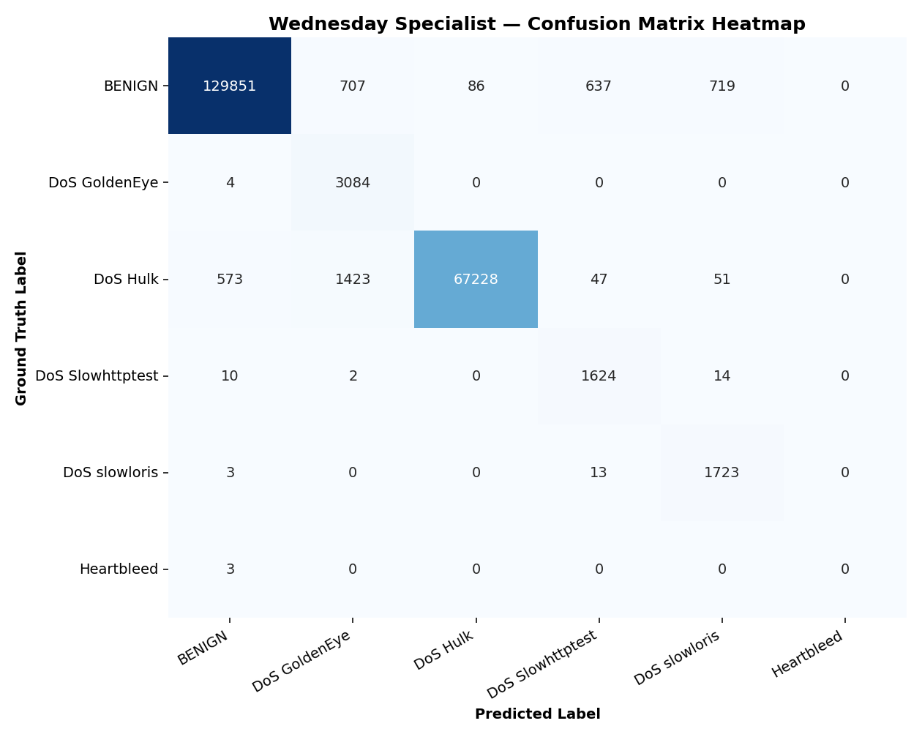
Figure 5. Wednesday specialist confusion matrix. The rare Heartbleed test examples are all predicted as benign.
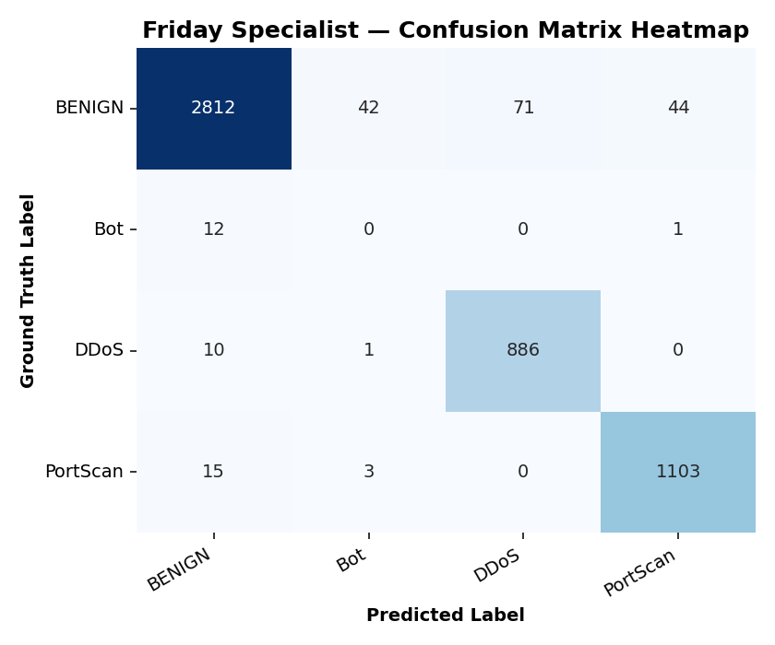
Figure 6. Friday specialist confusion matrix. DDoS and PortScan are classified well in this sampled test; all 13 Bot samples are missed.
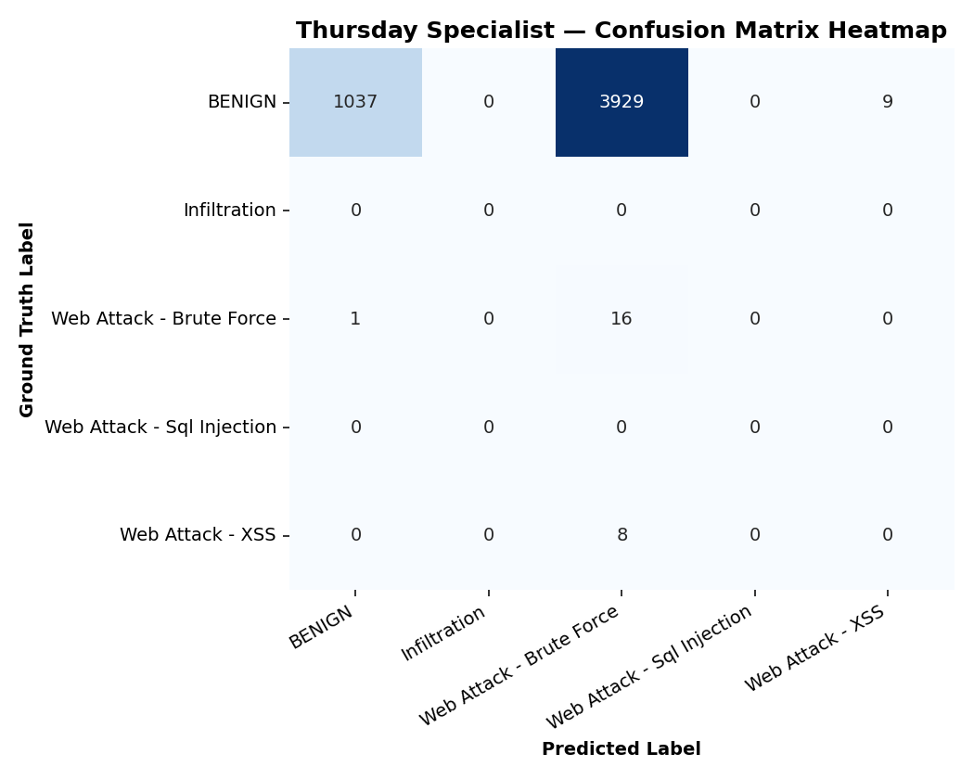
Figure 7. Thursday specialist confusion matrix. This 5,000-window test has only 25 attack examples and weak overall multiclass performance.

ROC and precision-recall curves
The saved reports include one-vs-rest ROC and precision-recall curves for Tuesday, Wednesday and Friday. They show ranking quality across all thresholds and complement the fixed-threshold metrics. Binary attack-vs-benign ROC-AUC is 0.998 for Tuesday and 0.999 for Wednesday, and 0.983 for Friday. A Thursday curve is not shown because its sampled test set contains too few attacks to be meaningful.
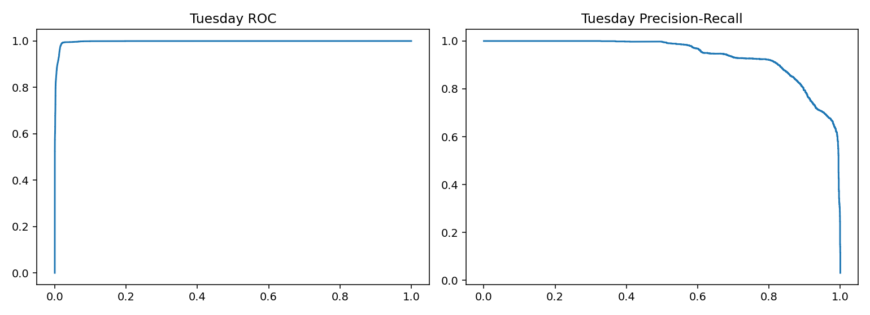
Figure 8. Engine C Tuesday specialist ROC and precision-recall curves.
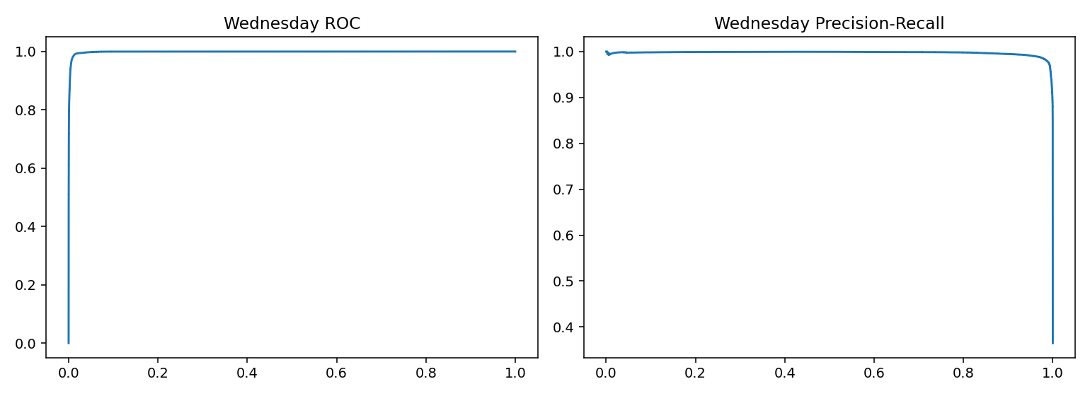
Figure 9. Engine C Wednesday specialist ROC and precision-recall curves.
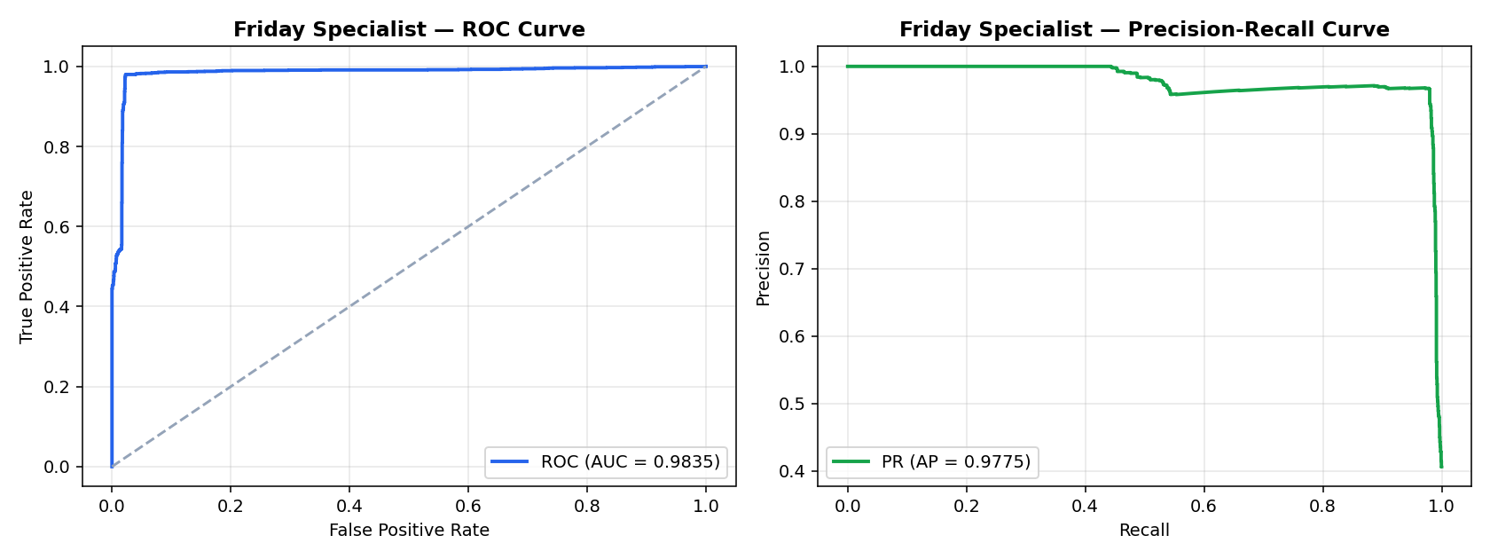
Figure 10. Engine C Friday specialist ROC and precision-recall curves.

4.5 Random versus Chronological Evaluation
The specialist reports use stratified random 70/30 splits, which benchmark same-day traffic. Our chronological experiment (first 70% of each day for training, last 30% for testing) gives very different numbers, as Table 4.5 shows.
Table 4.5. Random versus chronological weighted F1 per day.
Day | Stratified F1 | Chronological F1 | Difference
Tuesday | 0.985 | 0.967 | 0.018
Wednesday | 0.981 | 0.000 | 0.981
Thursday | 0.343 | 0.999 | -0.657
Friday | 0.963 | 0.000 | 0.963

Tuesday barely changes, which suggests the attack pattern stays stable through the day. Wednesday and Friday collapse to near zero, which fits what we see in the timestamps: on Friday the afternoon is dominated by DDoS that was not present in the morning, and on Wednesday the DoS activity ends, and the late flows are almost all benign. A supervised model trained on the morning has nothing to match the afternoon against. The Thursday value is high only because the afternoon test window is almost entirely benign.
We treat this table as provisional. Near-zero and near-perfect values like these can come from genuine regime change, but also from empty classes in the test window or from how binary scores are aggregated. Class support, unseen labels and score construction need to be audited before the table is used as a clean measure of temporal generalisation. Even so, the qualitative message is clear and matches the motivation of the project: a supervised model alone is fragile when attacks change during the day, which is the situation where an anomaly detector and a clustering stage should help.

4.6 Overall Discussion
Putting the pieces together: Engine B groups some attack-heavy traffic, Engine C recognises common DDoS, PortScan and DoS classes on random splits, and Engine A catches volumetric attacks while still missing many PortScan and web-attack flows at its p99 threshold. The supervised baselines in Section 4.1 show why Engine A is needed at all, and the chronological results show why supervised performance on random splits can be misleading. The engines were evaluated separately, and we have not validated any fusion rule or combined-system score.

4.7 Limitations
- Rare classes (Heartbleed, SQL Injection, Infiltration, Bot) have so few flows that percentage metrics are unreliable.
- The Thursday and Friday specialist results come from 5,000-window subsamples and are not comparable to Tuesday and Wednesday.
- Engine A thresholds are calibrated on Monday benign traffic and would need recalibration for another network.
- Cluster labels are behavioural groups, not ground-truth attack labels, and some clusters mix benign and malicious flows.
- Overlapping windows can cross train/test boundaries in random splits, which may make Engine C look better than it would in deployment.
- CICIDS2017 itself has known labelling and flow-construction issues [6]-[8], and a single benchmark cannot support deployment claims.
- Some saved metric names differ between files, so numbers should be reconciled with the evaluation code before publication.

CHAPTER 5 CONCLUSION AND FUTURE WORK

5.1 Conclusion
In this project we built a hybrid intrusion detection prototype for CICIDS2017 with three cooperating parts: a benign-only FT-Transformer autoencoder, a latent-space clustering stage for anomalies, and day-specific supervised classifiers that combine feature attention with temporal convolution. Along the way we audited and repaired the dataset, fitted all preprocessing on training data only, calibrated thresholds on benign validation data and saved a full set of models, plots and reports behind a dashboard.
The results are encouraging in some places and honest about their limits in others. The clustering separates DDoS and PortScan groups well, the supervised specialists are strong on common classes under random splits, and our supervised-baseline experiment confirms that supervised models alone miss new attack families. At the same time, Engine A's recall is threshold-dependent and low for subtle attacks, rare classes are not reliably detected, Thursday and Friday specialists need to be re-run on full data, and the chronological evaluation needs more auditing. The right conclusion is that the project demonstrates a modular hybrid approach and a set of informative experiments, not a deployment-ready detector.

5.2 Future Work

Hyperparameter tuning (planned next step)
The hyperparameters used in this report were chosen by hand, partly from the defaults of FT-Transformer and TCN papers and partly from a few quick trials. We have already written a separate random-search script, tune_hyperparameters.py, which keeps tuning results away from the production models. So far it has only been run in smoke mode (tiny data, two epochs per trial); for example, the Engine A smoke search ranked a larger configuration (token dimension 64, 8 heads, bottleneck 96, learning rate 0.001) best, and the Tuesday specialist smoke trial scored a macro-F1 of 1.0 on a 5,000-window sample. Those numbers come from tiny runs, so we do not treat them as tuned results or use them in this report. A full, proper tuning study is the first item of future work.
Table 5.1. Planned hyperparameter search space.
Model | Planned search space
Engine A (autoencoder) | Token dimension {32, 48, 64}; attention heads {2, 4, 8}; FT blocks {1, 2, 3}; bottleneck {32, 64, 96}; dropout {0.05, 0.1, 0.2}; learning rate {3e-4, 7e-4, 1e-3}; batch size {512, 1024}
Engine C (specialists) | Lookback {1, 5, 10}; batch size {256, 512, 1024}; token dimension {32, 48, 64}; heads {2, 4, 8}; FT blocks {1, 2, 3}; TCN filters {64, 96, 128}; kernel {3, 5, 7}; dropout {0.05, 0.1, 0.2, 0.3}; learning rate {2e-4, 5e-4, 1e-3}; weight decay {1e-5, 1e-4, 1e-3}
Engine B (clustering) | Number of K-Means clusters (3 to 12) judged by silhouette and cluster purity; HDBSCAN min cluster size and min samples; embedding dimension
Preprocessing | Number of selected features k {24, 32, 40, 48}; correlation cutoff; top-k size for the error score (k = 1, 3, 5)

We plan to follow a strict protocol so that tuning itself does not leak information. Each trial is trained on the training split only. Engine A trials are ranked by Monday validation reconstruction loss and, more importantly, by benign-validation false-positive rate together with attack separation on a held-out day; Engine C trials are ranked by validation macro-F1 (not accuracy, because of imbalance). The best configuration is then retrained from scratch with several random seeds and evaluated exactly once on the untouched test data. We would also compare random search against Bayesian optimisation (for example Optuna) because each trial is expensive, and run the study on a GPU with early pruning of poor trials.

Other planned improvements
- Recompute Engine A metrics directly from saved flow-level scores at p90, p95, p97, p99 and p99.5 and pick the operating point with a validation objective that caps the false-positive rate.
- Retrain and test all Engine C specialists on the full data (especially Thursday and Friday) with repeated seeds and confidence intervals for rare classes.
- Audit and repair the chronological evaluation, including label availability per window and score aggregation, and try strict group-wise or time-based splits so overlapping windows never cross the train/test boundary.
- Define and evaluate a proper fusion policy: for example, send flows to the specialists first, and send only low-confidence or "benign" flows to Engine A and Engine B.
- Improve rare-class handling with oversampling (SMOTE variants), focal loss or synthetic minority generation, and compare against class weighting.
- Try other anomaly detectors (variational autoencoders, Isolation Forest, one-class models) and contrastive embeddings for Engine B.
- Validate on a second dataset or a later collection period, such as CIC-IDS2018 or UNSW-NB15, before making any deployment claims.
- Add online flow ingestion, alert filtering and export to the dashboard, and measure explainability (feature attributions), analyst workload and inference cost.
- Use the corrected versions of CICIDS2017 [6]-[8] to see how much of our performance depends on dataset errors.

REFERENCES
[1] I. Sharafaldin, A. H. Lashkari, and A. A. Ghorbani, “Toward generating a new intrusion detection dataset and intrusion traffic characterization,” in Proc. ICISSP, 2018, pp. 108-116.
[2] I. Sharafaldin, A. H. Lashkari, and A. A. Ghorbani, “A detailed analysis of the CICIDS2017 data set,” in Information Systems Security and Privacy, 2018, pp. 172-188.
[3] M. Ring, S. Wunderlich, D. Scheuring, D. Landes, and A. Hotho, “A survey of network-based intrusion detection data sets,” Computers & Security, vol. 86, pp. 147-167, 2019.
[4] A. L. Buczak and E. Guven, “A survey of data mining and machine learning methods for cyber security intrusion detection,” IEEE Communications Surveys & Tutorials, vol. 18, no. 2, pp. 1153-1176, 2016.
[5] A. Khraisat, I. Gondal, P. Vamplew, and J. Kamruzzaman, “Survey of intrusion detection systems: Techniques, datasets and challenges,” Cybersecurity, vol. 2, art. 20, 2019.
[6] G. Engelen, V. Rimmer, and W. Joosen, “Troubleshooting an intrusion detection dataset: The CICIDS2017 case study,” in Proc. IEEE Security and Privacy Workshops, 2021, pp. 7-12, doi: 10.1109/SPW53761.2021.00009.
[7] M. Lanvin, A. H. Lashkari, and M. Burrage, “Errors in CICIDS2017 dataset,” arXiv:2301.04401, 2023.
[8] A. Rosay, L. Carlier, R. Fontugne, and G. Culotta, “CIC-IDS2017 to LYCOS-IDS2017: A corrected dataset,” Computer Networks, vol. 196, 2021.
[9] N. Shone, T. N. Ngoc, V. D. Phai, and Q. Shi, “A deep learning approach to network intrusion detection,” IEEE Transactions on Emerging Topics in Computational Intelligence, vol. 2, no. 1, pp. 41-50, 2018.
[10] Y. Mirsky, T. Doitshman, Y. Elovici, and A. Shabtai, “Kitsune: An ensemble of autoencoders for online network intrusion detection,” in Proc. NDSS, 2018.
[11] R. Vinayakumar et al., “Deep learning approach for intelligent intrusion detection system,” IEEE Access, vol. 7, pp. 41525-41550, 2019.
[12] C. Yin, Y. Zhu, J. Fei, and X. He, “A deep learning approach for intrusion detection using recurrent neural networks,” IEEE Access, vol. 5, pp. 21954-21961, 2017.
[13] H. Zhou and R. Paffenroth, “Anomaly detection with robust deep autoencoders,” in Proc. ACM SIGKDD, 2017, pp. 665-674.
[14] A. Vaswani et al., “Attention is all you need,” in Advances in Neural Information Processing Systems, 2017.
[15] Y. Gorishniy, I. Rubachev, V. Khrulkov, and A. Babenko, “Revisiting deep learning models for tabular data,” in Advances in Neural Information Processing Systems, 2021.
[16] X. Huang, A. Khetan, M. Cvitkovic, and Z. Karnin, “TabTransformer: Tabular data modeling using contextual embeddings,” arXiv:2012.06678, 2020.
[17] S. Bai, J. Z. Kolter, and V. Koltun, “An empirical evaluation of generic convolutional and recurrent networks for sequence modeling,” arXiv:1803.01271, 2018.
[18] A. Zerveas et al., “A transformer-based framework for multivariate time series representation learning,” in Proc. ACM SIGKDD, 2021, pp. 2114-2124.
[19] J. Gama, I. Zliobaite, A. Bifet, M. Pechenizkiy, and A. Bouchachia, “A survey on concept drift adaptation,” ACM Computing Surveys, vol. 46, no. 4, art. 44, 2014.
[20] J. Lu, A. Liu, F. Dong, F. Gu, J. Gama, and G. Zhang, “Learning under concept drift: A review,” IEEE Transactions on Knowledge and Data Engineering, vol. 31, no. 12, pp. 2346-2363, 2019.
[21] M. S. Milosevic and V. M. Ciric, “Extreme minority class detection in imbalanced data for network intrusion,” Computers & Security, vol. 123, art. 102940, 2022.
[22] N. Gupta, V. Jindal, and P. Bedi, “CSE-IDS: Using cost-sensitive deep learning and ensemble algorithms to handle class imbalance in network-based intrusion detection systems,” Computers & Security, vol. 112, art. 102499, 2022, doi: 10.1016/j.cose.2021.102499.
[23] T. Saito and M. Rehmsmeier, “The precision-recall plot is more informative than the ROC plot when evaluating binary classifiers on imbalanced datasets,” PLoS ONE, vol. 10, no. 3, e0118432, 2015.
[24] J. Davis and M. Goadrich, “The relationship between precision-recall and ROC curves,” in Proc. ICML, 2006, pp. 233-240.
[25] N. V. Chawla, K. W. Bowyer, L. O. Hall, and W. P. Kegelmeyer, “SMOTE: Synthetic minority over-sampling technique,” Journal of Artificial Intelligence Research, vol. 16, pp. 321-357, 2002.
[26] H. He and E. A. Garcia, “Learning from imbalanced data,” IEEE Transactions on Knowledge and Data Engineering, vol. 21, no. 9, pp. 1263-1284, 2009.
[27] B. Krawczyk, “Learning from imbalanced data: Open challenges and future directions,” Progress in Artificial Intelligence, vol. 5, pp. 221-232, 2016.
[28] I. Guyon and A. Elisseeff, “An introduction to variable and feature selection,” Journal of Machine Learning Research, vol. 3, pp. 1157-1182, 2003.
[29] L. Breiman, “Random forests,” Machine Learning, vol. 45, pp. 5-32, 2001.
[30] M. Ester, H.-P. Kriegel, J. Sander, and X. Xu, “A density-based algorithm for discovering clusters in large spatial databases with noise,” in Proc. KDD, 1996, pp. 226-231.
[31] R. C. Campello, D. Moulavi, and J. Sander, “Density-based clustering based on hierarchical density estimates,” in Advances in Knowledge Discovery and Data Mining, 2013, pp. 160-172.
[32] P. J. Rousseeuw, “Silhouettes: A graphical aid to the interpretation and validation of cluster analysis,” Journal of Computational and Applied Mathematics, vol. 20, pp. 53-65, 1987.
[33] M. Tavallaee, E. Bagheri, W. Lu, and A. A. Ghorbani, “A detailed analysis of the KDD CUP 99 data set,” in Proc. IEEE CISDA, 2009, pp. 1-6.
[34] N. Moustafa and J. Slay, “UNSW-NB15: A comprehensive data set for network intrusion detection systems,” in Proc. Military Communications and Information Systems Conference, 2015.
[35] M. A. Ferrag, L. Maglaras, S. Moschoyiannis, and H. Janicke, “Deep learning for cyber security intrusion detection: Approaches, datasets, and comparative study,” Journal of Information Security and Applications, vol. 50, art. 102419, 2020.

APPENDIX A PROJECT ARTIFACTS, FEATURE LIST AND REPOSITORY LAYOUT

A.1 Project Artifacts
The project contains source modules for the Engine A autoencoder, Engine B clustering, Engine C specialists and the temporal-generalisation experiment, along with a single launcher (run_hybrid_nids.py) and an isolated tuning script (tune_hyperparameters.py). Evaluation figures, metric summaries, model files and feature pipelines are stored in the production project folders. A Streamlit dashboard displays the saved artifacts and supports Engine A scoring for uploaded flow CSV files.

A.2 Selected Features (32)
Table A.1. The 32 features selected by combined Random Forest and mutual-information ranking.
Feature | Feature
1. Packet Length Variance | 2. Bwd Packet Length Max
3. Packet Length Mean | 4. Fwd IAT Mean
5. Init_Win_bytes_backward | 6. Flow IAT Max
7. Init_Win_bytes_forward | 8. Flow Packets/s
9. Flow IAT Mean | 10. Fwd IAT Std
11. Flow IAT Std | 12. Fwd Packet Length Max
13. Flow Duration | 14. Bwd Packets/s
15. Fwd Header Length | 16. Bwd Header Length
17. Total Length of Fwd Packets | 18. Min Packet Length
19. Flow Bytes/s | 20. Total Fwd Packets
21. Bwd Packet Length Min | 22. Fwd Packet Length Mean
23. Active Min | 24. Active Mean
25. Active Max | 26. Bwd IAT Total
27. Bwd IAT Max | 28. Fwd IAT Min
29. Fwd Packet Length Min | 30. Bwd IAT Mean
31. Bwd IAT Std | 32. FIN Flag Count

A.3 Repository Layout
Table A.2. Repository layout.
Folder / file | Contents
production_hybrid_nids/cache/ | Cleaned per-day parquet files, scaled NumPy feature matrices and label/timestamp tables
production_hybrid_nids/features/ | Selected feature list, feature ranking, medians and scalers (global and per-specialist)
production_hybrid_nids/models/ | Engine A autoencoder and thresholds; per-day specialist models and label encoders
production_hybrid_nids/clusters/ | K-Means model, cluster assignments, evaluation JSON, feature profiles, projection plot
production_hybrid_nids/reports/ | Specialist metrics, confusion matrices, ROC/PR plots, temporal-generalisation tables
tuning_results/ | Trial tables and best-parameter files from the tuning script (currently smoke trials only)
dashboard/ | Streamlit application, requirements and README

