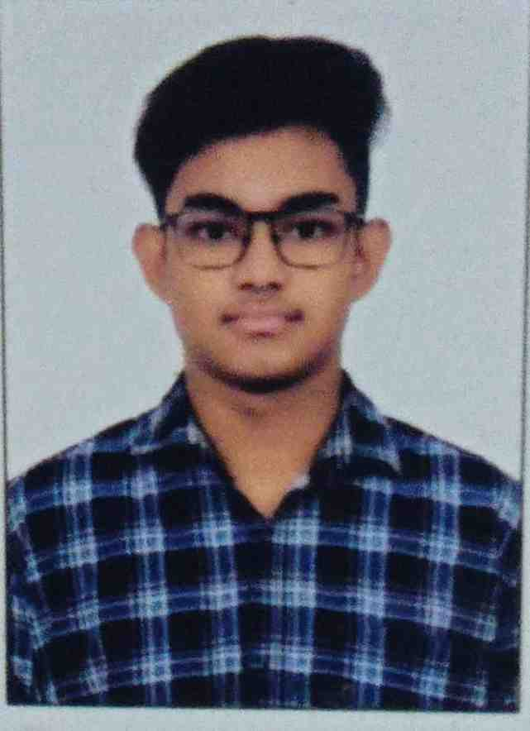
https://www.linkedin.com/in/soumyadeepdey-/
SOUMYADEEP DEY

Kolkata, West Bengal 700124 · +91 9330048673 · rohan.dey1206@gmail.com

https://soumyadeep-dey-portfolio.vercel.app/ https://github.com/SOUMYADEEPDEY1217

PROFESSIONAL SUMMARY

Motivated and detail-oriented Computer Science student with strong skills in Full Stack Development, Cybersecurity, Machine Learning, and AI-driven applications. Experienced in building hackathon-ready projects, scalable web applications, and problem-solving with modern technologies. Passionate about software engineering, cloud security, and developing impactful real-world solutions.

SKILLS

Programming Languages: C, C++, Java, Python, JavaScript
Frontend Development: HTML, CSS, React.js
Backend Development: Node.js, Express.js
Cybersecurity & Cloud: SIEM Concepts, Threat Detection, Google Cloud Basics, Generative AI Applications
Database: MongoDB, SQL, Firebase
Core Computer Science: Data Structures & Algorithms, Object-Oriented Programming, DBMS, UDB
Tools & Technologies: Git, GitHub, VS Code, Godot
Machine Learning: Pandas, NumPy, Data Preprocessing, Feature Engineering

EDUCATION

Bachelor of Technology — Computer Science & Engineering Core
Adamas University, Kolkata, West Bengal | Expected Aug 2028

Higher Secondary Education (Class XII — PCMB)
The Central Modern School, Barasat, Kolkata, India | May 2024
Pure Science Stream (PCMB) with Computer Science

Secondary Education (Class X)
The Central Modern School, Barasat, Kolkata, India | May 2022

PROJECTS

Personal Portfolio Website (https://github.com/SOUMYADEEPDEY1217/soumyadeepdeyportfolio)
Tech Stack: React.js, Vite, JavaScript, HTML, CSS, Framer Motion, Vercel.
Website -
- Designed and developed a fully responsive personal portfolio website to showcase projects, technical skills, achievements, and professional experience.
- Implemented modern UI/UX with smooth animations, interactive sections, and clean navigation for an engaging user experience.
- Integrated project showcase, contact section, resume access, and social profile links to improve professional online presence.
- Deployed and optimized the portfolio on Vercel for fast performance, accessibility, and seamless cross-device compatibility.

Clutch-AI — AI Application Descriptor (https://github.com/SOUMYADEEPDEY1217/Clutch-AI)
Tech Stack: React.js, FastAPI, Python, Google Cloud, Tailwind CSS
Website - https://clutch-ai.vercel.app/
- Developed a real-time AI-powered [type of tool, e.g., workflow automation] application as a successful submission for the Vibe2Ship hackathon, utilizing [Core AI Model/API] for seamless task execution.
- Implemented [key technical feature, e.g., robust endpoint schemas] tailored for autonomous coding agents, drawing on methodologies from the intensive 5-day Kaggle and Google vibe coding course.
- Built a high-performance backend architecture utilizing [Framework/Database] optimized for [performance metric, e.g., low-latency AI inference and concurrent user handling].
- Designed a modern, accessible UI with [specific UI details, e.g., dynamic data visualization, real-time capability comparisons, and clear visual branding] to ensure professional presentation across platforms.

Neon Air Draw — AI Spatial Interface (https://github.com/SOUMYADEEPDEY1217/Neon-Air-Draw)
Tech Stack: React.js, Vite, Media Pipe Hands, WebGL, Framer Motion, JavaScript, CSS
Website - https://neon-air-draw.vercel.app/
- Developed a real-time AI-powered air drawing web application using MediaPipe hand tracking and gesture recognition for seamless spatial interaction.
- Implemented dual-hand control system where one hand handled drawing/erasing and the other managed move, scale, and rotation of strokes.
- Built a high-performance WebGL rendering engine optimized for smooth 60 FPS performance with non-destructive matrix-based transformations.
- Designed a modern glass morphism UI with gesture guides, real-time visual feedback, and physics-based interactions like inertia and snap-to-angle rotation.

CERTIFICATIONS

- Innovating with Google Cloud Artificial Intelligence, Introduction To Generative AI — Google Cloud Skill Boost
- TechA CompTIA Security+(Plus) Certification — Infosys Springboard
- Accenture North America - Project Management Job Simulation— Forage
- Tata Group - Cybersecurity Analyst Job Simulation— Forage
- Deloitte Australia - Data Analytics Job Simulation— Forage
- Cybersecurity offered by Tech Mahindra Foundation— National Skill Development Corporation
- Introduction to Cybersecurity Awareness— HP Life
- Ethical Considerations for Generative Al, Agile Explorer— IBM SkillBuild

ACTIVITIES

- Active participant in hackathons and coding competitions (SIH, Clash of Coders, Coding Premier League)
- Regularly practise problem solving and competitive programming
- Contribute to technical discussions and peer learning communities
- Build projects spanning web development, machine learning, and system design

HOBBIES AND INTERESTS

- Building and experimenting with real-world tech projects
- Competitive programming and problem solving
- Participating in hackathons and technical competitions
- Learning emerging technologies in AI and software development

WEBSITES, PORTFOLIOS, PROFILES

Portfolio: https://soumyadeepdey-portfolio-1206.vercel.app/
LinkedIn: https://www.linkedin.com/in/soumyadeepdey-/
GitHub: https://github.com/SOUMYADEEPDEY1217
Google Cloud Skill Boost: https://www.skills.google/public_profiles/53fb6722-d16a-44eb-8970-ce1514c8fa2b
Google Developer Program: https://g.dev/soumyadeepdey

LANGUAGES

Bengali: Native
English: Proficient (C2)
Hindi: Proficient (C2)

