Rules for Automobiles Travelling in Opposite Directions
RULE 12
RULE 12(2)
(2) If neither automobile “A” nor automobile “B” changes lanes and both automobiles are on or over the centre lane when the incident (a “sideswipe”) occurs, the driver of each automobile is 50 per cent at fault for the incident.
Diagram
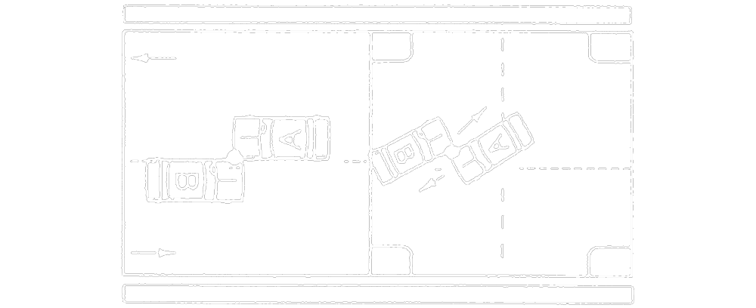
Text alternative: Diagram containing two types of collisions. In the first diagram, automobiles “A” and “B” are travelling in opposite directions in adjacent lanes and strike each other on the side along the centre line. In the second type, automobiles “A” and “B” are travelling in opposite directions and are both turning left at an intersection. The automobiles strike each other on the lane that automobile “A” is turning out of while both automobiles are across the centre line. This text alternative is provided for convenience only and does not form part of the official law.
R.R.O. 1990, Reg. 668, s. 12 (2).

RULE 12(3)
(3) If the location on the road of automobiles “A” and “B” when the incident (a “sideswipe”) occurs cannot be determined, the driver of each automobile is 50 per cent at fault for the incident.
Diagram
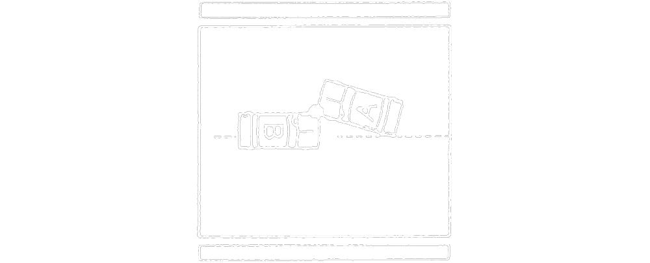

Text alternative: Diagram of a collision. Automobiles “A” and “B” are travelling in opposite directions. Automobile “B” has crossed the centre line and is in the oncoming lane. Automobile “A” and “B” strike the front driver side corner of each other as automobile “A” is changing lanes away from automobile “B”. The driver side rear corner of automobile “A” is on the centre line. This text alternative is provided for convenience only and does not form part of the official law.
R.R.O. 1990, Reg. 668, s. 12 (3).
RULE 12(4)
(4) If automobile “B” is over the centre line of the road when the incident occurs, the driver of automobile “A” is not at fault and the driver of automobile “B” is 100 per cent at fault for the incident.
Diagram
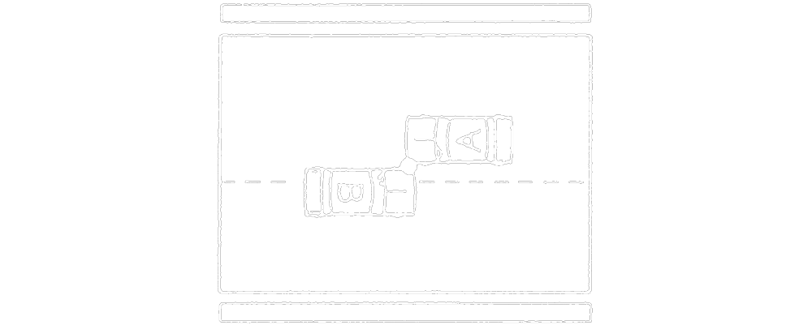
Text alternative: Diagram of a collision. Automobiles “A” and “B” are travelling in opposite directions. Automobile “B” has crossed the centre line into A’s lane. Automobile “A” and “B” strike the side of each other. This text alternative is provided for convenience only and does not form part of the official law.
R.R.O. 1990, Reg. 668, s. 12 (4).
RULE 12(5)
(5) If automobile “B” turns left into the path of automobile “A”, the driver of automobile “A” is not at fault and the driver of automobile “B” is 100 per cent at fault for the incident.
Diagram
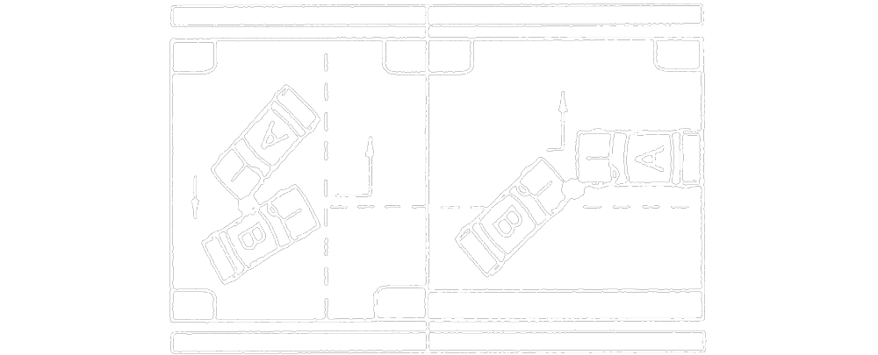
Text alternative: Diagram of two types of collisions. In the first diagram “A” and “B” are traveling perpendicular to one another. Automobile “B” pulls out into oncoming traffic to make a left turn and strikes automobile “A". In the second type, automobiles “A” and “B” are traveling in opposite directions and automobile “B” is turning left. Automobile “B” turns left in front of automobile “A” and the front of both automobiles collide. This text alternative is provided for convenience only and does not form part of the official law.
R.R.O. 1990, Reg. 668, s. 12 (5).

RULE 12(6)
(6) If automobile “B” is leaving a parking place or is entering the road from a private road or driveway, and if automobile “A” is overtaking to pass another automobile when the incident occurs, the driver of automobile “A” is not at fault and the driver of automobile “B” is 100 per cent at fault for the incident.
Diagram
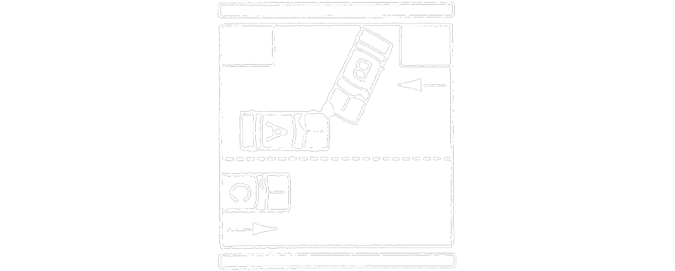
Text alternative: Diagram of a collision. Automobile “B” is entering a road with two lanes of traffic heading in opposite directions from a private road or driveway. In the lane closest to automobile “B”, automobile “A” is driving against traffic to overtake automobile “C”, which is driving alongside automobile “A” in the far lane. Automobile “B” exits the private road or driveway and collides with the front of automobile “A”. This text alternative is provided for convenience only and does not form part of the official law.
R.R.O. 1990, Reg. 668, s. 12 (6).

