Rules for Automobiles Travelling in the Same Direction and Lane
RULE 6
RULE 6(1)
6. (1) This section applies when automobile “A” is struck from the rear by automobile “B”, and both automobiles are travelling in the same direction and in the same lane. R.R.O. 1990, Reg. 668, s. 6 (1).
RULE 6(2)
(2) If automobile “A” is stopped or is in forward motion, the driver of automobile “A” is not at fault and the driver of automobile “B” is 100 per cent at fault for the incident.
Diagram
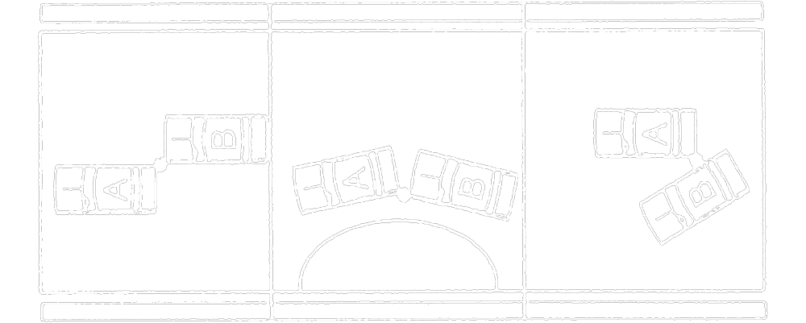
Text alternative: Diagram of three types of collisions. In the first type, automobile “A” is parallel to the road and is struck in the passenger side rear by the driver side front of automobile “B”. In the second type, automobile “A” is not parallel to the road and is struck in the driver side rear by the driver side front of automobile “B”. In the third type, automobile "A" is parallel to the road and is struck in the driver side rear by the passenger side of automobile “B”, which is trying to pull past automobile “A ”. This text alternative is provided for convenience only and does not form part of the official law.
R.R.O. 1990, Reg. 668, s. 6 (2).
RULE 6(3)
(3) If automobile “A” is turning, either to the right or to the left, in order to enter a side road, private road or driveway, the driver of automobile “A” is not at fault and the driver of automobile “B” is 100 per cent at fault for the incident.
Diagram
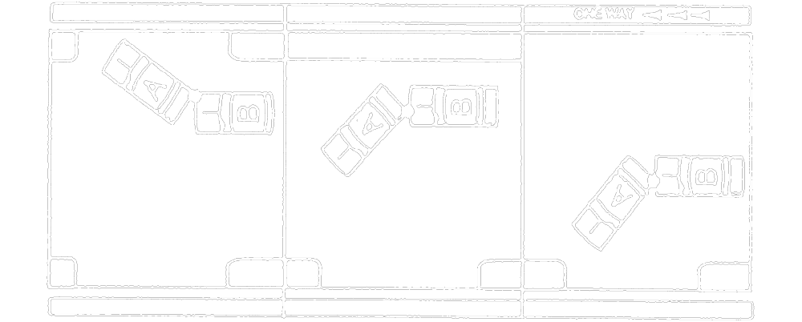
Text alternative: Diagram of three types of collisions. In the first type, automobile “A” is turning right and is struck in the passenger side rear by the passenger side front of automobile “B”. In the second type, automobile “A” is turning left and is struck in the driver side rear by the front of automobile “B”. In the third type, automobile “A” is turning left from a one-way road and is struck in the driver side rear by the front of automobile “B”. This text alternative is provided for convenience only and does not form part of the official law.
R.R.O. 1990, Reg. 668, s. 6 (3).
RULE 6(4)
(4) If automobile “A” is in forward motion and is entering a parking place on either the right or the left side of the road, the driver of automobile “A” is not at fault and the driver of automobile “B” is 100 per cent at fault for the incident.
Diagram
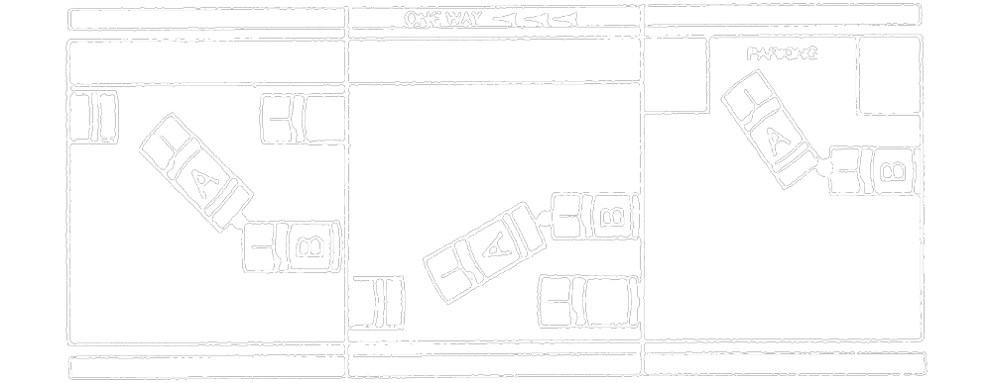
Text alternative: Diagram of three types of collisions. In the first type, automobile “A” is parallel parking on the right side of the road and is struck in the rear by automobile “B”. In the second type, automobile “A” is parallel parking on the left side of a one-way street and is struck in the rear by the front of automobile “B”. In the third type, automobile “A” is turning right into a parking place marked with the text “PARKING” and is struck in the passenger side rear by the front of automobile “B”. This text alternative is provided for convenience only and does not form part of the official law.
R.R.O. 1990, Reg. 668, s. 6 (4).
RULE 7
RULE 7(1)

7. (1) This section applies when automobile “A” collides with automobile “B” while automobile “B” is entering a road from a parking place, private road or driveway. R.R.O. 1990, Reg. 668, s. 7 (1).
RULE 7(2)
(2) If the incident occurs when automobile “B” is leaving a parking place and automobile “A” is passing the parking place, the driver of automobile “A” is not at fault and the driver of automobile “B” is 100 per cent at fault for the incident.
Diagram
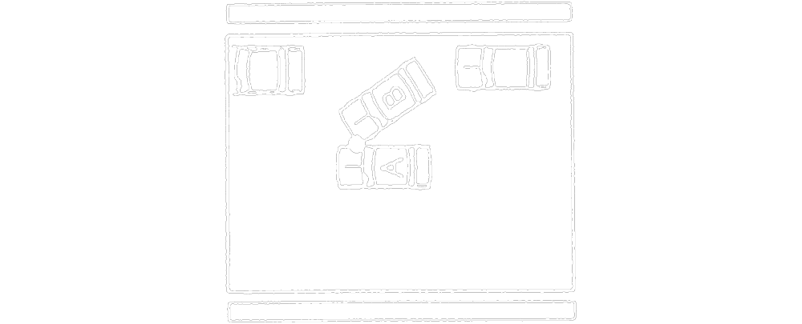
Text alternative: Diagram of a collision. Automobile “B” is pulling out of a parking place and the front driver side strikes the passenger side of automobile “A”, which is moving forward past the parking place. This text alternative is provided for convenience only and does not form part of the official law.
R.R.O. 1990, Reg. 668, s. 7 (2).
RULE 7(3)
(3) If the incident occurs when automobile “B” is entering a road from a private road or a driveway and automobile “A” is passing the private road or driveway and, if there are no traffic signals or signs, the driver of automobile “A” is not at fault and the driver of automobile “B” is 100 per cent at fault for the incident.
Diagram
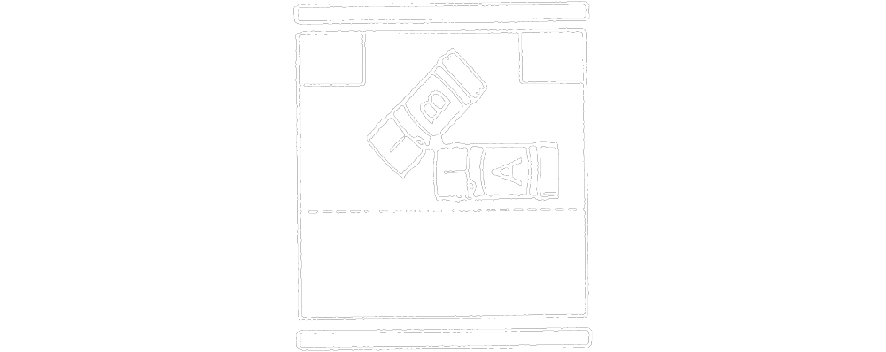
Text alternative: Diagram of a collision. Automobile “B” is entering a road from a private road or driveway and is struck in the driver side rear by the front passenger side of automobile “A”. This text alternative is provided for convenience only and does not form part of the official law.
R.R.O. 1990, Reg. 668, s. 7 (3).
RULE 8
8. If automobile “A” collides with automobile “B” on a controlled access road while automobile “B” is entering the road from an entrance lane, the driver of automobile “A” is not at fault and the driver of automobile “B” is 100 per cent at fault for the incident.
Diagram
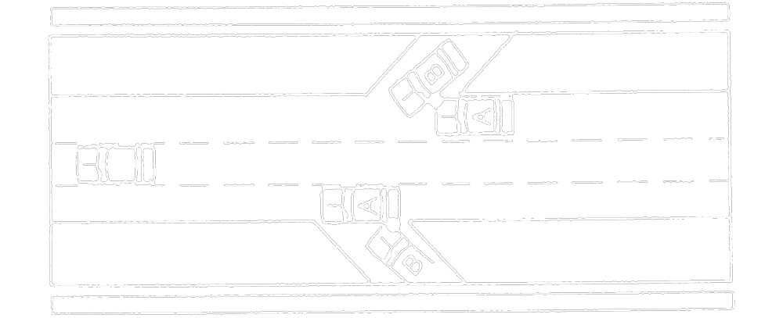
Text alternative: Diagram containing two collisions. In the collision at the top of the diagram, automobile “B” is entering a controlled access road from an entrance lane and is struck on the driver side by the front passenger side of automobile “A”. In the collision at the bottom of the diagram, automobile “B” is entering a controlled access road from an entrance lane and the front passenger side strikes the rear driver side of automobile “A”. This text alternative is provided for convenience only and does not form part of the official law.
R.R.O. 1990, Reg. 668, s. 8.
RULE 9
RULE 9(1)
9. (1) This section applies with respect to an incident involving three or more automobiles that are travelling in the same direction and in the same lane (a “chain reaction”). R.R.O. 1990, Reg. 668, s. 9 (1).
RULE 9(2)
(2) The degree of fault for each collision between two automobiles involved in the chain reaction is determined without reference to any related collisions involving either of the automobiles and another automobile. R.R.O. 1990, Reg. 668, s. 9 (2).
RULE 9(3)
(3) If all automobiles involved in the incident are in motion and automobile “A” is the leading vehicle, automobile “B” is second and automobile “C” is the third vehicle,
RULE 9(3)(A)
(a) in the collision between automobiles “A” and “B”, the driver of automobile “A” is not at fault and the driver of automobile “B” is 50 per cent at fault for the incident;
RULE 9(3)(A)
(b) in the collision between automobiles “B” and “C”, the driver of automobile “B” is not at fault and the driver of automobile “C” is 100 per cent at fault for the incident.
Diagram
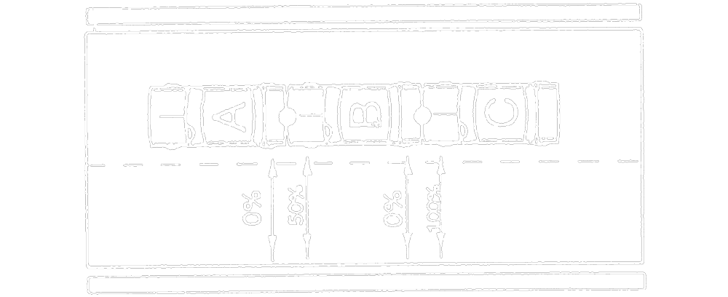
Text alternative: Diagram containing a multiple collision involving 3 vehicles traveling in the same direction, in the same lane. Automobile “A” is in the front and has been struck in the rear by the front of automobile “B”. Automobile “B” has been struck in the rear by the front of automobile “C”. An arrow to the rear of automobile “A” has the text “0 %”. An arrow to the front of automobile “B” has the text “50 %”. An arrow to the rear of automobile “B” has the text “0 %”. An arrow to the front of automobile “C” has the text “100 %”. This text alternative is provided for convenience only and does not form part of the official law.
R.R.O. 1990, Reg. 668, s. 9 (3).
RULE 9
RULE 9(4)
(4) If only automobile “C” is in motion when the incident occurs,
RULE 9(4)(A)
(a) in the collision between automobiles “A” and “B”, neither driver is at fault for the incident; and
RULE 9(4)(b)
(b) in the collision between automobiles “B” and “C”, the driver of automobile “B” is not at fault and the driver of automobile “C” is 100 per cent at fault for the incident.
Diagram
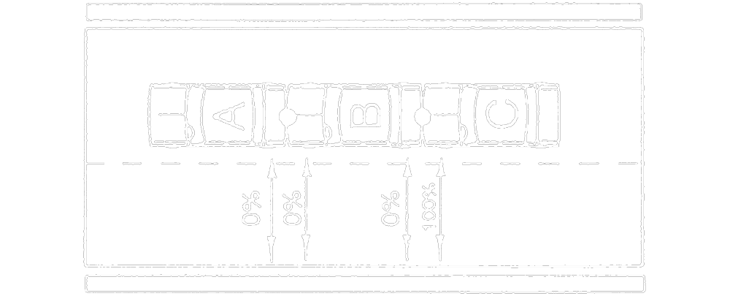
Text alternative: Diagram containing a multiple collision involving 3 vehicles traveling in the same direction, in the same lane. Automobile “A” is in the front and has been struck in the rear by the front of automobile “B”. Automobile “B” has been struck in the rear by the front of automobile “C”. An arrow to the rear of automobile “A” has the text “0 %”. An arrow to the front of automobile “B” has the text “0 %”. An arrow to the rear of automobile “B” has the text “0 %”. An arrow to the front of automobile “C” has the text “100 %”. This text alternative is provided for convenience only and does not form part of the official law.
R.R.O. 1990, Reg. 668, s. 9 (4).

