RULE 9
RULE 9(3)
(3) If all automobiles involved in the incident are in motion and automobile “A” is the leading vehicle, automobile “B” is second and automobile “C” is the third vehicle,
(a) in the collision between automobiles “A” and “B”, the driver of automobile “A” is not at fault and the driver of automobile “B” is 50 per cent at fault for the incident;
(b) in the collision between automobiles “B” and “C”, the driver of automobile “B” is not at fault and the driver of automobile “C” is 100 per cent at fault for the incident.
Diagram
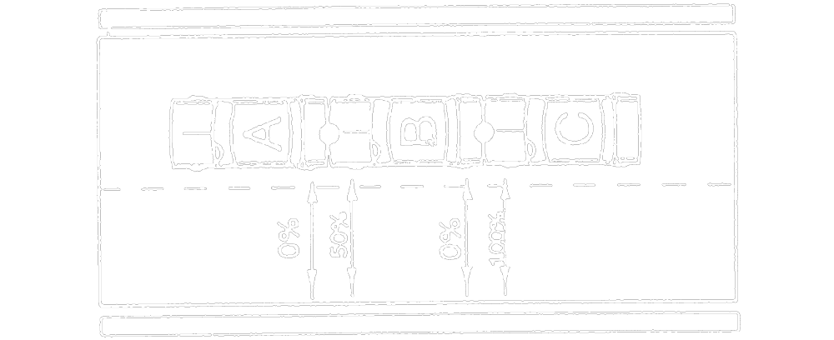
Text alternative: Diagram containing a multiple collision involving 3 vehicles traveling in the same direction, in the same lane. Automobile “A” is in the front and has been struck in the rear by the front of automobile “B”. Automobile “B” has been struck in the rear by the front of automobile “C”. An arrow to the rear of automobile “A” has the text “0 %”. An arrow to the front of automobile “B” has the text “50 %”. An arrow to the rear of automobile “B” has the text “0 %”. An arrow to the front of automobile “C” has the text “100 %”. This text alternative is provided for convenience only and does not form part of the official law.
R.R.O. 1990, Reg. 668, s. 9 (3).
RULE 9(4)
(4) If only automobile “C” is in motion when the incident occurs,
(a) in the collision between automobiles “A” and “B”, neither driver is at fault for the incident; and
(b) in the collision between automobiles “B” and “C”, the driver of automobile “B” is not at fault and the driver of automobile “C” is 100 per cent at fault for the incident.
Diagram
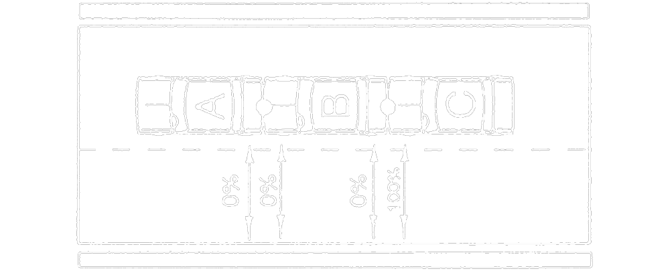
Text alternative: Diagram containing a multiple collision involving 3 vehicles traveling in the same direction, in the same lane. Automobile “A” is in the front and has been struck in the rear by the front of automobile “B”. Automobile “B” has been struck in the rear by the front of automobile “C”. An arrow to the rear of automobile “A” has the text “0 %”. An arrow to the front of automobile “B” has the text “0 %”. An arrow to the rear of automobile “B” has the text “0 %”. An arrow to the front of automobile “C” has the text “100 %”. This text alternative is provided for convenience only and does not form part of the official law.
R.R.O. 1990, Reg. 668, s. 9 (4).

