Comparative Frequency Spectrum Analysis of
Digital Window Functions using MATLAB
Submitted By
Sounak Chattopadhyay
B.Tech Electrical Engineering
National Institute of Technology Agartala
2026

Abstract
This project presents a MATLAB-based comparative analysis of Rectangular, Hanning, Hamming, and Blackman window functions. Magnitude and phase spectra are generated to study spectral leakage, side-lobe attenuation, and frequency resolution. The project demonstrates practical applications of windowing techniques in Digital Signal Processing (DSP).

Introduction
Window functions are widely used in Digital Signal Processing to minimize spectral leakage while performing Fourier analysis. Different window functions provide different trade-offs between frequency resolution and side-lobe attenuation. This project implements and compares four commonly used window functions using MATLAB.

Objectives
• Analyze four popular window functions.
• Compare magnitude and phase responses.
• Study spectral leakage and frequency resolution.
• Visualize frequency-domain characteristics.
• Demonstrate MATLAB implementation for DSP analysis.

Methodology
1. Input window length.
2. Generate frequency vector.
3. Compute Rectangular, Hanning, Hamming and Blackman spectra.
4. Plot magnitude and phase responses.
5. Generate comparison graph.
6. Save figures automatically.

Results and Discussion
Figure 1 shows the magnitude and phase responses of the four window functions generated by the MATLAB program.
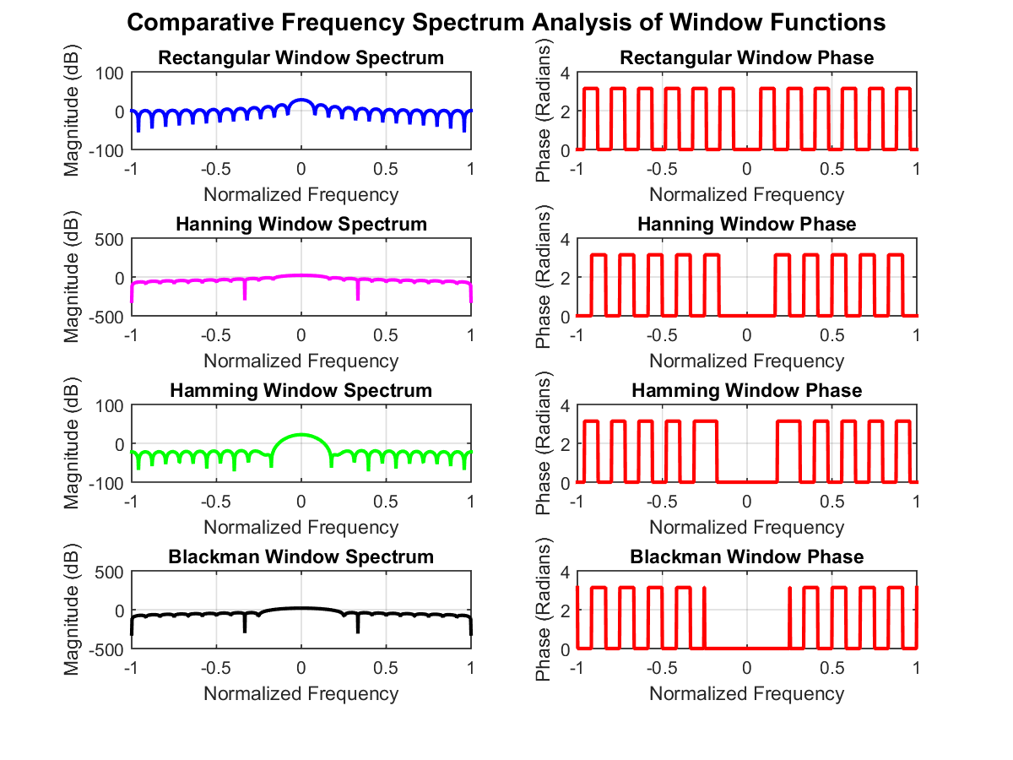
Figure 1. Magnitude and Phase Responses of Rectangular, Hanning, Hamming and Blackman Window Functions
Figure 2 compares the magnitude responses of all window functions on a single graph.
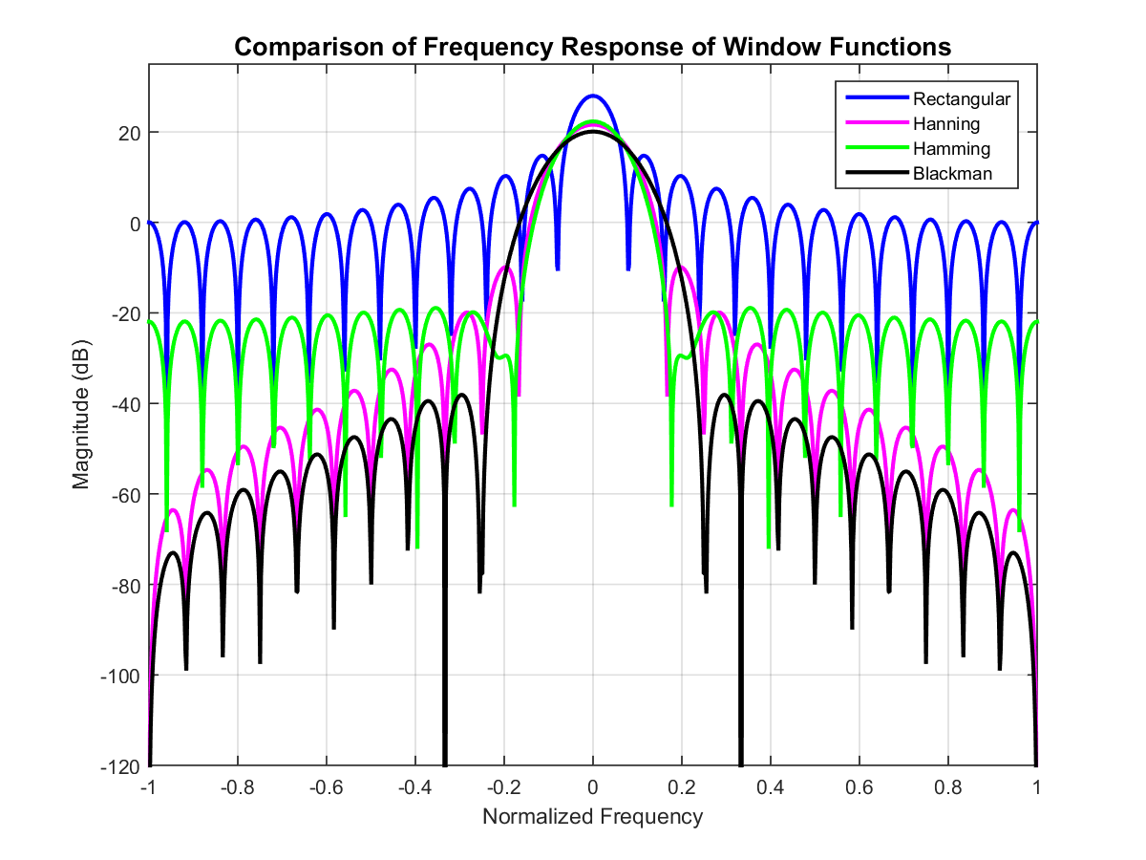
Figure 2. Comparative Frequency Response of Digital Window Functions

Observations
- Rectangular window provides the highest frequency resolution but exhibits the highest spectral leakage.
- Hanning window reduces side-lobe levels compared to the Rectangular window.
- Hamming window offers a good balance between frequency resolution and leakage.
- Blackman window provides the best side-lobe suppression at the cost of a wider main lobe.

Applications
- Digital Signal Processing
- FFT Analysis
- FIR Filter Design
- Communication Systems
- Audio & Speech Processing
- Biomedical Signal Processing

Conclusion
The project successfully compares four widely used digital window functions using MATLAB. The generated plots clearly illustrate the trade-offs between spectral leakage and frequency resolution, making the project a useful educational demonstration of DSP windowing techniques.

References
- A.V. Oppenheim & R.W. Schafer, Discrete-Time Signal Processing.
- J.G. Proakis & D.G. Manolakis, Digital Signal Processing.
- MATLAB Documentation.

