1.Write a program where a method accepts an integer parameter and tries to change its value. Print the value before and after the method call.

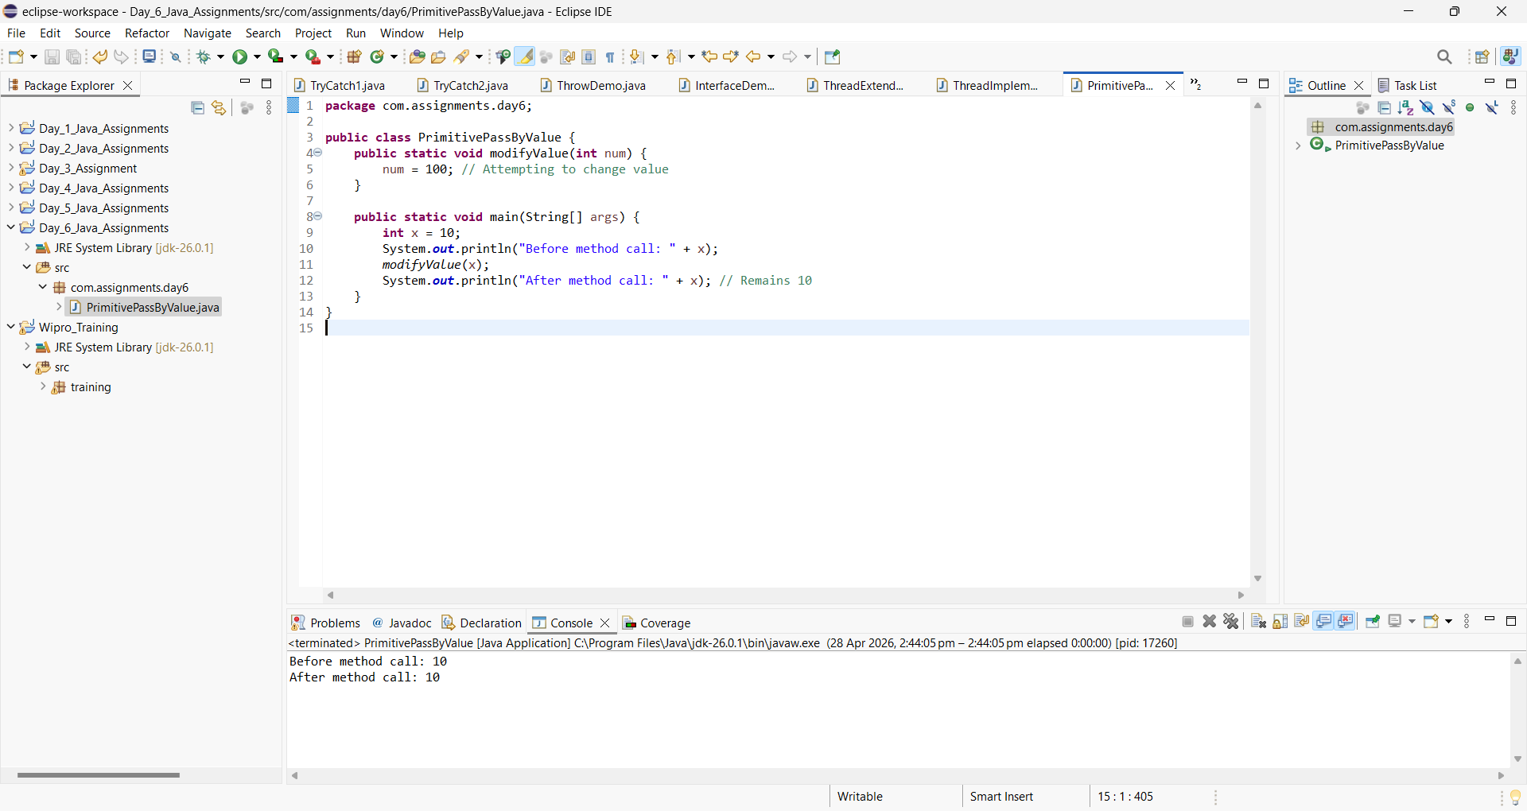

2.Create a class Box with a variable length. Write a method that modifies the value of length by passing the Box object. Show that the original object is modified.

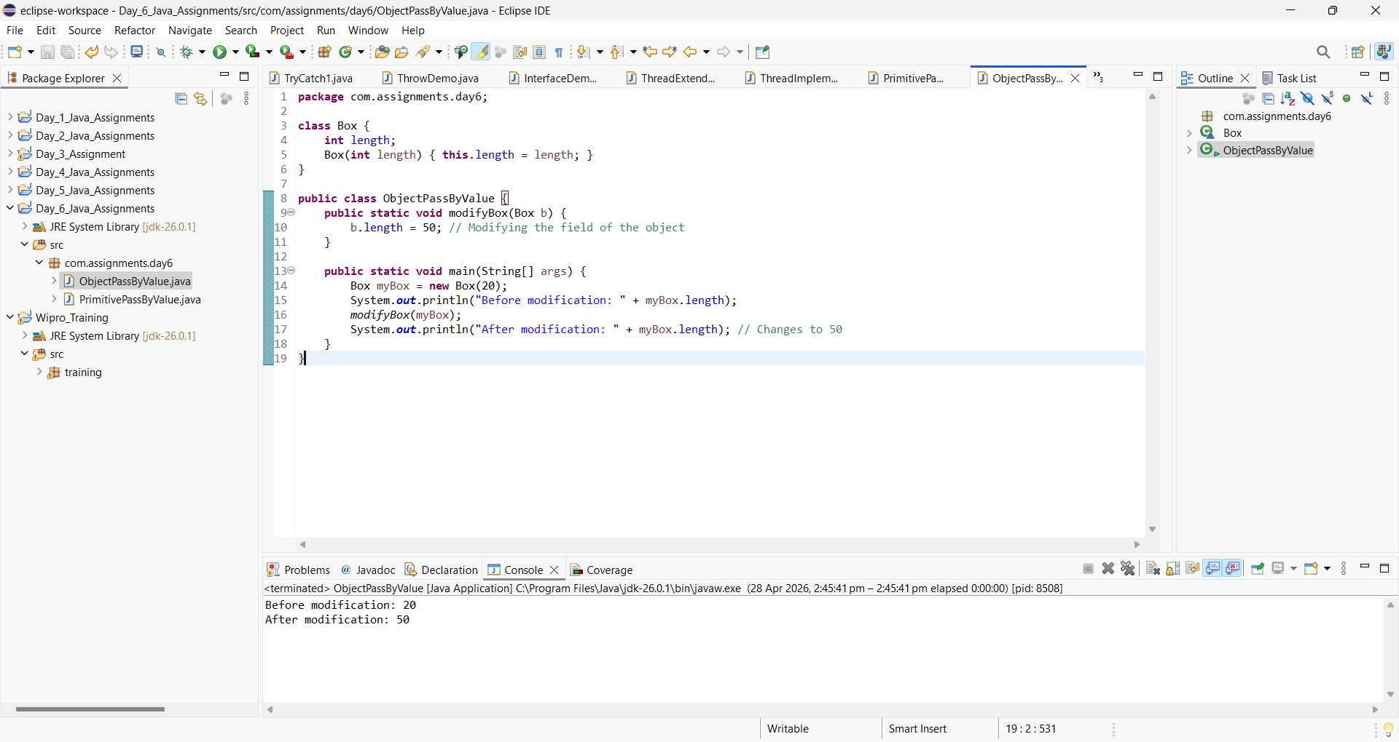

3.Check if character is a Digit

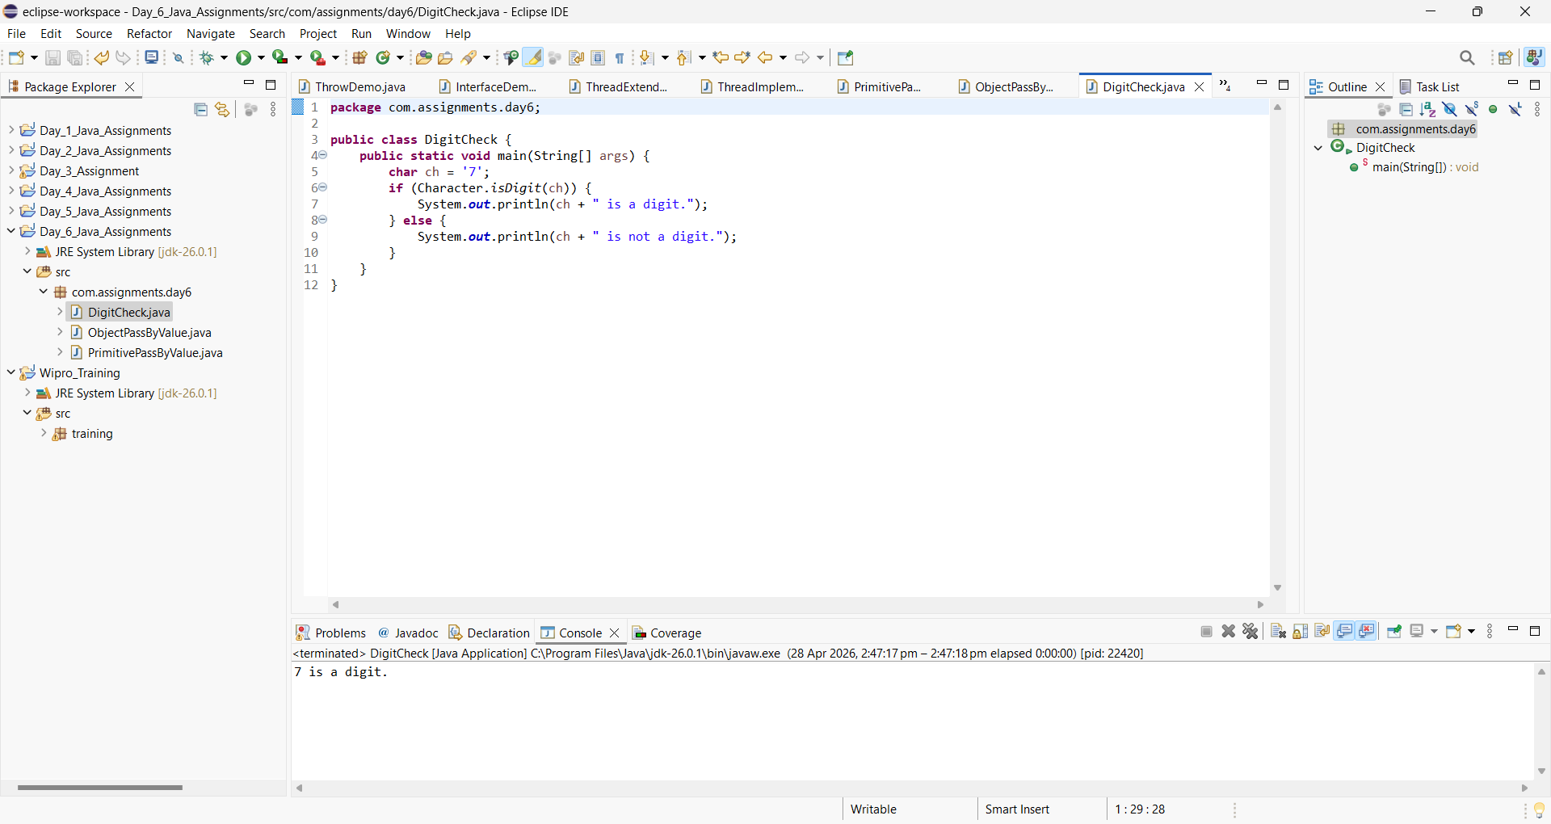

4.Compare two Strings

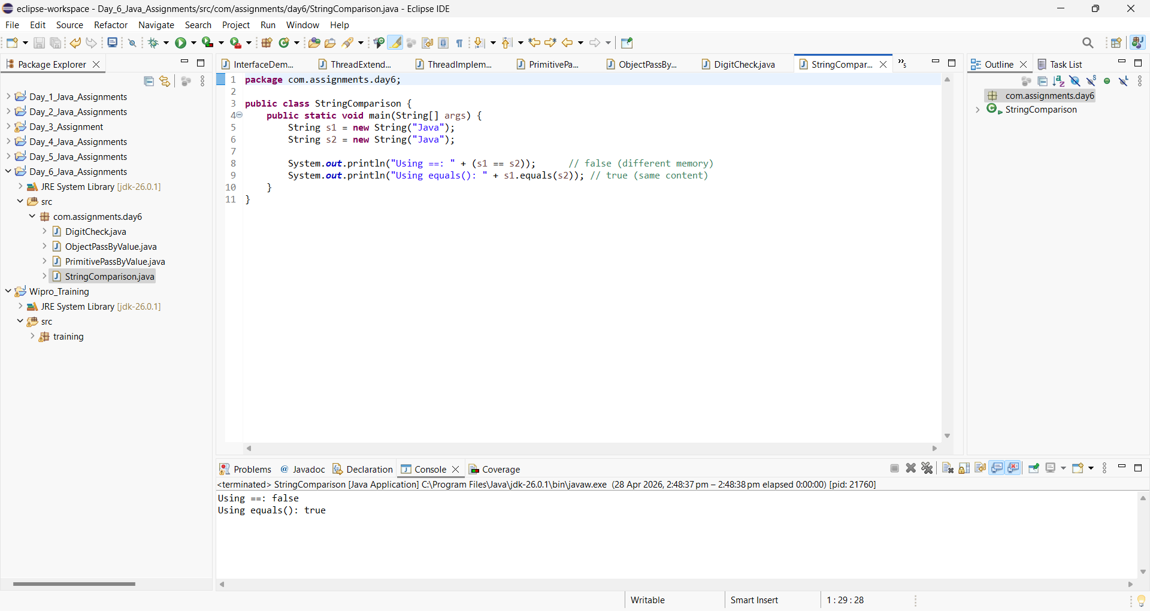

5.Convert using valueof method

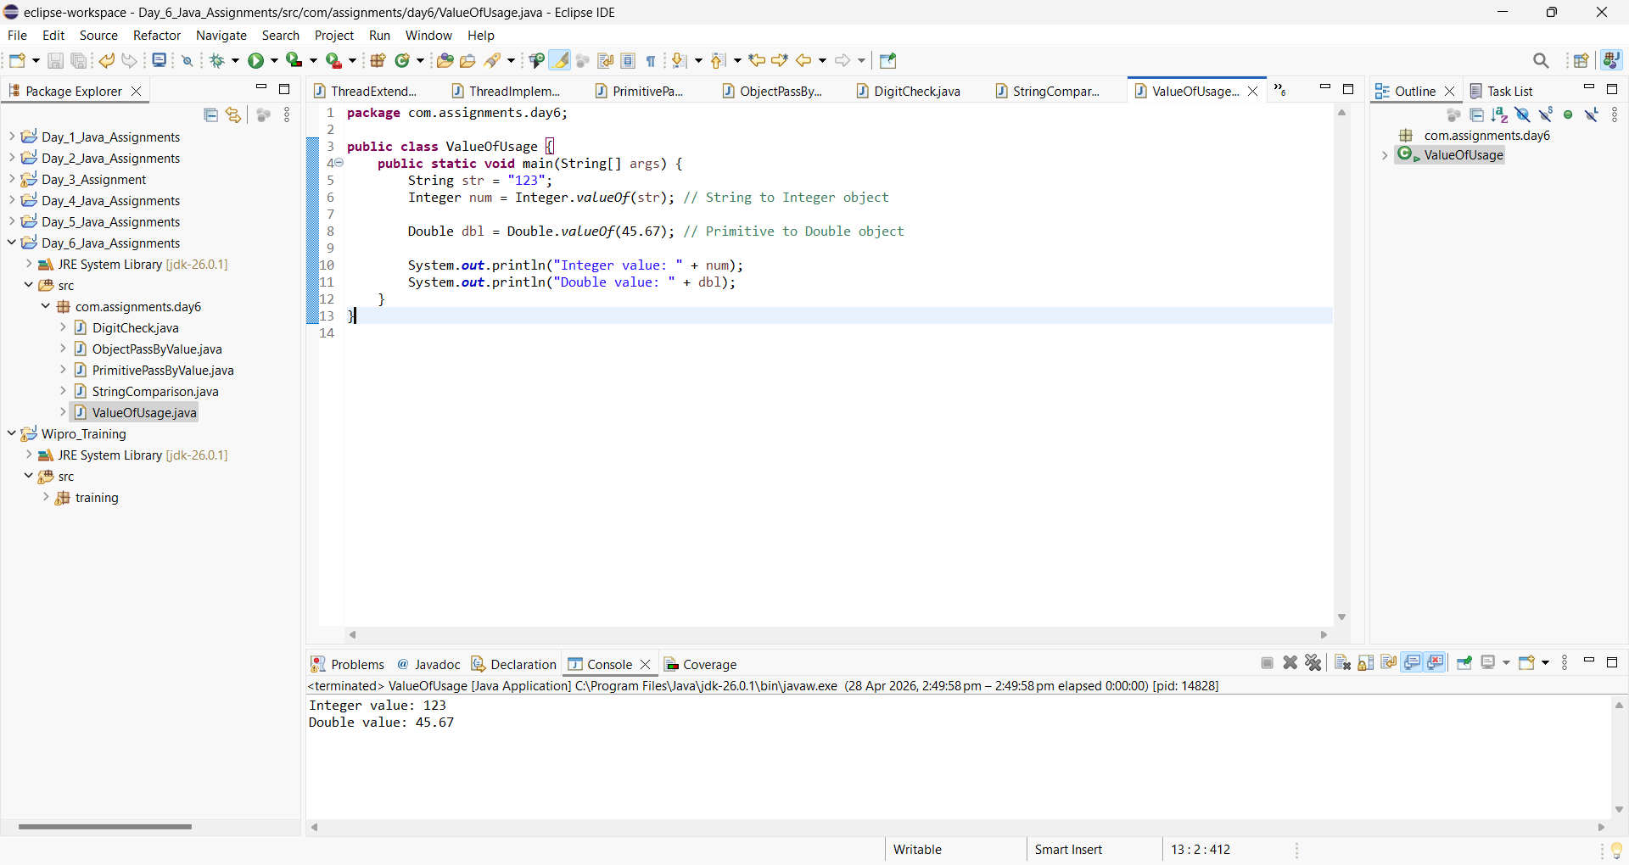

6.Create Boolean Wrapper usage

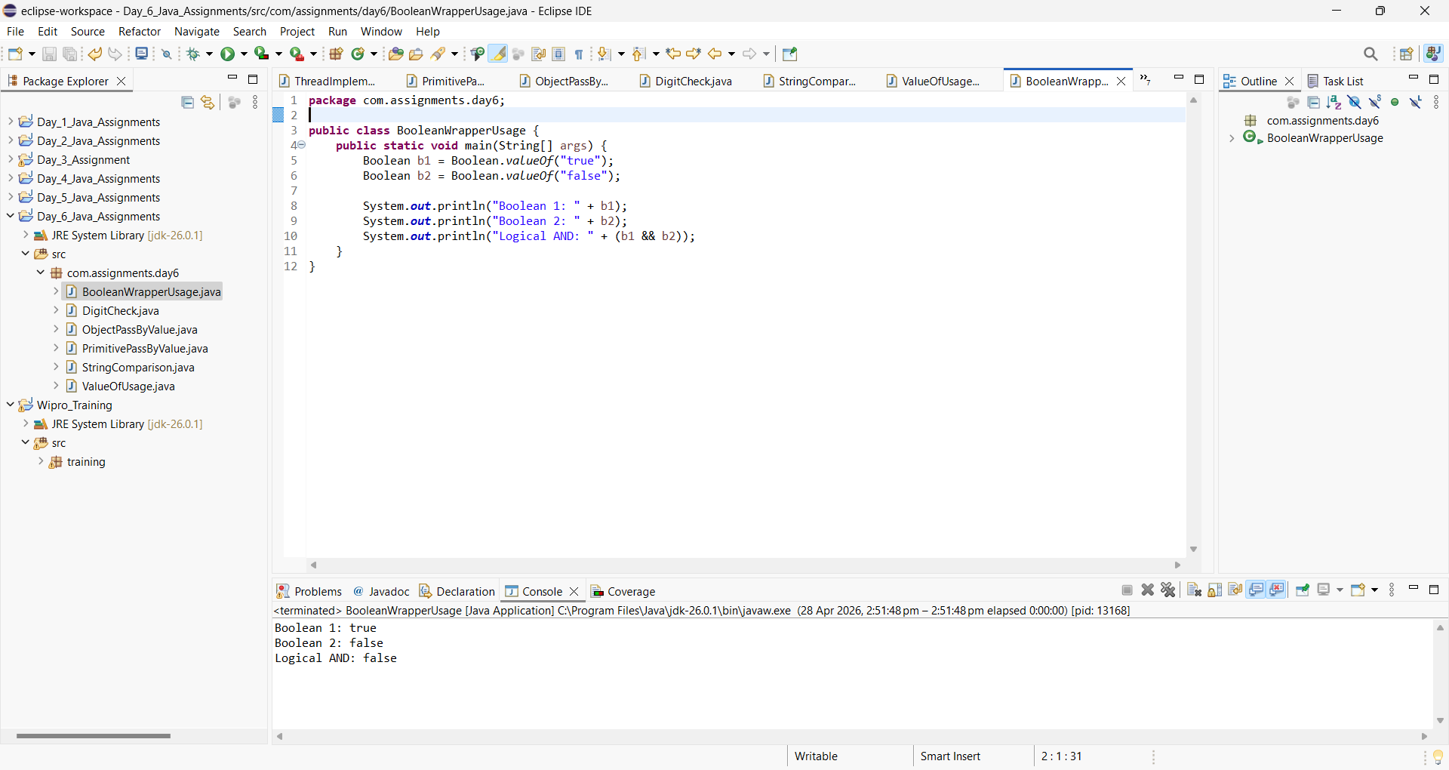

7.Convert null to wrapper classes
