Second Largest Element
• Find the second largest element in a List.
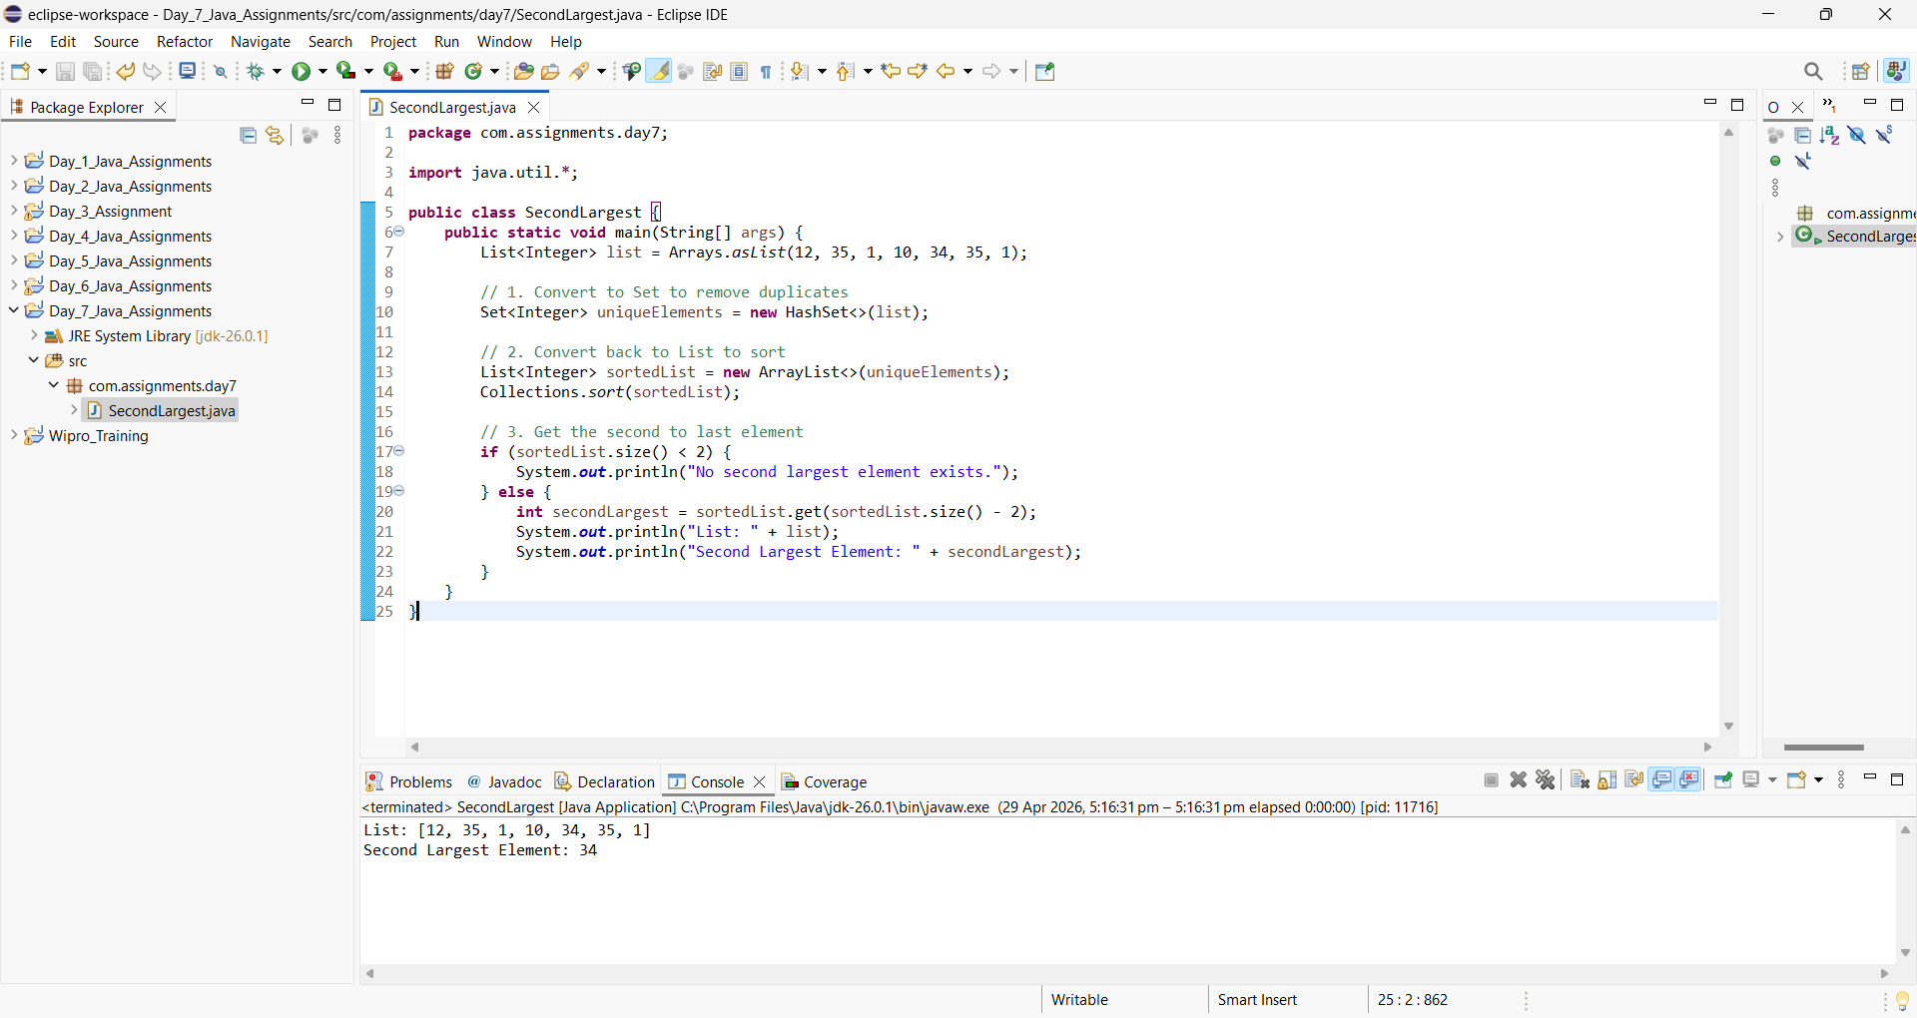

Common Elements Between Two Sets
• Find intersection of two HashSet.
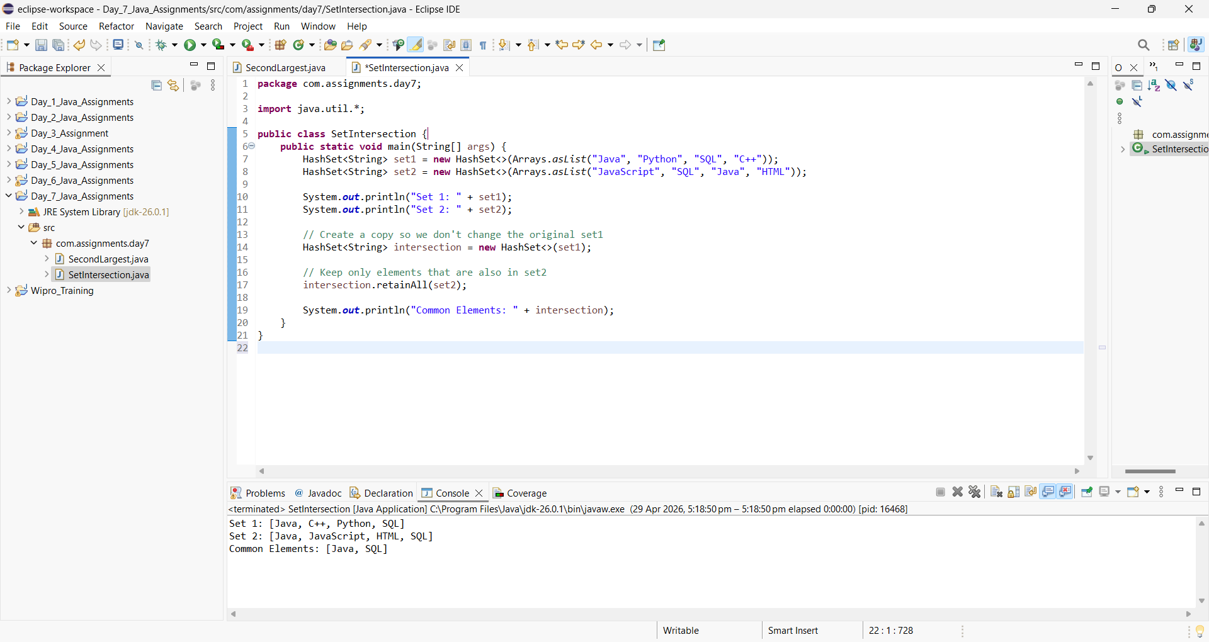

Symmetric Difference
• Find elements present in either of the sets but not both
