- Write a program to check whether a number is even or odd using switch-case.

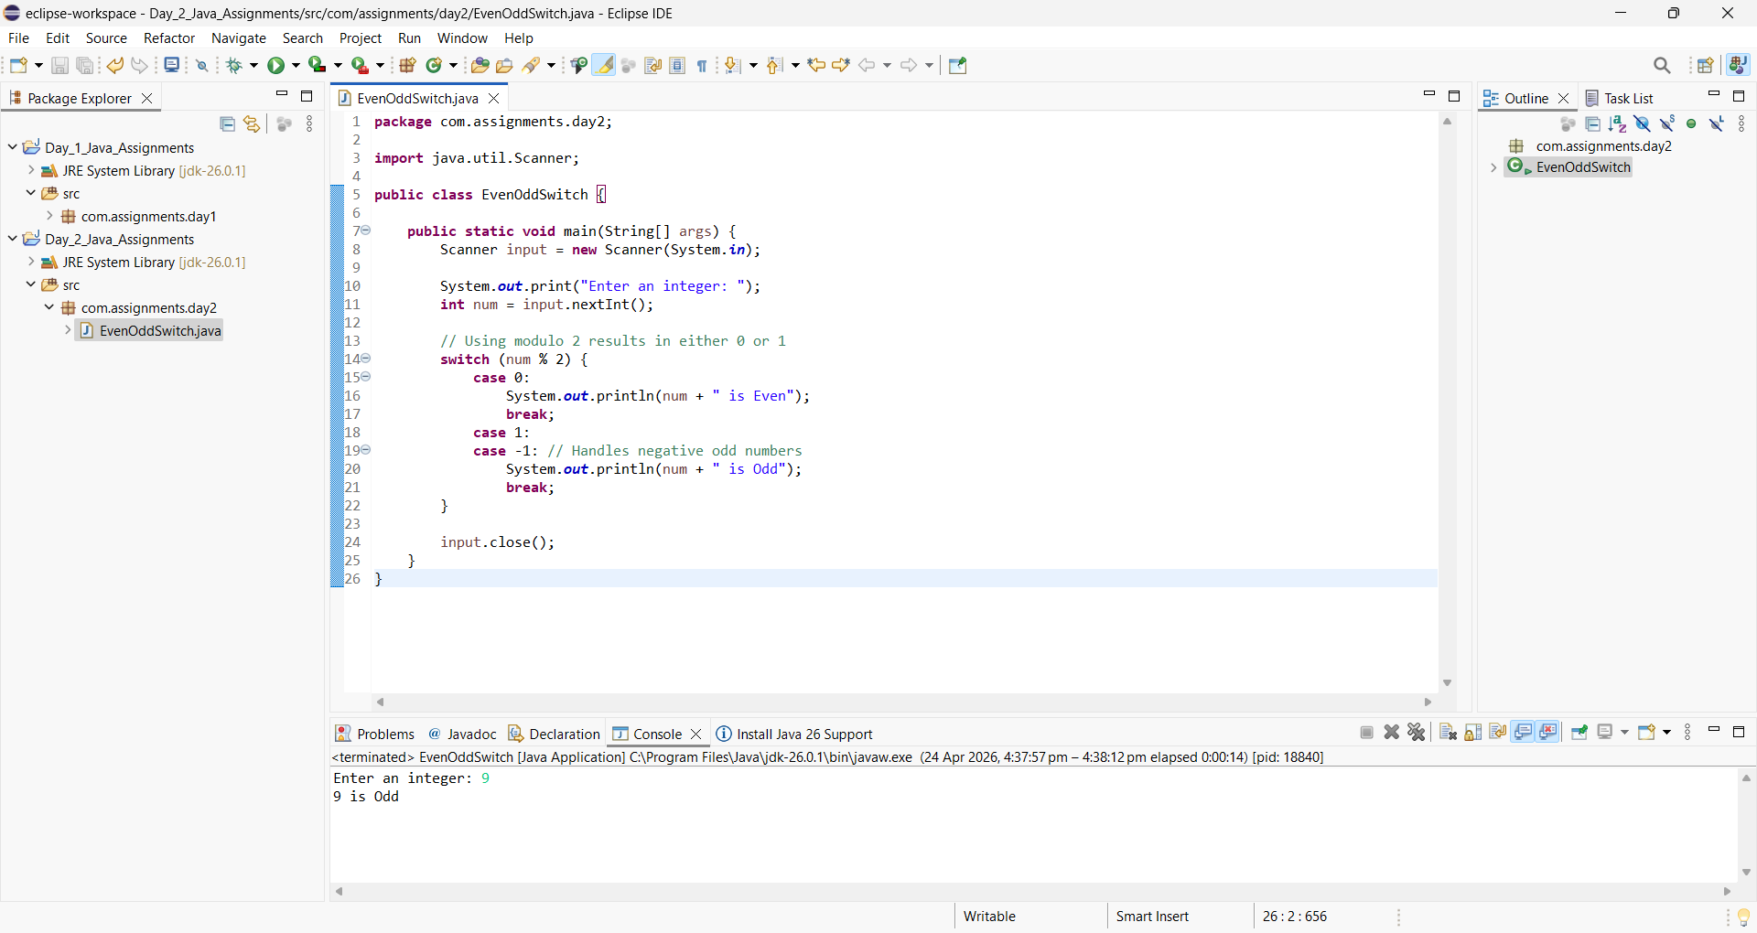
- Write a program that takes a character as input and checks whether it is a vowel or consonant using switch-case.
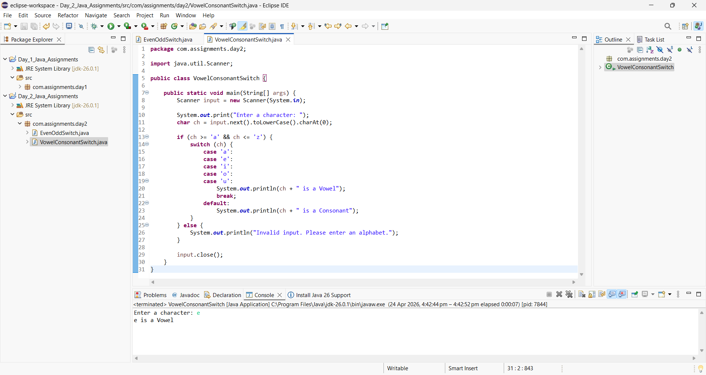

- Write a program that takes a grade (A, B, C, D, F) and displays the performance message.
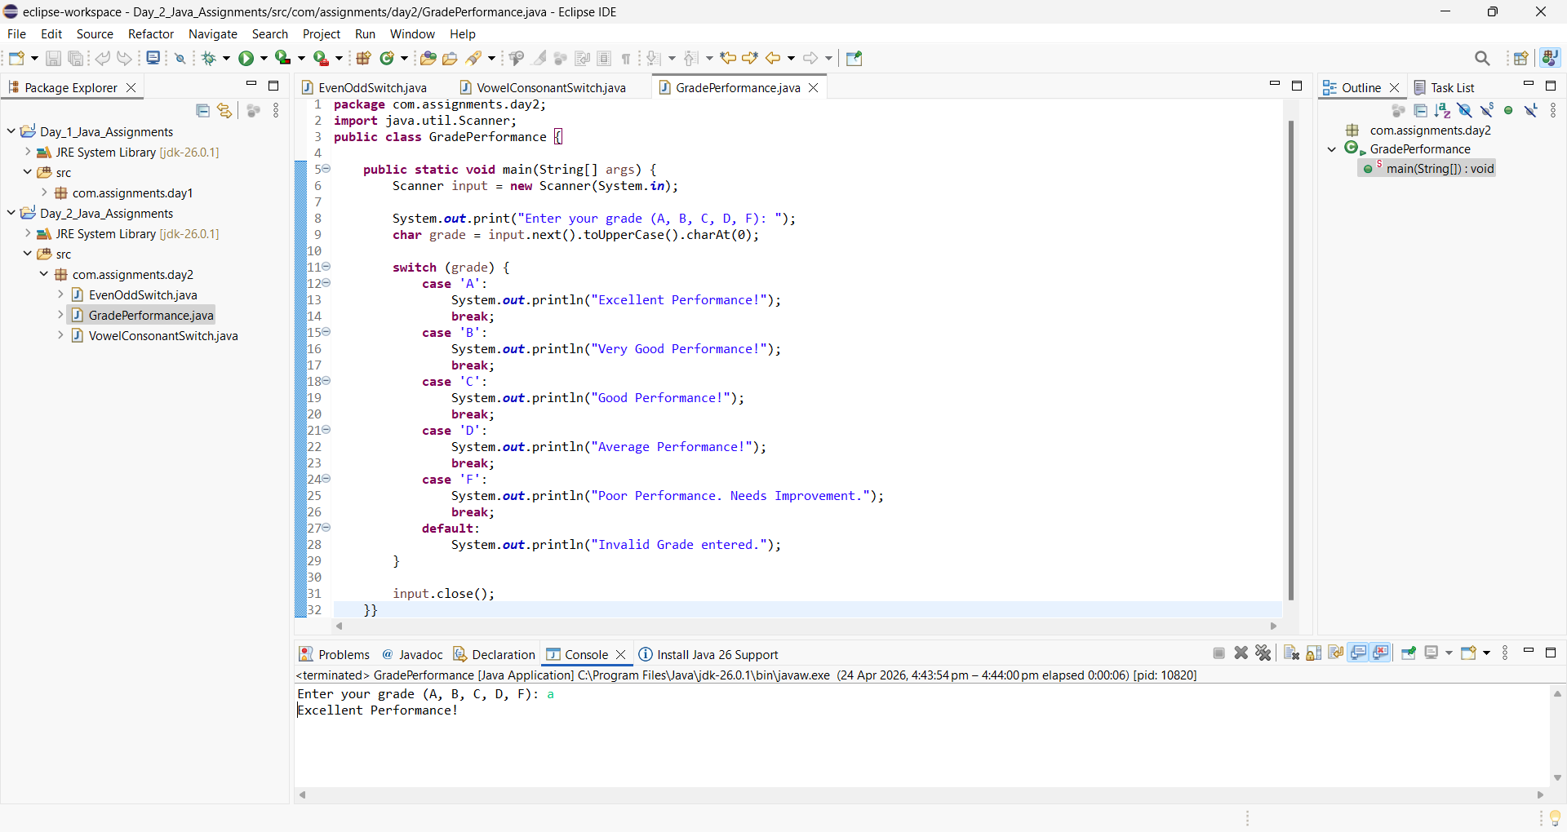

- Create a menu-driven program for ATM operations: • 1 → Check Balance • 2 → Deposit • 3 → Withdraw • 4 → Exit Perform the operation based on user choice.
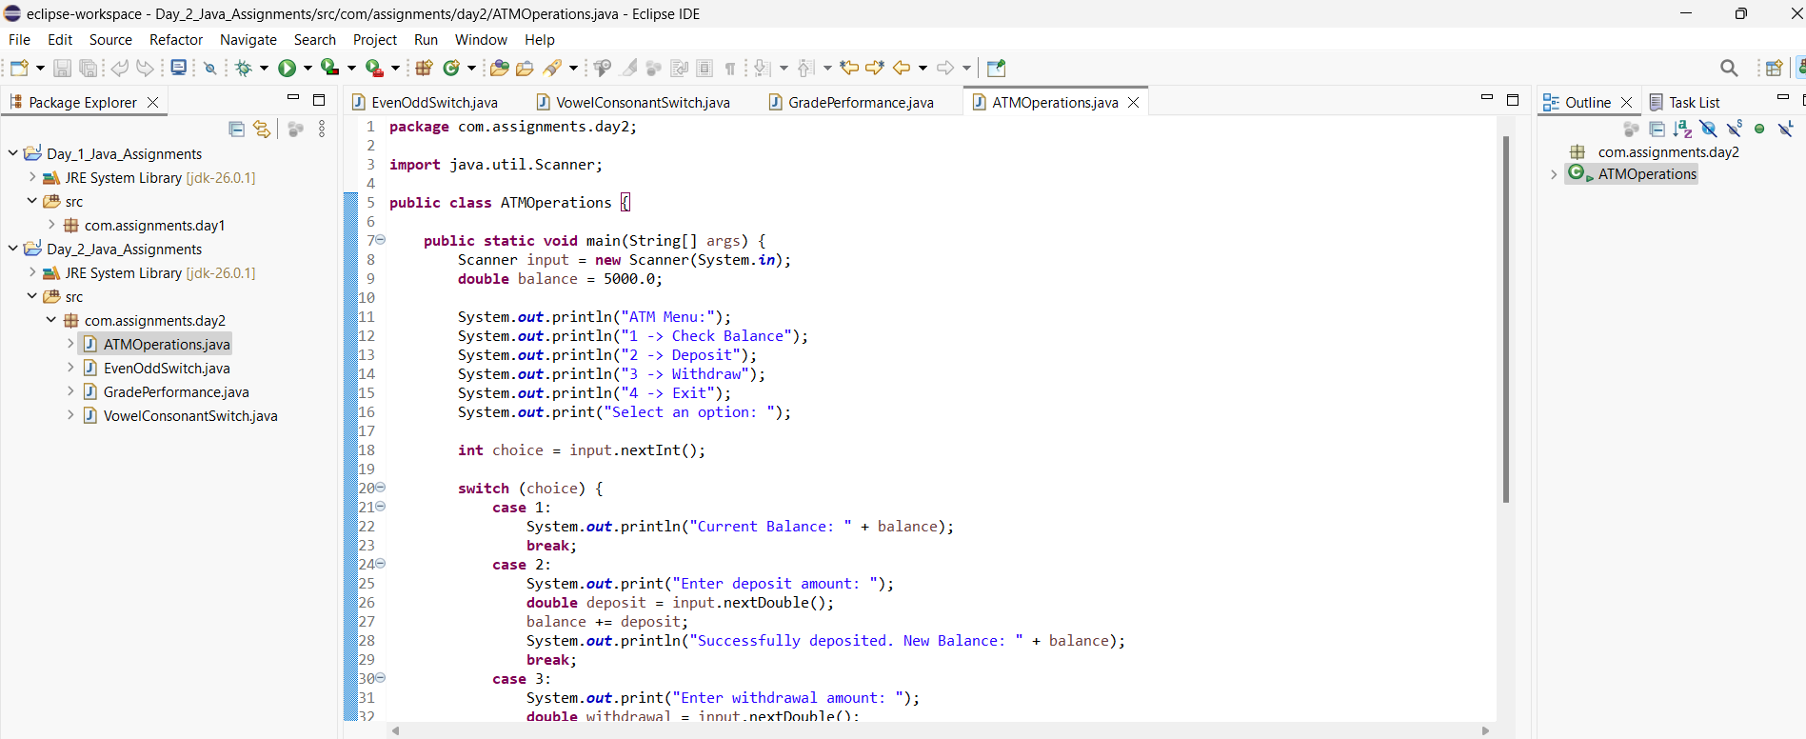
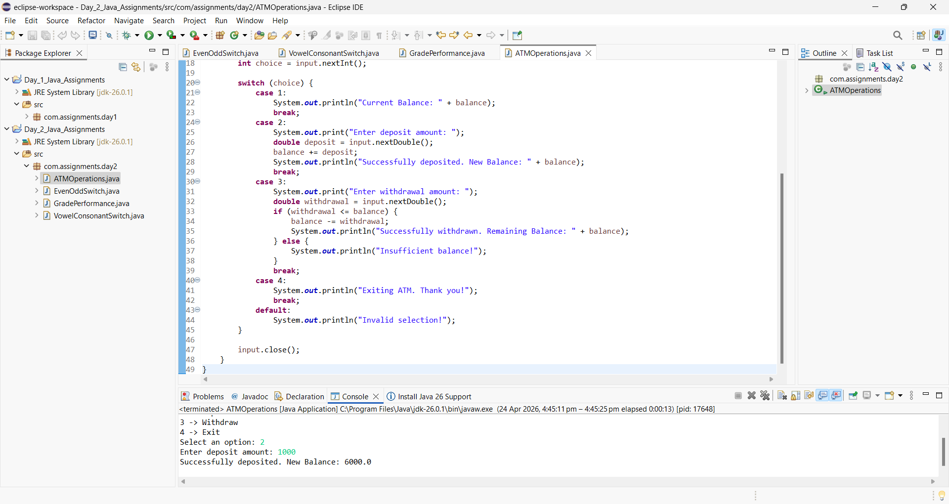

- Create a program where user selects food item number and the program displays item name and price.
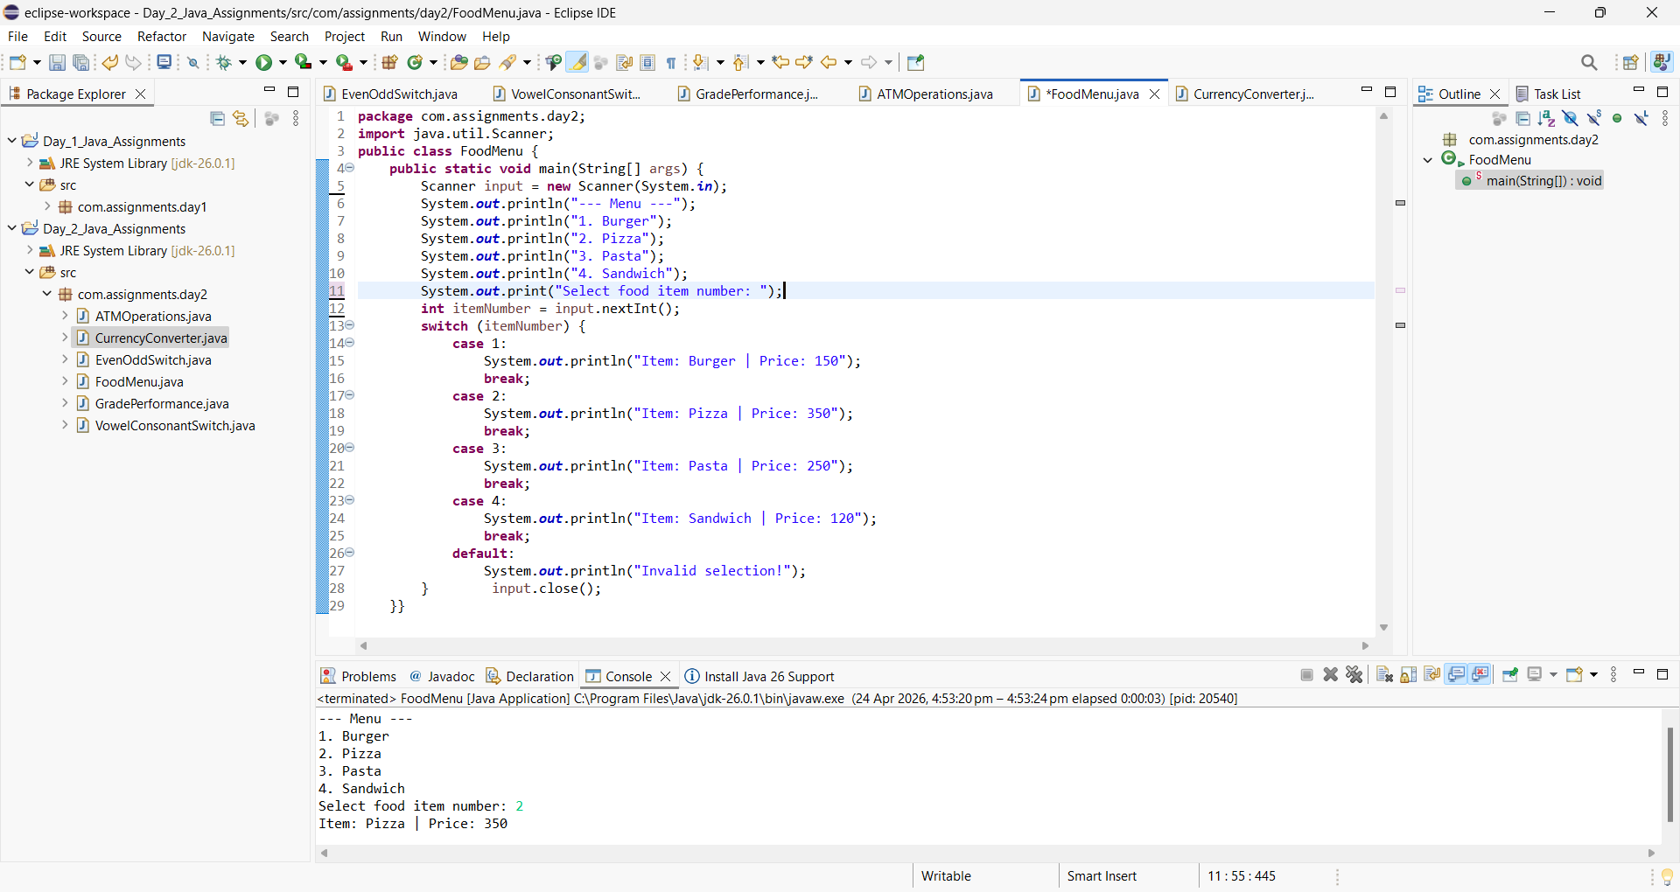
- Write a program to check whether a number is even or odd using switch-case.


- Write a program that converts currency based on user choice (e.g., INR to USD, INR to EUR, etc.).

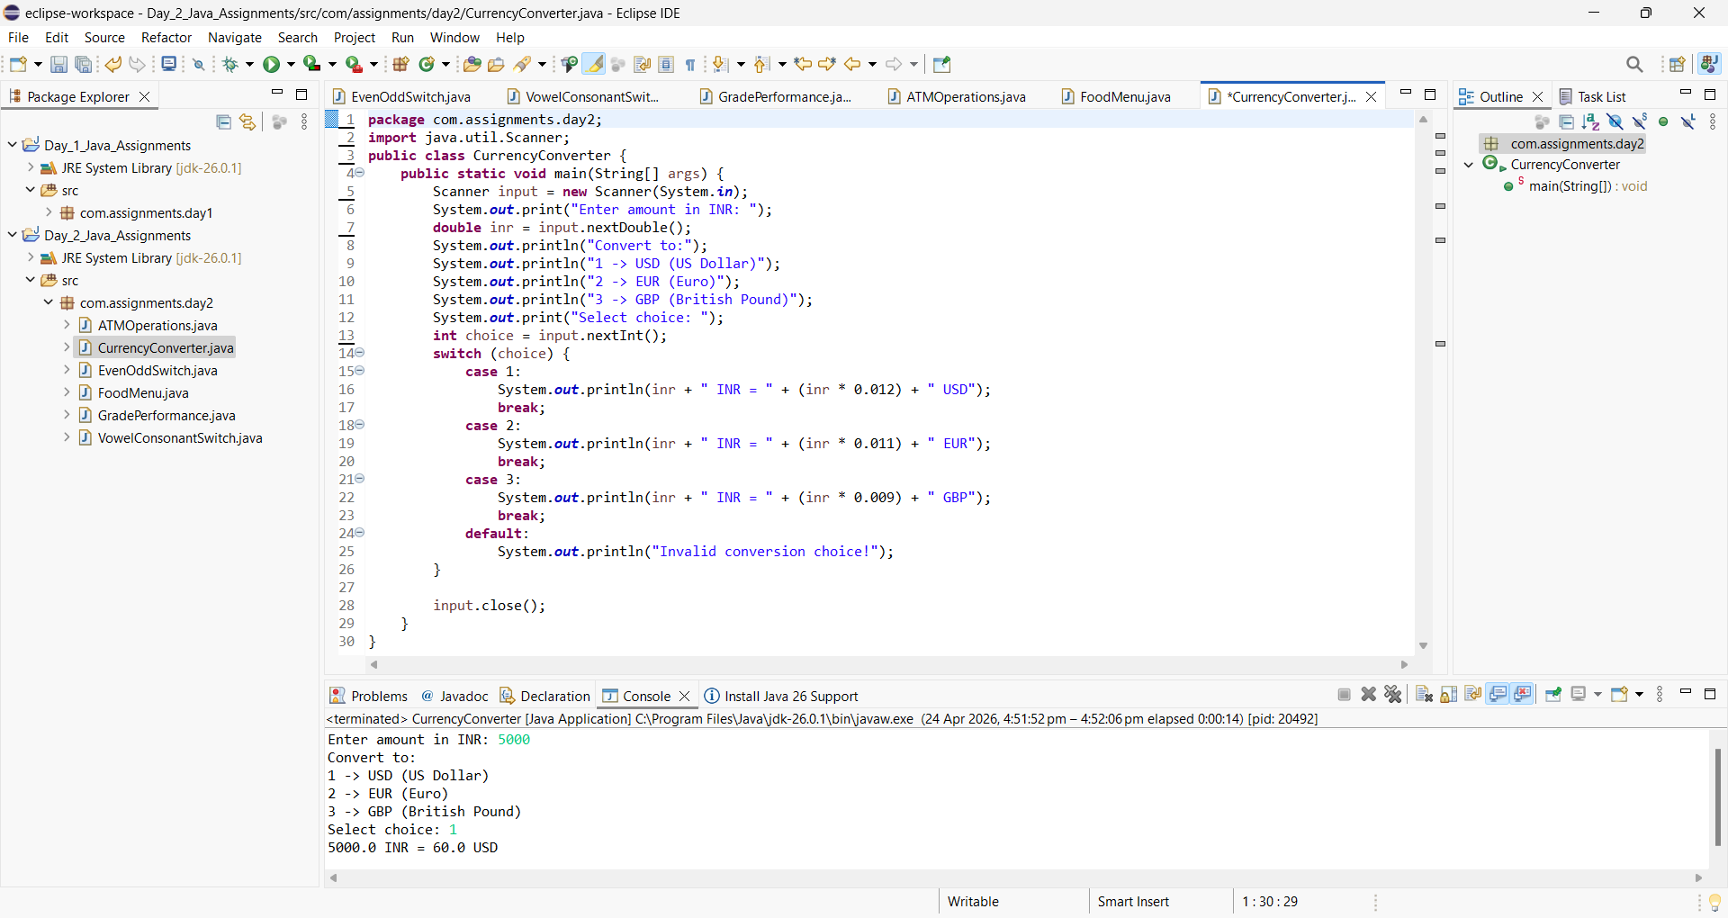
- Create a program that checks user role (Admin, User, Guest) and displays access permissions.
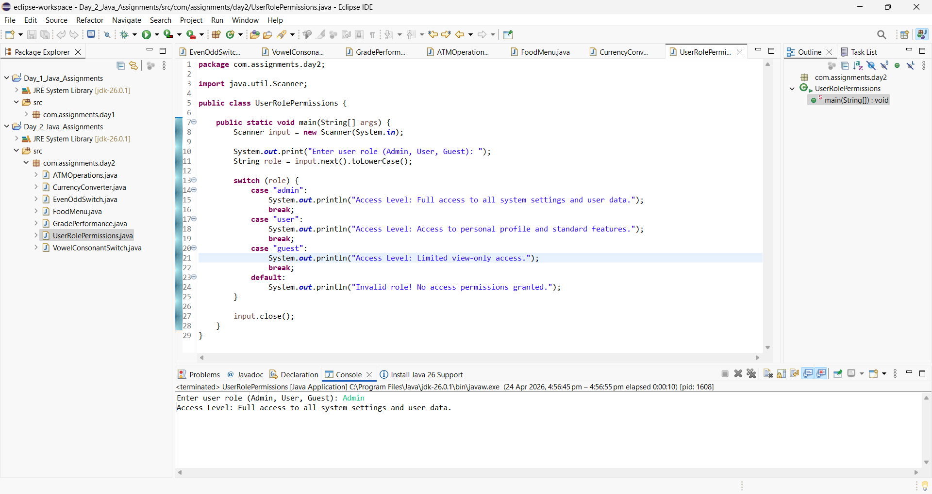

- Write a program to calculate the factorial of a given number using a while loop.
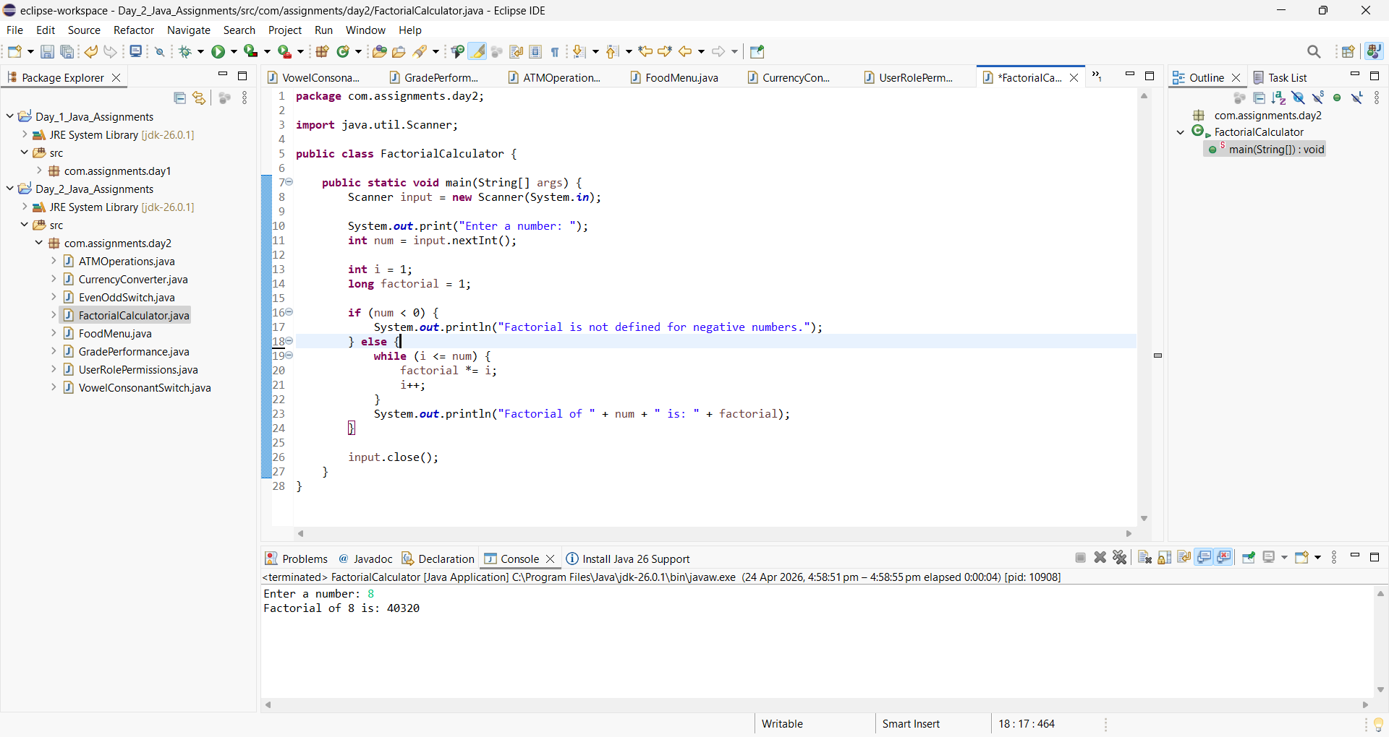
- Write a program to print the multiplication table of a given number using a while loop.
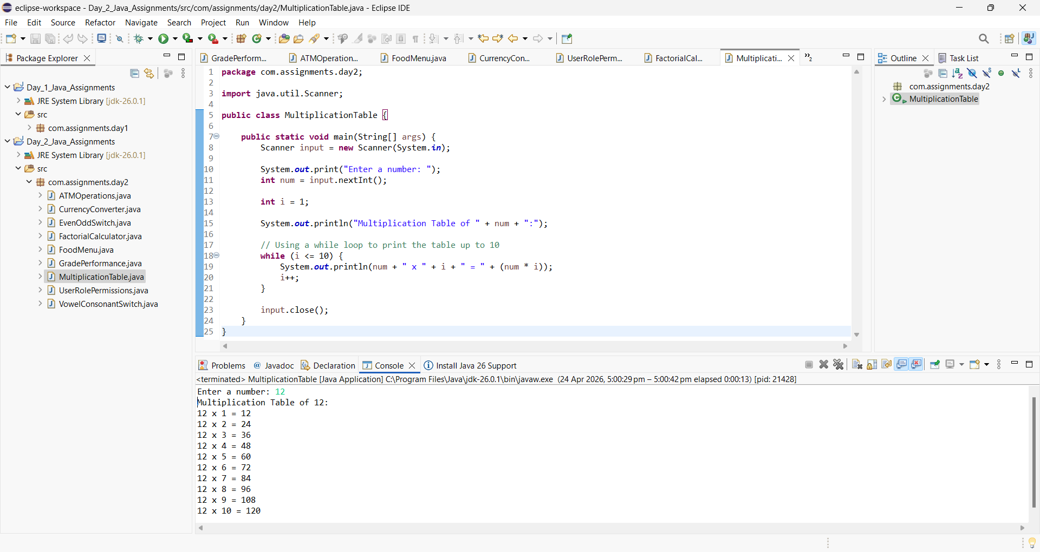

- Write a program to count the number of digits in a given number using a while loop.

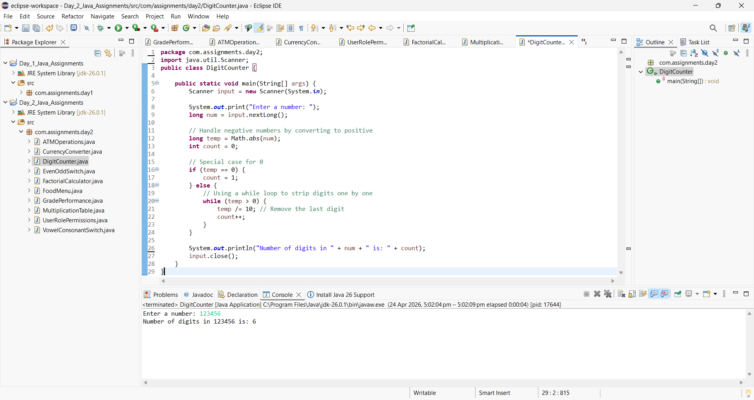

- Write a program to reverse a given number using a while loop.
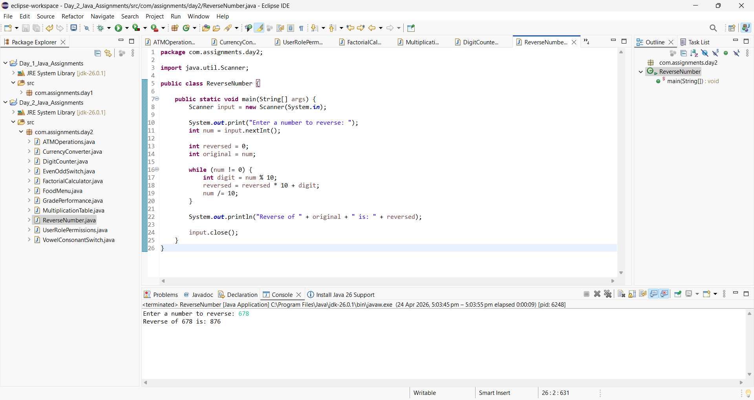

- Write a program to check whether a number is a palindrome using a while loop.

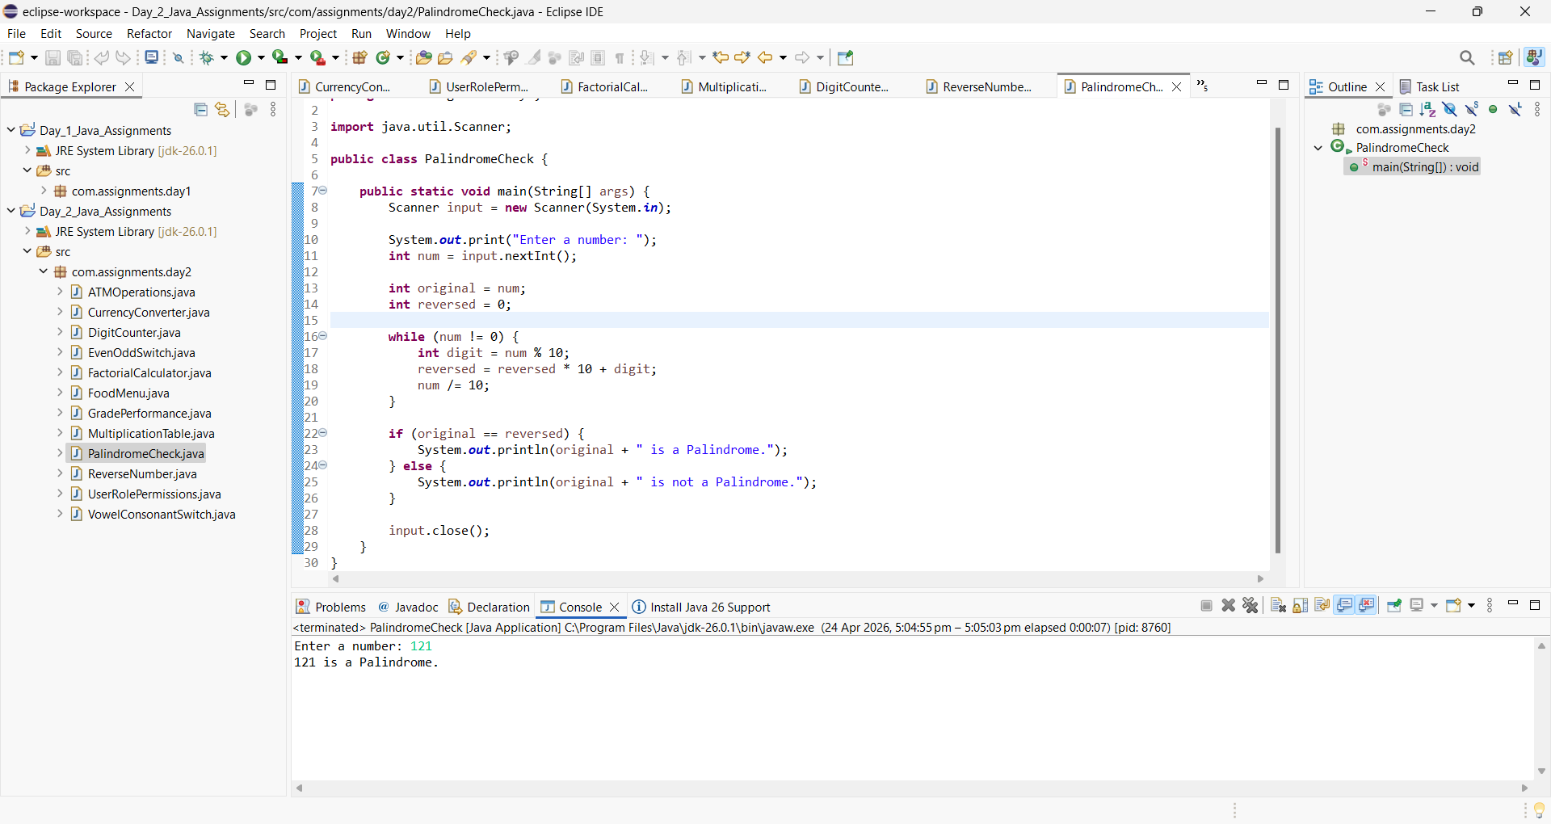

- Write a program to find the sum of digits of a number using a while loop.

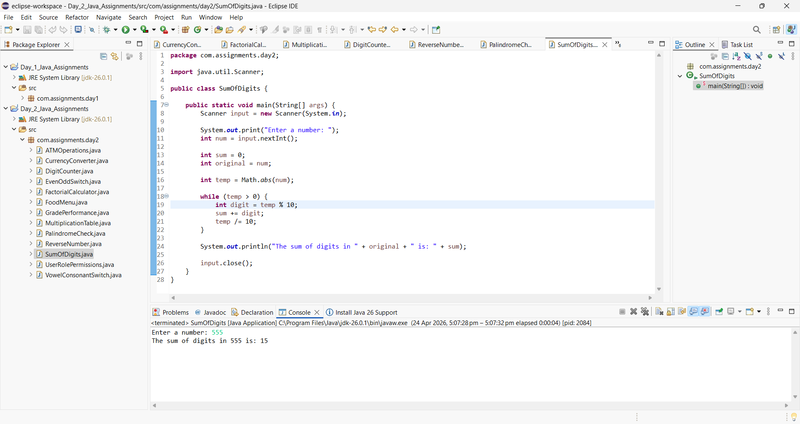

- Write a program to check whether a number is an Armstrong number using a while loop.
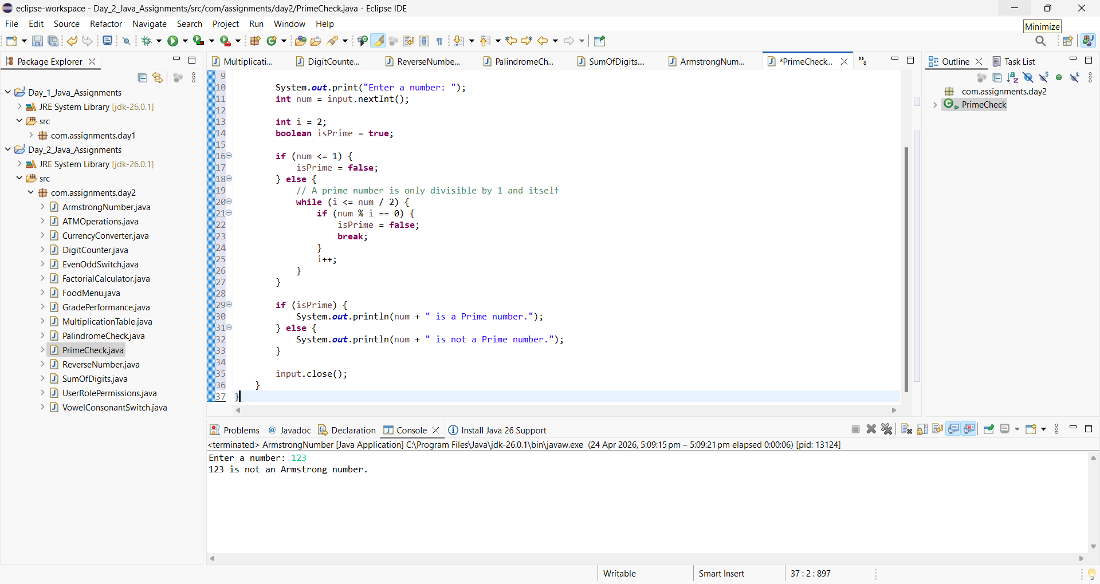

- Write a program to check whether a number is prime using a while loop.

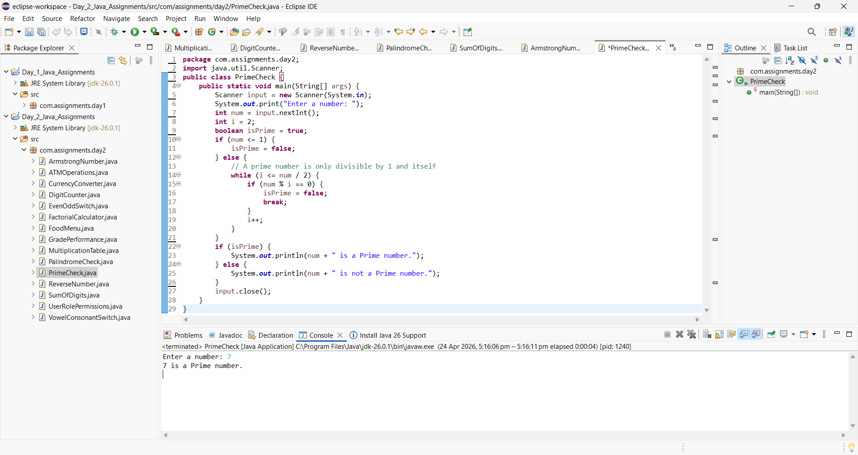

- Write a program to print Fibonacci series up to N terms using a while loop.

