- Write a Java program to read a text file and count: • Number of lines • Number of words • Number of characters

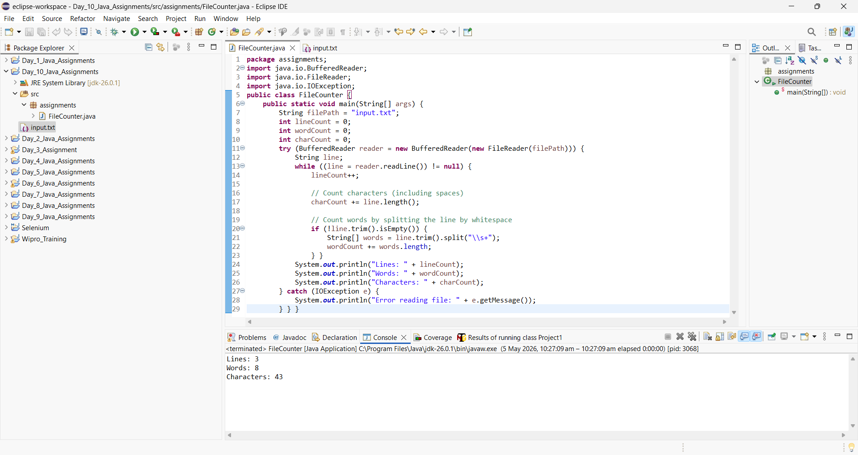

- Append Data to File Write a program to: • Take user input • Append that data into an existing file without deleting previous content.

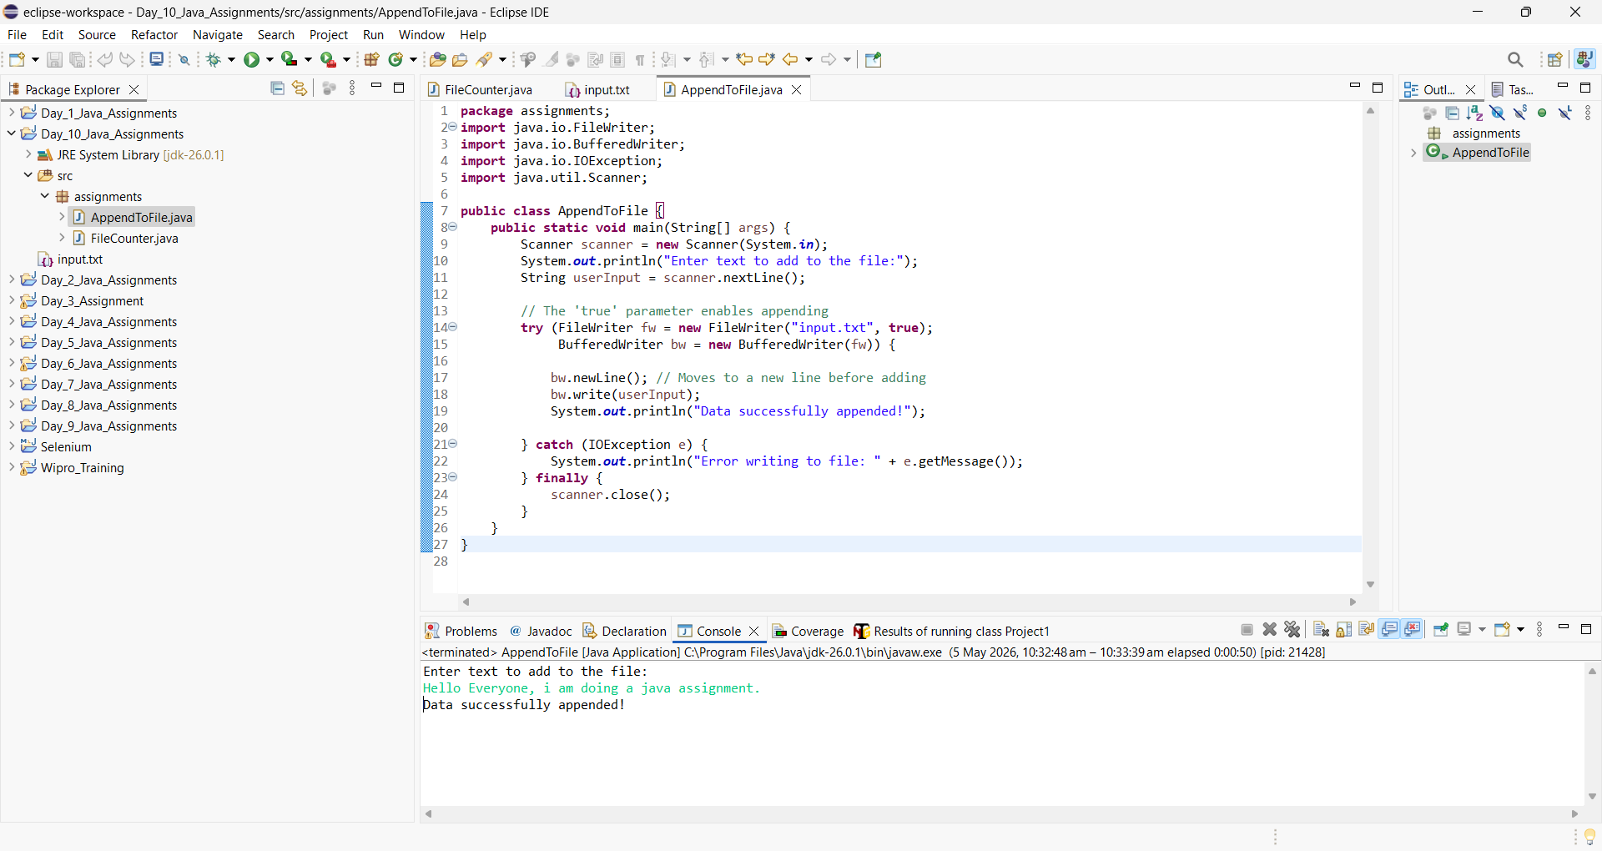

- Buffered Reader Usage Write a Java program to read a file using BufferedReader and print only those lines that contain the word "Java".

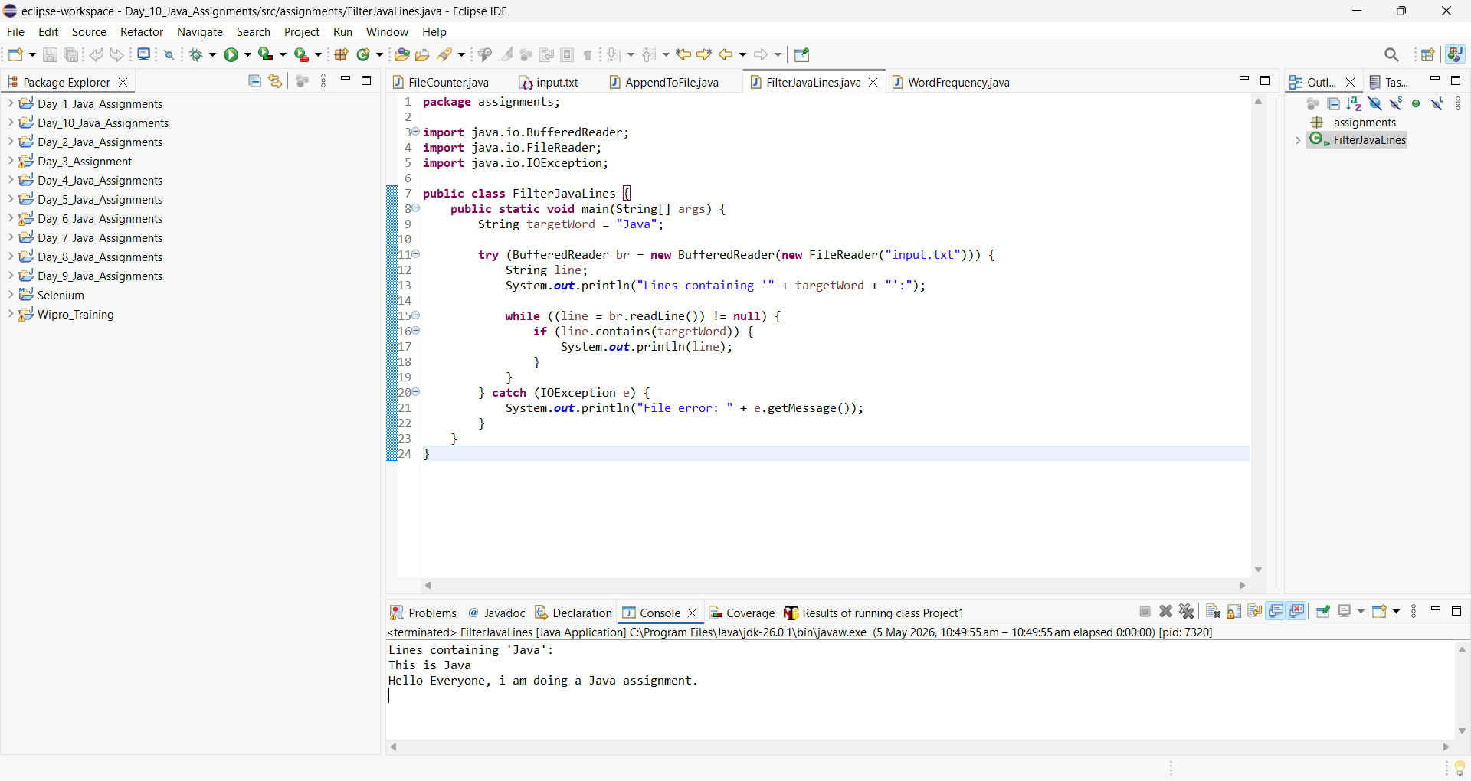

- Count Specific Word in File Write a program to count how many times a specific word (e.g., "Java") appears in a file.

