1. Sort an array in ascending and descending order.
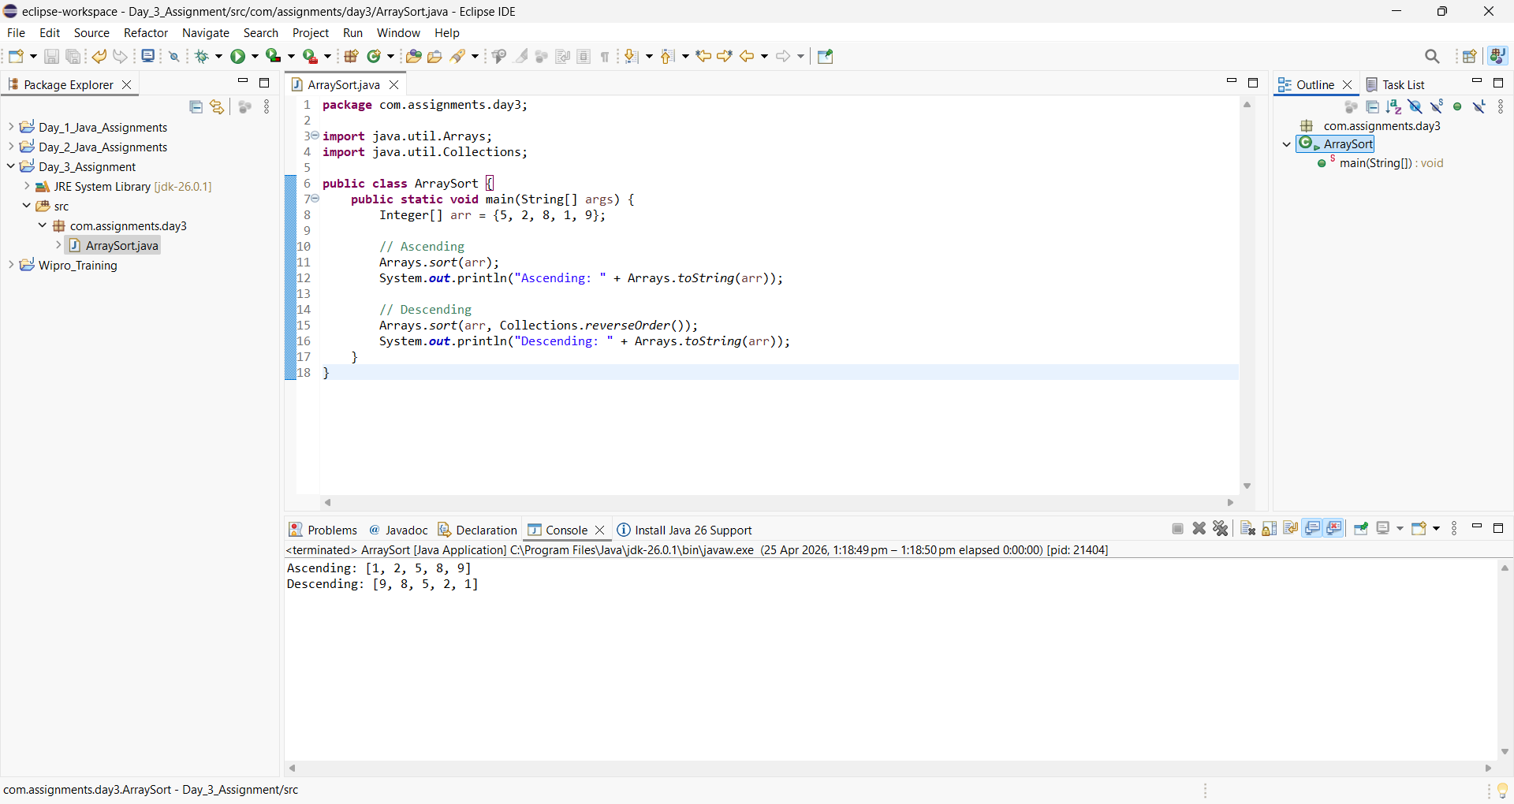

2. Remove duplicate elements from an array.
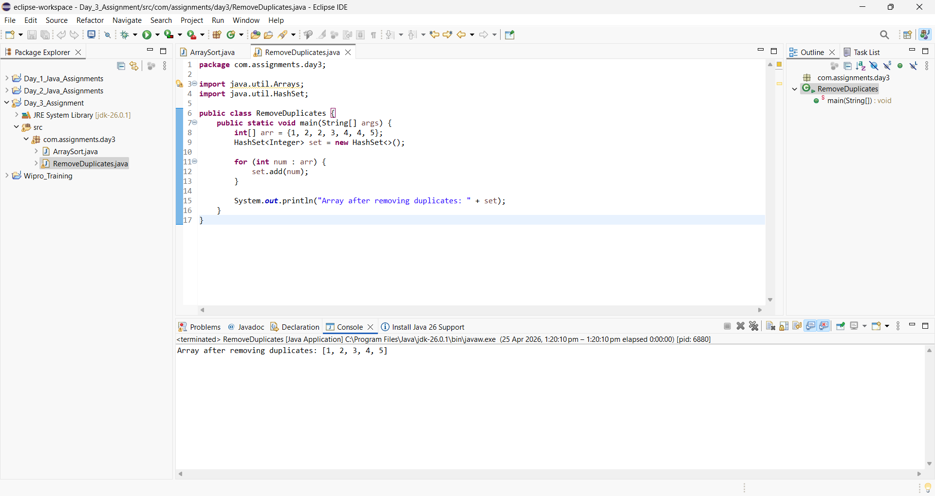

3. Find largest element in each row.
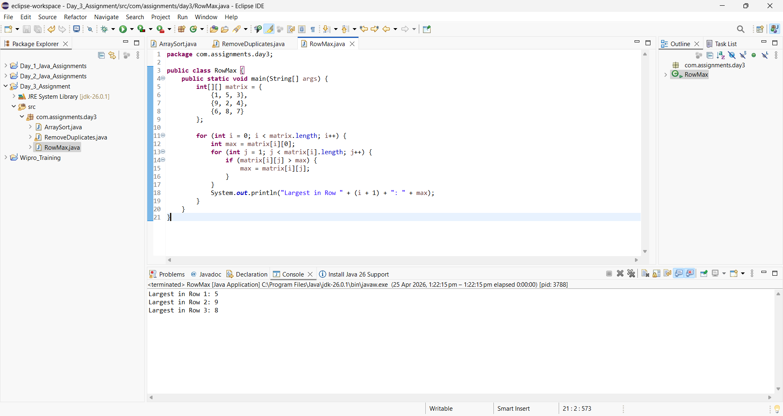

4. Check if array is palindrome.
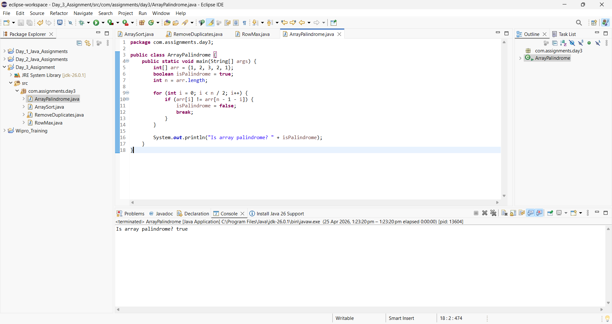

5. Rotate matrix by 90 degrees
