- Alternate Printing (Even-Odd) • Create two threads: one prints even numbers, another prints odd numbers (1–100) in sequence.

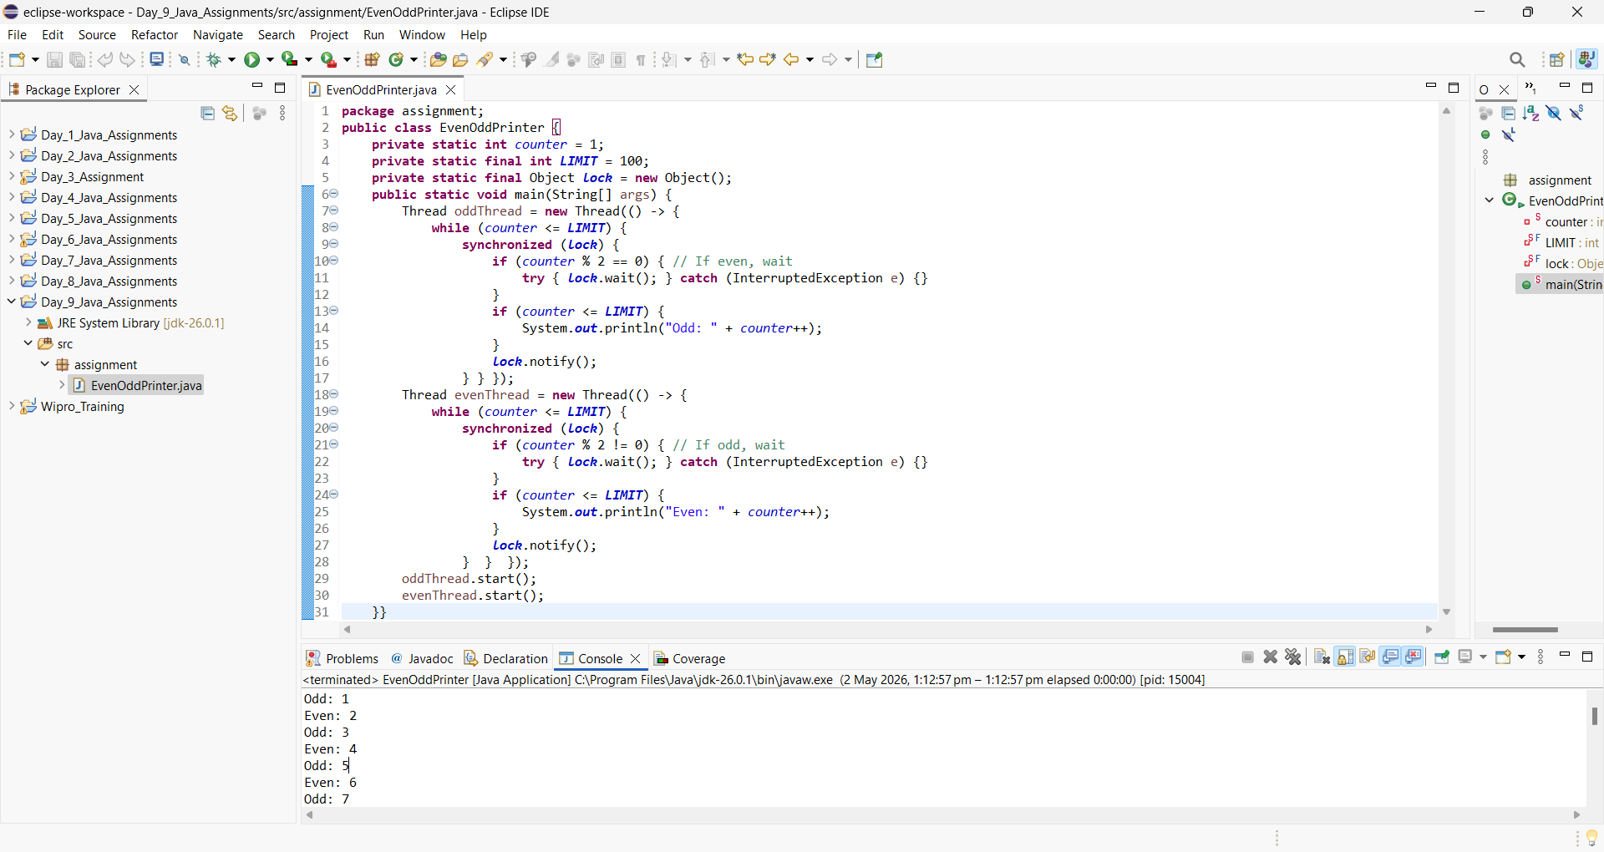

- Print A B C in Sequence • Three threads print A, B, C repeatedly in order (ABCABC…).

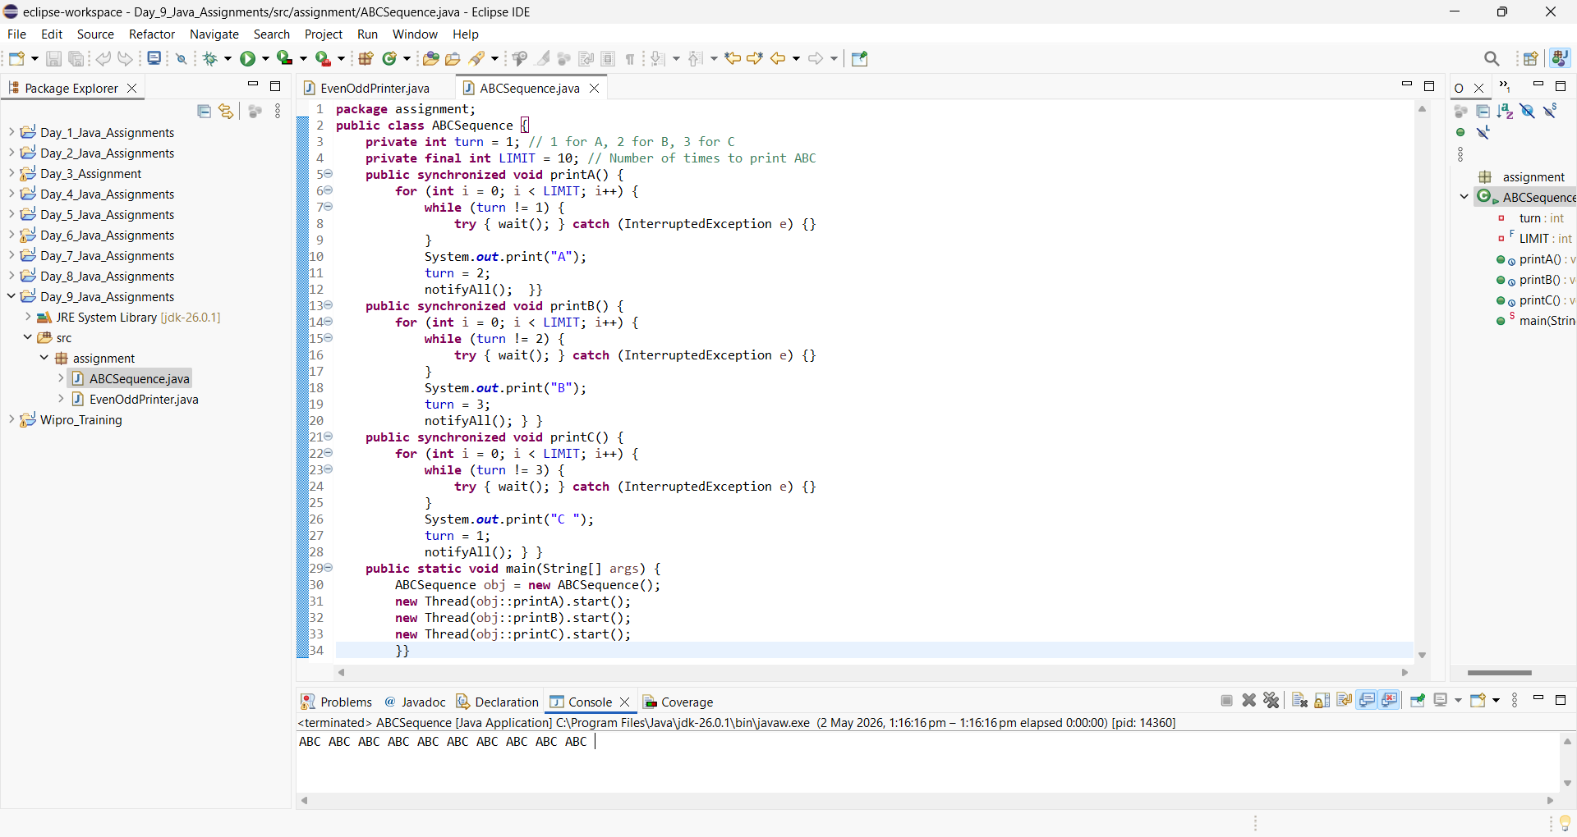

- Bank Account System • Multiple threads deposit and withdraw from same account safely.

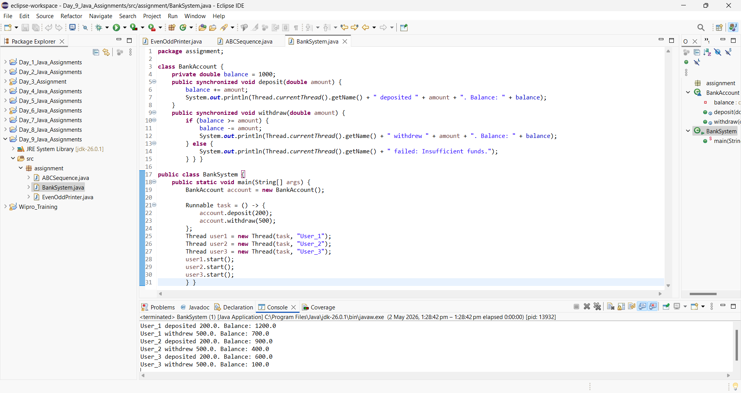

- Online Food Delivery System • Multiple orders processed by limited delivery agents (thread pool).

