• Create a program to store user input data into database using Scanner and JDBC.

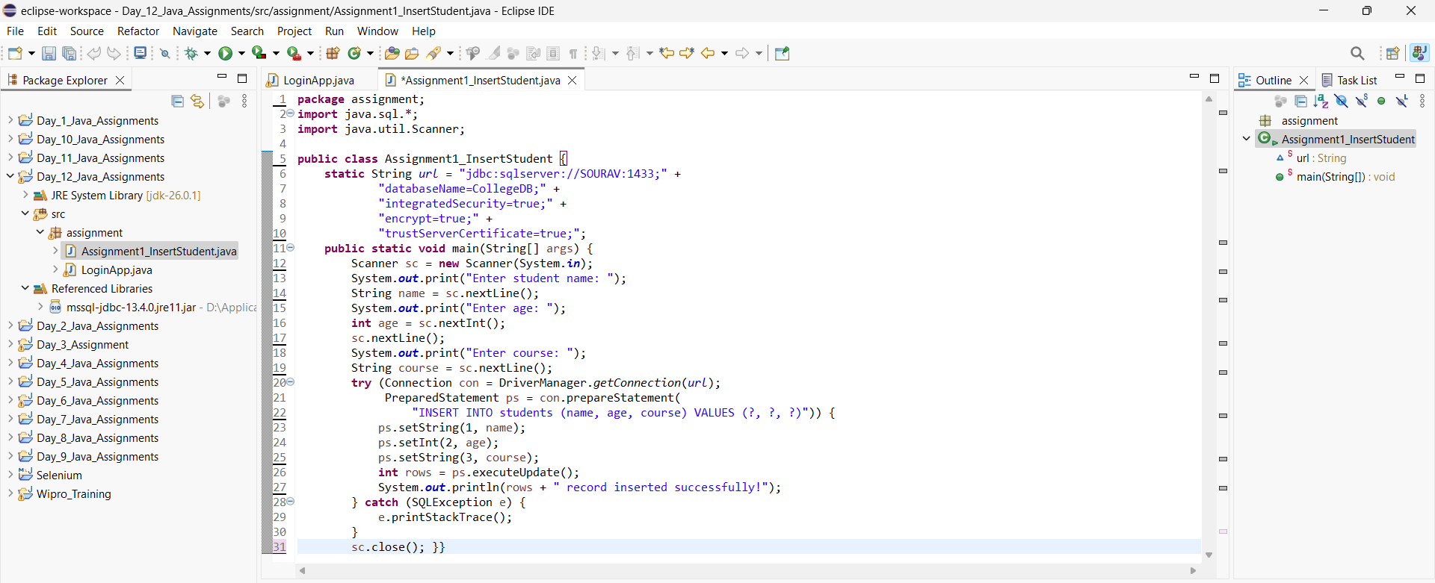
output
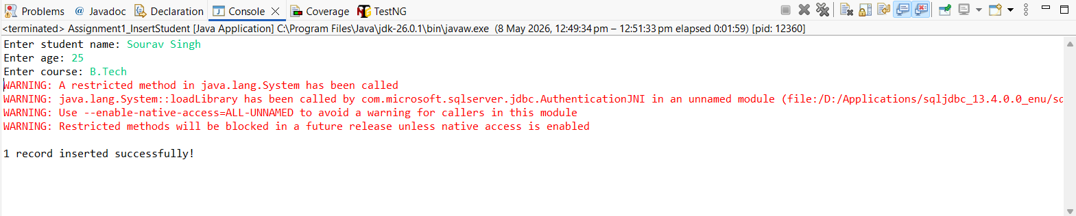

• Create a program to validate login using username & password from database.

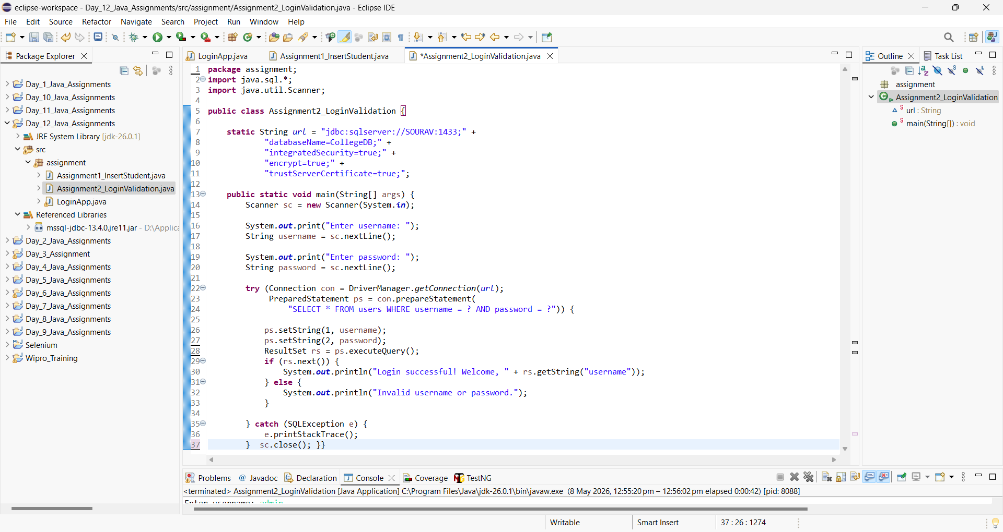
output
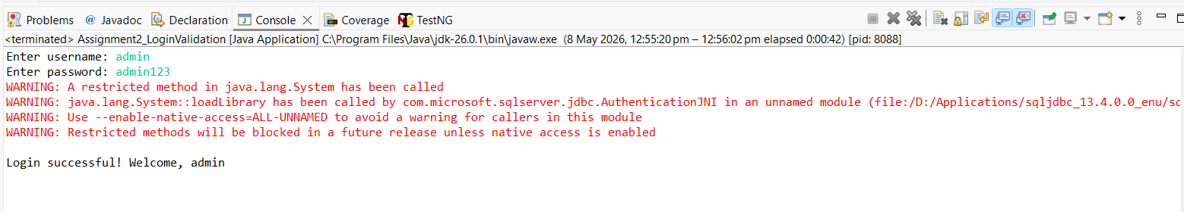

• Write a program to insert multiple records using JDBC.

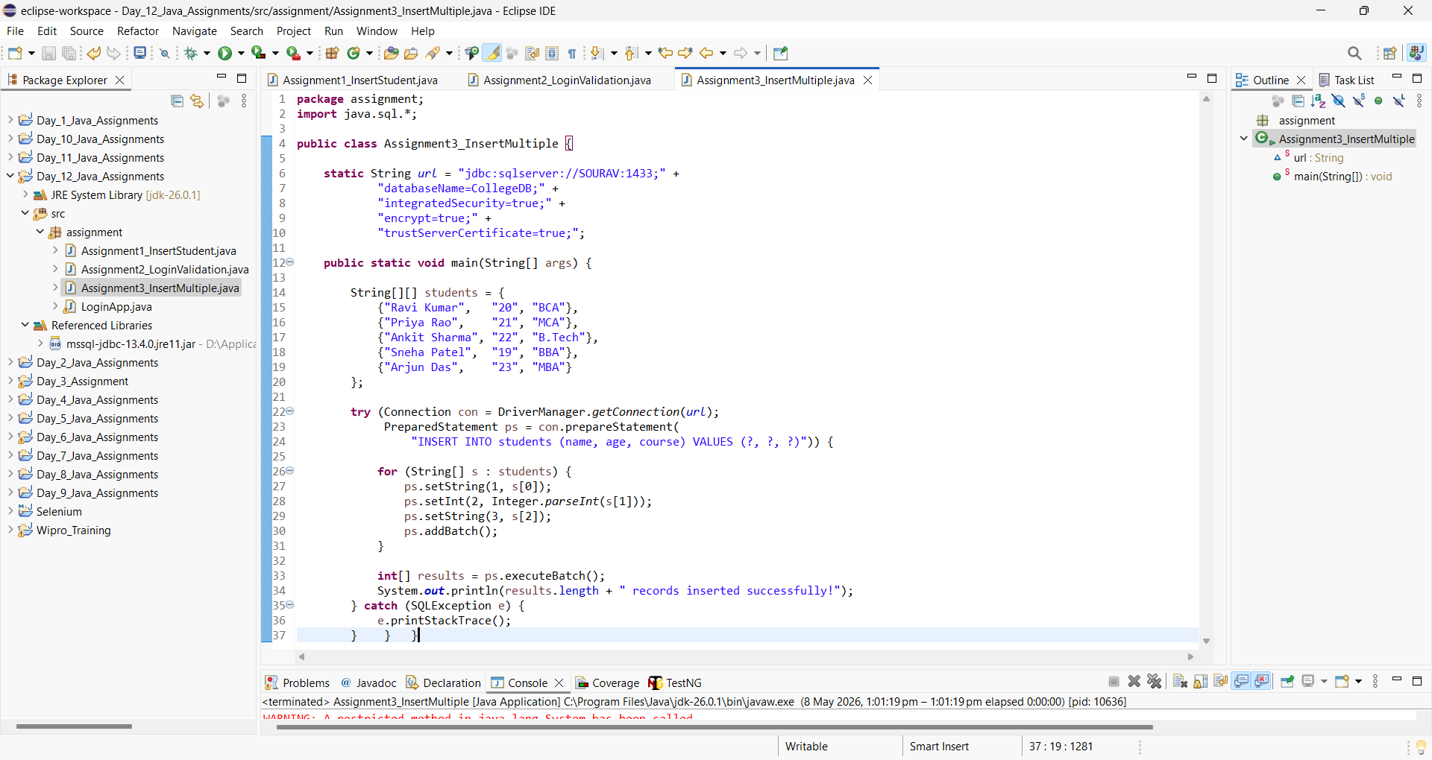
output
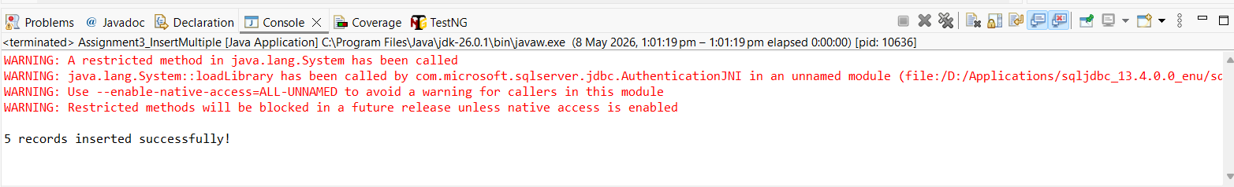

• Create a program to display all records from students table.
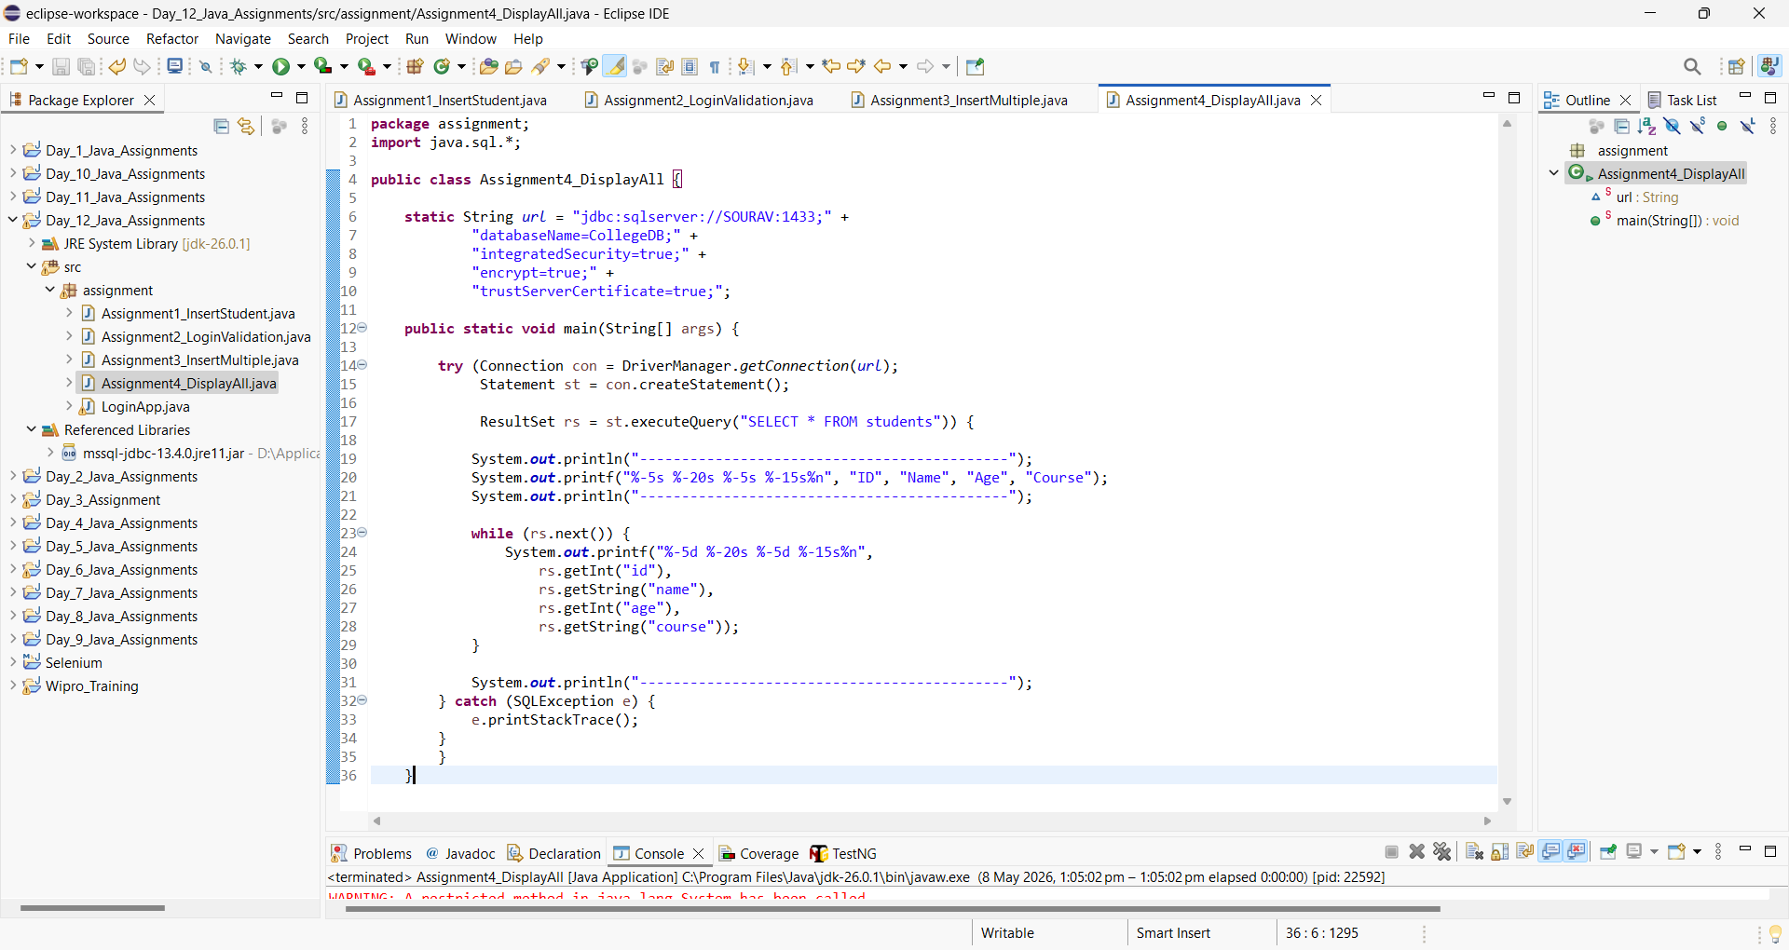
ouput
