1. Check whether a number is positive or negative
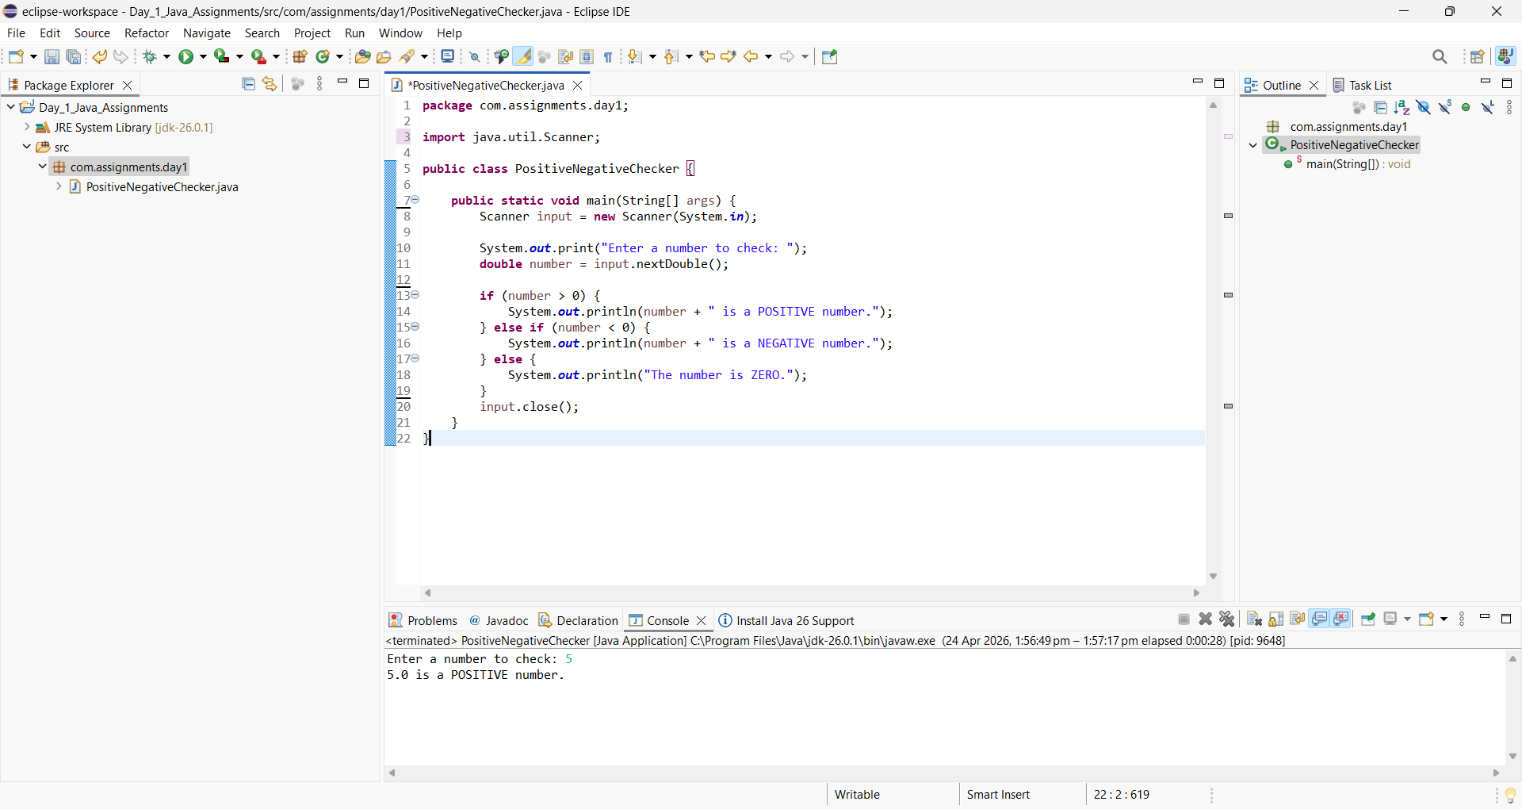

2. Check whether a number is even or odd
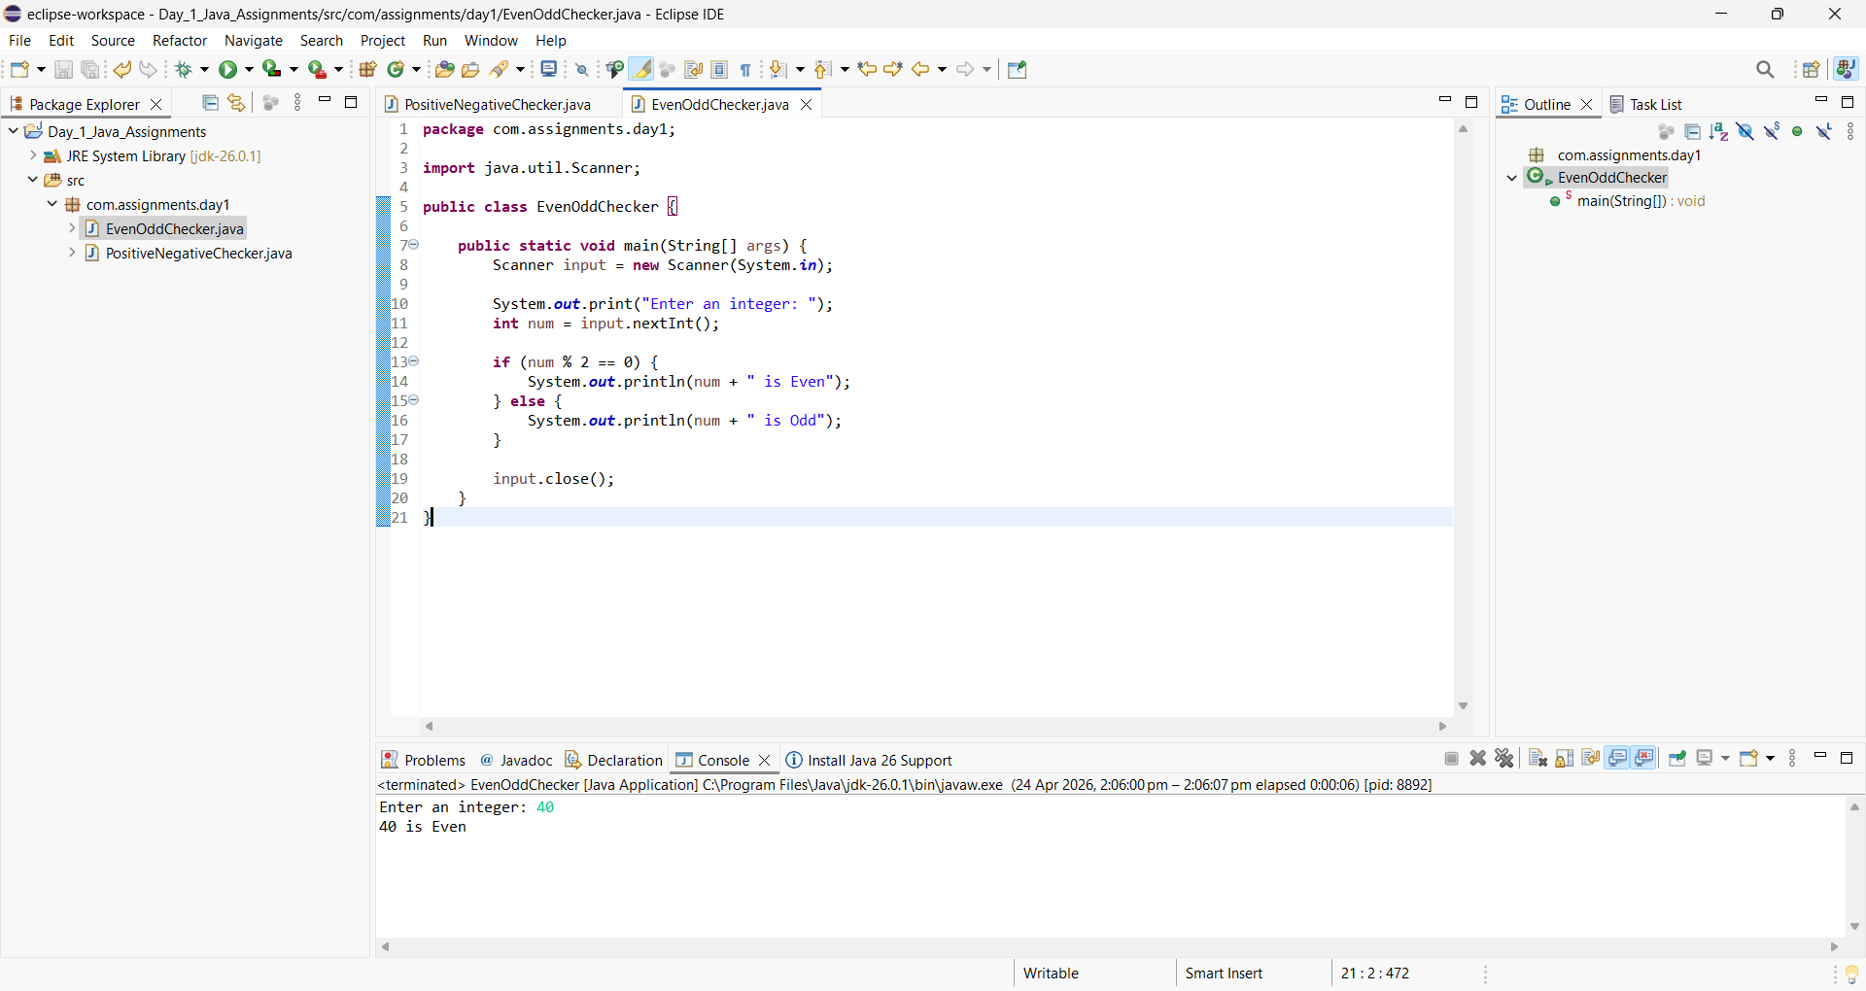

3. Find the largest of two numbers
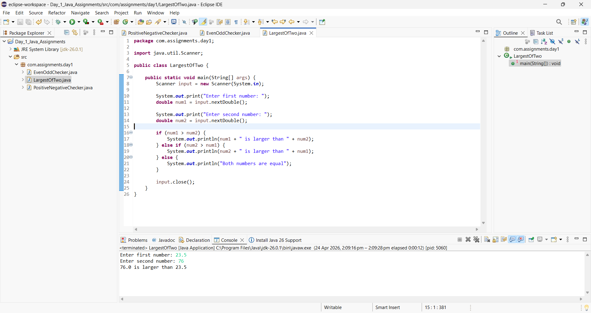

4. Find the largest of three numbers
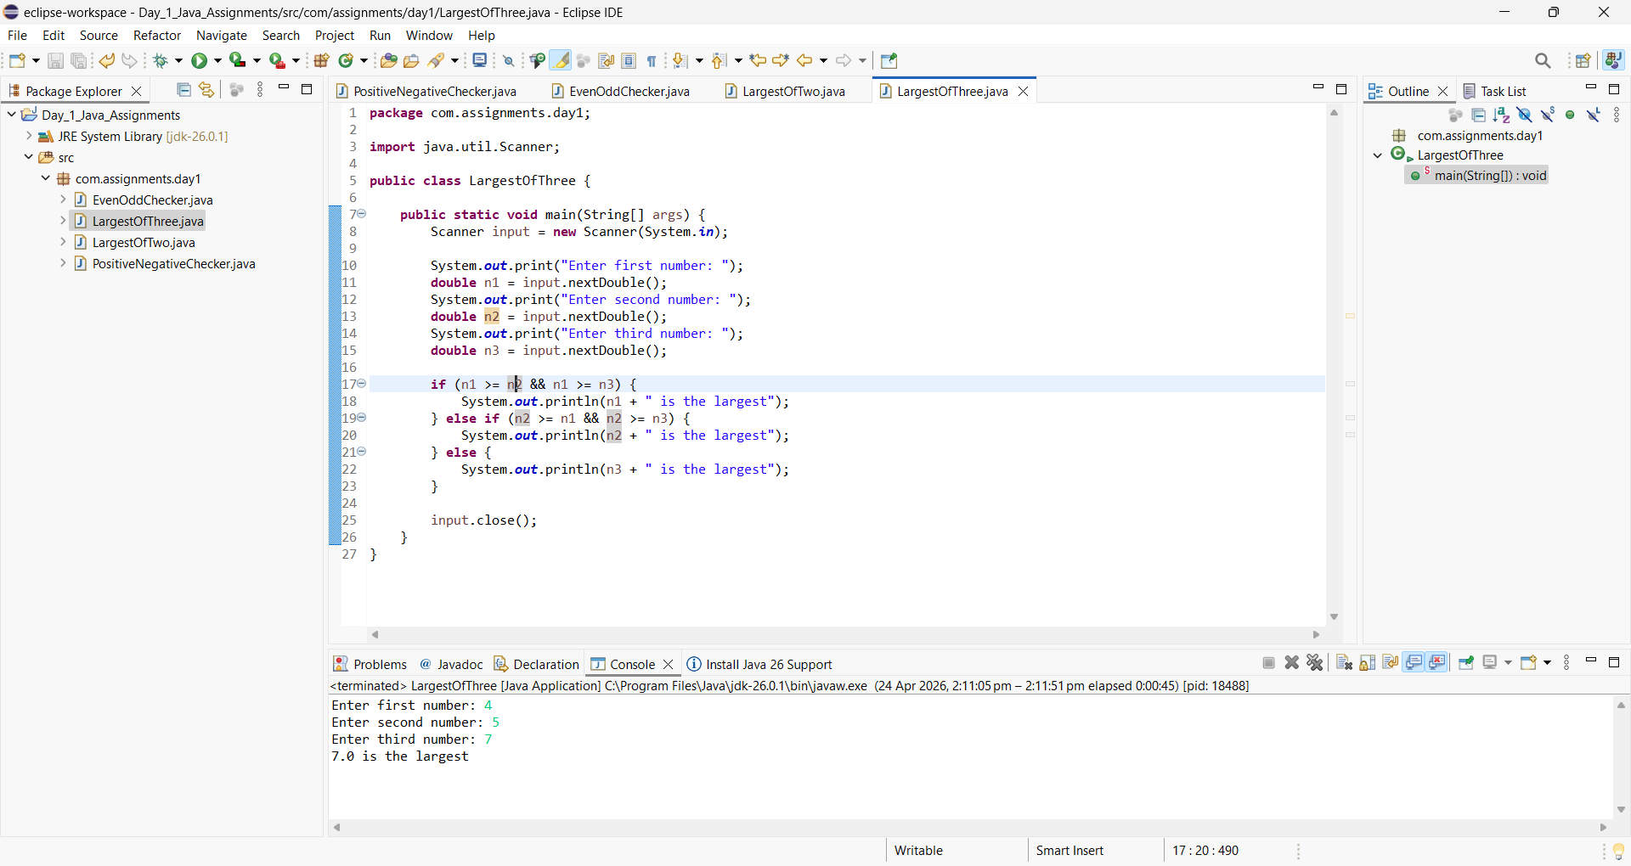

5. Check whether a year is a leap year

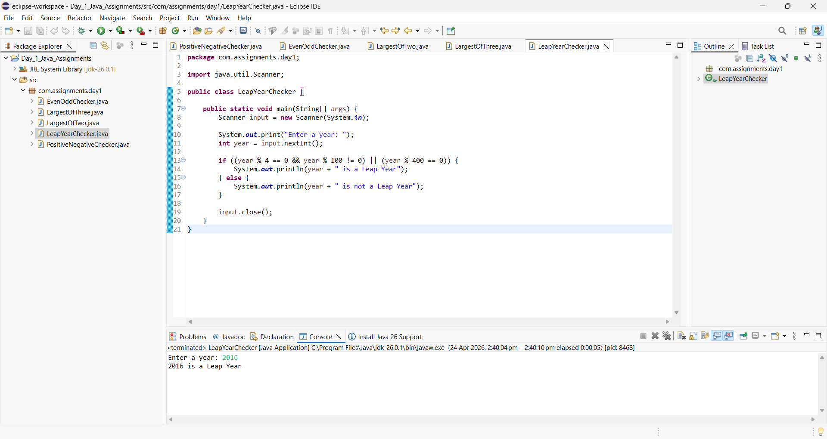

6. Check whether a character is a vowel or consonant
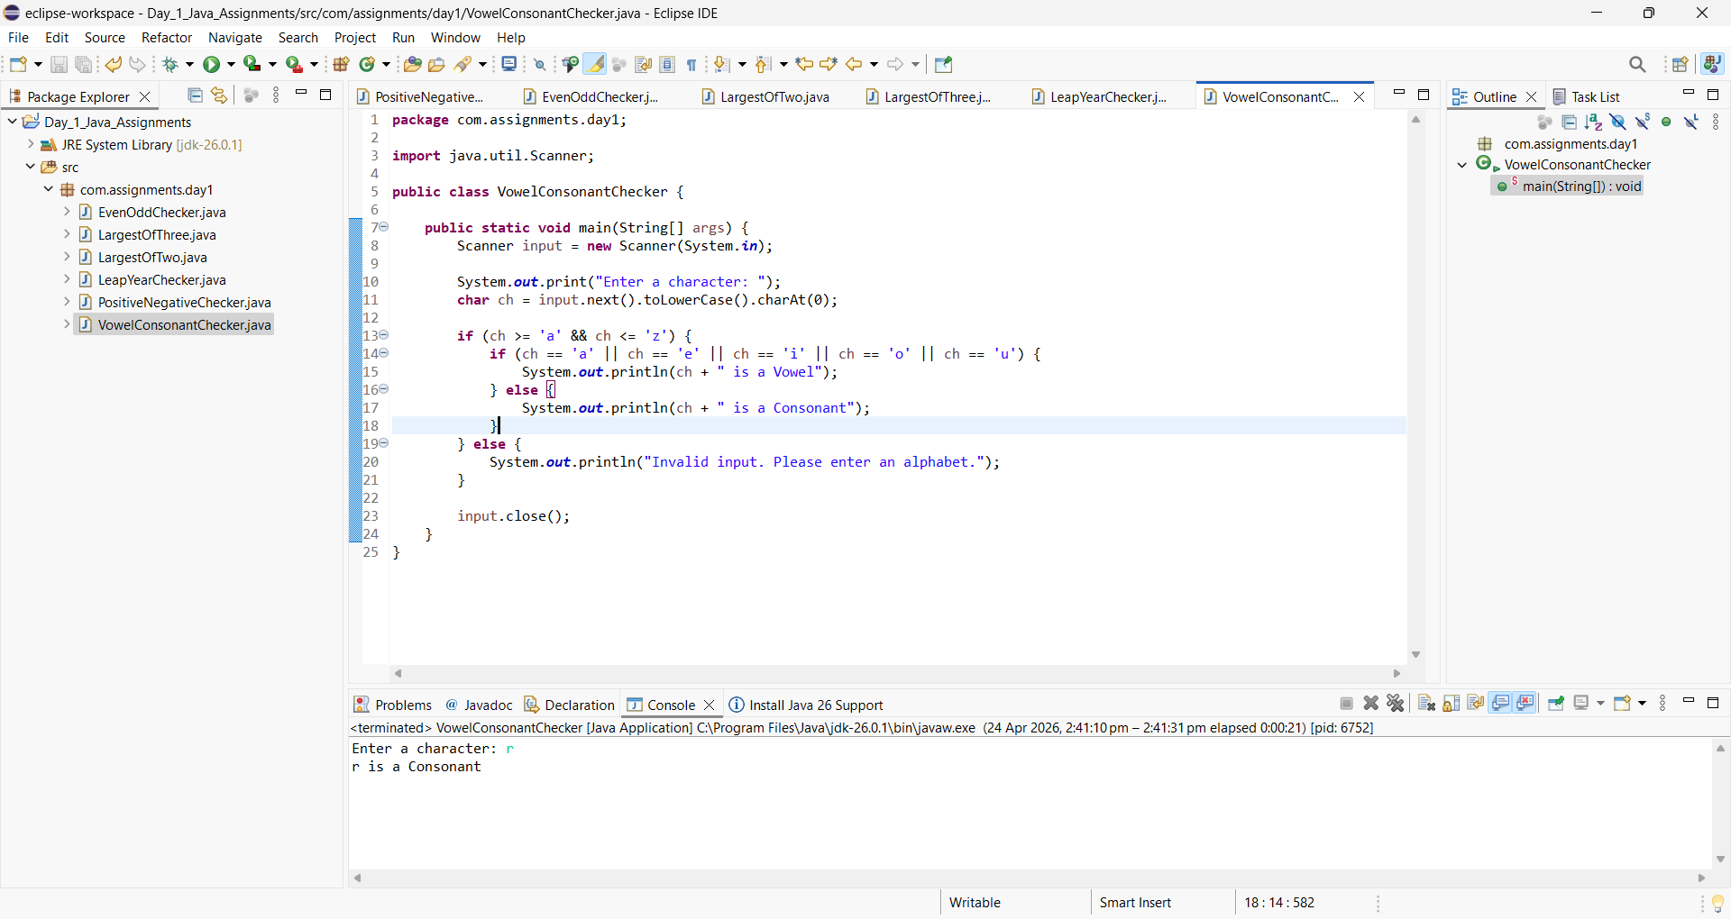

7. Check eligibility for voting based on age
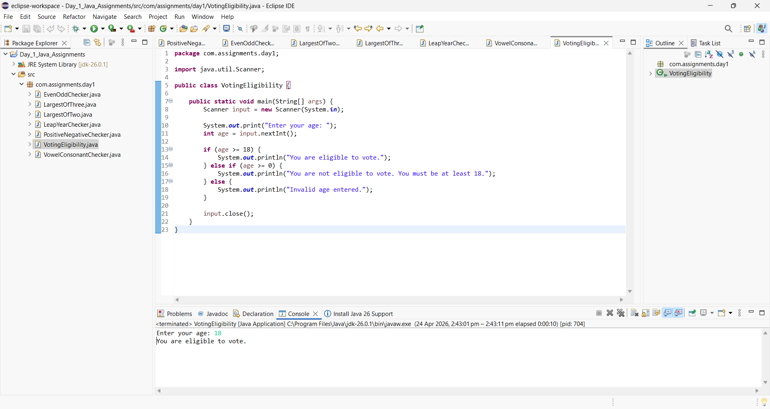
8. Check whether a number is divisible by 5 and 11
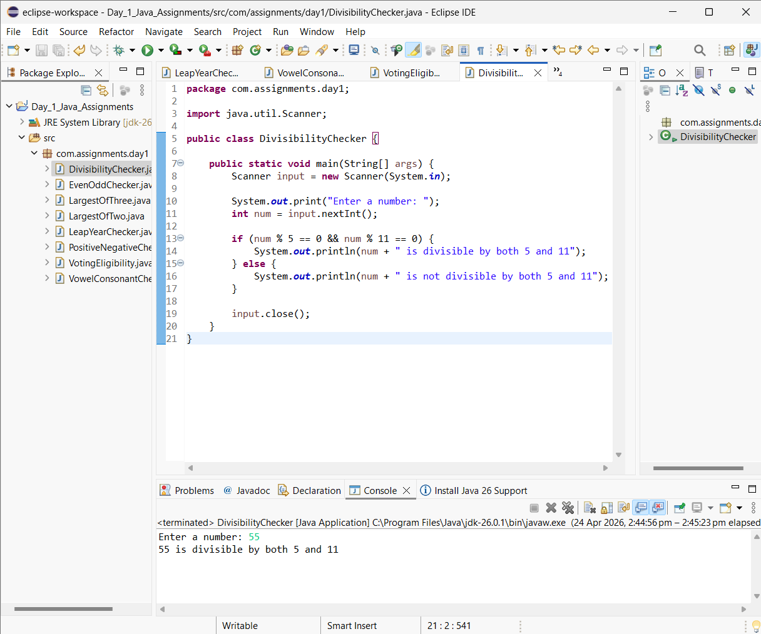
9. Find grade based on marks (if-else-if ladder)
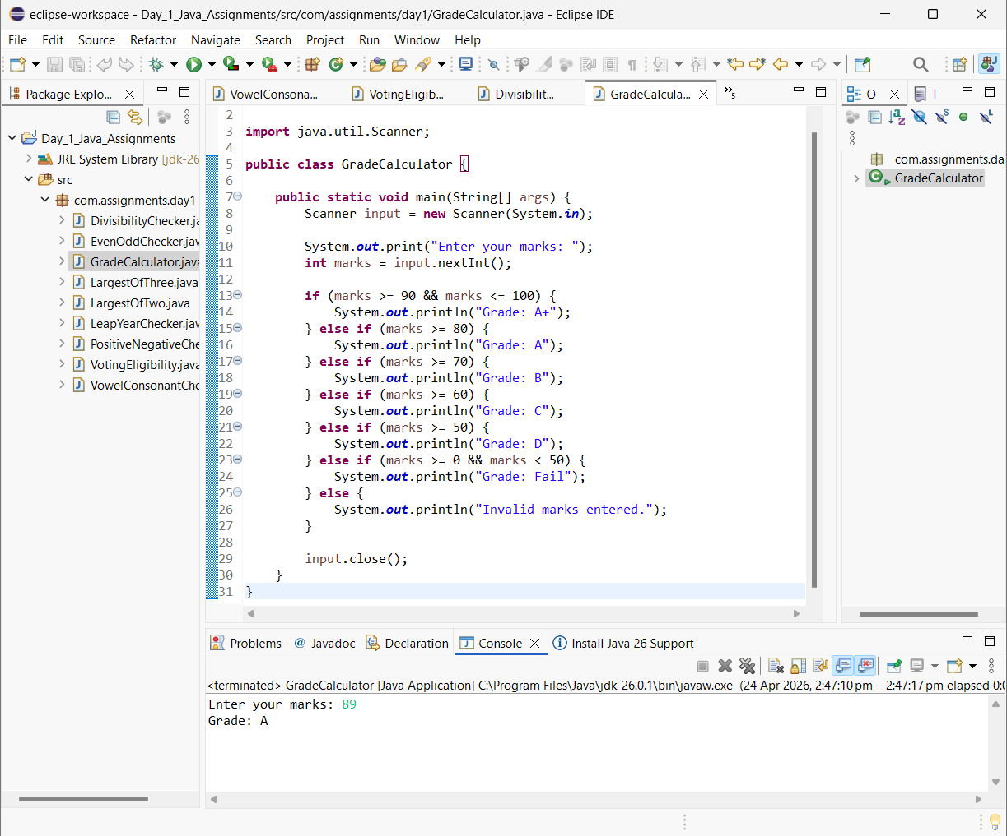

10.Check whether a number is zero, positive, or negative
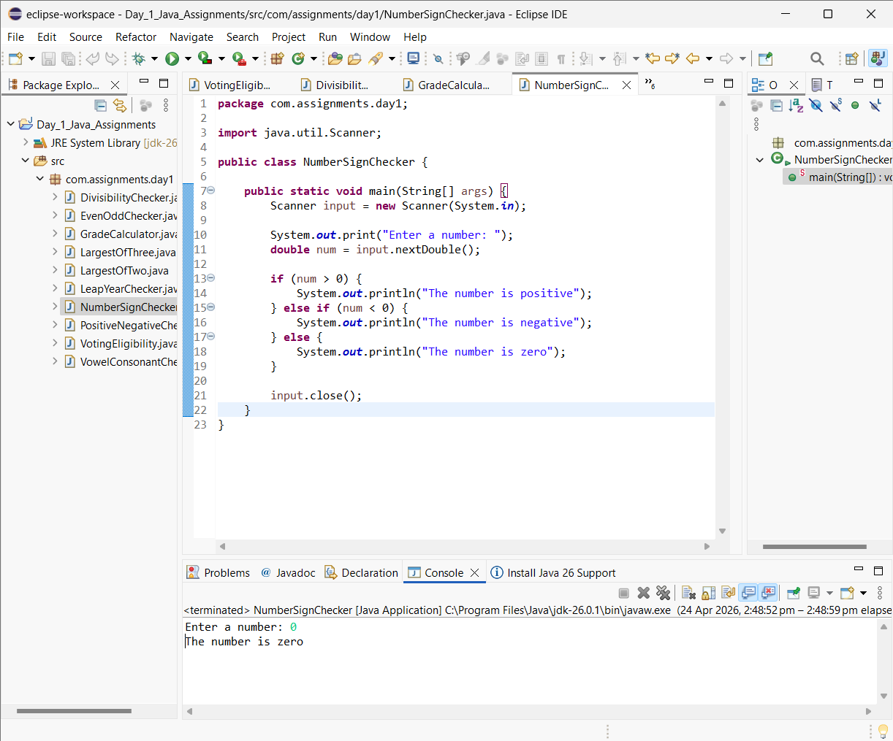

11. Find the smallest of three numbers
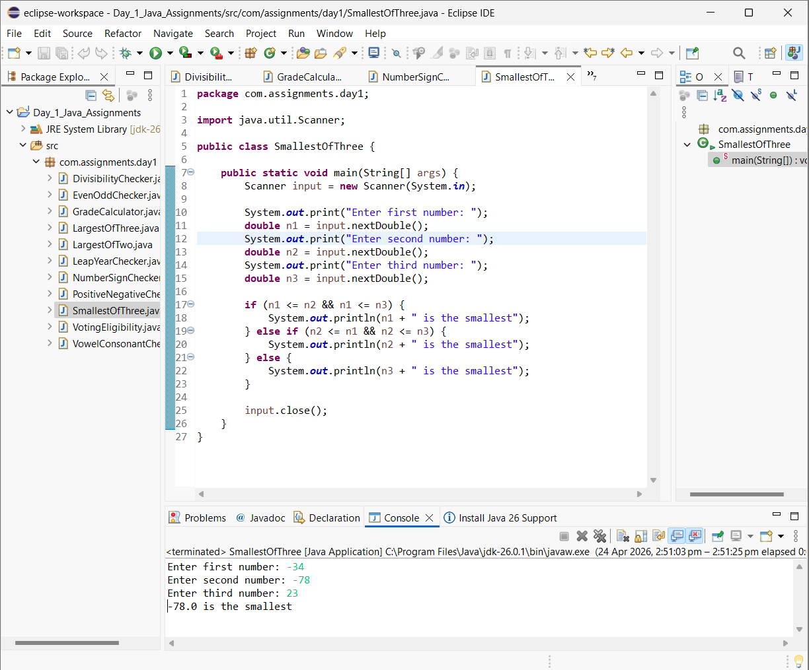

12.Check whether a person is eligible for a loan (age + salary condition)
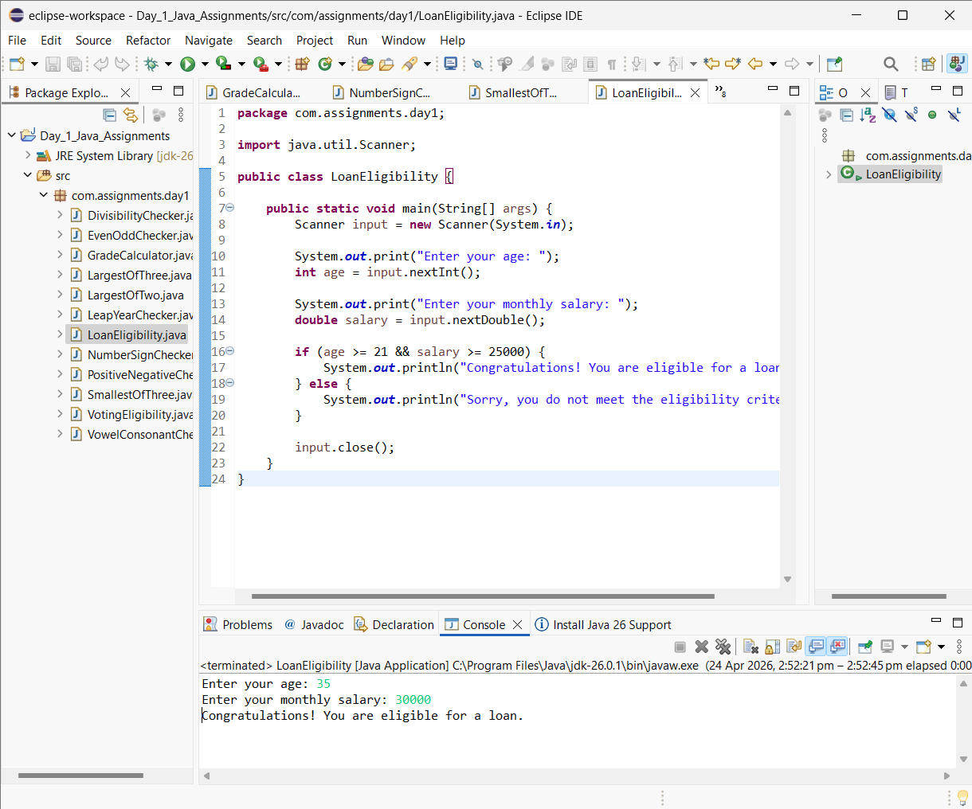

13.Check whether a number is divisible by 3 or 7
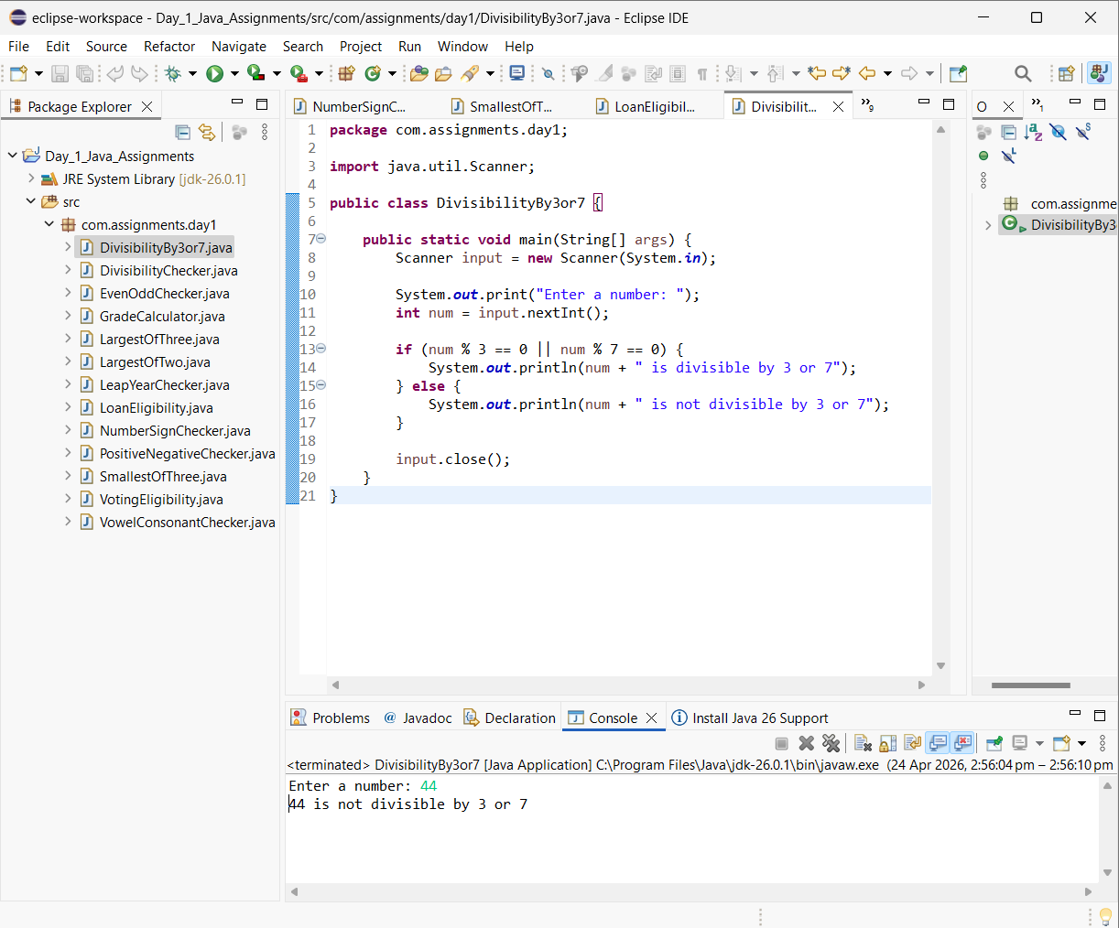

14. Simple calculator using switch case

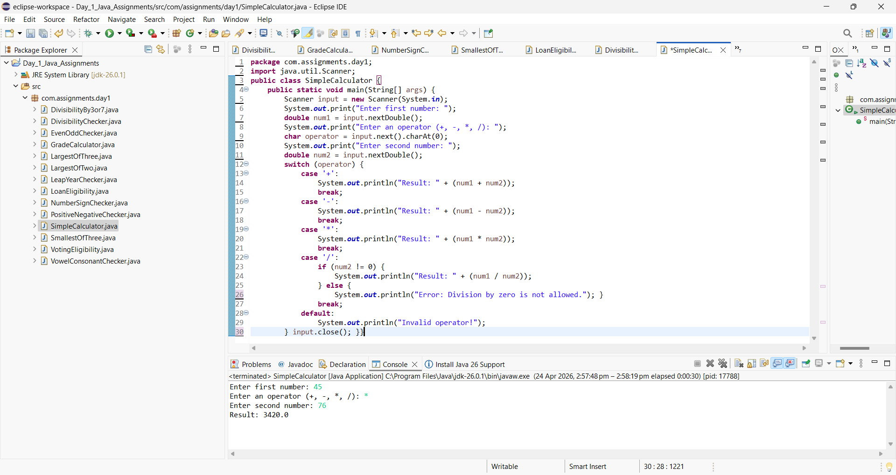
15.Display day of week using switch case
