1. Moveable Shapes Simulation
• Define an interface Movable with methods: moveUp(), moveDown(), moveLeft(), moveRight().
• Implement classes: o MovablePoint(x, y, xSpeed, ySpeed) implements Movable o MovableCircle(radius, center: MovablePoint)
o MovableRectangle(topLeft: MovablePoint, bottomRight: MovablePoint) (ensuring both points have same speed)
• Provide toString() to display positions.
• In main(), create a few objects and call move methods to simulate motion.

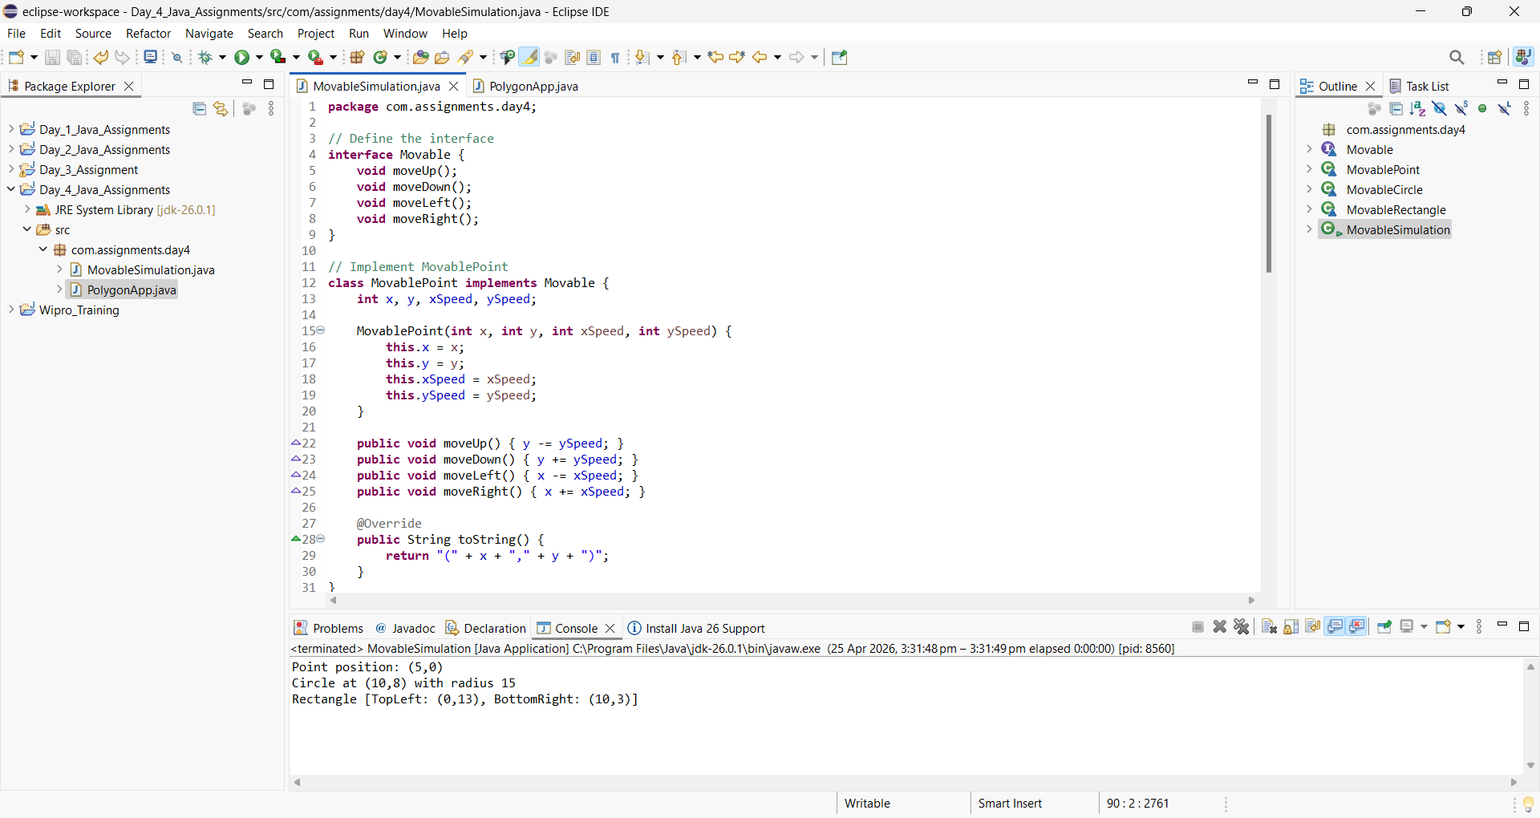

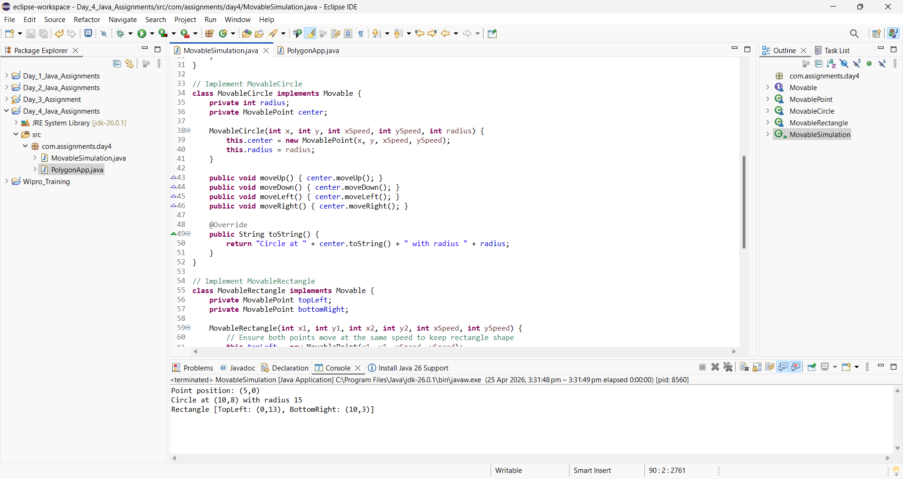
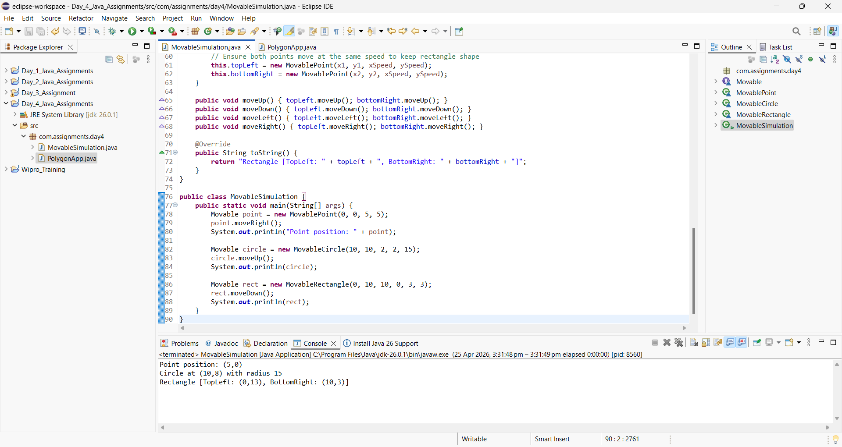

2. Default and Static Methods in Interfaces
• Declare interface Polygon with: o double getArea()
o default method default double getPerimeter(int... sides) that computes sum of sides
o a static helper static String shapeInfo() returning a description string
• Implement classes Rectangle and Triangle, providing appropriate getArea().
• In Main, call getPerimeter(...) and Polygon.shapeInfo().

