1. Create a package com.math.operations and write a class to perform addition and subtraction.
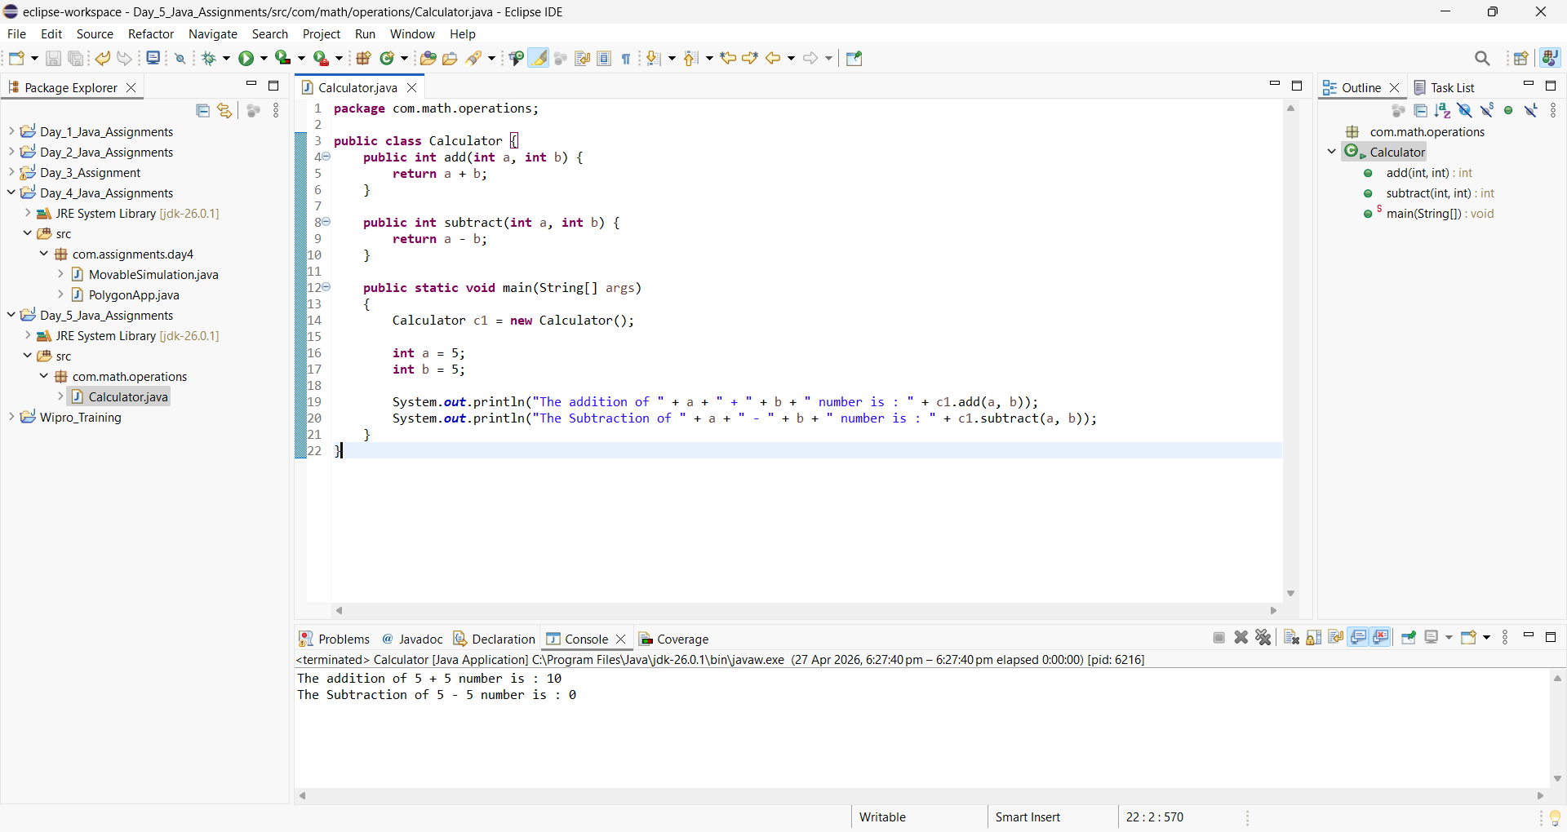

2. Create an abstract class Bank with method getInterestRate() and implement it in different bank classes.
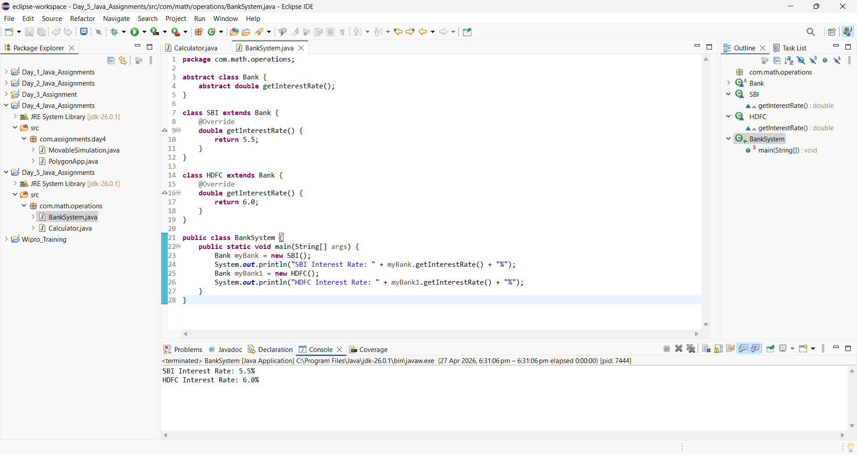

3. Write a program where an interface is implemented and exception handling is used inside the method.

