First Non-Repeating Character • Find the first non-repeating character in a string using HashMap.
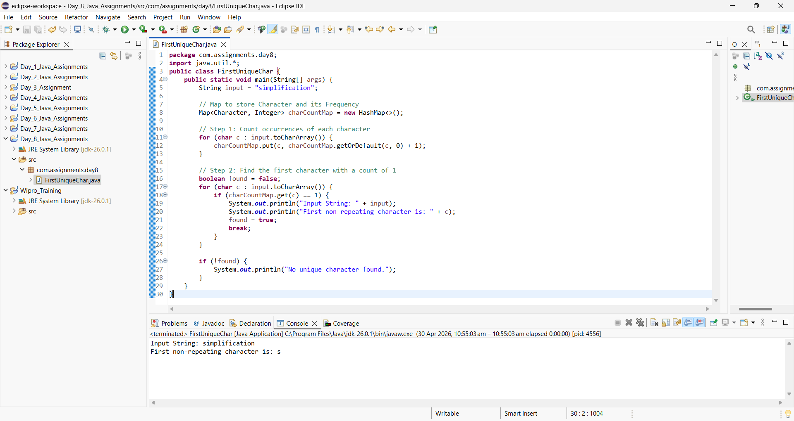

Online Shopping Cart • Use List for cart, Map for product-price mapping.

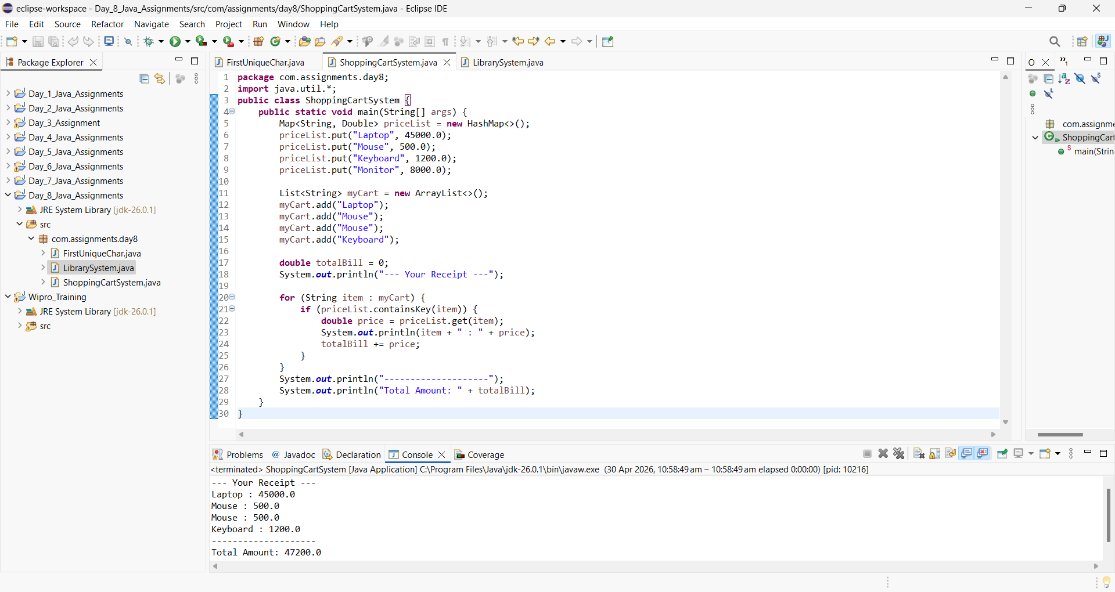

Library Management • Use Map to track availability.

