Automate e-commerce website flow
//• login with valid credentials
//• Search with valid keyword (e.g., “laptop”)
//• product title, price, and rating displayed
//• image zoom functionality
//• “Add to Cart” button visibility
//• “buy” button visibility
//• “checkout” button visibility

FLIPKART E-COMMERCE
Selenium_Java_code
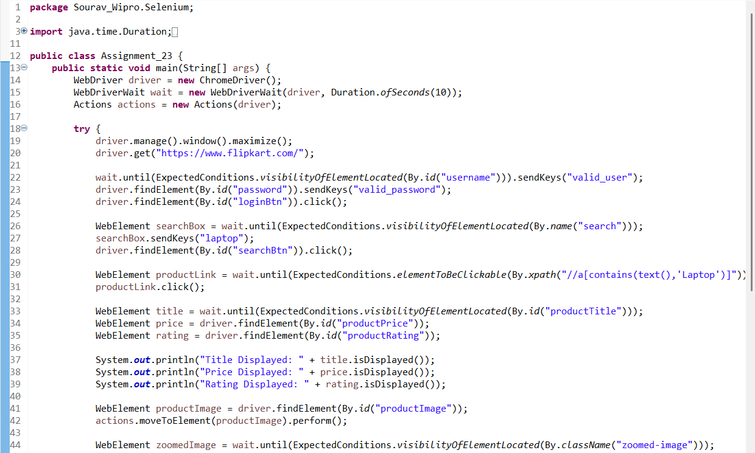
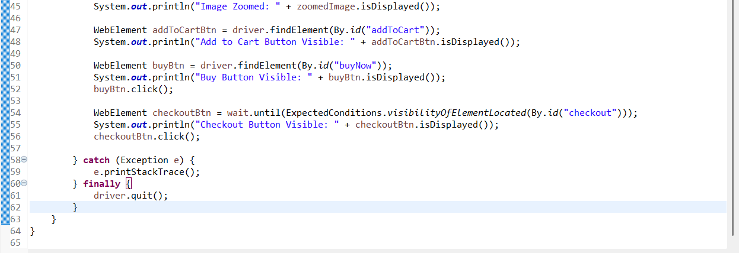

Flipkart website Screenshot
