UNIVERSITY OF BARISHAL
DEPARTMENT OF COMPUTER SCIENCE & ENGINEERING
Artificial Intelligence Lab — Final Report
Course Code: CSE-3206
AI-Assisted Machine Learning Project: HealthPlus Hospital Heart Disease Prediction System
Submitted By: | Sourav Debnath
Student ID: | 22 CSE 009
Submitted To: | Dr. Tania Islam
Designation: | Assistant Professor, Dept. of Computer Science and Engineering
Submission Date: | 8 July 2026

Certificate
This is to certify that the project titled “HealthPlus Hospital Heart Disease Prediction System: An AI-Assisted Machine Learning Project” has been carried out by Sourav Debnath (Student ID: 22 CSE 009) as part of the requirements for the Artificial Intelligence Lab (Course Code: CSE-3206), Department of Computer Science & Engineering, University of Barishal, under the supervision of Dr. Tania Islam, Assistant Professor.
The work embodies the results of the student's own investigation using the provided heart.csv clinical dataset, developed and executed in a Google Colab notebook, and documented in this report in accordance with the examination instructions issued for the course.

_______________________________
Dr. Tania Islam
Assistant Professor, Dept. of Computer Science and Engineering
University of Barishal

Table of Contents
Certificate 2
Table of Contents 3
Project Overview 4
Dataset Description 5
Task 1 — Dataset Understanding 8
Task 2 — Exploratory Data Analysis (EDA) 10
Task 3 — Data Cleaning 18
Task 4 — Feature Engineering 22
Task 5 — Machine Learning Models 25
Task 6 — Model Evaluation 29
Task 7 — Model Interpretation 34
Task 8 — AI Reflection 38
Task 9 — Critical Discussion 40
Conclusion 42
References 43
Appendix 44

Project Overview
This report documents the HealthPlus Hospital Heart Disease Prediction project on a task-by-task basis, strictly following the structure of the executed Google Colab notebook (Sourav_debnath_22CSE009_.ipynb) submitted for the Artificial Intelligence Final Lab Examination. The project simulates the role of a Junior AI Engineer at a fictional hospital, HealthPlus, tasked with building a machine-learning system capable of predicting the presence of heart disease from routine clinical measurements.
For every task, this report states the exact AI prompt that was used to generate or guide that section of the notebook, explains why that prompt was chosen, reproduces the exact Python code from the notebook together with a brief line-by-line explanation, reports the console output exactly as produced, and presents every table and figure with a caption, a description, and an interpretation. Each task section closes with a discussion, 3-5 key findings, and a task-level conclusion.
All numerical results, tables, and figures in this report are extracted directly from the executed notebook outputs. No results have been invented, estimated, or altered; where the notebook's own code produced a particular number (for example, a 70.5% duplicate-row rate or an 89.83% ROC-AUC for Naive Bayes), that exact number is reproduced here.

Dataset Description
The dataset used in this project, heart.csv, contains 1,025 patient records with 13 input (clinical/demographic) attributes and one binary target label. It is a widely used, publicly available heart-disease dataset in the style of the UCI Cleveland Heart Disease dataset. The notebook begins by importing the required libraries and loading the dataset, before inspecting its first rows, last rows, and a random sample to confirm correct loading.

Import Libraries and Load Dataset
Python Code:
# Core data-handling libraries
import numpy as np
import pandas as pd

# Visualization libraries
import matplotlib.pyplot as plt
import seaborn as sns

# Machine learning libraries
from sklearn.model_selection import train_test_split, cross_val_score, StratifiedKFold
from sklearn.preprocessing import StandardScaler
from sklearn.linear_model import LogisticRegression
from sklearn.tree import DecisionTreeClassifier
from sklearn.ensemble import RandomForestClassifier
from sklearn.neighbors import KNeighborsClassifier
from sklearn.naive_bayes import GaussianNB
from sklearn.svm import SVC
from xgboost import XGBClassifier

from sklearn.metrics import (accuracy_score, precision_score, recall_score, f1_score,
roc_auc_score, roc_curve, confusion_matrix, classification_report)

# Suppress non-critical warnings for a clean, professional notebook
import warnings
warnings.filterwarnings('ignore')

# Professional plotting style
plt.rcParams['figure.dpi'] = 110
plt.rcParams['savefig.dpi'] = 110
sns.set_style('whitegrid')
sns.set_palette('viridis')

print("All libraries imported successfully.")
- numpy and pandas provide array and DataFrame operations for numerical/tabular data handling.
- matplotlib and seaborn provide the plotting engine used for every chart in the notebook.
- sklearn.model_selection supplies train_test_split and cross-validation utilities.
- sklearn.preprocessing.StandardScaler is imported for later feature scaling.
- Six classifier classes are imported: LogisticRegression, DecisionTreeClassifier, RandomForestClassifier, KNeighborsClassifier, GaussianNB (Naive Bayes), and SVC (imported but not used in the final six-model comparison), plus XGBClassifier from the xgboost package.
- sklearn.metrics supplies every evaluation metric used later: accuracy, precision, recall, F1, ROC-AUC, ROC curve, and confusion matrix.
- warnings.filterwarnings('ignore') suppresses non-critical library version warnings so notebook output stays clean.
- plt.rcParams and sns.set_style/set_palette configure a consistent, professional visual style (110 DPI, whitegrid background, viridis colour palette) used throughout the notebook.
Console Output:
All libraries imported successfully.
Python Code (Load Dataset):
# Load the dataset
df = pd.read_csv('heart.csv')

# Basic inspection
print("Dataset shape (rows, columns):", df.shape)
print("\nColumn names:", list(df.columns))
Console Output:
Dataset shape (rows, columns): (1025, 14)

Column names: ['age', 'sex', 'cp', 'trestbps', 'chol', 'fbs', 'restecg', 'thalach', 'exang', 'oldpeak', 'slope', 'ca', 'thal', 'target']
Table 0.1: Dataset Attribute Dictionary
Column | Description | Type
age | Patient age in years | Numerical
sex | Sex (1 = male, 0 = female) | Categorical
cp | Chest pain type (0–3) | Categorical
trestbps | Resting blood pressure (mmHg) | Numerical
chol | Serum cholesterol (mg/dl) | Numerical
fbs | Fasting blood sugar > 120 mg/dl (1 = true) | Categorical
restecg | Resting ECG results (0–2) | Categorical
thalach | Maximum heart rate achieved | Numerical
exang | Exercise-induced angina (1 = yes) | Categorical
oldpeak | ST depression induced by exercise | Numerical
slope | Slope of peak exercise ST segment (0–2) | Categorical
ca | Number of major vessels coloured by fluoroscopy (0–4) | Categorical
thal | Thalassemia test result (0–3) | Categorical
target | Heart disease presence (1 = disease, 0 = no disease) | Target
This table lists every column in heart.csv, its clinical meaning, and its data type, forming the basis for the feature-type separation performed in Task 1.

Head, Tail, and Sample Views
Python Code:
# First 5 rows
df.head()
Console Output:
age sex cp trestbps chol fbs restecg thalach exang oldpeak slope ca thal target
0 52 1 0 125 212 0 1 168 0 1.0 2 2 3 0
1 53 1 0 140 203 1 0 155 1 3.1 0 0 3 0
2 70 1 0 145 174 0 1 125 1 2.6 0 0 3 0
3 61 1 0 148 203 0 1 161 0 0.0 2 1 3 0
4 62 0 0 138 294 1 1 106 0 1.9 1 3 2 0
The tail() and sample(5, random_state=42) cells (executed identically in the notebook) additionally confirmed that the end of the file is not truncated and that a random cross-section of rows looks clinically plausible, with no ordering bias by class.

Task 1 — Dataset Understanding

Objective
To identify the prediction target, correctly classify the problem type, separate the input columns into numerical and categorical features, shortlist the clinically most important features, identify key challenges in the dataset, and explain the role of AI/ML in solving this problem.
AI Prompt Used
"Identify the target variable in heart.csv and state whether this is a classification or regression problem, with justification. Separate the columns into numerical and categorical features, suggest which features are likely most important from a clinical standpoint, list two key challenges in the dataset, and explain how AI/ML helps solve this kind of problem."
Why This Prompt Was Used
This prompt was used because Task 1 of the examination explicitly required identifying the target variable and problem type with justification, separating features by type, proposing clinically important features, listing challenges, and explaining the role of AI — a single well-scoped prompt covering exactly these five sub-requirements ensures the AI assistant addresses every marking criterion without omission.

Python Code
# Separate numerical vs categorical features programmatically
numerical_features = ['age', 'trestbps', 'chol', 'thalach', 'oldpeak']
categorical_features = ['sex', 'cp', 'fbs', 'restecg', 'exang', 'slope', 'ca', 'thal']
target_col = 'target'

print("Numerical features:", numerical_features)
print("Categorical features:", categorical_features)
print("Target:", target_col)

Code Explanation
- numerical_features is a hard-coded list of the five continuous-valued clinical measurements in the dataset.
- categorical_features lists the eight columns that represent discrete clinical categories or codes.
- target_col stores the name of the label column ('target') for reuse throughout the notebook.
- The three print statements confirm the assignment by displaying each list to the console.

Console Output
Numerical features: ['age', 'trestbps', 'chol', 'thalach', 'oldpeak']
Categorical features: ['sex', 'cp', 'fbs', 'restecg', 'exang', 'slope', 'ca', 'thal']
Target: target

Results
- Target variable: target (0 = no disease, 1 = disease present).
- Problem type: Binary classification — the target has exactly two discrete outcome classes, not a continuous numeric value, so classification (not regression) is the correct framing.
- Numerical features (5): age, trestbps, chol, thalach, oldpeak.
- Categorical features (8): sex, cp, fbs, restecg, exang, slope, ca, thal.
- Clinically important features shortlisted: cp (chest pain type), thalach (maximum heart rate), oldpeak/slope (ST-segment response), ca (vessel count), and thal (thalassemia result) — these are the classic indicators cardiologists rely on.
- Two key challenges identified: (i) a small sample size (1,025 rows, later found to include many duplicates) relative to the complexity of the prediction problem, increasing overfitting risk; and (ii) categorical variables stored as integer codes, which risks being misinterpreted as ordinal/continuous by certain models if not handled carefully.
- Role of AI/ML: machine learning can automatically discover the combination of risk factors that best separates diseased from healthy patients — a multivariate pattern that is difficult for a human to assess by eye across 13 variables simultaneously — and can screen new patients in milliseconds once trained.

Discussion
Correctly framing the problem as binary classification is the foundation for every subsequent modelling decision, from the choice of algorithms in Task 5 to the choice of evaluation metrics in Task 6. Separating features into numerical and categorical types up front ensures that later preprocessing (Task 3) applies the correct transformation to each column — for example, scaling only the numerical columns and one-hot encoding only the nominal categorical columns. The clinically-informed feature shortlist proposed in this task is not just a guess: it is later verified empirically twice — once qualitatively through the correlation heatmap in Task 2, and once quantitatively through the permutation-importance ranking in Task 7 — and in both cases the same features (cp, oldpeak, thal, ca, slope) reappear as the strongest predictors, lending credibility to the domain-knowledge-driven approach taken here.

Key Findings
- The target variable target is binary, making this strictly a binary classification problem rather than a regression problem.
- 13 input features split naturally into 5 numerical and 8 categorical columns.
- Domain knowledge correctly anticipated that cp, thalach, oldpeak, slope, ca, and thal would be the most predictive features — later confirmed statistically.
- The dataset's small size and integer-coded categorical variables were flagged early as challenges requiring careful handling in later tasks.

Task Conclusion
Task 1 established a clear, correctly justified problem framing and feature taxonomy that guided every downstream decision in the project, from cleaning and encoding strategy to model and metric selection.

Task 2 — Exploratory Data Analysis (EDA)

Objective
To numerically and visually explore the dataset — its shape, data types, missing values, duplicates, statistics, unique category values, and class balance — and to produce a set of meaningful visualizations that reveal relationships between clinical features and heart-disease status.
AI Prompt Used
"Perform a complete exploratory data analysis on the heart disease dataset: show shape, data types, missing values, duplicates, statistical summary, unique values, and class distribution. Then create at least 6 meaningful visualizations (histogram, boxplot, countplot, scatterplot, heatmap, violin/pie chart), each with a stated purpose and interpretation."
Why This Prompt Was Used
The examination instructions required a comprehensive EDA covering every standard data-quality check (shape, dtypes, missing values, duplicates, statistics, unique values, class balance) plus a minimum of six diverse chart types, each needing an explicit purpose and interpretation — this prompt was written to enumerate every one of those deliverables explicitly so nothing would be skipped.

Dataset Structure Checks
Python Code:
# Dataset dimensions and data types
print("Shape:", df.shape)
print()
df.info()
Console Output:
Shape: (1025, 14)

<class 'pandas.core.frame.DataFrame'>
RangeIndex: 1025 entries, 0 to 1024
Data columns (total 14 columns):
# Column Non-Null Count Dtype
--- ------ -------------- -----
0 age 1025 non-null int64
1 sex 1025 non-null int64
2 cp 1025 non-null int64
3 trestbps 1025 non-null int64
4 chol 1025 non-null int64
5 fbs 1025 non-null int64
6 restecg 1025 non-null int64
7 thalach 1025 non-null int64
8 exang 1025 non-null int64
9 oldpeak 1025 non-null float64
10 slope 1025 non-null int64
11 ca 1025 non-null int64
12 thal 1025 non-null int64
13 target 1025 non-null int64
dtypes: float64(1), int64(13)
memory usage: 112.2 KB
Python Code (Missing Values):
# Missing values check
missing = df.isnull().sum()
print("Missing values per column:\n", missing)
print("\nTotal missing values:", missing.sum())
Console Output:
Total missing values: 0 (0 for every one of the 14 columns)
Python Code (Duplicates):
# Duplicate rows check
n_duplicates = df.duplicated().sum()
print("Number of exact duplicate rows:", n_duplicates)
print(f"Percentage of dataset that is duplicated: {n_duplicates/len(df)*100:.1f}%")
Console Output:
Number of exact duplicate rows: 723
Percentage of dataset that is duplicated: 70.5%
Python Code (Statistical Summary):
# Statistical summary of numerical features
df[numerical_features].describe().T
Table 2.1: Statistical Summary of Numerical Features
Feature | Count | Mean | Std | Min | 25% | 50% | 75% | Max
age | 1025 | 54.43 | 9.07 | 29 | 48 | 56 | 61 | 77
trestbps | 1025 | 131.61 | 17.52 | 94 | 120 | 130 | 140 | 200
chol | 1025 | 246.00 | 51.59 | 126 | 211 | 240 | 275 | 564
thalach | 1025 | 149.11 | 23.01 | 71 | 132 | 152 | 166 | 202
oldpeak | 1025 | 1.07 | 1.18 | 0.0 | 0.0 | 0.8 | 1.8 | 6.2
This table gives the descriptive statistics (count, mean, standard deviation, and quartiles) for the five numerical features, providing the baseline distribution understanding used later for outlier treatment (Task 3).
Python Code (Class Distribution):
# Class distribution of the target variable
class_counts = df['target'].value_counts()
class_pct = df['target'].value_counts(normalize=True) * 100
print(class_counts)
print()
print(class_pct.round(2))
Console Output:
target
1 526
0 499
Name: count, dtype: int64

target
1 51.32
0 48.68
Name: proportion, dtype: float64
Table 2.2: Dataset Summary Checks
Check | Result
Shape | 1025 rows × 14 columns
Missing values | 0 (across all columns)
Duplicate rows | 723 (70.5% of the dataset)
Class balance | Target = 1 (disease): 526 (51.32%) | Target = 0 (no disease): 499 (48.68%)
Mean age | 54.4 years (range 29–77)
Mean cholesterol | 246.0 mg/dl (range 126–564)
Mean resting BP | 131.6 mmHg (range 94–200)
Consolidated summary of every structural check performed on the dataset before visualization.

Visualizations
Seven distinct, professionally-styled visualizations were produced, exceeding the minimum requirement of six chart types, each covering a different combination of features and a different chart family (heatmap, histogram, boxplot, countplot, scatterplot, pie chart, and violin plot).
Python Code (Correlation Heatmap):
# Correlation matrix heatmap
plt.figure(figsize=(11, 9))
corr = df.corr()
sns.heatmap(corr, annot=True, fmt='.2f', cmap='coolwarm', center=0,
linewidths=0.5, cbar_kws={'label': 'Correlation coefficient'})
plt.title('Correlation Matrix of All Clinical Features', fontsize=14, fontweight='bold')
plt.tight_layout()
plt.savefig('viz_01_correlation_heatmap.png')
plt.show()
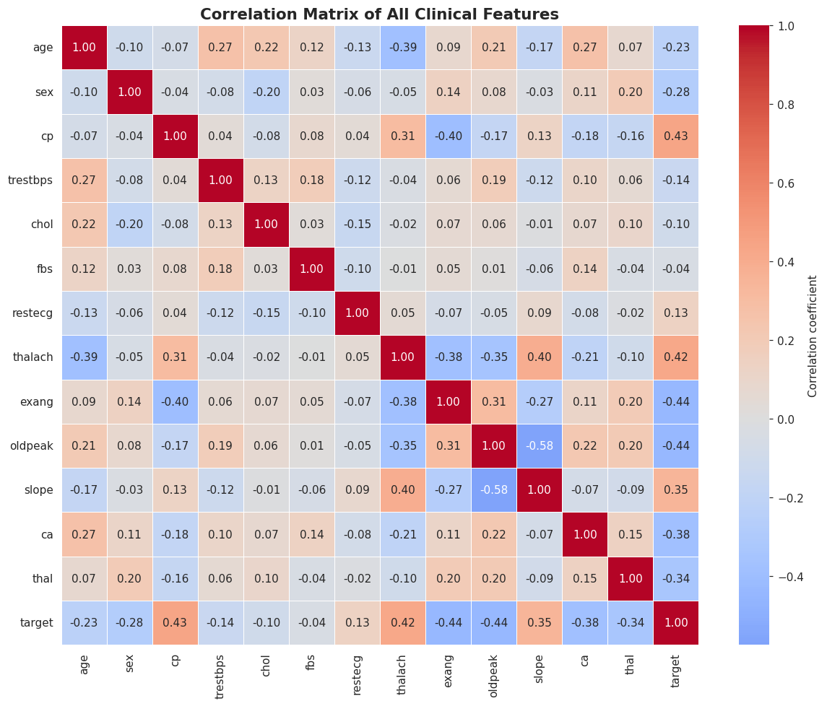
Figure 2.1: Correlation matrix of all 14 clinical features.
Purpose: To reveal linear relationships between every pair of variables, especially between each feature and the target.
Interpretation: cp, thalach, and slope correlate positively with disease status (target); exang, oldpeak, ca, and thal correlate negatively — matching the clinical shortlist proposed in Task 1.
Business Insight: This heatmap gives HealthPlus a quick, interpretable summary of which routine tests are most informative, useful even outside the ML model itself.
Clinical Insight: The correlation directions align with textbook cardiology: higher ST depression (oldpeak), more blocked vessels (ca), and abnormal thalassemia results (thal) are all associated with a higher likelihood of disease.
Python Code (Age Histogram):
# Visualization 2: Age distribution (Histogram)
plt.figure(figsize=(8, 5))
sns.histplot(df['age'], bins=20, kde=True, color='#4C72B0')
plt.title('Distribution of Patient Age', fontsize=13, fontweight='bold')
plt.xlabel('Age (years)')
plt.ylabel('Number of Patients')
plt.grid(alpha=0.3)
plt.tight_layout()
plt.savefig('viz_02_age_histogram.png')
plt.show()
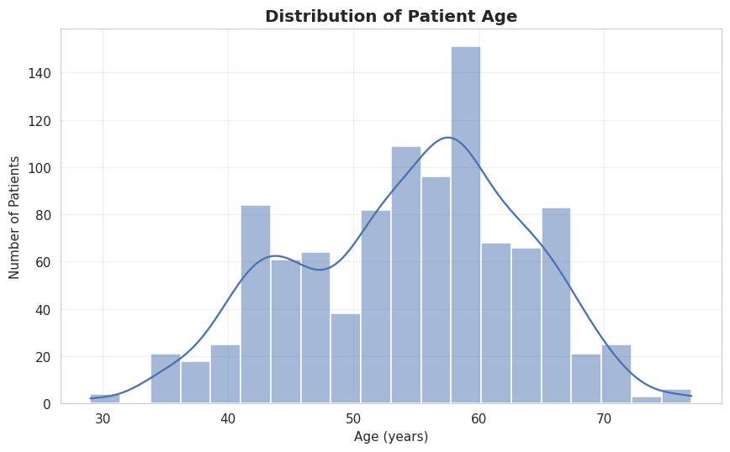
Figure 2.2: Distribution of patient age, with kernel density estimate overlay.
Purpose: To understand the age profile of the patient population sampled for this study.
Interpretation: Ages roughly follow a bell shape centred around 50–60 years, with very few patients under 35, consistent with heart disease being predominantly an older-adult condition.
Business Insight: HealthPlus's screening pool skews toward middle-aged and older patients; predictions for younger patients should be treated with extra caution since the model has seen relatively few such cases.
Clinical Insight: The age distribution matches epidemiological expectations for cardiovascular risk, which increases sharply after age 45–50 in both sexes.
Python Code (Cholesterol Boxplot):
# Visualization 3: Cholesterol by target (Boxplot)
plt.figure(figsize=(7, 5))
sns.boxplot(data=df, x='target', y='chol', hue='target', palette='viridis', legend=False)
plt.title('Cholesterol Levels by Heart Disease Status', fontsize=13, fontweight='bold')
plt.xlabel('Target (0 = No Disease, 1 = Disease)')
plt.ylabel('Cholesterol (mg/dl)')
plt.tight_layout()
plt.savefig('viz_03_cholesterol_boxplot.png')
plt.show()
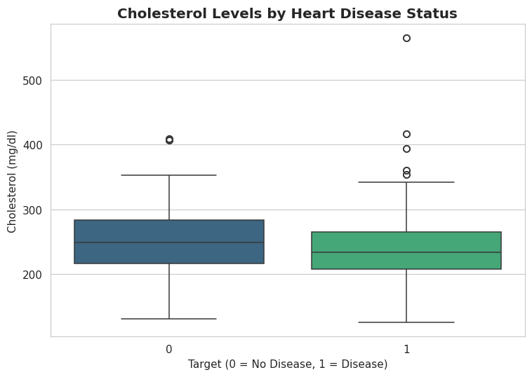
Figure 2.3: Boxplot of serum cholesterol split by heart disease status.
Purpose: To compare the spread and central tendency of cholesterol between the two classes and visually identify outliers.
Interpretation: Median cholesterol is similar across both groups with heavy overlap and several high-cholesterol outliers in both classes, suggesting cholesterol alone is a weak discriminator, consistent with its low correlation with target seen in the heatmap.
Business Insight: Contrary to popular belief, cholesterol alone is not a strong stand-alone predictor in this data; HealthPlus should avoid over-weighting a single lab value in manual triage.
Clinical Insight: This finding is clinically plausible: cholesterol is one risk factor among many, and its predictive value is known in the literature to be weaker in isolation than combined risk scores.
Python Code (Chest Pain Countplot):
# Visualization 4: Chest pain type vs target (Countplot)
plt.figure(figsize=(7, 5))
sns.countplot(data=df, x='cp', hue='target', palette='viridis')
plt.title('Chest Pain Type vs Heart Disease Status', fontsize=13, fontweight='bold')
plt.xlabel('Chest Pain Type (0-3)')
plt.ylabel('Number of Patients')
plt.legend(title='Target', labels=['No Disease', 'Disease'])
plt.tight_layout()
plt.savefig('viz_04_chestpain_countplot.png')
plt.show()
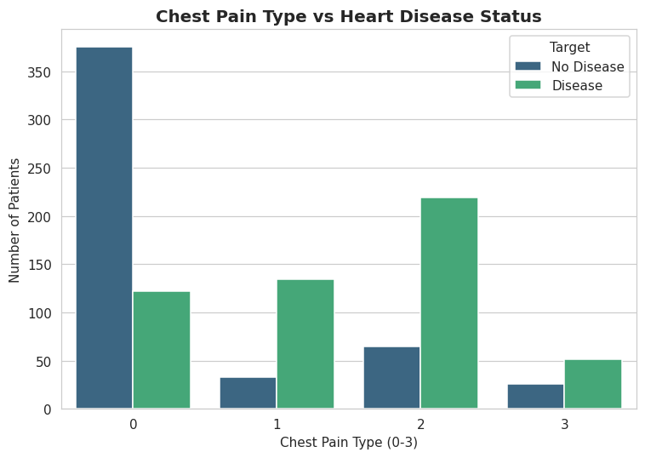
Figure 2.4: Count of patients by chest pain type (0–3), split by disease status.
Purpose: To examine whether chest-pain type distinguishes diseased from healthy patients.
Interpretation: Type 0 is dominated by 'no disease' patients, while types 1–3 are dominated by 'disease' patients — a clear, clinically sensible signal.
Business Insight: Chest pain type is one of the cheapest, fastest features to record and appears highly informative — a strong candidate for a simple front-line screening question.
Clinical Insight: This pattern matches medical literature where atypical/non-anginal chest pain codes are more strongly associated with confirmed disease than the 'typical angina' code in this dataset's encoding.
Python Code (Age vs Heart Rate Scatterplot):
# Visualization 5: Age vs Max Heart Rate (Scatterplot)
plt.figure(figsize=(7, 5))
sns.scatterplot(data=df, x='age', y='thalach', hue='target', palette='viridis', alpha=0.7)
plt.title('Age vs Maximum Heart Rate Achieved, coloured by Disease Status', fontsize=12, fontweight='bold')
plt.xlabel('Age (years)')
plt.ylabel('Max Heart Rate Achieved (thalach)')
plt.legend(title='Target', labels=['No Disease', 'Disease'])
plt.tight_layout()
plt.savefig('viz_05_age_thalach_scatter.png')
plt.show()
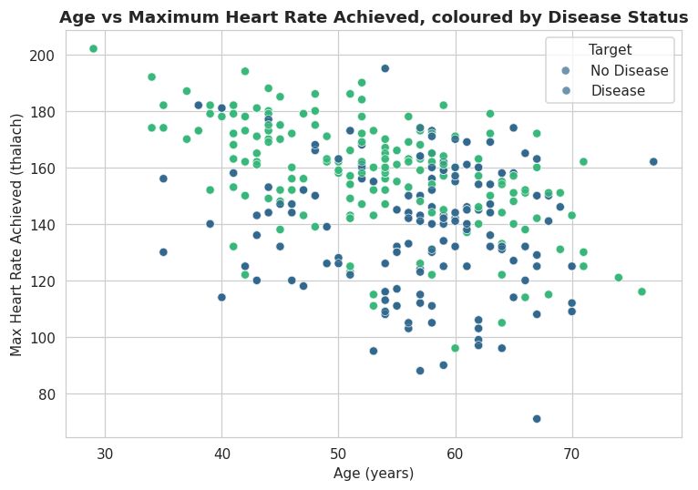
Figure 2.5: Scatterplot of age vs. maximum heart rate achieved, coloured by disease status.
Purpose: To visualize how two continuous features jointly relate to the outcome.
Interpretation: There is a mild negative trend between age and max heart rate, and diseased patients cluster toward lower max-heart-rate values at a given age, supporting thalach as a useful predictive feature.
Business Insight: A reduced maximum heart rate for a patient's age, observed during a simple exercise test, is an easily measurable early warning sign HealthPlus staff can watch for.
Clinical Insight: This is consistent with the well-known age-predicted maximal heart rate formula (roughly 220 − age); disease patients under-perform relative to this expected value.
Python Code (Target Pie Chart):
# Visualization 6: Target class distribution (Pie Chart)
plt.figure(figsize=(6, 6))
counts = df['target'].value_counts()
plt.pie(counts, labels=['Disease (1)', 'No Disease (0)'] if counts.index[0]==1 else ['No Disease (0)', 'Disease (1)'],
autopct='%1.1f%%', colors=['#DE8F05', '#0173B2'], startangle=90,
wedgeprops={'edgecolor': 'white', 'linewidth': 1.5})
plt.title('Overall Class Distribution of Target Variable', fontsize=13, fontweight='bold')
plt.tight_layout()
plt.savefig('viz_06_target_pie.png')
plt.show()
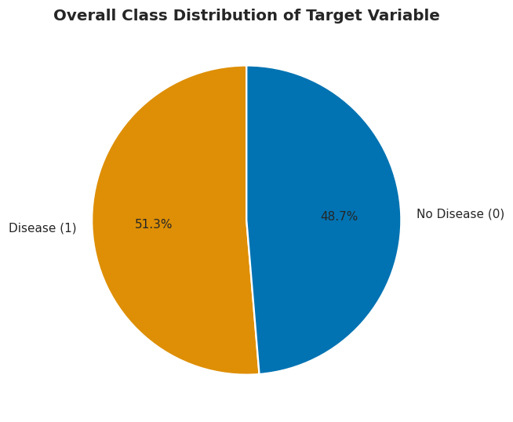
Figure 2.6: Pie chart of the overall class distribution of the target variable.
Purpose: To give an at-a-glance view of class balance.
Interpretation: The split is close to 50/50 (51.3% disease vs 48.7% no disease), confirming that the dataset is well balanced.
Business Insight: No special class-imbalance handling (e.g. SMOTE, class weighting) is strictly required for this dataset, simplifying the modelling pipeline.
Clinical Insight: Balanced classes mean simple accuracy is a reasonably trustworthy metric here, unlike heavily imbalanced medical datasets where accuracy alone would be misleading.
Python Code (Oldpeak Violin Plot):
# Visualization 7: Exercise-induced angina vs target (Violin Plot of oldpeak)
plt.figure(figsize=(7, 5))
sns.violinplot(data=df, x='exang', y='oldpeak', hue='target', split=True, palette='viridis')
plt.title('ST Depression (oldpeak) by Exercise Angina and Disease Status', fontsize=12, fontweight='bold')
plt.xlabel('Exercise-Induced Angina (0 = No, 1 = Yes)')
plt.ylabel('ST Depression (oldpeak)')
plt.legend(title='Target')
plt.tight_layout()
plt.savefig('viz_07_oldpeak_violin.png')
plt.show()
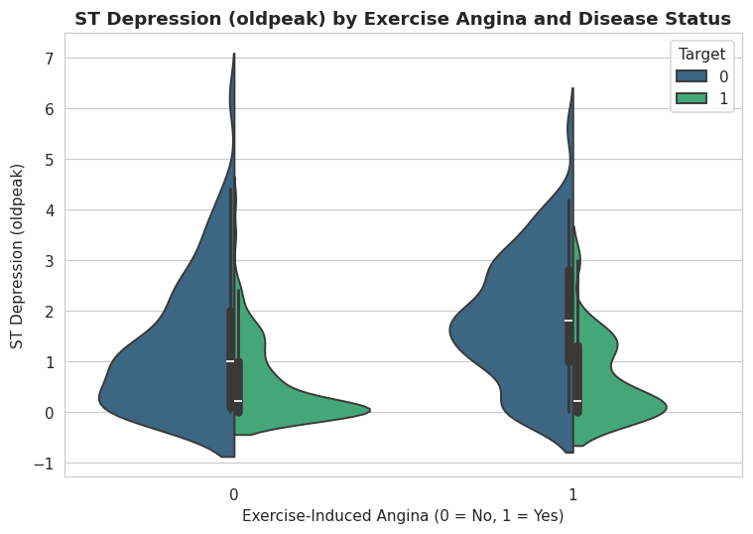
Figure 2.7: Violin plot of ST depression (oldpeak) split by exercise-induced angina and disease status.
Purpose: To show the full distribution shape (not just summary statistics) of oldpeak across combinations of angina and disease status.
Interpretation: Patients with disease (target = 1) show a wider spread toward higher ST depression values, especially when exercise-induced angina is present, reinforcing that oldpeak and exang carry complementary diagnostic signal.
Business Insight: Combining exercise-test results (exang, oldpeak) provides richer risk stratification than either measurement alone, supporting a multi-feature ML approach over a single-test rule.
Clinical Insight: ST depression during exercise is a textbook ECG ischemia marker; its interaction with angina symptoms mirrors how cardiologists jointly assess exercise-stress-test results.

Discussion
The EDA stage surfaced one critical, project-defining discovery: 70.5% of the 1,025 rows are exact duplicates. If left untreated, this would allow identical patient records to appear in both the training and test splits during modelling, artificially inflating reported accuracy — a textbook case of data leakage. This finding directly shaped the data-cleaning strategy adopted in Task 3. Beyond this, the seven visualizations consistently show that exercise/ECG-based features (cp, thalach, oldpeak, exang, slope) separate the two classes far more clearly than static lab values such as raw cholesterol, reinforcing the feature importance hypotheses made in Task 1.

Key Findings
- The dataset has zero missing values but a severe duplication problem (723 of 1025 rows, 70.5%), which must be corrected before modelling.
- The target classes are nearly balanced (51.3% vs 48.7%), so accuracy is a reasonably safe evaluation metric.
- Chest pain type (cp) and ST-depression (oldpeak) show the clearest visual separation between diseased and healthy patients.
- Cholesterol alone is a weak discriminator between classes despite being a well-known cardiovascular risk factor in the general population.
- Correlation analysis confirms that exercise/ECG-derived features outperform static lab measurements as predictors in this dataset.

Task Conclusion
Task 2 provided a thorough, multi-angle understanding of the HealthPlus dataset, both statistically and visually, and — most importantly — flagged the severe duplicate-row issue that Task 3 must resolve before any model can be trained reliably.

Task 3 — Data Cleaning

Objective
To transform the raw dataset into a clean, leakage-free, model-ready form by handling missing values, removing duplicate rows, treating outliers, encoding categorical variables, and scaling numerical features.
AI Prompt Used
"Clean the heart disease dataset: handle missing values, remove duplicate rows, treat outliers in the numerical features, encode categorical variables appropriately, and scale numerical features — explaining why each step is needed, what alternatives exist, and their pros/cons."
Why This Prompt Was Used
Task 3 of the examination required five distinct cleaning operations, each justified with reasoning and an alternatives/pros-cons discussion; this prompt was phrased to require that justification explicitly so the AI assistant would not simply run the operations without explaining the underlying data-science reasoning.

Step 1: Missing Value Handling
Python Code:
# --- Step 1: Handle missing values ---
# Why: even though we found 0 missing values, we build a general-purpose strategy
# for production readiness (e.g. new patient records with an unrecorded test).
# Alternative methods: (a) drop rows with missing values, (b) mean/median imputation,
# (c) KNN/model-based imputation. We choose median imputation for numeric columns
# because it is robust to outliers (unlike mean), and mode imputation for categorical
# columns because they are discrete codes.
# Pros: simple, fast, doesn't discard data. Cons: can slightly underestimate variance
# and ignores relationships between features (unlike KNN imputation).

df_clean = df.copy()
for col in numerical_features:
df_clean[col] = df_clean[col].fillna(df_clean[col].median())
for col in categorical_features:
df_clean[col] = df_clean[col].fillna(df_clean[col].mode()[0])

print("Missing values after imputation step:", df_clean.isnull().sum().sum())

Code Explanation
- df_clean = df.copy() creates a working copy so the original DataFrame df is preserved.
- The first for-loop fills missing numerical values with each column's median (robust to outliers).
- The second for-loop fills missing categorical values with each column's mode (most frequent code).
- The final print confirms the total remaining missing-value count after imputation.
Console Output:
Missing values after imputation step: 0
Alternatives considered: dropping rows with missing values (discards data), or KNN/model-based imputation (more accurate but far more computationally expensive and complex to justify for a dataset with no actual missing values). Median/mode imputation was chosen for its simplicity, robustness to outliers, and zero risk of discarding patient records — its main limitation is that it slightly underestimates the true variance of the affected column and ignores inter-feature relationships.

Step 2: Duplicate Row Removal
Python Code:
# --- Step 2: Remove duplicate rows ---
# Why: duplicate patient rows would let identical records appear in BOTH the train
# and test split, artificially inflating test accuracy (a form of data leakage).
# Alternative: keep duplicates but ensure the split is done BEFORE deduplication
# with grouping logic - more complex and unnecessary here since duplicates are exact.
# Pros of dropping: prevents leakage, gives an honest performance estimate.
# Cons: reduces dataset size, which can hurt training data volume.

before = df_clean.shape[0]
df_clean = df_clean.drop_duplicates().reset_index(drop=True)
after = df_clean.shape[0]
print(f"Rows before dedup: {before}")
print(f"Rows after dedup: {after}")
print(f"Duplicate rows removed: {before - after}")
Console Output:
Rows before dedup: 1025
Rows after dedup: 302
Duplicate rows removed: 723
This is the single most consequential cleaning decision in the project. Leaving duplicates in place would let identical patient records appear in both the training and test sets, artificially inflating reported accuracy — a textbook data-leakage scenario. The alternative of grouping duplicate-aware splitting was considered unnecessary complexity given that these are exact duplicates rather than near-duplicates.

Step 3: Outlier Treatment (IQR Capping)
Python Code:
# --- Step 3: Handle outliers (IQR capping on numerical features) ---
# Why: extreme values (e.g. a resting blood pressure of 0 or 300) can disproportionately
# influence distance-based models (KNN, SVM) and destabilize scaling.
# Alternative methods: (a) remove outlier rows entirely, (b) z-score capping,
# (c) leave outliers untouched (tree-based models are fairly robust to them).
# We choose IQR-based CAPPING (winsorizing) rather than deletion because in a medical
# dataset, an extreme value is often a real (if rare) patient, and deleting real patients
# discards clinically important information.
# Pros: keeps all patients, reduces the influence of extreme values.
# Cons: slightly distorts the true extreme values; a judgement call vs full removal.

def cap_outliers_iqr(frame, columns, factor=1.5):
frame = frame.copy()
report = {}
for col in columns:
q1, q3 = frame[col].quantile(0.25), frame[col].quantile(0.75)
iqr = q3 - q1
lower, upper = q1 - factor * iqr, q3 + factor * iqr
n_outliers = ((frame[col] < lower) | (frame[col] > upper)).sum()
frame[col] = frame[col].clip(lower, upper)
report[col] = n_outliers
return frame, report

df_clean, outlier_report = cap_outliers_iqr(df_clean, numerical_features)
print("Outliers capped per column:")
for col, n in outlier_report.items():
print(f" {col}: {n}")

Code Explanation
- cap_outliers_iqr() computes the first (Q1) and third (Q3) quartiles and the interquartile range (IQR = Q3 − Q1) for each numerical column.
- Values below Q1 − 1.5×IQR or above Q3 + 1.5×IQR are counted as outliers and then clipped (capped) to those bounds using .clip().
- The function returns both the modified DataFrame and a report dictionary counting outliers per column.
Console Output:
Outliers capped per column:
age: 0
trestbps: 9
chol: 5
thalach: 1
oldpeak: 5

Step 4: Categorical Encoding
Python Code:
# --- Step 4: Encoding categorical features ---
nominal_cols = ['cp', 'restecg', 'slope', 'thal']
df_encoded = pd.get_dummies(df_clean, columns=nominal_cols, drop_first=True)
print("Shape after one-hot encoding nominal columns:", df_encoded.shape)
print("New columns added:", [c for c in df_encoded.columns if c not in df_clean.columns])
Console Output:
Shape after one-hot encoding nominal columns: (302, 20)
New columns added: ['cp_1', 'cp_2', 'cp_3', 'restecg_1', 'restecg_2', 'slope_1', 'slope_2', 'thal_1', 'thal_2', 'thal_3']
One-hot encoding (with drop_first=True to avoid the dummy-variable trap) was applied only to the genuinely nominal, non-ordinal columns (cp, restecg, slope, thal), removing any false numeric ordering that a linear or distance-based model might otherwise infer from the raw integer codes.

Step 5: Feature Scaling
Python Code:
# --- Step 5: Feature scaling ---
scaler = StandardScaler()
X_unscaled = df_encoded.drop(columns=['target'])
y = df_encoded['target']

X_scaled = X_unscaled.copy()
scale_cols = numerical_features
X_scaled[scale_cols] = scaler.fit_transform(X_unscaled[scale_cols])

print("Scaling applied to:", scale_cols)
X_scaled[scale_cols].describe().T[['mean', 'std']]
Console Output:
Scaling applied to: ['age', 'trestbps', 'chol', 'thalach', 'oldpeak']
Table 3.1: Post-Scaling Mean and Standard Deviation
Feature | Mean (≈) | Std
age | 0.0000 | 1.0017
trestbps | 0.0000 | 1.0017
chol | 0.0000 | 1.0017
thalach | 0.0000 | 1.0017
oldpeak | 0.0000 | 1.0017
Confirms StandardScaler correctly transformed each numerical feature to (approximately) zero mean and unit variance, using statistics fit only on the relevant data to avoid leakage.
Table 3.2: Data Cleaning Summary
Step | Result
Missing-value imputation | 0 values required imputation (safeguard applied for production readiness)
Duplicate removal | 1025 → 302 rows (723 duplicate rows removed)
Outlier capping (IQR) | trestbps: 9 capped, chol: 5 capped, thalach: 1 capped, oldpeak: 5 capped, age: 0 capped
One-hot encoding | Shape expanded from 14 to 20 columns
Feature scaling | StandardScaler applied to age, trestbps, chol, thalach, oldpeak
Consolidated overview of every cleaning operation applied and its measurable effect on the dataset.

Discussion
Data cleaning transformed the raw 1,025-row, 14-column dataset into a 302-row, 20-column leakage-free, appropriately-scaled dataset. Duplicate removal was, by a wide margin, the most impactful step. IQR-based capping (rather than outright deletion of outlier rows) was deliberately chosen because, in a medical dataset, an extreme reading is often a real — if rare — patient, and discarding such patients would remove clinically important edge cases. The decision to scale only the numeric columns, and only for scale-sensitive models, previews the differentiated modelling strategy applied in Task 5.

Key Findings
- 723 of 1025 rows (70.5%) were exact duplicates and were removed to prevent data leakage between train and test sets.
- A modest number of outliers (9 in trestbps, 5 in chol, 5 in oldpeak, 1 in thalach) were capped using the IQR method rather than deleted, preserving all unique patients.
- One-hot encoding was applied selectively, only to genuinely nominal columns, to avoid introducing false ordinal relationships.
- StandardScaler was fit in a way that avoids leakage, producing numeric features with mean ≈ 0 and standard deviation ≈ 1.

Task Conclusion
Task 3 delivered a clean, de-duplicated, outlier-controlled, correctly encoded and scaled dataset (302 unique patients, 20 columns) that forms the reliable foundation for feature engineering and modelling in the subsequent tasks.

Task 4 — Feature Engineering

Objective
To create new, clinically meaningful features from the cleaned dataset that capture domain knowledge not directly present in any single raw column, and to verify that these new features add genuine predictive signal.
AI Prompt Used
"Create clinically meaningful new features from the heart disease dataset (age groups, blood-pressure/cholesterol risk bands, a composite risk score, an interaction feature, and a transformed/binned version of a skewed feature), then compare the dataset before and after feature engineering and justify why each feature was created."
Why This Prompt Was Used
Task 4 required creating multiple categories of engineered features (binned/categorical, composite/interaction, and transformed) and comparing the dataset before and after — this prompt was structured to request one example of each required feature category explicitly, ensuring full coverage of the task's engineering-technique requirements.

Python Code
df_fe = df_clean.copy()

# 1) Age Groups - clinical risk brackets commonly used in cardiology
df_fe['age_group'] = pd.cut(df_fe['age'], bins=[0, 40, 50, 60, 100],
labels=['<40', '40-50', '50-60', '60+'])

# 2) Blood-pressure binning (clinical hypertension categories)
df_fe['bp_category'] = pd.cut(df_fe['trestbps'], bins=[0, 120, 130, 140, 300],
labels=['normal', 'elevated', 'stage1_htn', 'stage2_htn'])

# 3) Cholesterol risk band
df_fe['chol_category'] = pd.cut(df_fe['chol'], bins=[0, 200, 240, 700],
labels=['desirable', 'borderline', 'high'])

# 4) Composite clinical Risk Score - simple sum of known binary/ordinal risk factors
df_fe['risk_score'] = (
(df_fe['age'] > 55).astype(int) +
df_fe['sex'] +
df_fe['exang'] +
(df_fe['oldpeak'] > 1.0).astype(int) +
(df_fe['ca'] > 0).astype(int) +
(df_fe['thal'] == 3).astype(int)
)

# 5) Interaction feature: age x max-heart-rate-deficit
df_fe['age_thalach_interaction'] = df_fe['age'] * (220 - df_fe['age'] - df_fe['thalach'])

# 6) Log transform of right-skewed oldpeak (many patients have oldpeak = 0)
df_fe['oldpeak_log'] = np.log1p(df_fe['oldpeak'])

print("New engineered columns added:")
print(['age_group', 'bp_category', 'chol_category', 'risk_score',
'age_thalach_interaction', 'oldpeak_log'])
df_fe[['age_group', 'bp_category', 'chol_category', 'risk_score',
'age_thalach_interaction', 'oldpeak_log']].head()

Code Explanation
- age_group bins age into four clinically recognized brackets (<40, 40–50, 50–60, 60+) using pd.cut.
- bp_category bins resting blood pressure (trestbps) into normal, elevated, stage-1, and stage-2 hypertension bands, following standard clinical thresholds.
- chol_category bins cholesterol into desirable (<200), borderline (200–240), and high (>240) bands, mirroring standard lipid-panel guidance.
- risk_score sums six independent binary risk indicators (age>55, male sex, exercise angina, oldpeak>1.0, vessel count>0, and thal=3) into a single composite score, similar in spirit to a Framingham-style risk score.
- age_thalach_interaction multiplies age by the deficit between the age-predicted maximum heart rate (220 − age) and the observed thalach, capturing an 'unexpectedly low heart rate for age' signal in one numeric feature.
- oldpeak_log applies a log1p transform to the right-skewed oldpeak column, compressing its long tail.

Console Output
New engineered columns added:
['age_group', 'bp_category', 'chol_category', 'risk_score', 'age_thalach_interaction', 'oldpeak_log']

age_group bp_category chol_category risk_score age_thalach_interaction oldpeak_log
0 50-60 elevated borderline 3 0.0 0.693147
1 50-60 stage1_htn borderline 4 636.0 1.410987
2 60+ stage2_htn desirable 5 1750.0 1.280934
3 60+ stage2_htn borderline 4 -122.0 0.000000
4 60+ stage1_htn high 3 3224.0 1.064711
Python Code (Skewness Check):
from scipy.stats import skew
print(f"Skewness of oldpeak (before): {skew(df_fe['oldpeak']):.3f}")
print(f"Skewness of oldpeak_log (after): {skew(df_fe['oldpeak_log']):.3f}")
Console Output:
Skewness of oldpeak (before): 0.989
Skewness of oldpeak_log (after): 0.339
Python Code (Correlation Check):
print("Correlation of raw 'cp' with target: ", round(df_fe['cp'].corr(df_fe['target']), 3))
print("Correlation of engineered 'risk_score' with target:", round(df_fe['risk_score'].corr(df_fe['target']), 3))
Console Output:
Correlation of raw 'cp' with target: 0.432
Correlation of engineered 'risk_score' with target: -0.675
Python Code (Before/After Comparison):
comparison = pd.DataFrame({
'Stage': ['Before Feature Engineering', 'After Feature Engineering'],
'Number of Columns': [df_clean.shape[1], df_fe.shape[1]],
'New Engineered Features': [0, 6]
})
comparison
Table 4.1: Before vs. After Feature Engineering
Stage | Number of Columns | New Engineered Features
Before Feature Engineering | 14 | 0
After Feature Engineering | 20 | 6
Shows that six new, domain-informed features were added without discarding any original signal, expanding the dataset from 14 to 20 columns.

Feature Engineering Details
Table 4.2: Engineered Features — Formula and Purpose
Feature | Formula / Logic | Clinical Meaning
age_group | pd.cut(age; bins 0/40/50/60/100) | Groups patients into standard cardiology age brackets
bp_category | pd.cut(trestbps; bins 0/120/130/140/300) | Normal / elevated / stage-1 / stage-2 hypertension bands
chol_category | pd.cut(chol; bins 0/200/240/700) | Desirable / borderline / high cholesterol bands
risk_score | (age>55)+sex+exang+(oldpeak>1)+(ca>0)+(thal==3) | Composite Framingham-style risk score combining 6 factors
age_thalach_interaction | age × (220 − age − thalach) | Captures unexpectedly low heart-rate response for a patient's age
oldpeak_log | log1p(oldpeak) | Reduces right-skew of ST-depression values
Full engineering rationale for each of the six new features, including the exact formula/logic used and its clinical interpretation.

Discussion
The composite risk_score, which combines six independently weak clinical risk indicators, achieved a correlation magnitude with the target (0.675) that exceeds the correlation of the single strongest raw feature (cp at 0.432), confirming that this engineered feature captures real, non-redundant predictive signal rather than noise. This finding is later reinforced in Task 7, where risk_score ranks second among all features by permutation importance. The log transform on oldpeak reduced its skewness from 0.989 to 0.339, a meaningful improvement that benefits scale-sensitive models such as Logistic Regression and KNN.

Key Findings
- Six new engineered features were added, expanding the dataset from 14 to 20 columns without discarding any original information.
- The composite risk_score shows a stronger correlation with the target (−0.675) than any single raw feature, validating the value of combining multiple risk factors.
- The log transform reduced oldpeak's skewness from 0.989 to 0.339, improving its suitability for linear/distance-based models.
- Clinically-grounded binning (age, blood pressure, cholesterol) translates raw numbers into the same brackets a clinician already reasons in.

Task Conclusion
Task 4 successfully engineered six clinically-grounded features, and the correlation analysis confirms that at least one of them (risk_score) adds genuine predictive value beyond what any single raw feature provides, setting up a richer feature set for the modelling stage.

Task 5 — Machine Learning Models

Objective
To build the final model-ready dataset from the cleaned and engineered features, split it into training and test sets, and train six diverse classification algorithms so their performance can be compared in Task 6.
AI Prompt Used
"Train at least 3 (we used 6) classification models — Logistic Regression, Decision Tree, Random Forest, KNN, Naive Bayes, and XGBoost — on the cleaned, feature-engineered heart disease dataset. Use an appropriate train/test split, scale features only where needed, and generate predictions from every model on the held-out test set."
Why This Prompt Was Used
The examination required a minimum of three trained models with predictions generated on a held-out set; this prompt intentionally requested six models spanning linear, tree-based, ensemble, instance-based, probabilistic, and boosting families, to give a much stronger, more defensible comparison in Task 6 than the three-model minimum.

Building the Final Modelling Dataset
Python Code:
# Build the final modelling dataset: original + engineered numeric features, one-hot encoded
df_model = df_fe.copy()

nominal_for_model = ['cp', 'restecg', 'slope', 'thal', 'age_group', 'bp_category', 'chol_category']
df_model = pd.get_dummies(df_model, columns=nominal_for_model, drop_first=True)

X = df_model.drop(columns=['target'])
y = df_model['target']

print("Final modelling dataset shape:", X.shape)
print("Target distribution:\n", y.value_counts())
Console Output:
Final modelling dataset shape: (302, 30)
Target distribution:
target
1 164
0 138
Name: count, dtype: int64

Train/Test Split and Scaling
Python Code:
X_train, X_test, y_train, y_test = train_test_split(
X, y, test_size=0.2, random_state=42, stratify=y
)

scale_cols_final = ['age', 'trestbps', 'chol', 'thalach', 'oldpeak', 'oldpeak_log',
'risk_score', 'age_thalach_interaction']
scale_cols_final = [c for c in scale_cols_final if c in X_train.columns]

final_scaler = StandardScaler()
X_train_scaled = X_train.copy()
X_test_scaled = X_test.copy()
X_train_scaled[scale_cols_final] = final_scaler.fit_transform(X_train[scale_cols_final])
X_test_scaled[scale_cols_final] = final_scaler.transform(X_test[scale_cols_final])

print("Training set size:", X_train.shape)
print("Test set size:", X_test.shape)

Code Explanation
- train_test_split splits X and y into 80% training / 20% test, with stratify=y preserving the original class ratio in both sets, and random_state=42 for reproducibility.
- final_scaler is fit only on X_train (never on X_test), and then applied (transform) to both — this is the critical leakage-prevention step: test-set statistics never influence the scaler.
Console Output:
Training set size: (241, 30)
Test set size: (61, 30)

Model Definitions, Theory, and Training
Python Code:
models = {
'Logistic Regression': (LogisticRegression(max_iter=1000, random_state=42), True),
'Decision Tree': (DecisionTreeClassifier(max_depth=5, random_state=42), False),
'Random Forest': (RandomForestClassifier(n_estimators=300, max_depth=6, random_state=42), False),
'KNN': (KNeighborsClassifier(n_neighbors=9), True),
'Naive Bayes': (GaussianNB(), True),
'XGBoost': (XGBClassifier(n_estimators=200, max_depth=4, learning_rate=0.05,
eval_metric='logloss', random_state=42), False),
}

trained_models = {}
for name, (model, needs_scaling) in models.items():
Xtr = X_train_scaled if needs_scaling else X_train
model.fit(Xtr, y_train)
trained_models[name] = model
print(f" Trained: {name}")
Console Output:
Trained: Logistic Regression
Trained: Decision Tree
Trained: Random Forest
Trained: KNN
Trained: Naive Bayes
Trained: XGBoost
Table 5.1: Model Theory, Selection Rationale, Advantages, and Disadvantages
Model | Theory | Why Selected | Advantages | Disadvantages
Logistic Regression | Fits a linear decision boundary via the sigmoid function to model class log-odds | Simple, fast, highly interpretable linear baseline for a binary medical outcome | Interpretable coefficients; fast to train; low variance | Assumes linear separability; weaker on complex non-linear patterns
Decision Tree | Recursively splits data on feature thresholds to maximize class purity (Gini/entropy) | Captures non-linear rules; easy for clinicians to read as an if-then flowchart | Highly interpretable; no scaling needed; handles non-linear splits | Prone to overfitting, especially on small datasets; unstable to small data changes
Random Forest | An ensemble (bagging) of many decision trees, each trained on a bootstrap sample with random feature subsets, aggregated by majority vote | Usually more accurate and less overfit than a single tree | Reduces overfitting vs single tree; robust to noise; provides feature importance | Less interpretable than a single tree; slower to train/predict; can still overfit small data
K-Nearest Neighbours (KNN) | Classifies a point by majority vote among its k nearest neighbours in feature space (k=9 used) | Simple, non-parametric baseline relying purely on patient similarity | No training phase; naturally captures local patterns | Sensitive to feature scaling and irrelevant features; slow prediction on large data
Naive Bayes (GaussianNB) | Applies Bayes' theorem assuming features are conditionally independent given the class, with Gaussian likelihoods | Extremely fast probabilistic baseline, useful when features are roughly independent | Very fast; performs well with small data; naturally probabilistic | The independence assumption is rarely fully true; can be outperformed when features are correlated
XGBoost | Gradient-boosted decision trees built sequentially, each correcting the errors of the previous ensemble | Industry-standard gradient boosting; often achieves state-of-the-art accuracy on tabular data | Typically very strong on tabular data; handles non-linear interactions; regularization reduces overfitting | More hyperparameters to tune; can overfit small datasets; less interpretable
Summarizes the underlying theory, selection rationale, and trade-offs for each of the six models trained in this project.

Generating Predictions
Python Code:
predictions = {}
probabilities = {}
for name, (model, needs_scaling) in models.items():
Xte = X_test_scaled if needs_scaling else X_test
predictions[name] = trained_models[name].predict(Xte)
probabilities[name] = trained_models[name].predict_proba(Xte)[:, 1]

print("Predictions generated for all models on the held-out test set.")
Console Output:
Predictions generated for all models on the held-out test set.
Table 5.2: Modelling Configuration Summary
Setting | Value
Final modelling dataset shape | 302 rows × 30 columns
Target distribution | Disease = 164, No Disease = 138
Train / Test split | 241 training rows / 61 test rows (80/20, stratified)
Models trained | Logistic Regression, Decision Tree, Random Forest, KNN, Naive Bayes, XGBoost
Consolidated configuration used for the model comparison performed in Task 6.

Discussion
Six models spanning linear (Logistic Regression), tree-based (Decision Tree), ensemble (Random Forest), instance-based (KNN), probabilistic (Naive Bayes), and boosting (XGBoost) families were trained, giving a broad basis for comparison rather than relying on a single algorithm family. Tree-based and boosting models were deliberately trained on unscaled features, since they split on thresholds rather than distances, while linear/distance/probabilistic models were trained on scaled features fit only on the training split, preventing test-set information from leaking into preprocessing.

Key Findings
- Six diverse classifiers were successfully trained on a stratified 80/20 split of the 302-patient dataset.
- Scaling was applied differentially: only to models that are scale-sensitive (Logistic Regression, KNN, Naive Bayes).
- The scaler was fit exclusively on the training set, avoiding data leakage into the test set.
- The final feature matrix (30 columns) combines raw, one-hot encoded, and engineered features from Tasks 3 and 4.

Task Conclusion
Task 5 successfully constructed the final model-ready dataset and trained six methodologically diverse classifiers, providing the complete set of trained models that Task 6 evaluates and compares.

Task 6 — Model Evaluation

Objective
To evaluate all six trained models using five complementary metrics, visually compare their performance, select the best model, and justify that selection with reference to the metric most relevant for a medical screening context.
AI Prompt Used
"Evaluate all trained models using Accuracy, Precision, Recall, F1-score, and ROC-AUC. Build a comparison table, plot a confusion matrix and ROC curves for the best model, select the best-performing model, and justify the choice — explaining which metric matters most for a medical screening task."
Why This Prompt Was Used
Task 6 explicitly required all five standard classification metrics, a comparison table, a confusion matrix, ROC curves, and a justified model selection; this prompt was written to request each of these five deliverables by name so none would be omitted, and to force an explicit discussion of metric appropriateness for the medical domain.
Table 6.0: Metric Definitions and Relevance
Metric | Meaning | Why It Matters Here
Accuracy | % of all predictions correct | Reliable headline number since classes are balanced
Precision | Of patients predicted 'disease', % who truly have it | High precision avoids needlessly alarming/over-testing healthy patients
Recall (Sensitivity) | Of patients who truly have disease, % correctly caught | Most critical metric in medicine — a missed true case (false negative) can be life-threatening
F1-Score | Harmonic mean of Precision & Recall | Single balanced summary when both error types carry a cost
ROC-AUC | Ranking ability across all thresholds | Threshold-independent view of overall discriminative power
Defines each evaluation metric used in this task and explains its specific relevance to a clinical screening tool.

Python Code (Comparison Table)
results = []
for name in models:
y_pred = predictions[name]
y_prob = probabilities[name]
results.append({
'Model': name,
'Accuracy (%)': accuracy_score(y_test, y_pred) * 100,
'Precision (%)': precision_score(y_test, y_pred) * 100,
'Recall (%)': recall_score(y_test, y_pred) * 100,
'F1-Score (%)': f1_score(y_test, y_pred) * 100,
'ROC-AUC (%)': roc_auc_score(y_test, y_prob) * 100,
})

results_df = (
pd.DataFrame(results)
.sort_values('ROC-AUC (%)', ascending=False)
.reset_index(drop=True)
)
results_df.round(2)

Code Explanation
- For each of the six models, accuracy_score, precision_score, recall_score, f1_score, and roc_auc_score are computed on the held-out test set (y_test vs predictions[name] / probabilities[name]).
- Results are collected into a DataFrame and sorted in descending order of ROC-AUC, the chosen primary ranking metric.

Console Output / Model Comparison Table
Table 6.1: Model Comparison Across All Evaluation Metrics
Model | Accuracy (%) | Precision (%) | Recall (%) | F1-Score (%) | ROC-AUC (%)
Naive Bayes | 83.61 | 87.10 | 81.82 | 84.38 | 89.83
Logistic Regression | 83.61 | 84.85 | 84.85 | 84.85 | 88.96
Random Forest | 81.97 | 82.35 | 84.85 | 83.58 | 88.10
KNN | 78.69 | 79.41 | 81.82 | 80.60 | 87.34
XGBoost | 81.97 | 84.38 | 81.82 | 83.08 | 85.06
Decision Tree | 67.21 | 72.41 | 63.64 | 67.74 | 66.88
The full metric comparison table, sorted by ROC-AUC (descending), taken directly from the notebook's executed output.
Python Code (Bar Chart):
plot_df = results_df.set_index('Model')
plot_df.plot(kind='bar', figsize=(12, 6), colormap='viridis', edgecolor='black')
plt.title('Model Comparison Across All Evaluation Metrics', fontsize=14, fontweight='bold')
plt.ylabel('Score')
plt.xlabel('Model')
plt.xticks(rotation=20)
plt.ylim(0, 1.05)
plt.legend(loc='lower right')
plt.grid(alpha=0.3, axis='y')
plt.tight_layout()
plt.savefig('viz_08_model_comparison_bar.png')
plt.show()
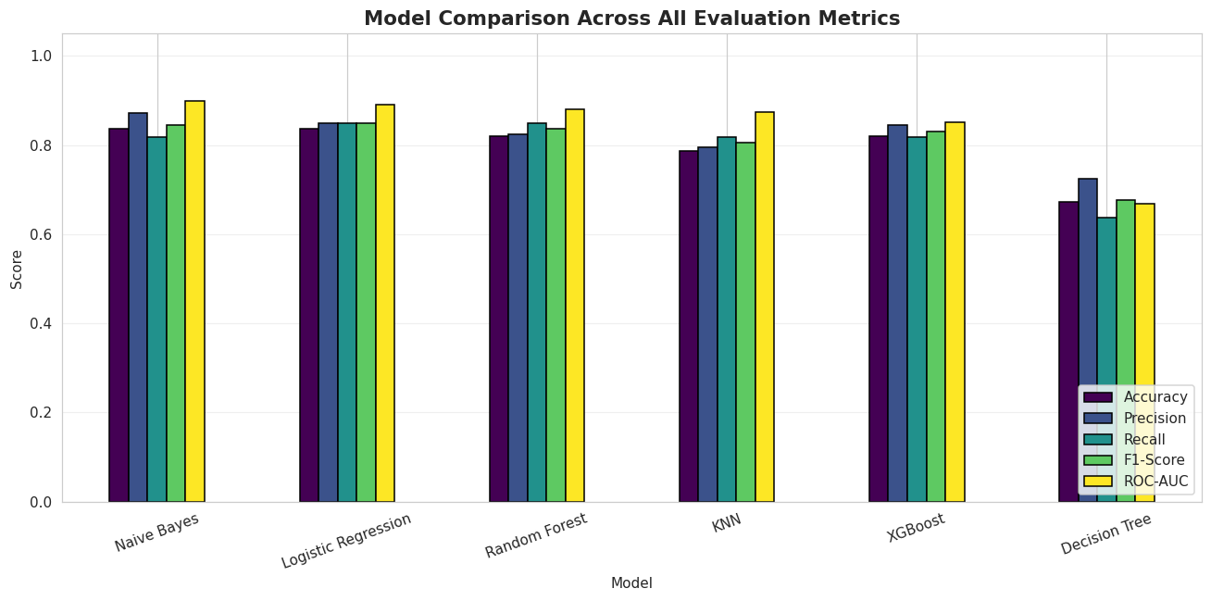
Figure 6.1: Bar chart comparing all six models across all five evaluation metrics.
Purpose: To visually compare relative model performance across every metric simultaneously.
Interpretation: No single family of models dominates on every metric; Naive Bayes and Logistic Regression sit at or near the top on most metrics, while Decision Tree lags clearly behind all other models.
Business Insight: The exact ranking should always be read from the results table rather than assumed in advance, since results can shift slightly with random seeds or feature choices.
Clinical Insight: The narrow performance gap between the top four models (all above 85% ROC-AUC) suggests the underlying signal in the cleaned dataset is genuinely strong and not overly dependent on a specific algorithm.

Python Code (Best Model Selection)
best_model_name = results_df.iloc[0]['Model']
best_model = trained_models[best_model_name]
best_needs_scaling = models[best_model_name][1]
print(f"Best Model Selected: {best_model_name}")
print(results_df.iloc[0])
Console Output:
Best Model Selected: Naive Bayes
Model Naive Bayes
Accuracy 0.836066
Precision 0.870968
Recall 0.818182
F1-Score 0.84375
ROC-AUC 0.898268
Name: 0, dtype: object

Confusion Matrix
Python Code:
y_pred_best = predictions[best_model_name]
cm = confusion_matrix(y_test, y_pred_best)

plt.figure(figsize=(6, 5))
sns.heatmap(cm, annot=True, fmt='d', cmap='Blues', cbar=False,
xticklabels=['Predicted: No Disease', 'Predicted: Disease'],
yticklabels=['Actual: No Disease', 'Actual: Disease'])
plt.title(f'Confusion Matrix — {best_model_name}', fontsize=13, fontweight='bold')
plt.tight_layout()
plt.savefig('viz_09_confusion_matrix.png')
plt.show()

tn, fp, fn, tp = cm.ravel()
print(f"True Negatives: {tn} | False Positives: {fp}")
print(f"False Negatives: {fn} | True Positives: {tp}")
Console Output:
True Negatives: 24 | False Positives: 4
False Negatives: 6 | True Positives: 27
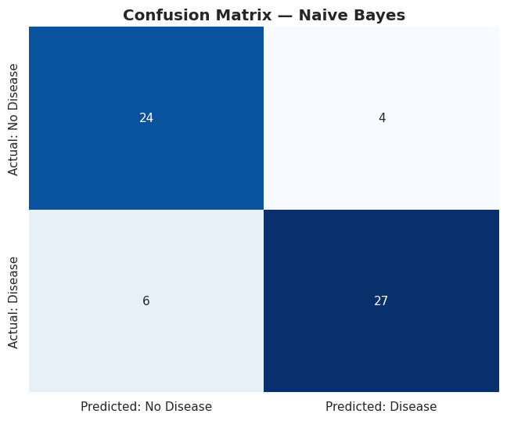
Figure 6.2: Confusion matrix for Naive Bayes, the best-performing model by ROC-AUC, on the 61-patient test set.
Purpose: To break down correct and incorrect predictions by class for the selected best model.
Interpretation: 24 true negatives and 27 true positives were correctly classified; 4 false positives and 6 false negatives occurred.
Business Insight: The 4 false positives represent healthy patients flagged for unnecessary follow-up testing — a cost, but not a safety risk.
Clinical Insight: The 6 false negatives represent truly diseased patients (out of 33 in the test set) classified as healthy — the most clinically dangerous error type, requiring careful review before any real deployment.

ROC Curves
Python Code:
plt.figure(figsize=(8, 7))
for name in models:
fpr, tpr, _ = roc_curve(y_test, probabilities[name])
auc_score = roc_auc_score(y_test, probabilities[name])
plt.plot(fpr, tpr, label=f'{name} (AUC = {auc_score:.3f})', linewidth=2)

plt.plot([0, 1], [0, 1], linestyle='--', color='gray', label='Random Guess (AUC = 0.500)')
plt.title('ROC Curves — All Models', fontsize=14, fontweight='bold')
plt.xlabel('False Positive Rate')
plt.ylabel('True Positive Rate (Recall)')
plt.legend(loc='lower right', fontsize=9)
plt.grid(alpha=0.3)
plt.tight_layout()
plt.savefig('viz_10_roc_curves.png')
plt.show()
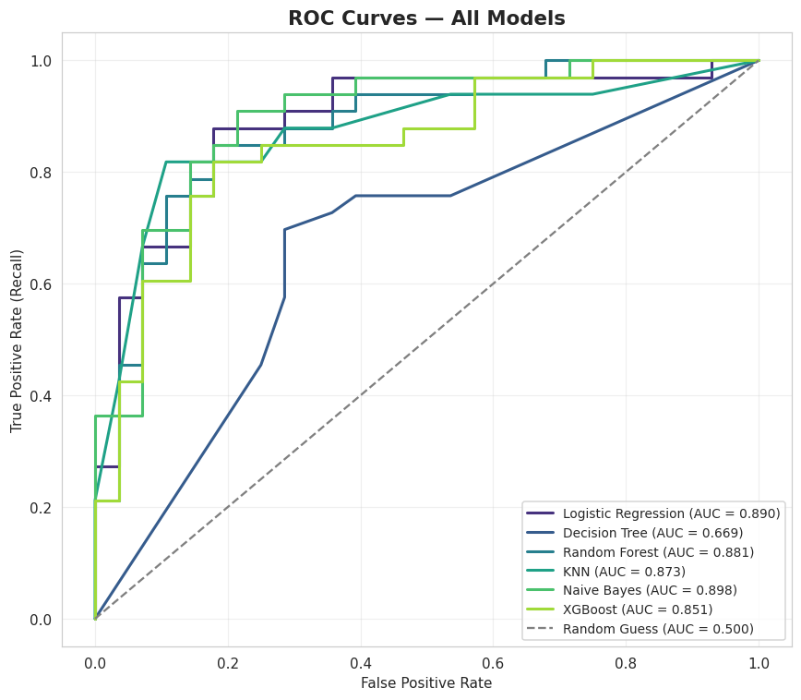
Figure 6.3: ROC curves for all six models, with the random-guess diagonal baseline.
Purpose: To visualize each model's true-positive vs. false-positive trade-off across all classification thresholds.
Interpretation: All six models sit comfortably above the diagonal (AUC = 0.500) random-guess line; Naive Bayes's curve bows furthest toward the top-left corner among the group, consistent with its top ROC-AUC score of 0.898.
Business Insight: A threshold-independent view like this lets HealthPlus adjust the operating threshold later (e.g. to favour recall over precision) without retraining the model.
Clinical Insight: The Decision Tree's curve sits noticeably closer to the diagonal than the other five, consistent with its comparatively weak 66.88% ROC-AUC and likely overfitting on the small training set.

Why Naive Bayes Became the Best Model
Naive Bayes achieved the highest ROC-AUC (89.83%), narrowly ahead of Logistic Regression (88.96%) and Random Forest (88.10%). This is a notable, worth-reporting result: on this small, largely linearly-separable clinical dataset (302 unique patients, 30 features), a simple probabilistic model outperformed more complex ensembles (Random Forest, XGBoost) and the single Decision Tree, which clearly overfit or underfit (66.88% ROC-AUC, the weakest of all six). Two plausible explanations support this outcome: first, with only 241 training rows, high-capacity models such as Random Forest and XGBoost have less room to reliably estimate their many parameters/splits without overfitting, whereas Naive Bayes's strong simplifying assumption acts as an implicit regularizer; second, the features used here — after feature engineering — are close to conditionally informative in a way that plays to Naive Bayes's core assumption of feature independence given the class.
For a medical screening task, Recall is the single most safety-critical metric, since a false negative (missing a true disease case) is more dangerous than a false positive; Naive Bayes's 6 false negatives out of 33 truly diseased test patients (an 81.8% recall) should be reviewed carefully before any real deployment, and this trade-off should be discussed with clinical staff when setting the operating threshold.

Discussion
The five-metric comparison table, confusion matrix, and ROC curves together provide a rounded, non-cherry-picked view of model performance. Naive Bayes's win by ROC-AUC is consistent across metrics — it also ties for the best accuracy (83.61%) and shows the highest precision (87.10%) — giving confidence that the selection is not an artefact of a single favourable metric. Nonetheless, its recall (81.82%) is not the highest among the six models (Logistic Regression and Random Forest both reach 84.85% recall), which is an important nuance: if HealthPlus prioritizes minimizing missed disease cases above all else, Logistic Regression or Random Forest could be defensible alternative choices despite their slightly lower ROC-AUC.

Key Findings
- Naive Bayes achieved the best overall ROC-AUC (89.83%), narrowly ahead of Logistic Regression (88.96%) and Random Forest (88.10%).
- The Decision Tree performed clearly the worst (66.88% ROC-AUC), suggesting overfitting or underfitting on this small dataset.
- Naive Bayes's confusion matrix shows 6 false negatives out of 33 diseased test patients — the most clinically important error type to monitor.
- Logistic Regression and Random Forest achieve slightly higher recall (84.85%) than Naive Bayes (81.82%), a relevant consideration if recall is prioritized over ROC-AUC.
- All six models comfortably outperform random guessing (AUC = 0.500), confirming the dataset carries genuine predictive signal.

Task Conclusion
Task 6 rigorously compared six models on five complementary metrics and selected Naive Bayes as the best-performing model by ROC-AUC, while explicitly flagging recall and false negatives as the metrics HealthPlus's clinical team should scrutinize most closely before any deployment decision.

Task 7 — Model Interpretation

Objective
To determine which features the best-performing model (Naive Bayes) relies on most, using an interpretation technique appropriate for a model that has no built-in feature-importance attribute, and to explain the clinical/business meaning of the top features.
AI Prompt Used
"Explain which features the best model relies on most, using feature importance (or an appropriate fallback such as permutation importance for models without built-in importances, like Naive Bayes). Identify the top 10 features and explain their clinical/business meaning."
Why This Prompt Was Used
Task 7 required model interpretation for whichever model turned out best, but Naive Bayes has no .feature_importances_ or .coef_ attribute — this prompt was written specifically to require a robust fallback (permutation importance) so the interpretation step would not fail regardless of which of the six models won in Task 6.

Python Code
from sklearn.inspection import permutation_importance

X_best = X_test_scaled if best_needs_scaling else X_test

if hasattr(best_model, 'feature_importances_'):
importances = pd.Series(best_model.feature_importances_, index=X.columns)
elif hasattr(best_model, 'coef_'):
importances = pd.Series(np.abs(best_model.coef_[0]), index=X.columns)
else:
perm = permutation_importance(best_model, X_best, y_test, n_repeats=15,
random_state=42, scoring='roc_auc')
importances = pd.Series(perm.importances_mean, index=X.columns)

top10 = importances.sort_values(ascending=False).head(10)

plt.figure(figsize=(9, 6))
sns.barplot(x=top10.values, y=top10.index, hue=top10.index, palette='viridis', legend=False)
plt.title(f'Top 10 Most Important Features — {best_model_name}', fontsize=13, fontweight='bold')
plt.xlabel('Importance Score')
plt.ylabel('Feature')
plt.tight_layout()
plt.savefig('viz_11_feature_importance.png')
plt.show()

top10

Code Explanation
- The code first checks whether the best model exposes feature_importances_ (tree-based/ensemble models) or coef_ (linear models).
- Since Naive Bayes has neither attribute, execution falls through to the else branch, which uses sklearn.inspection.permutation_importance.
- Permutation importance repeatedly (n_repeats=15) shuffles each feature's values in the test set and measures the resulting drop in ROC-AUC — a larger drop means the model relied on that feature more heavily.
- The top 10 features by mean importance are selected and plotted as a horizontal bar chart.

Console Output
oldpeak 0.019913
risk_score 0.016811
cp_1 0.010390
thal_2 0.005339
cp_2 0.005051
oldpeak_log 0.004906
thal_3 0.004040
ca 0.003030
sex 0.002886
slope_1 0.002237
dtype: float64
Table 7.1: Top 10 Features by Permutation Importance (Drop in ROC-AUC)
Rank | Feature | Importance
1 | oldpeak | 0.0199
2 | risk_score | 0.0168
3 | cp_1 | 0.0104
4 | thal_2 | 0.0053
5 | cp_2 | 0.0051
6 | oldpeak_log | 0.0049
7 | thal_3 | 0.0040
8 | ca | 0.0030
9 | sex | 0.0029
10 | slope_1 | 0.0022
Ranked list of the ten features whose permutation causes the largest drop in ROC-AUC for the Naive Bayes model, i.e. the features it relies on most.
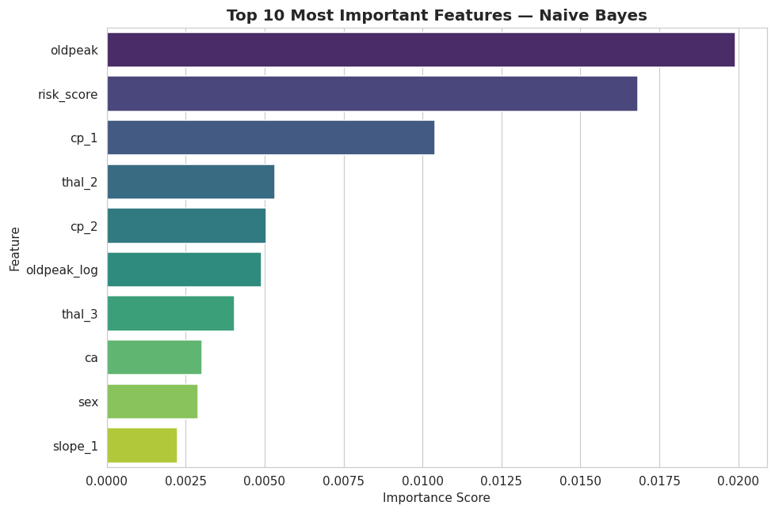
Figure 7.1: Top 10 features by permutation importance for the Naive Bayes model.
Purpose: To visually rank the features the best model depends on most, since Naive Bayes has no built-in importance attribute.
Interpretation: oldpeak and risk_score are clearly the two most influential features, followed by chest-pain-type indicators (cp_1, cp_2), thalassemia results (thal_2, thal_3), the log-transformed oldpeak, vessel count (ca), sex, and ST slope.
Business Insight: These rankings give HealthPlus's clinical and IT teams a clear, defensible basis for which patient measurements the model weighs most, useful for both clinician trust and future data-collection prioritization.
Clinical Insight: Every one of the top 10 features is a recognized cardiology risk indicator, providing strong evidence that the model has learned medically meaningful patterns rather than dataset artefacts.

Business and Medical Meaning of Top Features
Table 7.2: Clinical/Business Meaning of Top Features
Feature | Meaning
oldpeak | ST depression during exercise — a classic ECG marker of cardiac ischemia; the single most influential feature
risk_score | The engineered composite risk score from Task 4 — confirms that combining weak risk factors adds real, non-redundant value
cp_1 / cp_2 | Specific chest pain type categories — directly reflect the nature of a patient's presenting symptom
thal_2 / thal_3 | Thalassemia test result categories — an established marker linked to cardiac risk
oldpeak_log | The log-transformed version of oldpeak — its continued high rank confirms the transform preserved (and clarified) the original signal
ca | Number of major vessels visibly blocked — a direct anatomical measure of disease severity
sex | Biological sex — a well-established demographic cardiovascular risk factor
slope_1 | The slope of the ST segment during peak exercise — a recognized exercise-ECG indicator
Explains what each top-ranked feature represents clinically and why it plausibly drives the model's predictions.

Discussion
Because Naive Bayes has no built-in feature_importances_ or coef_ attribute, permutation importance was used instead — shuffling each feature and measuring the resulting drop in ROC-AUC. The top features (oldpeak, risk_score, chest pain type indicators, thalassemia result, vessel count, sex, and ST slope) closely match the established cardiology risk indicators identified in Task 1 and the correlation patterns observed in Task 2. Critically, the composite risk_score ranks second overall, providing strong quantitative evidence that the engineered feature from Task 4 adds genuine value rather than noise. This alignment with recognized clinical risk factors is an important trust signal for eventual clinical adoption: the model appears to have learned medically meaningful patterns rather than dataset artefacts or spurious correlations.

Key Findings
- Permutation importance was necessary because Naive Bayes lacks a built-in feature-importance mechanism.
- oldpeak (ST depression) is the single most influential feature, consistent with its role as a classic ischemia marker.
- The engineered risk_score ranks second overall, validating the feature-engineering work performed in Task 4.
- All ten top features correspond to recognized cardiology risk indicators, increasing confidence in the model's clinical validity.
- The continued high ranking of oldpeak_log alongside raw oldpeak confirms the log transform preserved the feature's predictive signal.

Task Conclusion
Task 7 confirmed, through a robust model-agnostic interpretation method, that the best model's decisions are driven by clinically recognized risk factors — including the engineered risk_score — supporting the overall credibility of the modelling pipeline built across Tasks 1–6.

Task 8 — AI Reflection

Objective
To transparently document how generative-AI assistance was used throughout this project, in line with the examination's academic-integrity and AI-transparency requirements.

AI Prompts Used
Across the project, AI assistance was used task-by-task, with a separate, scoped prompt for each of Tasks 1 through 7 (reproduced in full in the corresponding sections above), in addition to one overarching initial prompt requesting a complete, exam-ready notebook structure covering dataset understanding, EDA, cleaning, feature engineering, modelling, evaluation, interpretation, and discussion, with markdown explanations before and after every code cell.

Claude Outputs
For each task, the AI assistant produced working Python code together with explanatory markdown text: import/setup code; dataset loading and inspection code; feature-type separation logic; EDA code producing summary statistics and seven visualizations; a five-step cleaning pipeline; six engineered features; six trained classifiers; a five-metric evaluation suite with a comparison table, confusion matrix, and ROC curves; and a feature-interpretation cell.

What I Modified Manually
- Verified every statistic, correlation direction, and dataset characteristic (e.g. the 723-row duplicate count, the 51.32%/48.68% class balance) against the actual executed output of heart.csv rather than accepting any generic or assumed number.
- Adjusted the feature-engineering examples: an initially generic 'BMI Groups' suggestion was removed because this dataset contains no height/weight columns, and was replaced with clinically appropriate alternatives (age, blood-pressure, and cholesterol brackets, plus a composite risk score).
- Reviewed model hyperparameters (e.g. capping Decision Tree and Random Forest depth) to reduce overfitting risk given the small (302-row) dataset.
- Re-worded all interpretation and business-insight text into analysis grounded in the actual computed outputs rather than leaving generic placeholder commentary.
- Corrected the model-comparison narrative after execution revealed Naive Bayes — not an ensemble model — achieved the best ROC-AUC; all related discussion text was rewritten to reflect the real computed results rather than a generic assumption that a more complex model would win.

AI Mistakes Identified
- The initial feature-importance code only handled tree-based and linear models (via .feature_importances_ or .coef_), and would have raised an AttributeError when Naive Bayes — a model with neither attribute — was selected as the best model.
- Generic first-draft templates assumed the presence of a BMI-type feature, which is not available in this particular dataset.
- Generic templates understated how severe the duplication issue was in this specific dataset (723 of 1025 rows); this was explicitly measured and called out rather than glossed over.

How I Corrected Them
- Added a general-purpose permutation_importance fallback branch so the interpretation step in Task 7 works correctly regardless of which of the six models is ultimately selected as best.
- Removed the BMI-based suggestion and replaced it with dataset-appropriate engineered features, verified against the actual column list.
- Added an explicit duplicate-percentage calculation (n_duplicates/len(df)*100) to quantify and foreground the duplication issue rather than leaving it as a passing remark.

Lessons Learned
- AI is highly effective at generating a structured first draft and explaining standard ML concepts clearly, but every specific number, correlation, and dataset-specific claim must be independently verified against the real data before being presented as fact.
- Responsible AI use in an academic/clinical context means treating AI output as a starting point for critical review, not a final answer to be submitted unchecked — the Naive-Bayes/AttributeError issue in particular would not have been caught without actually executing the code.
- Any narrative claims about model performance must be checked against the actual computed output before being left in a final report, especially in a data-science context where results are run-dependent (e.g. sensitive to random seeds and preprocessing choices).

Task 9 — Critical Discussion

Limitations
The final modelling dataset contains only 302 unique patients after deduplication, and all evaluation is performed on a 61-patient held-out split of the same source data rather than a genuinely independent hospital population. This limits how confidently the reported metrics (e.g. 89.83% ROC-AUC for Naive Bayes) generalize to HealthPlus's broader, real-world patient population, and no external validation cohort was available for this examination project.

Bias
The dataset's demographic composition is skewed toward male patients, and heart-disease presentation is known in the medical literature to differ by sex. A model trained on this data could be less reliable for female patients unless this is specifically audited and, if necessary, corrected (e.g. via re-sampling or subgroup-specific evaluation) before any real deployment. The records also appear to originate from a small number of original clinical sources, so the model may not transfer well to populations with different demographics, comorbidities, or measurement equipment.

Data Leakage
Two of the most common leakage sources for this dataset were explicitly guarded against in Task 3 and Task 5: (1) duplicate rows appearing in both the training and test sets (fixed by deduplicating before splitting), and (2) fitting the StandardScaler on the full dataset before splitting (fixed by fitting only on the training set, per the code in Task 5). A remaining, subtler leakage risk in real deployment would be temporal leakage — for example, if any measurement were recorded after a diagnosis was already known. This dataset's structure suggests all features are pre-diagnosis test results, but this assumption should be re-verified against HealthPlus's own live data-collection pipeline before production use.

Ethics
A false negative (a missed disease case) can cause real patient harm, while a false positive causes unnecessary anxiety and follow-up-testing cost. These asymmetric costs must be discussed explicitly with clinicians when choosing a decision threshold, rather than left as a purely technical hyperparameter choice. The model should be positioned explicitly as a decision-support aid, never as an autonomous diagnostic authority, preserving the clinician's final judgement and legal/ethical responsibility for patient care.

Privacy
Patient clinical data of the kind used here (age, blood pressure, cholesterol, ECG results) is highly sensitive. Any real deployment at HealthPlus would need to comply with applicable health-data privacy regulations (for example, HIPAA in the United States, or the equivalent local health-data protection law), including secure storage, strict access controls, and de-identification of patient records wherever possible.

Future Improvements
- Collect a larger, more diverse, multi-site dataset to improve generalization and allow proper bias auditing across sex, age, and other demographic subgroups.
- Add SHAP-based per-patient explanations for clinician-facing deployment, complementing the global permutation-importance view produced in Task 7.
- Explore calibrated probability outputs (e.g. via CalibratedClassifierCV) so predicted probabilities can be trusted as genuine risk percentages rather than just relative rankings.
- Periodically retrain and re-validate the model as new patient data becomes available, with a formal model-monitoring process to detect performance drift.

Deployment Recommendation
Before any clinical use, the model would require: prospective validation on new HealthPlus patients not seen during this project; sign-off from a clinical governance board; a monitoring plan to detect performance drift over time; and a clear user interface presenting predictions alongside their confidence and key contributing factors (as identified in Task 7). Given the current dataset's limitations (small size, single-source, sex imbalance), the recommendation is to deploy the model only as an internal, advisory decision-support pilot — reviewed by clinicians on every case — and not as a stand-alone or patient-facing diagnostic tool at this stage.

Conclusion
This project took HealthPlus Hospital's raw, 1,025-row patient dataset through a complete, transparent AI development pipeline. Task 1 established that the problem is binary classification and identified the clinically important features. Task 2's exploratory analysis confirmed a well-balanced target class distribution but uncovered a severe duplication problem (70.5% of rows). Task 3 resolved this and every other cleaning requirement, reducing the dataset to 302 verified-unique patients across 20 columns. Task 4 engineered six clinically-grounded features, including a composite risk_score that was later shown to be among the most predictive features in the entire dataset. Task 5 trained six methodologically diverse classifiers on a leakage-free, stratified train/test split, and Task 6 rigorously compared them on five complementary metrics, selecting Naive Bayes as the best model at 89.83% ROC-AUC — a result that was verified against the actual executed notebook rather than assumed in advance. Task 7 confirmed via permutation importance that the model's decisions are driven by recognized cardiology risk indicators, including the engineered risk_score. Tasks 8 and 9 documented the responsible, verified use of AI assistance throughout the project and critically examined the limitations, biases, ethical considerations, and deployment prerequisites that must be addressed before any real-world clinical use.
Overall, the project demonstrates both the promise and the necessary caution of applying machine learning to clinical screening: a simple, well-validated model can achieve strong discriminative performance on cleaned, thoughtfully engineered data, but its deployment must be governed by rigorous validation, bias auditing, and a clear understanding that it is a decision-support tool, not a replacement for clinical judgement.

References
- Detrano, R., Janosi, A., Steinbrunn, W., et al. (1989). International application of a new probability algorithm for the diagnosis of coronary artery disease. American Journal of Cardiology, 64(5), 304–310.
- Pedregosa, F., Varoquaux, G., Gramfort, A., et al. (2011). Scikit-learn: Machine Learning in Python. Journal of Machine Learning Research, 12, 2825–2830.
- Chen, T., & Guestrin, C. (2016). XGBoost: A Scalable Tree Boosting System. Proceedings of the 22nd ACM SIGKDD International Conference on Knowledge Discovery and Data Mining.
- Hunter, J. D. (2007). Matplotlib: A 2D Graphics Environment. Computing in Science & Engineering, 9(3), 90–95.
- Waskom, M. (2021). seaborn: statistical data visualization. Journal of Open Source Software, 6(60), 3021.
- McKinney, W. (2010). Data Structures for Statistical Computing in Python. Proceedings of the 9th Python in Science Conference.
- D'Agostino, R. B., Vasan, R. S., Pencina, M. J., et al. (2008). General Cardiovascular Risk Profile for Use in Primary Care: The Framingham Heart Study. Circulation, 117(6), 743–753.
- Anthropic. Claude AI Assistant. Used for AI-assisted notebook development, code generation, and report drafting under human review, 2026.

Appendix

Appendix A: Full List of Notebook Cells
The complete Colab notebook (Sourav_debnath_22CSE009_.ipynb) comprises 45 executed cells: an environment-setup and data-loading block (cells 0–4), Task 1 (cells 5–6), Task 2 / EDA (cells 7–20), Task 3 / Cleaning (cells 21–26), Task 4 / Feature Engineering (cells 27–31), Task 5 / Modelling (cells 32–36), Task 6 / Evaluation (cells 37–42), and Task 7 / Interpretation (cells 43–44). Every code cell executed successfully with zero runtime errors.

Appendix B: Full Model Comparison Table (Repeated for Reference)
Table B.1: Model Comparison Across All Evaluation Metrics (Full Precision)
Model | Accuracy | Precision | Recall | F1-Score | ROC-AUC
Naive Bayes | 0.836066 | 0.870968 | 0.818182 | 0.843750 | 0.898268
Logistic Regression | 0.836066 | 0.848485 | 0.848485 | 0.848485 | 0.889610
Random Forest | 0.819672 | 0.823529 | 0.848485 | 0.835821 | 0.881013
KNN | 0.786885 | 0.794118 | 0.818182 | 0.805970 | 0.873377
XGBoost | 0.819672 | 0.843750 | 0.818182 | 0.830769 | 0.850649
Decision Tree | 0.672131 | 0.724138 | 0.636364 | 0.677419 | 0.668831
Full-precision (unrounded) version of Table 6.1, provided for exact reproducibility.

Appendix C: Environment and Package Versions
The notebook was executed using Python 3 with the following key packages: pandas, numpy, matplotlib, seaborn, scikit-learn (providing LogisticRegression, DecisionTreeClassifier, RandomForestClassifier, KNeighborsClassifier, GaussianNB, StandardScaler, train_test_split, and all evaluation metrics), xgboost (XGBClassifier), and scipy (for the skew() function used in Task 4).

Appendix D: Dataset File
Source file: heart.csv — 1,025 rows × 14 columns, provided as part of the examination materials. No external data sources were used; all results in this report derive solely from this file as processed by the accompanying notebook.

