PROGRAM 1

import java.io.*;

import java.util.Scanner;

public class empsalary

{

public static void main(String [] args){

Scanner scan = new Scanner(System.in);

double wage = scan.nextDouble();

int hour = scan.nextInt();

int no_week = scan.nextInt();

double total;

if(hour>40)

{

total = (40*wage)+(hour-40)*(wage*1.5);

}

else

{

total = hour*wage;

}

if(hour<20)

{

total = total*(10/100);

}

double salary = total*no_week;

System.out.println(salary);

}

}

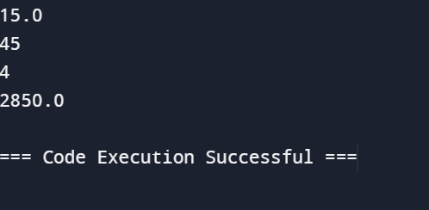

PROGRAM 2

import java.io.*;

import java.util.Scanner;

public class ticket

{

public static void main(String[] args)

{

Scanner scan=new Scanner(System.in);

String t=scan.nextLine();

int n=scan.nextInt();

double total=0.0;

switch(t){

case "Regular":

if(n>10){

total=n*50*0.90;

}

else{

total=n*50;

}

if (total<200){

total=total+20;

}

break;

case "VIP":

if(n>5){

total=n*100*0.85;

}

else{

total=n*100;

}

if (total<200){

total=total+20;

}

break;

case "Premium":

if(n>3){

total=n*150*0.80;

}

else{

total=n*150;

}

if(total<200){

total=total+20;

}

break;

default:

System.out.println("Invalid input");

break;

}

System.out.println(total);

}

}

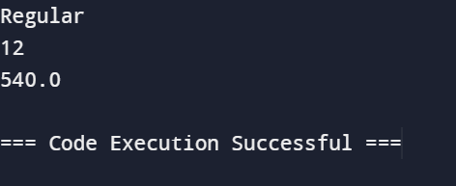

PROGRAM 3

import java.io.*;

import java.util.Scanner;

public class pg1

{

public static void main(String []args){

Scanner scan = new Scanner(System.in);

int n = scan.nextInt();

int l = Integer.MIN_VALUE;

int s = Integer.MAX_VALUE;

while(n!=0)

{

int digit=n%10;

if(digit>l)

{

l=digit;

}

if(digit<s)

{

s=digit;

}

n/=10;

}

System.out.println(s+" "+l);

}

}

