ZERO-ONE TRIANGLE:

import java.util.Scanner;  
import java.io.*;  
public class triangle{  
public static void main(String args[]){  
Scanner scan = new Scanner(System.in);  
int n = scan.nextInt();  
for(int i=1; i<=n; i++){  
for(int j=0; j<i;j++){  
if((i+j)%2==0)  
System.out.print("0");  
else  
System.out.print("1");  
}  
System.out.println();  
}  
}  
}

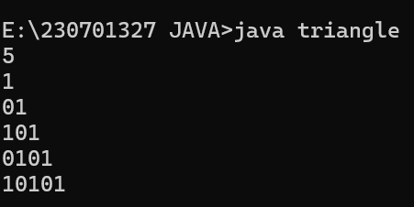

REVERSE PYRAMID PATTERN:

import java.io.*;  
import java.util.Scanner;  
public class pattern{  
public static void main(String []a){  
Scanner scan = new Scanner(System.in);  
int n = scan.nextInt();  
for(int i=n; i>=1; i--){  
for(int j=1; j<=i;j++){  
System.out.print(j);  
}  
System.out.println();  
}  
}  
}

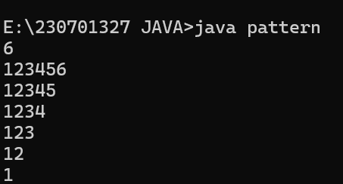

|  |  |
| --- | --- |
|  |  |

WEEKDAY OR WEEKEND:

import java.util.*;  
public class week{  
public static void main(String []a){  
Scanner scan= new Scanner(System.in);  
String n = scan.nextLine();  
switch(n){  
case "Monday":  
case "Tuesday":  
case "Wednesday":  
case "Thursday":  
case "Friday":  
System.out.print("It's a Weekday");  
break;  
  
case "Saturday":  
case "Sunday":  
System.out.print("It's Weekend");  
break;  
 default:  
 System.out.println("Invalid Input");  
 break;  
  
}  
}  
}

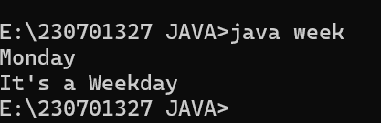

STRONG NUMBER:

import java.util.*;  
  
public class strong{  
public static void main(String args[]){  
Scanner scan = new Scanner(System.in);  
int n = scan.nextInt();  
int temp = n;  
                int sum=0;  
                while(n>0){  
                   int d=n%10;  
                   int fact=1;  
                   for(int i =1;i<=d;i++){  
                     fact=fact*i;  
                   }  
                   sum=sum+fact;  
                   n/=10;  
               }  
               if(sum==temp){  
                    System.out.println("Strong number");  
               }  
               else{  
                   System.out.println("Not Strong number");  
               }  
  
        }  
}

