Name: Sowbarnigaa Sridharan
Reg no: 230701327

EXPERIMENT – 1
Installation and Configuration of Kali Linux in Oracle VirtualBox

Step 1: Install VirtualBox
Download and install Oracle VirtualBox on your system.

Step 2: Download Kali Linux
Download the ISO file of Kali Linux (64-bit) from the official website.

Step 3: Create Virtual Machine
Open VirtualBox and click “New”. Set:
- Name: Kali Linux
- Type: Linux
- Version: Debian (64-bit) Step 4: Allocate Resources Assign:
- RAM: Minimum 2 GB
- CPU: 2 cores
- Disk size: 30 GB (VDI, dynamically allocated)

Step 5: Install Kali Linux
Attach the ISO file and start the virtual machine.
Select “Graphical Install” and complete the setup by configuring language, user credentials, and disk partition. Reboot after installation.

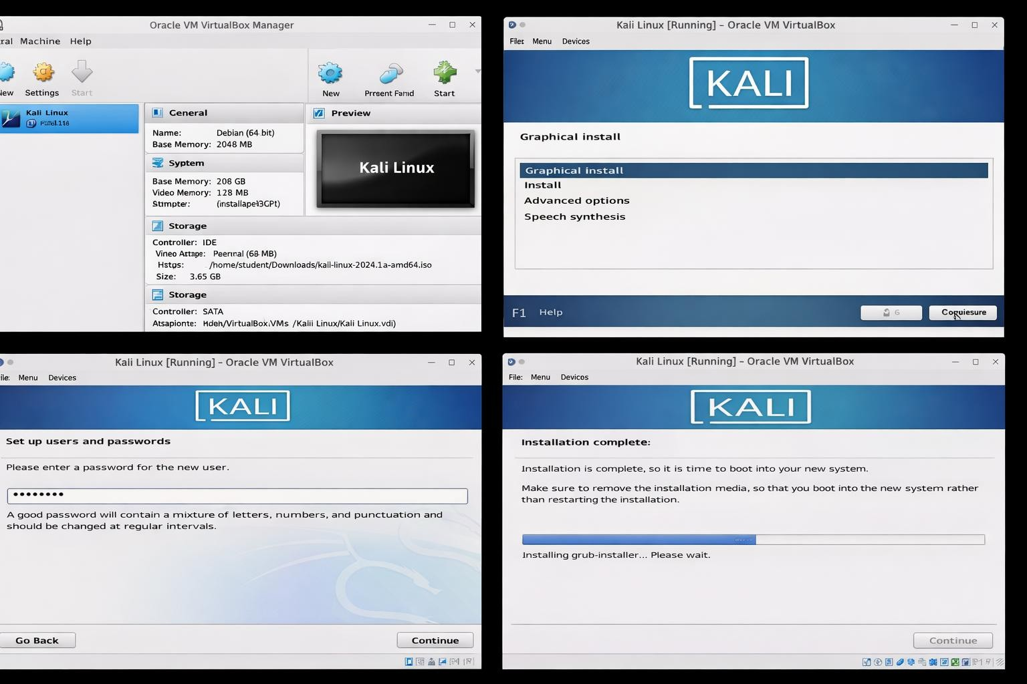

Result
Kali Linux was successfully installed and configured in Oracle VirtualBox.

