Name: Sowbarnigaa Sridharan
Reg No: 230701327

EXPERIMENT - 8
Privilege Escalation Using TryHackMe

Step 1: Login to Platform Open TryHackMe and log in Step 2: Open Room
Search for Linux Privilege Escalation and join the room.

Step 3: Start AttackBox
Launch the AttackBox and open the terminal.

Step 4: Perform Enumeration
Check user details, system information, and permissions to identify possible vulnerabilities.

Step 5: Identify Vulnerabilities
Look for misconfigurations such as sudo permissions, SUID files, weak file access, or cron jobs.

Step 6: Escalate Privileges
Exploit the identified vulnerability to gain higher privileges (root access).

Step 7: Verify and Complete Tasks
Confirm root access and capture required flags to complete the exercise.
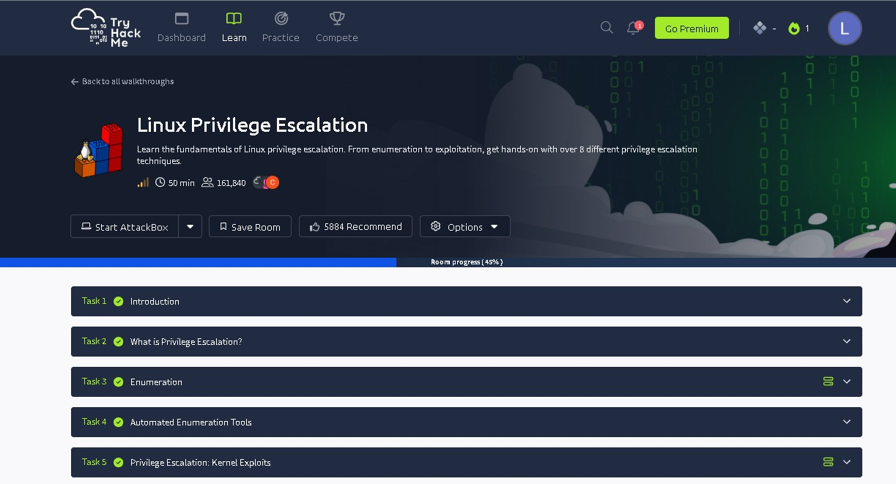

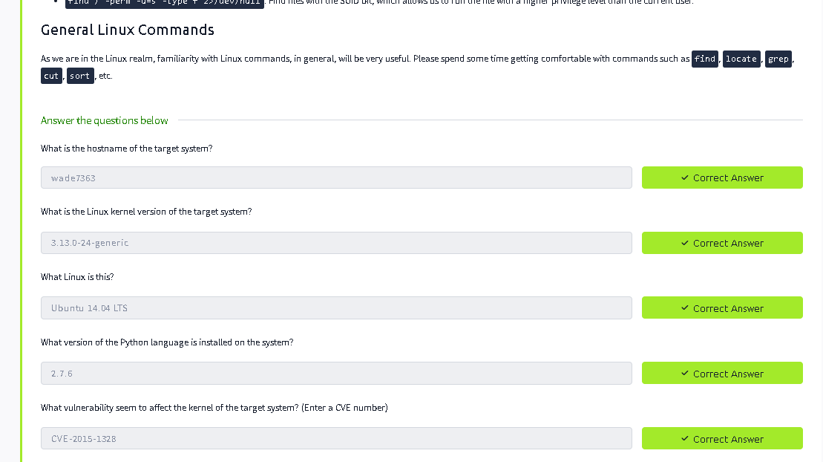

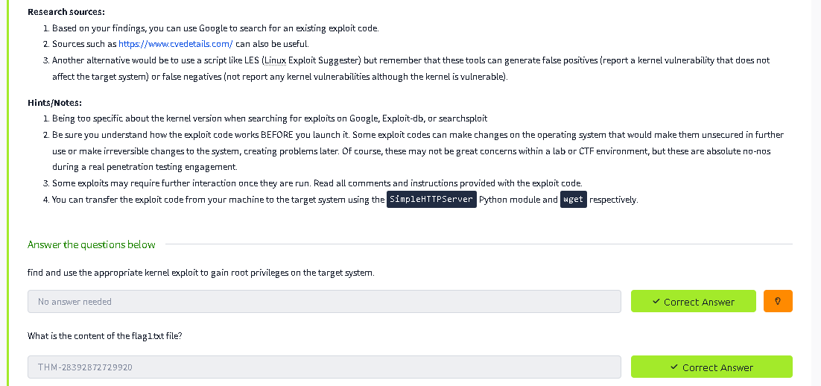

Result
Privilege escalation was successfully performed, demonstrating how system misconfigurations can lead to unauthorized access and highlighting the importance of secure system practices.

