Name: Sowbarnigaa Sridharan
Reg No: 230701327

EXPERIMENT - 13
Phishing Attack Study Using Z-Phisher (Simple Steps) Step 1: Start Environment
Open Oracle VirtualBox and start Kali Linux.

Step 2: Study Tool
Refer to the Z-Phisher framework on GitHub and understand its features.

Step 3: Analyze Workflow
Study how phishing pages imitate real websites and trick users into entering credentials.

Step 4: Simulated Demonstration
Observe phishing page behavior using a safe, consent-based simulation with dummy data.

Step 5: Identify Risks and Prevention
Understand risks like credential theft and learn prevention methods such as user awareness, HTTPS verification, and two-factor authentication.

Output
Understanding of phishing techniques and social-engineering risks.

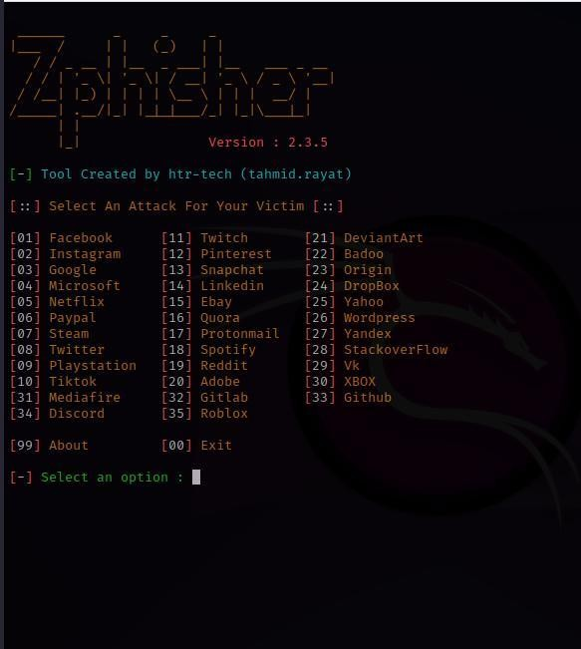
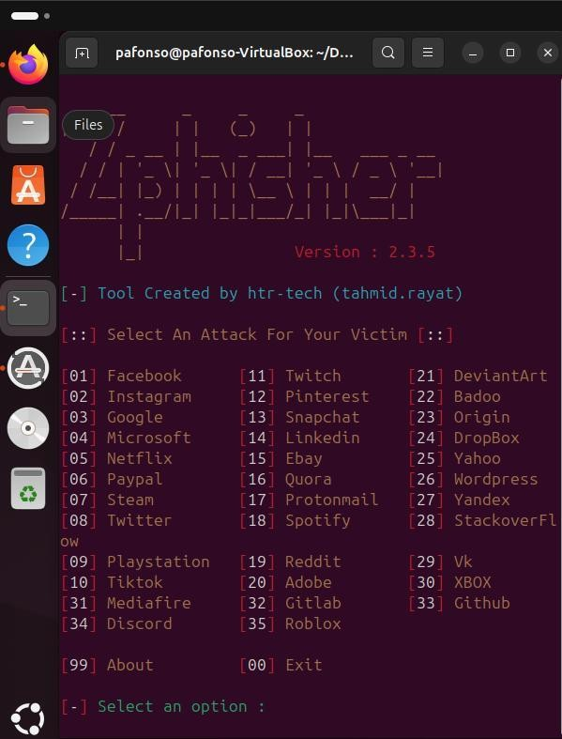

Result
Phishing concepts were successfully studied, emphasizing user awareness and security practices.

