Name: Sowbarnigaa Sridharan
Reg No: 230701327

EXPERIMENT – 10
Wireless Audit Using Aircrack-ng

Step 1: Start Environment
Open Oracle VirtualBox and start Kali Linux. Connect the external Wi-Fi adapter.

Step 2: Verify Wireless Interface
Check the available wireless interface and ensure it is detected properly.

Step 3: Enable Monitor Mode
Switch the wireless adapter to monitor mode to capture network packets.

Step 4: Scan Wireless Networks
Scan nearby Wi-Fi networks and identify the target network details such as BSSID and channel.

Step 5: Capture Handshake
Capture the WPA/WPA2 handshake by monitoring the target network traffic.

Step 6: Perform Password Cracking
Use a wordlist to attempt password recovery from the captured handshake.

Step 7: Stop Monitoring
Disable monitor mode after completing the analysis.

Output
WPA/WPA2 handshake is captured and password cracking process is performed successfully.

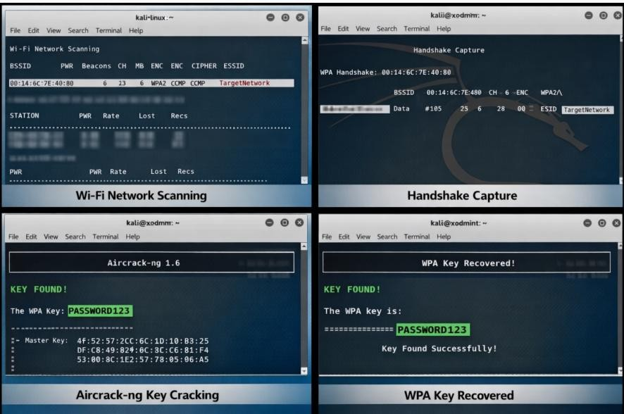

Result
Wireless auditing was successfully demonstrated using Aircrack-ng, highlighting the importance of strong passwords and secure wireless configurations.

