RISE KRISHNA SAI GANDHI GROUP OF INSTITUTIONS
Valluru-523272 (Affiliated to JNTU, KAKINADA)
DEPARTMENT OF COMPUTER SCIENCE AND ENGINEERING


SMARTINTERNZ VIRTUAL INTERNSHIP PROGRAM-2025


TITLE: Online Payments Fraud Detection using Machine Learning

Submitted by
Team Id: LTVIP2026TMIDS62776
Team leader: M. Divyanjali (228B1A0512)
Team member: A. Naga Vyshnavi(228B1A0501)
Team member: Ch. Sowjanya (228B1A0506)
Team Member: B. Akhila (228B1A0504)
Date Of Submission: 20-02-2026

CERTIFICATE
This is to certify that the project report titled “Online Payments Fraud Detection using Machine Learning” is a bona fide work carried out by the following students:
- Mettela Divyanjali (228B1A0512)
- Annanthu Naga Vyshnavi (228B1A0501)
- Cheekati Sowjanya(228B1A0506)
- Bezzam Akhila(228B1A0504)
of RISE KRISHNA SAI GANDHI GROUP OF INSTITUTIONS, in partial fulfillment of the requirements for the SmartInternz Virtual Internship Program-2025, during the period from 16-12-2025 to 20-02-2026.
The work embodied in this project report has not been submitted to any other institution for the award of any degree or diploma.

Endorsements:
Project Guide: Mr.P.Suresh
Head of Department: Mr.Ch.Hari Krishna
Principal: Dr.K.V.Subrahmanyam

TABLE OF CONTENTS
- Introduction
- Pre Requisites
- Project Objectives
- Project Flow
- Project Structure
- Data Collection
  - Download The Dataset
- Visualizing And Analyzing Data
  - Importing The Libraries
  - Read The Dataset
  - Univariate Analysis
  - Bivariate Analysis
  - Descriptive Analysis
- Data Pre-Processing
  - Checking For Null Values
  - Handling Outliers
  - Object Data Labelencodin
  - Splitting Data Into Train And Test
- Model Building
- Random Forest Classifier
- Decision Tree Classifier
- Extra Trees Classifier
- SupportVectorMachine Classifier
- Xgboost Classifier
- Compare The Models
- Evaluaing Performance Of The Model And Saving The Model
- Application Building
  - Build HTML Code
  - Main Python Script
  - Run the App
  - Output
- Conclusion

INTRODUCTION

Online Payments Fraud Detection using Machine Learning

Project Description:

Online Payments Fraud Detection using Machine Learning is an intelligent security system designed to identify and prevent fraudulent transactions in digital payment platforms. The system analyzes historical transaction data, user behavior patterns, and transaction features such as amount, location, and device information to detect suspicious activities in real time.

By applying machine learning algorithms, the model can recognize unusual patterns, flag high-risk transactions, and detect potentially fraudulent accounts. The system continuously improves by learning from new data, enabling adaptive fraud prevention against evolving cyber threats.

This approach enhances transaction security, reduces financial losses, and ensures a safe and reliable online payment experience for both users and businesses.

Technical Architecture

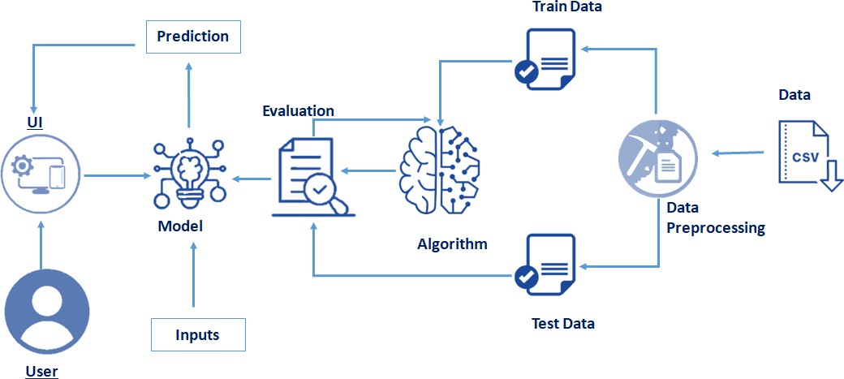

PRE REQUISITES
To complete this project, you must require the following software’s, concepts, and packages.

Anaconda navigator:

Refer to the link below to download anaconda navigator.
https://youtu.be/1ra4zH2G4o0

Python packages:

Open anaconda prompt as administrator.

  - Open anaconda prompt as administrator
  - Type “pip install numpy” and click enter.
  - Type “pip install pandas” and click enter.
  - Type “pip install scikit-learn” and click enter.
  - Type ”pip install matplotlib” and click enter.
  - Type ”pip install scipy” and click enter.
  - Type ”pip install pickle-mixin” and click enter.
  - Type ”pip install seaborn” and click enter.
  - Type “pip install Flask” and click enter.

PROJECT OBJECTIVES
By the end of this project you will:
- Know fundamental concepts and techniques used for machine learning.
- Gain a broad understanding of data.
- Have knowledge of pre-processing the data/transformation techniques and some visualization concepts before building the model
- Learn how to build a machine learning model and tune it for better performance
- Know how to evaluate the model and deploy it using flask

PROJECT FLOW

- The user interacts with the UI to enter the input.
- Entered input is analyzed by the model which is integrated.
- The predictions made by the model are showcased on the UI
To accomplish this, we have to complete all the activities listed below,
- Data collection
  - Collect the dataset or create the dataset
- Data pre-processing
  - Removing unnecessary columns
  - Checking for null values
- Visualizing and analyzing data
- Univariate analysis
- Bivariate analysis
- Descriptive analysis
- Model building
  - Handling categorical values
  - Dividing data into train and test sets
  - Import the model building libraries
  - Comparing the accuracy of various models
  - Hyperparameter tuning of the selected model
  - Evaluating the performance of models
  - Save the model
- Application Building
  - Create an HTML file
  - Build python code

PROJECT STRUCTURE
Create a Project folder that contains files as shown below:
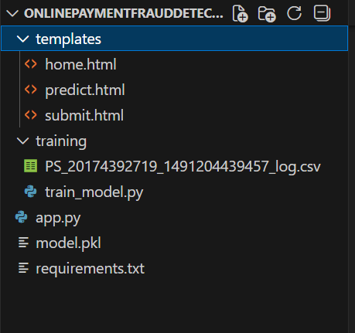
- We are building a flask application which needs HTML pages stored in the templates folder and a python script app.py for scripting.
- Model.pkl is our saved model. Further we will use this model for flask integration.
- Training folder contains model training files and the training_ibm folder contains IBM deployment files.

DATA COLLECTION

Collect the dataset or create the dataset or Download the dataset:
There are many popular open sources for collecting the data. Eg: kaggle.com, UCI repository, etc.
In this project we have used PS_20174392719_1491204439457_logs.csv data. This data is downloaded from kaggle.com. Please refer to the link given below to download the dataset.

Link:link
7.Visualizing and analyzing data

As the dataset is downloaded. Let us read and understand the data properly with the help of some visualisation techniques and some analysing techniques.

Import Necessary Libraries:
Import the necessary libraries as shown in the image. (optional) Here we have used visualisation style as fivethirtyeight.
- Numpy- It is an open-source numerical Python library. It contains a multi-dimensional array and matrix data structures. It can be used to perform mathematical operations on arrays such as trigonometric, statistical, and algebraic routines.
- Pandas- It is a fast, powerful, flexible and easy to use open-source data analysis and manipulation tool, built on top of the Python programming language.
- Seaborn- Seaborn is a Python data visualization library based on matplotlib. It provides a high-level interface for drawing attractive and informative statistical graphics.
- Matplotlib- Visualisation with python. It is a comprehensive library for creating static, animated, and interactive visualizations in Python
- Sklearn – which contains all the modules required for model building.
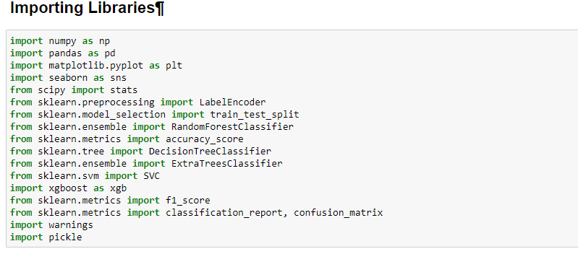

Read The Dataset:
- Our dataset format might be in .csv, excel files, .txt, .json, etc. We can read the dataset with the help of pandas.
- In pandas we have a function called read_csv() to read the dataset. As a parameter we have to give the directory of the csv file.
- df = pd.read_csv("PS_20174392719_1491204439457_log.csv")
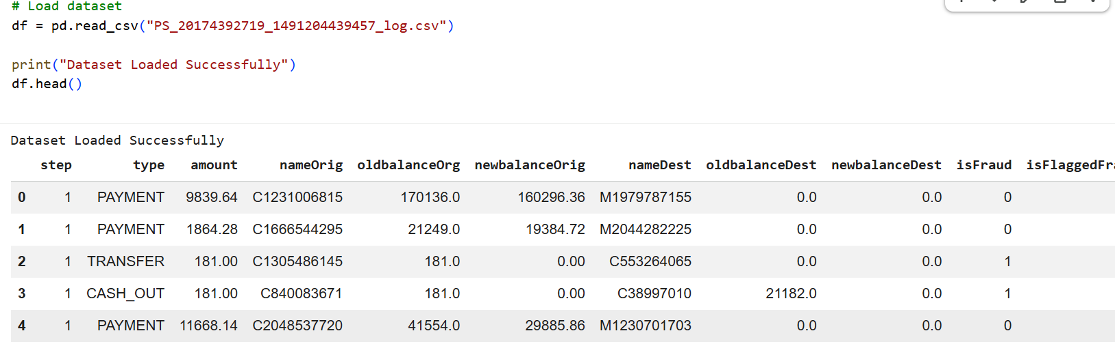
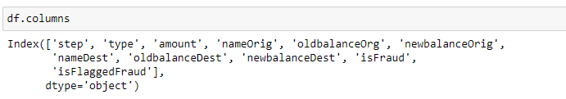
Here, the input features in the dataset are known using the df.columns function.

Here, the dataset's superfluous columns are being removed using the drop method.
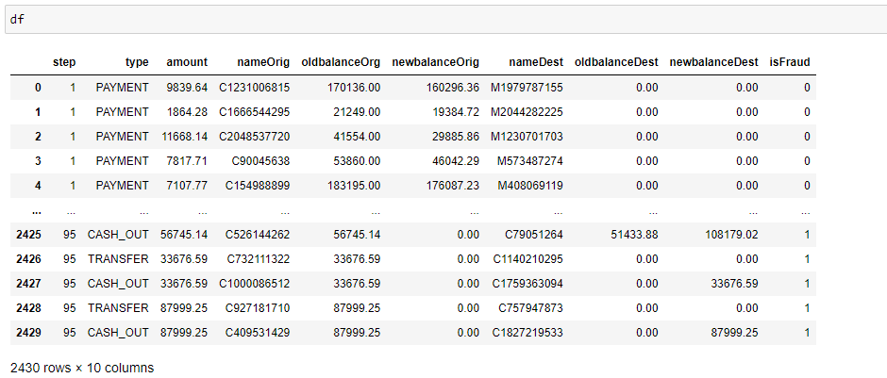

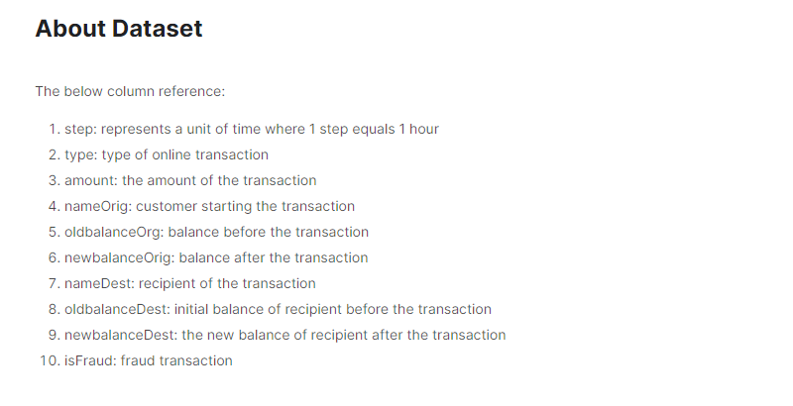

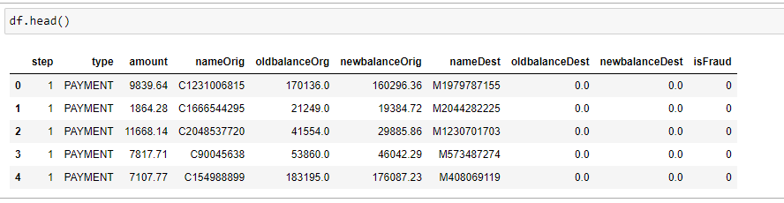
above, the dataset's first five values are loaded using the head method.
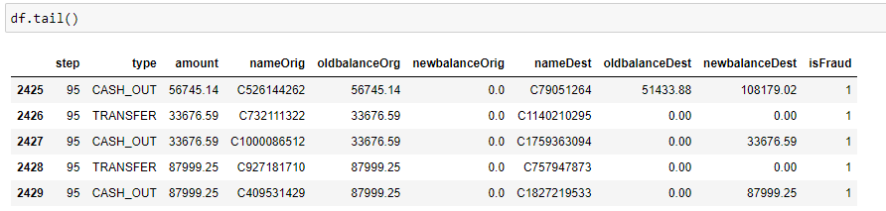

above, the dataset's last five values are loaded using the tail method.
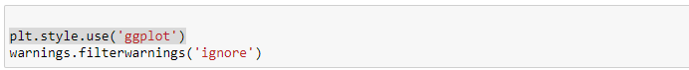

utilising Style use here The Ggplot approach Setting "styles"—basically stylesheets that resemble matplotlibrc files—is a fundamental feature of mpltools. The "ggplot" style, which modifies the style to resemble ggplot, is demonstrated in this dataset.
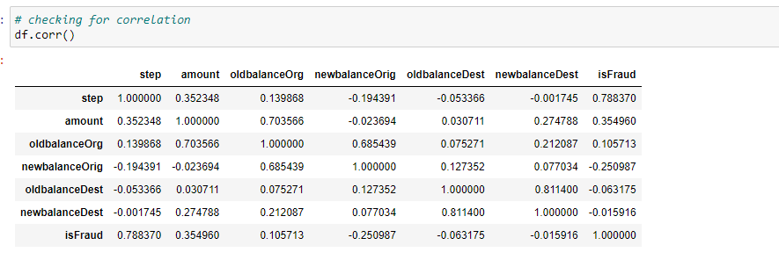
utilising the corr function to examine the dataset's correlation.
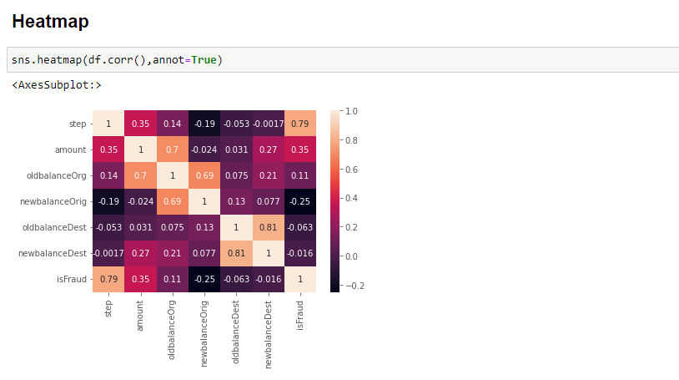

Here, a heatmap is used to understand the relationship between the input attributes and the anticipated goal value.

Univariant Analysis:
In simple words, univariate analysis is understanding the data with a single feature. Here I have displayed the graph such as histplot .
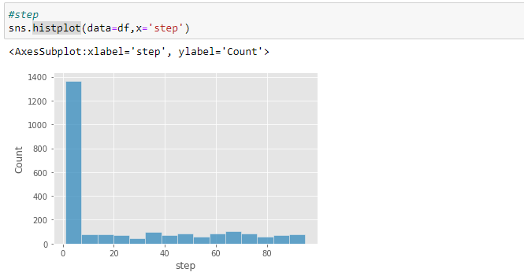
The distribution of one or more variables is represented by a histogram, a traditional visualisation tool, by counting the number of observations that fall within.
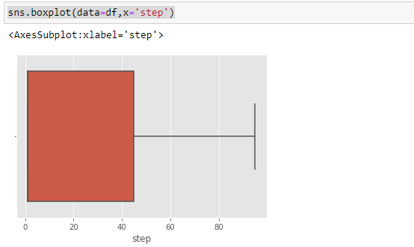
Here, the relationship between the step attribute and the boxplot is visualised.
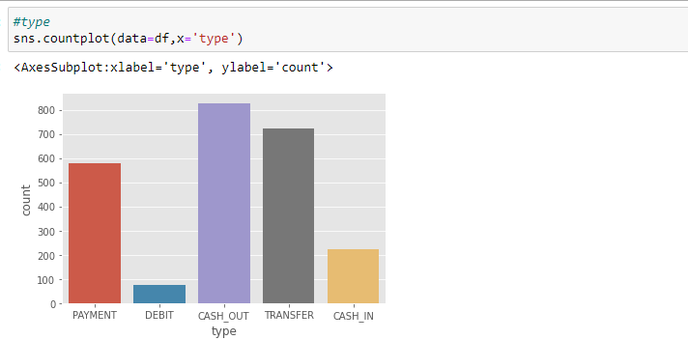
Here, the counts of observations in the type attribute of the dataset will be displayed using a countplot.
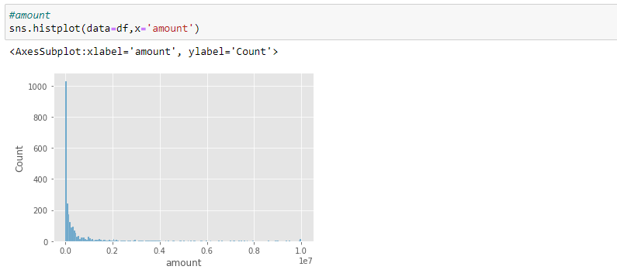
By creating bins along the data's range and then drawing bars to reflect the number of observations that fall within the amount attribute in the dataset.
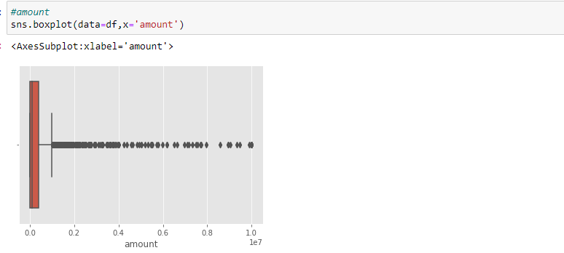
Here, the relationship between the amount attribute and the boxplot is visualised.
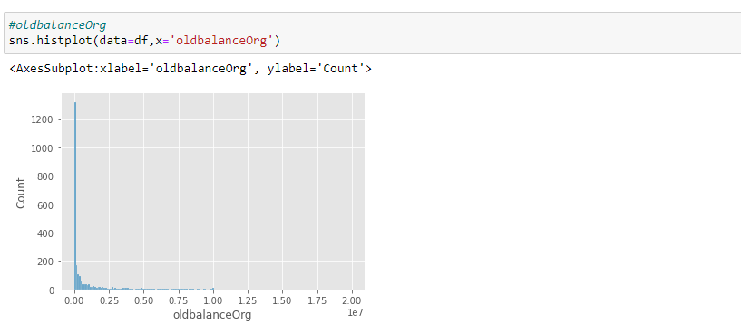
By creating bins along the data's range and then drawing bars to reflect the number of observations that fall within the oldbalanceOrg attribute in the dataset.
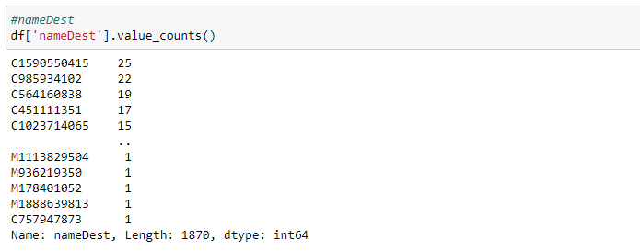
utilising the value counts() function here to determine how many times the nameDest column appears.
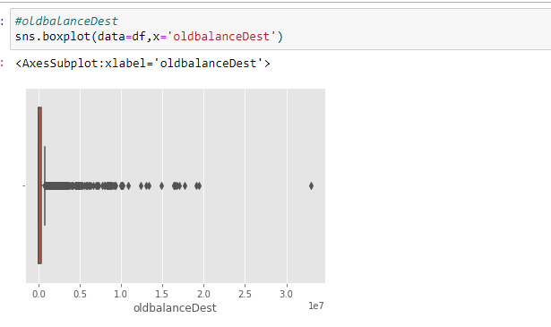
Here, the relationship between the oldbalanceDest attribute and the boxplot is visualised.
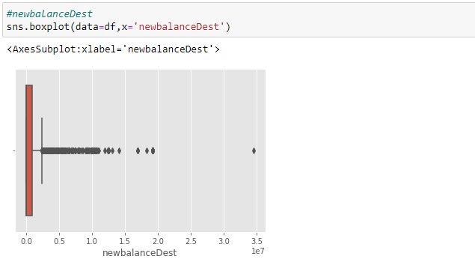
Here, the relationship between the newbalanceDest attribute and the boxplot is visualised.
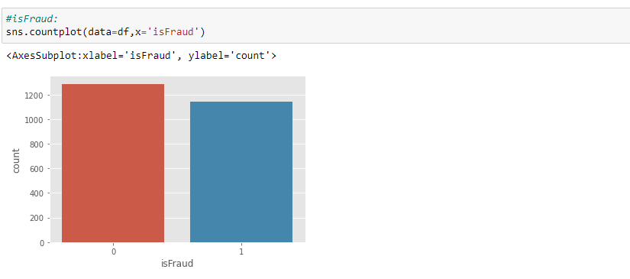
using the countplot approach here to count the number of instances in the dataset's target isFraud column.
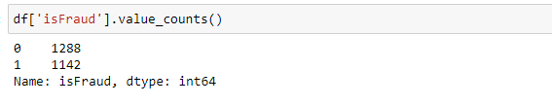
Here, we're using the value counts method to figure out how many classes there are in the dataset's target isFraud column.
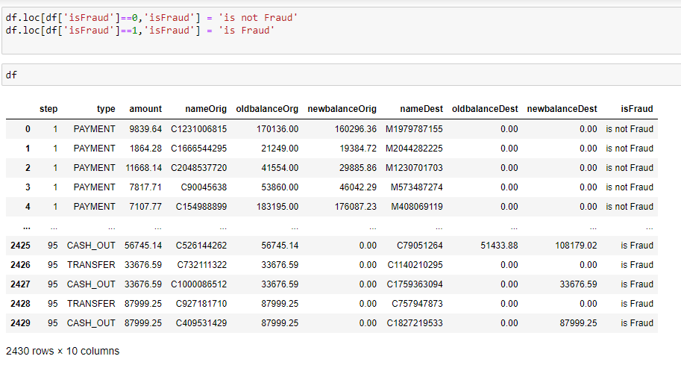
converting 0-means: is not fraud and 1-means: is fraud using the loc technique here.
Bivariate Analysis:
To find the relation between two features we use bivariate analysis. Here we are visualising the relationship between newbalanceDest and isFraud.
jointplot is used here. As a 1st parameter we are passing x value and as a 2nd parameter we are passing hue value.
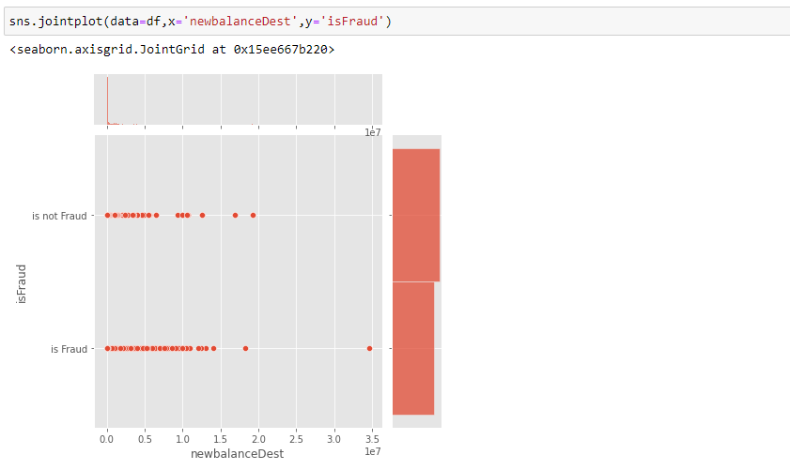
Here we are visualising the relationship between type and isFraud.countplot is used here. As a 1st parameter we are passing x value and as a 2nd parameter we are passing hue value.
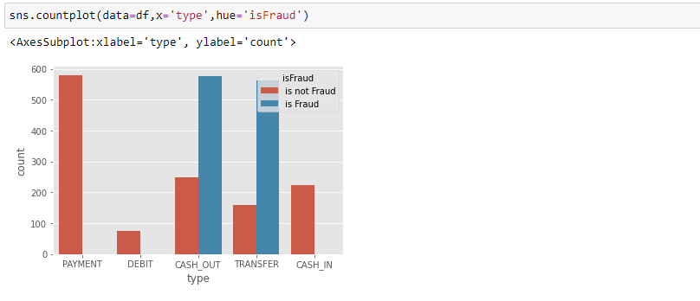
Here we are visualising the relationship between isFraud and step.boxtplot is used here. As a 1st parameter we are passing x value and as a 2nd parameter we are passing hue value.
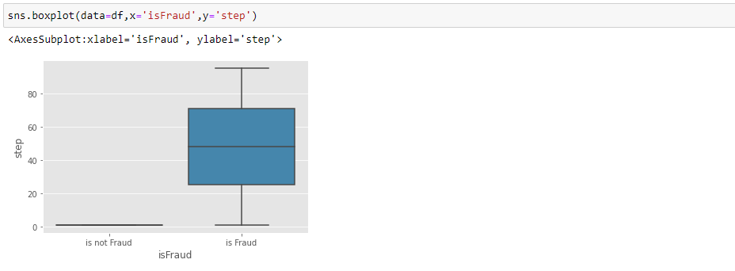
Here we are visualising the relationship between isFraud and amount.boxtplot is used here. As a 1st parameter we are passing x value and as a 2nd parameter we are passing hue value.
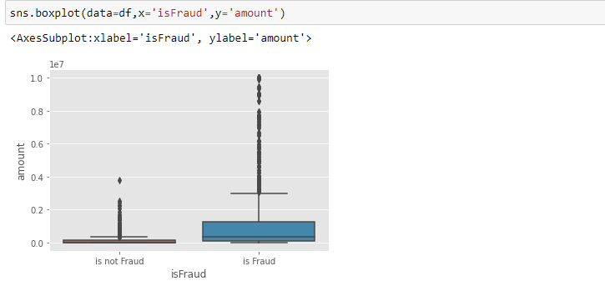
Here we are visualising the relationship between isFraud and oldbalanceOrg. boxtplot is used here. As a 1st parameter we are passing x value and as a 2nd parameter we are passing hue value.
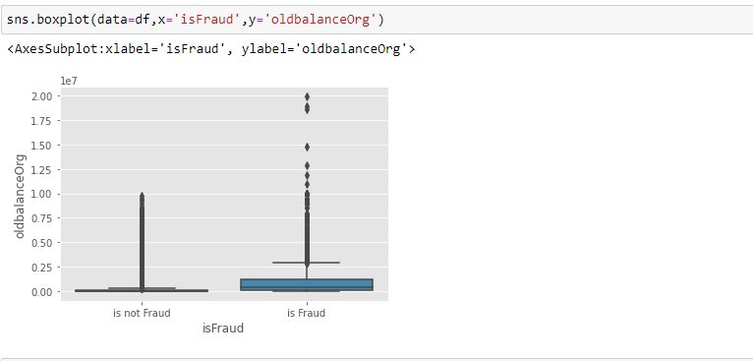
Here we are visualising the relationship between isFraud and newbalanceOrig. boxtplot is used here. As a 1st parameter we are passing x value and as a 2nd parameter we are passing hue value.
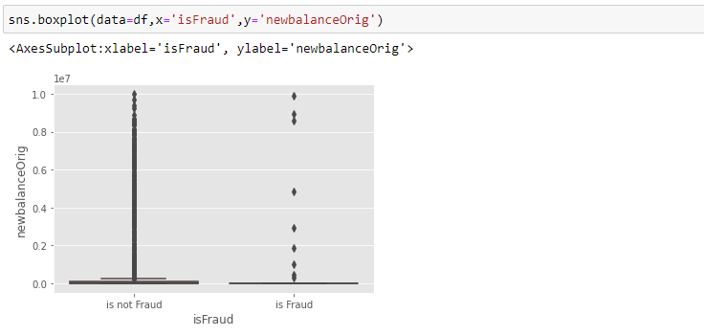
Here we are visualising the relationship between isFraud and oldbalanceDest. violinplot is used here. As a 1st parameter we are passing x value and as a 2nd parameter we are passing hue value.
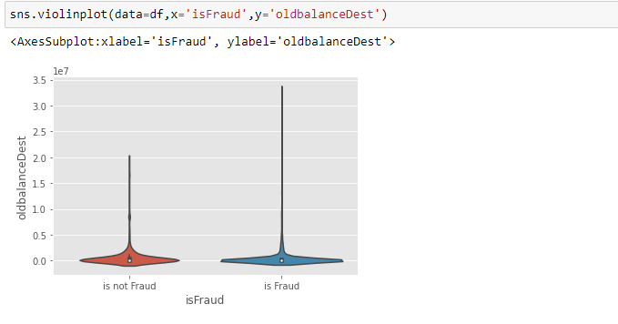
Here we are visualising the relationship between isFraud and newbalanceDest. violinplot is used here. As a 1st parameter we are passing x value and as a 2nd parameter we are passing hue value.
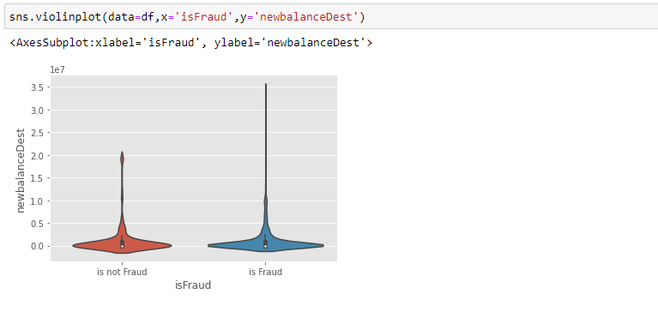
Descriptive analysis:
Descriptive analysis is to study the basic features of data with the statistical process. Here pandas has a worthy function called describe. With this describe function we can understand the unique, top and frequent values of categorical features. And we can find mean, std, min, max and percentile values of continuous features.
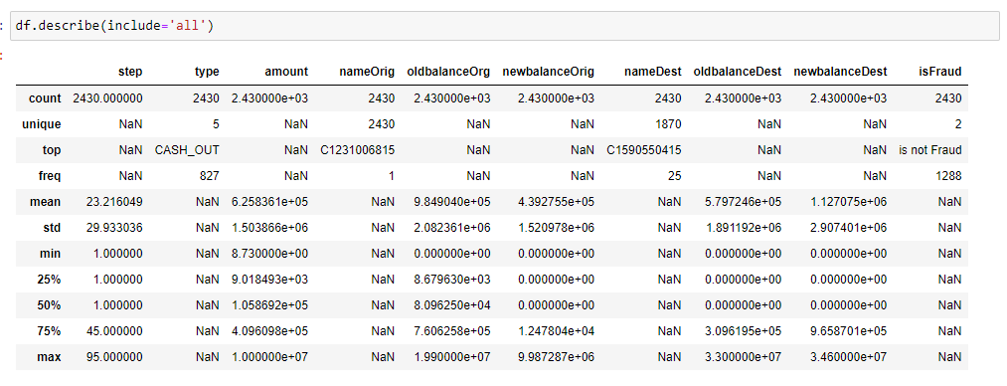

8.Data Pre-Processing
As we have understood how the data is, let's pre-process the collected data.
The download data set is not suitable for training the machine learning model as it might have so much randomness so we need to clean the dataset properly in order to fetch good results. This activity includes the following steps.
Handling missing values
Handling Object data label encoding
Splitting dataset into training and test set
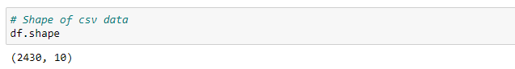
Here, I'm using the shape approach to figure out how big my dataset is
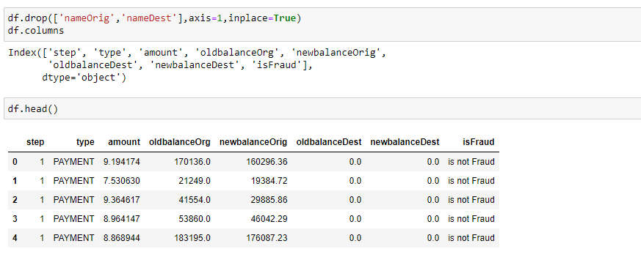
here, the dataset's superfluous columns (nameOrig,nameDest) are being removed using the drop method.
Checking for null values:
Isnull is used (). sum() to check your database for null values. Using the df.info() function, the data type can be determined.
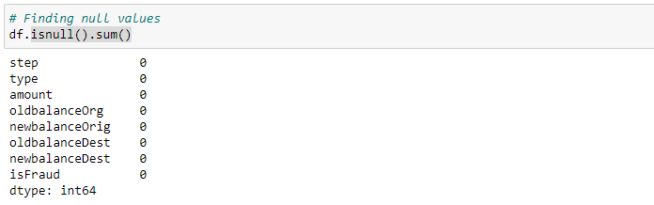
For checking the null values, data.isnull() function is used. To sum those null values we use the .sum() function to it. From the above image we found that there are no null values present in our dataset.So we can skip handling of missing values step.
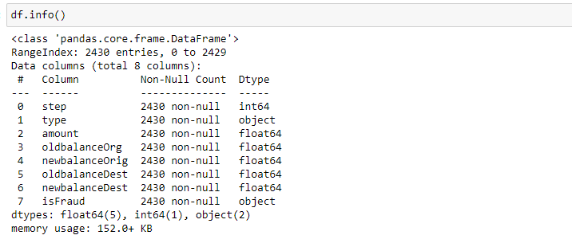
determining the types of each attribute in the dataset using the info() function
Handling outliers:
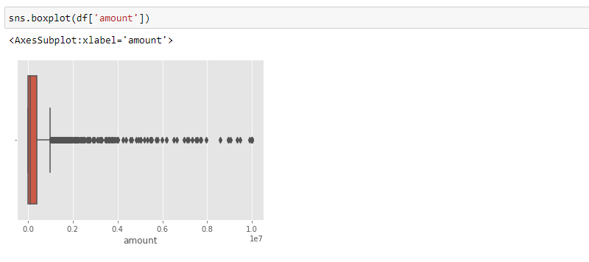
Here, a boxplot is used to identify outliers in the dataset's amount attribute.
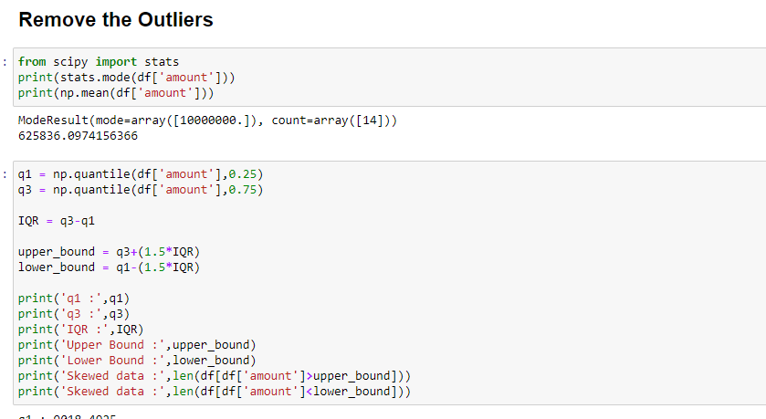
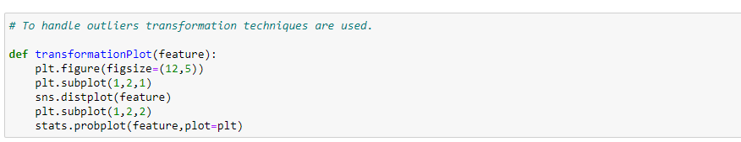
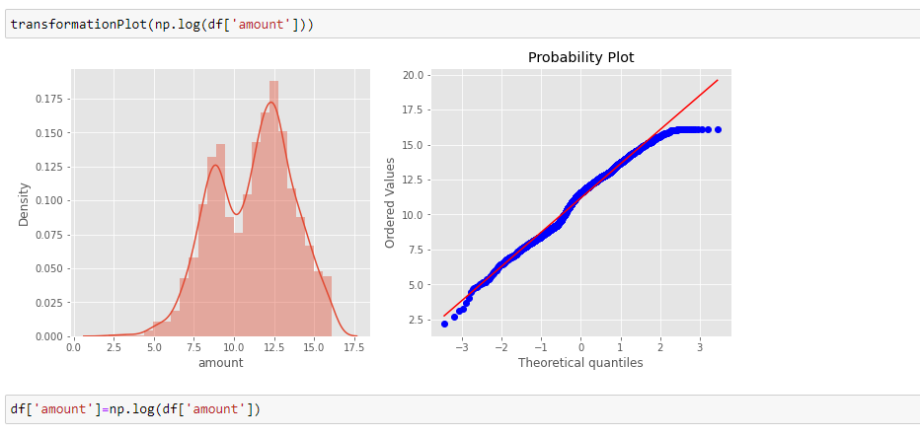
Here, transformationPlot is used to plot the dataset's outliers for the amount property.
Object data labelencoding:
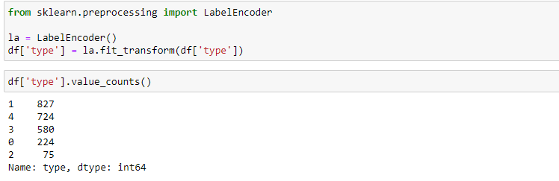
using labelencoder to encode the dataset's object type
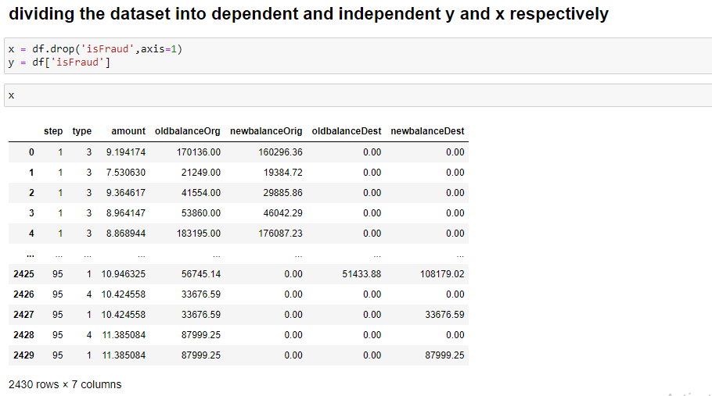
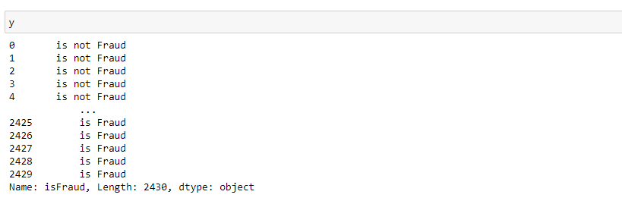
Splitting data into train and test:
Now let’s split the Dataset into train and test setsChanges: first split the dataset into x and y and then split the data set.
Here x and y variables are created. On x variable, df is passed with dropping the target variable. And my target variable is passed. For splitting training and testing data we are using the train_test_split() function from sklearn. As parameters, we are passing x, y, test_size, random_state.
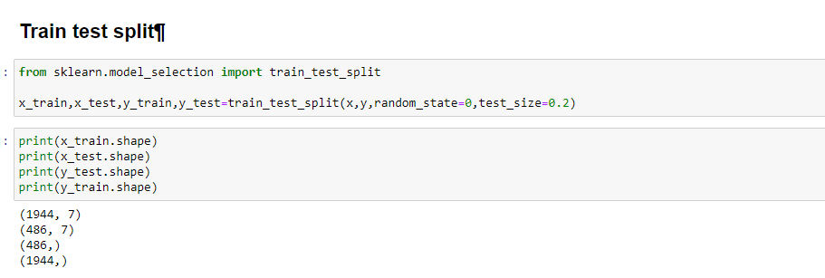

9.Model Building
Now our data is cleaned and it’s time to build the model. We can train our data on different algorithms. For this project we are applying four classification algorithms. The best model is saved based on its performance.
Random Forest classifier:
A function named RandomForest is created and train and test data are passed as the parameters. Inside the function, the RandomForestClassifier algorithm is initialised and training data is passed to the model with the .fit() function. Test data is predicted with .predict() function and saved in a new variable. For evaluating the model, a confusion matrix and classification report is done.
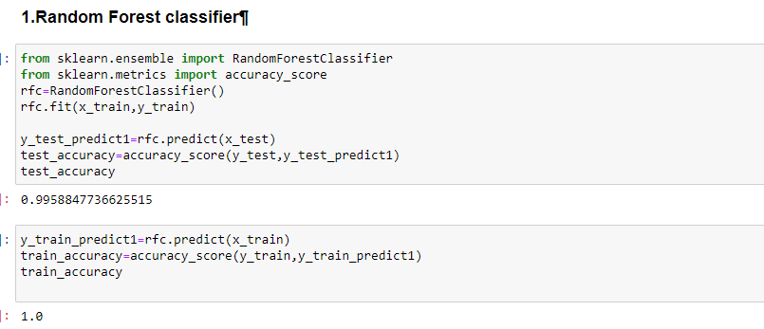
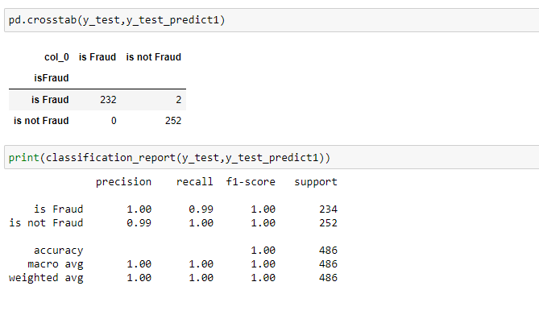
Decision tree Classifier:
A function named Decisiontree is created and train and test data are passed as the parameters. Inside the function, the DecisiontreeClassifier algorithm is initialised and training data is passed to the model with the .fit() function. Test data is predicted with the .predict() function and saved in a new variable. For evaluating the model, a confusion matrix and classification report is done.
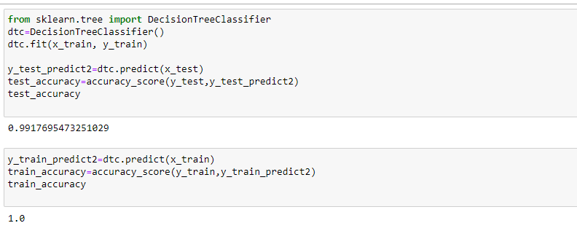
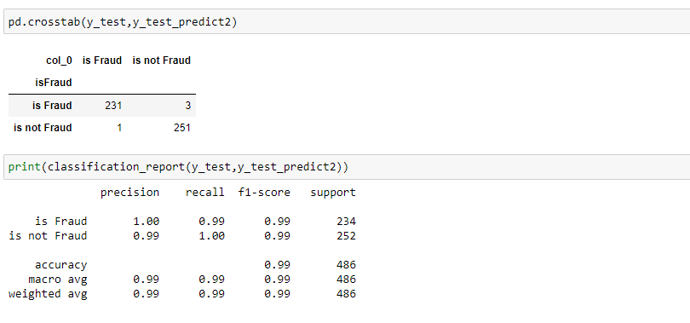
ExtraTrees Classifier:
A function named ExtraTree is created and train and test data are passed as the parameters. Inside the function, ExtraTreeClassifier algorithm is initialised and training data is passed to the model with the .fit() function. Test data is predicted with .predict() function and saved in a new variable. For evaluating the model, a confusion matrix and classification report is done.
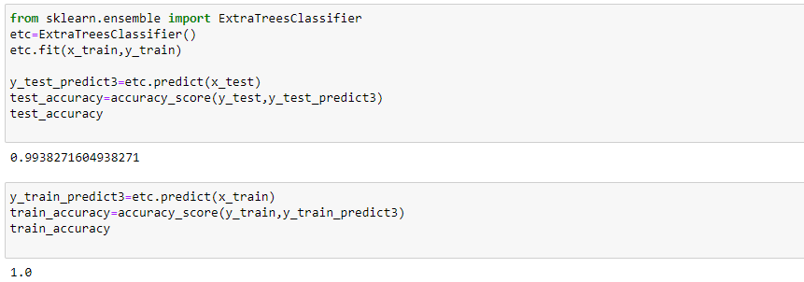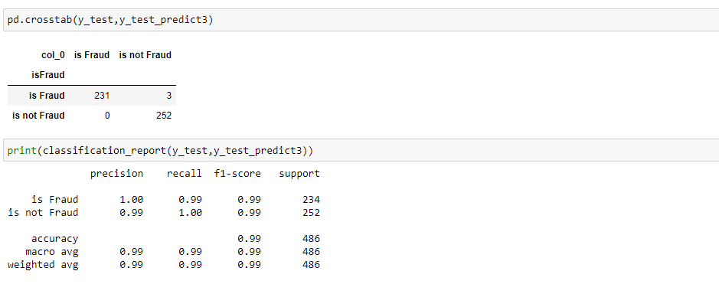
SupportVector Machine Classifier:
A function named SupportVector is created and train and test data are passed as the parameters. Inside the function, the SupportVectorClassifier algorithm is initialised and training data is passed to the model with the .fit() function. Test data is predicted with .predict() function and saved in a new variable. For evaluating the model, confusion matrix and classification report is done.
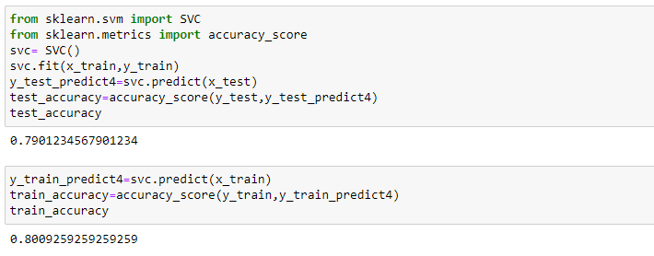
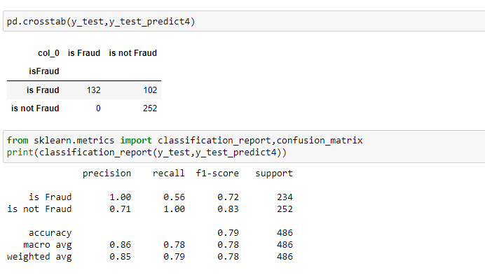
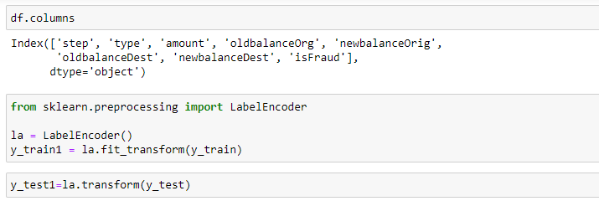
preprocessing class of sklearn. LabelEncoder[source] 0 to n classes-1 as the range for the target labels to be encoded. Instead of encoding the input X, the target values, i.e. y, should be encoded using this transformer.
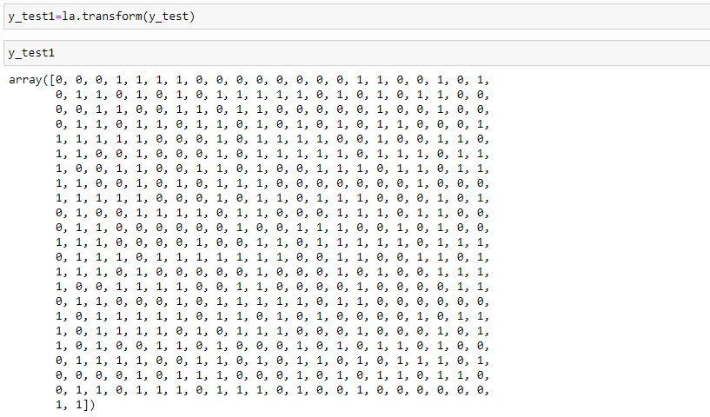
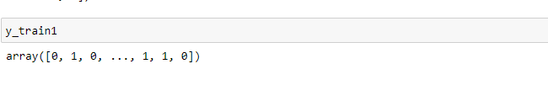
xgboost Classifier:
A function named xgboost is created and train and test data are passed as the parameters. Inside the function, the xgboostClassifier algorithm is initialised and training data is passed to the model with the .fit() function. Test data is predicted with .predict() function and saved in a new variable. For evaluating the model, confusion matrix and classification report is done.
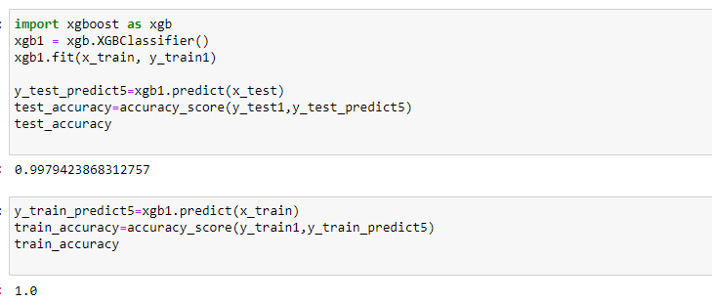
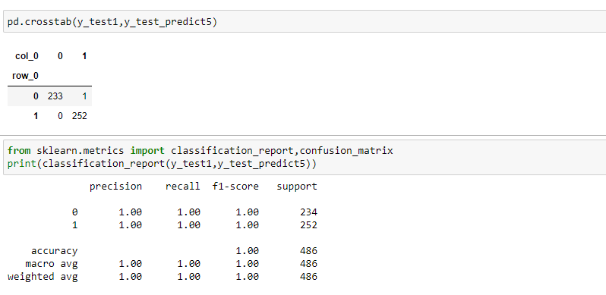
Compare the models:
For comparing the above four models, the compareModel function is defined.
After calling the function, the results of models are displayed as output. From the five models, the svc is performing well. From the below image, We can see the accuracy of the model is 79% accuracy. .
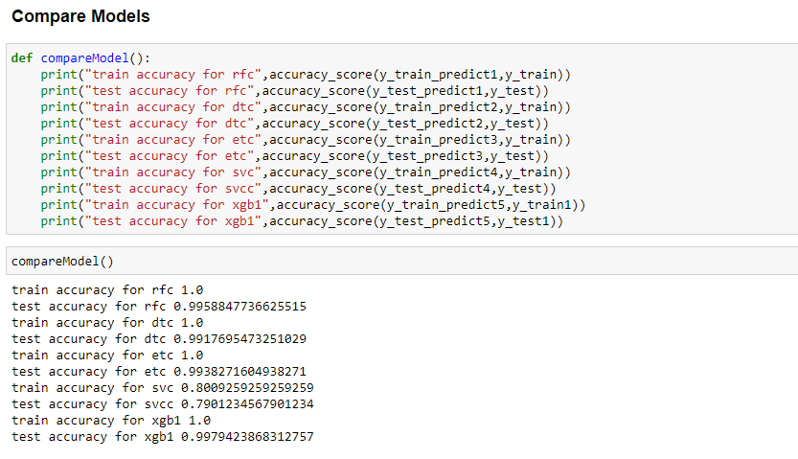
Evaluating performance of the model and saving the model:
From sklearn, accuracy_score is used to evaluate the score of the model. On the parameters, we have given svc (model name), x, y, cv (as 5 folds). Our model is performing well. So, we are saving the model is svc by pickle.dump().
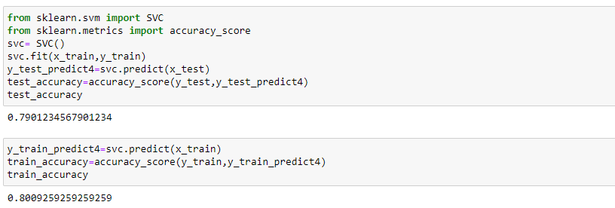
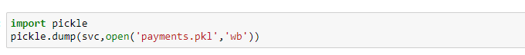

10.Application_Building
In this section, we will be building a web application that is integrated to the model we built. A UI is provided for the uses where he has to enter the values for predictions. The enter values are given to the saved model and prediction is showcased on the UI.
This section has the following tasks
Building HTML Pages
Building server side script
Building Html Pages:
For this project create three HTML files namely
- home.html
- predict.html
- submit.html
and save them in the templates folder.
Let’s see how our home.html page looks like:
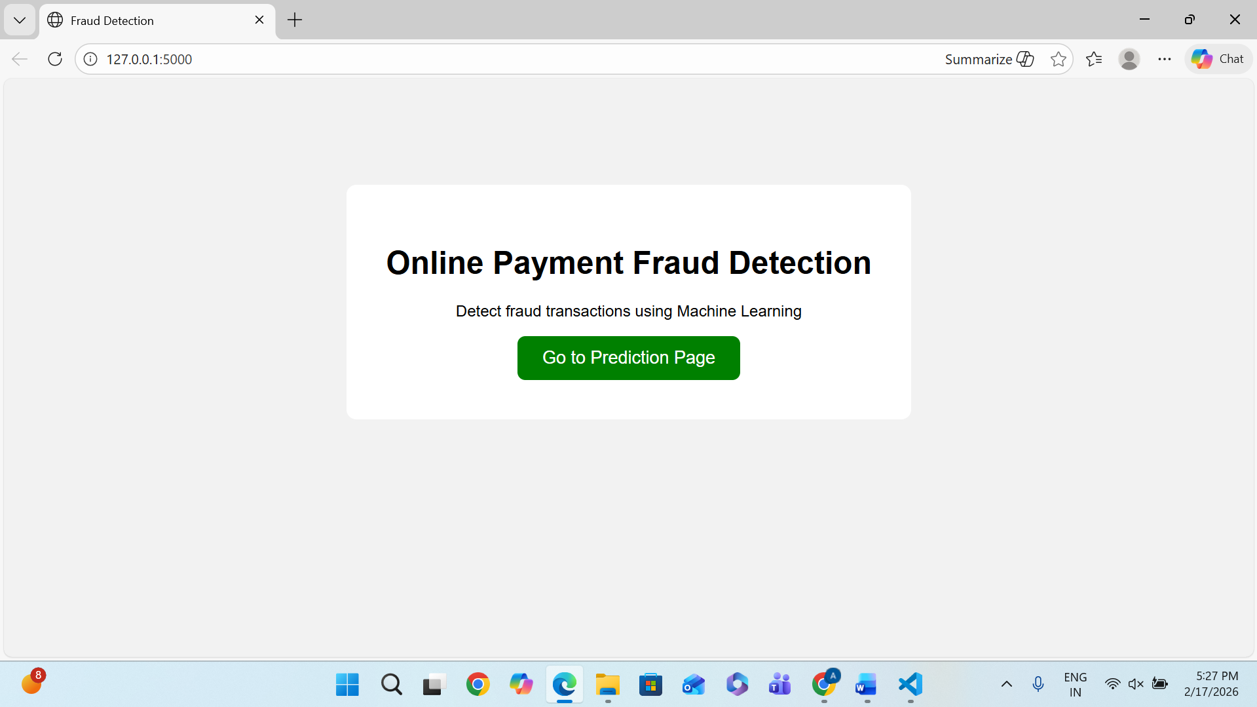
Now when you click on predict button from top right corner you will get redirected to predict.html
Let's look how our predict.html file looks like:
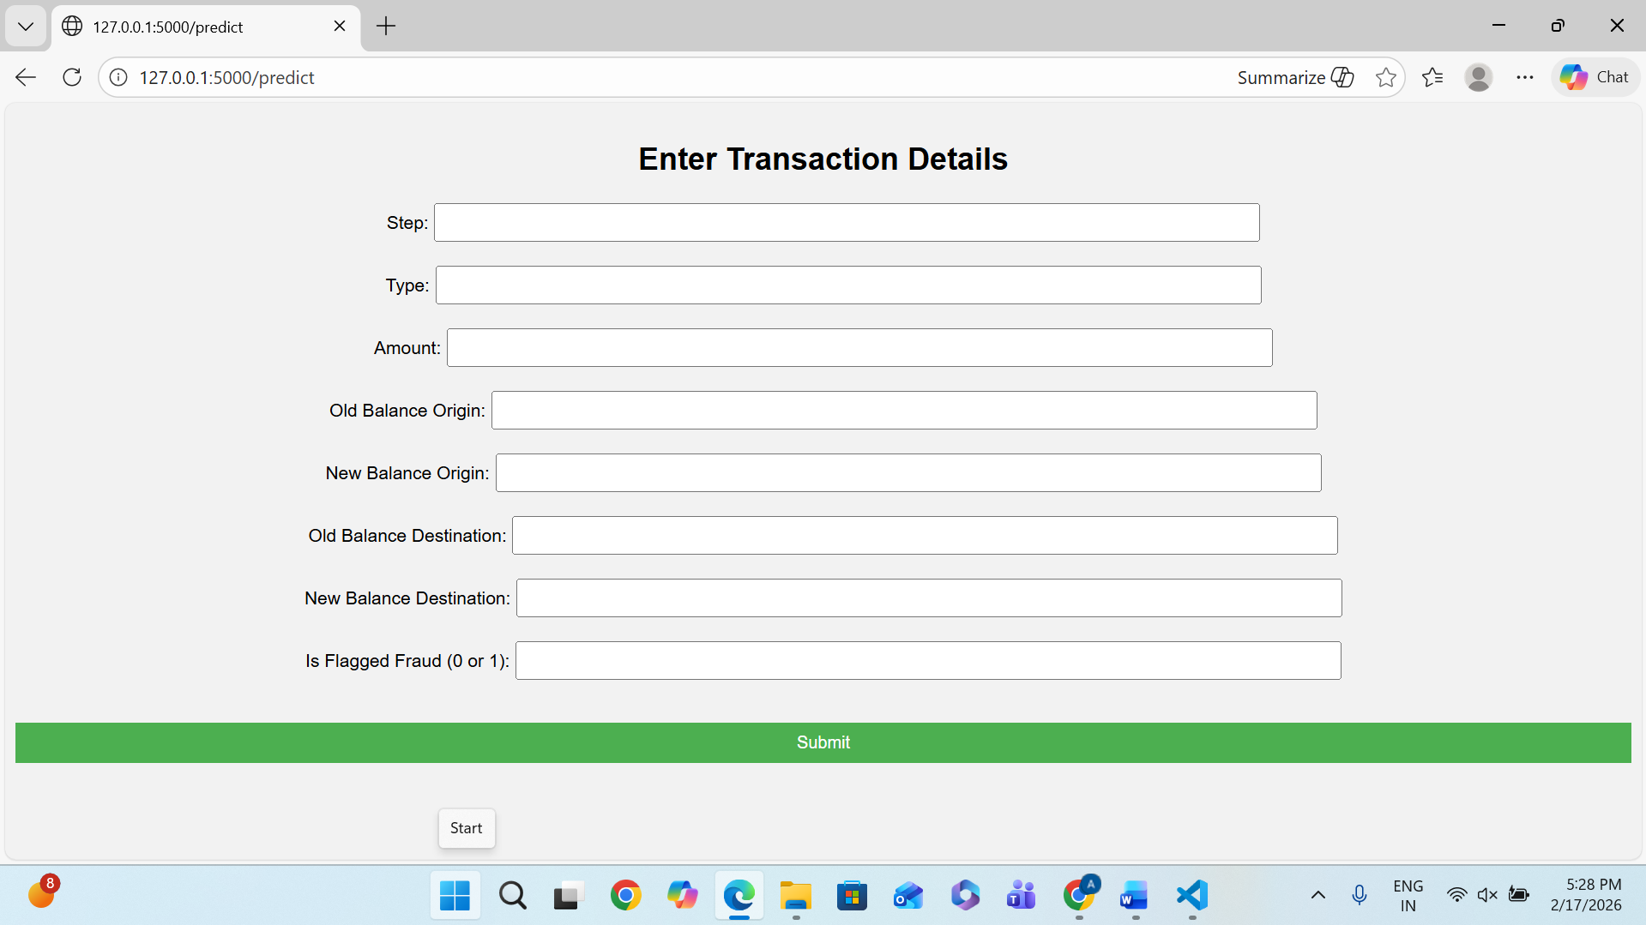
Now when you click on submit button from left bottom corner you will get redirected to submit.html
Let's look how our submit.html file looks like:
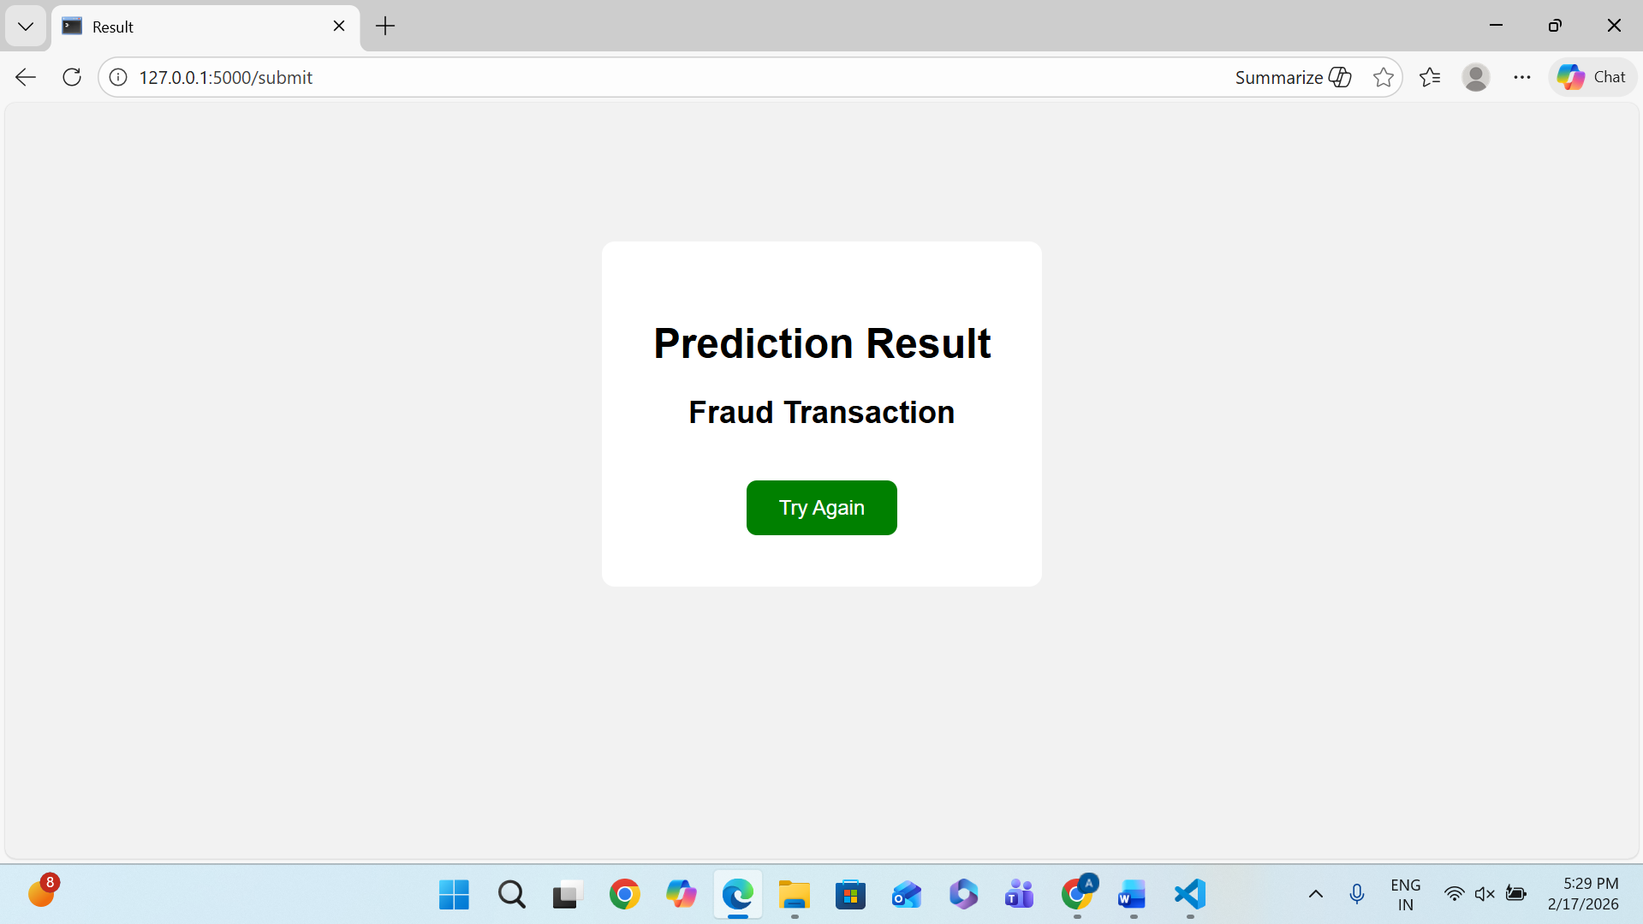

Build Python code
Import the libraries
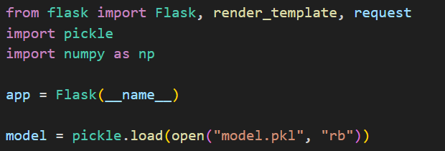
Load the saved model. Importing the flask module in the project is mandatory. An object of Flask class is our WSGI application. Flask constructor takes the name of the current module (__name__) as argument.
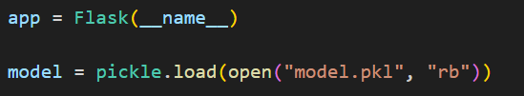
Render HTML page:
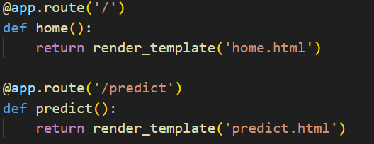
Here we will be using a declared constructor to route to the HTML page which we have created earlier.
In the above example, ‘/’ URL is bound with the home.html function. Hence, when the home page of the web server is opened in the browser, the html page will be rendered. Whenever you enter the values from the html page the values can be retrieved using POST Method.
Retrieves the value from UI:
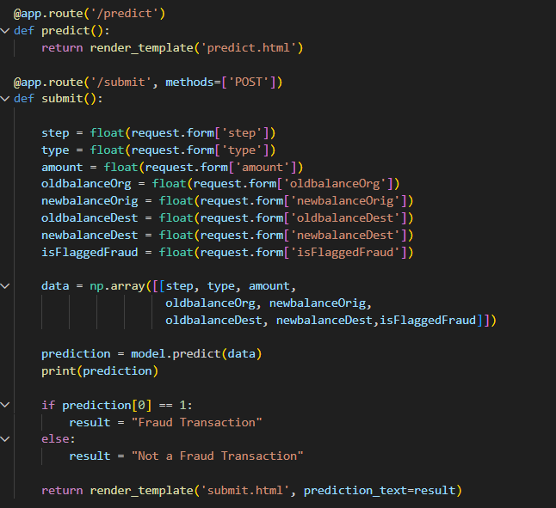
Here we are routing our app to predict() function. This function retrieves all the values from the HTML page using Post request. That is stored in an array. This array is passed to the model.predict() function. This function returns the prediction. And this prediction value will be rendered to the text that we have mentioned in the submit.html page earlier.
Main Function:
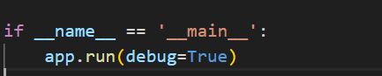

Run the application
- Open VS CODE from the start menu
- Navigate to the folder where your python script is.
- Now type “python app.py” command
- Navigate to the localhost where you can view your web page.
- Click on the predict button from the top right corner, enter the inputs, click on the submit button, and see the result/prediction on the web.
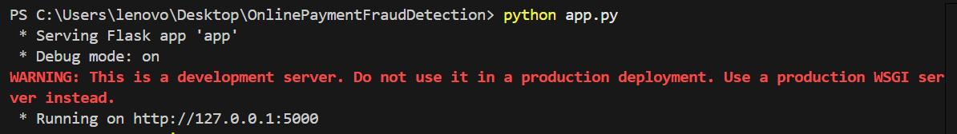
Output Screenshots:
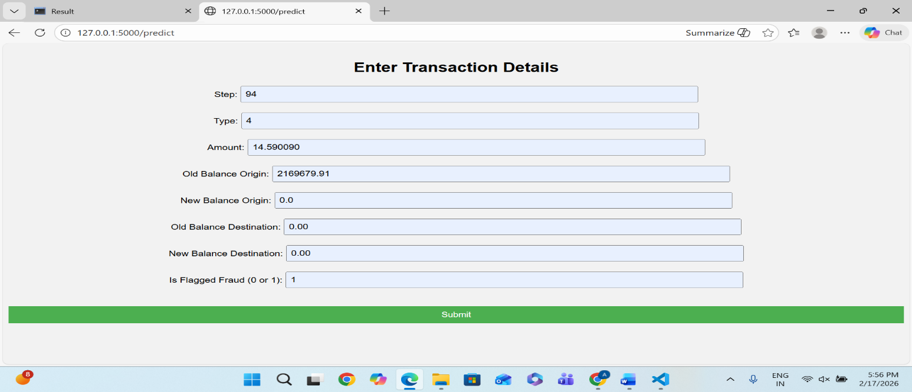
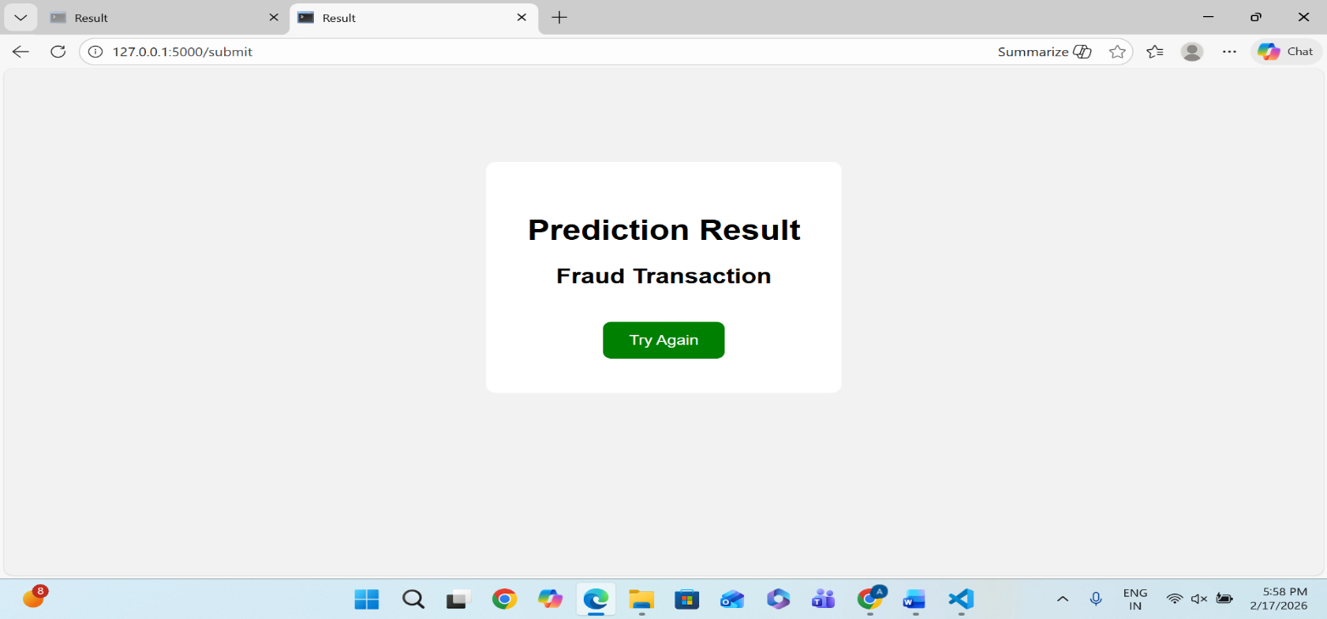
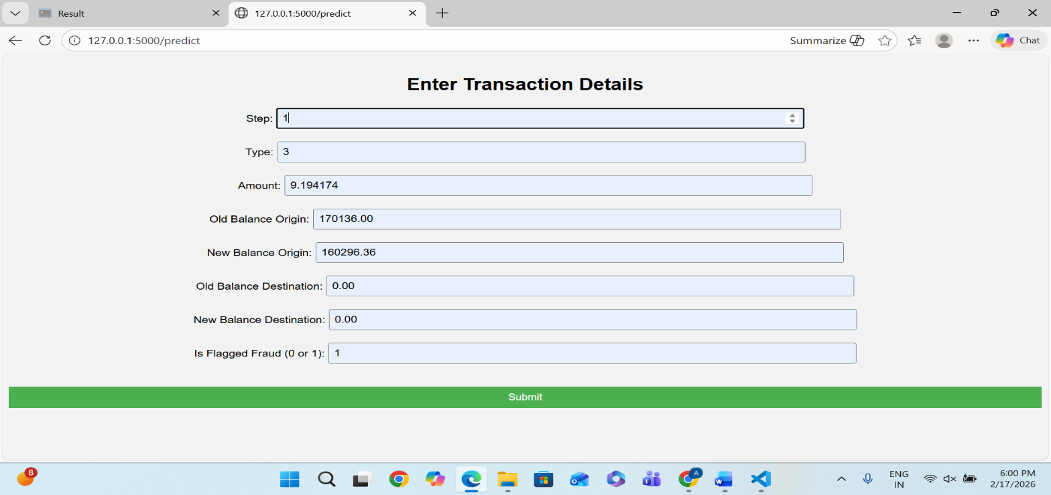
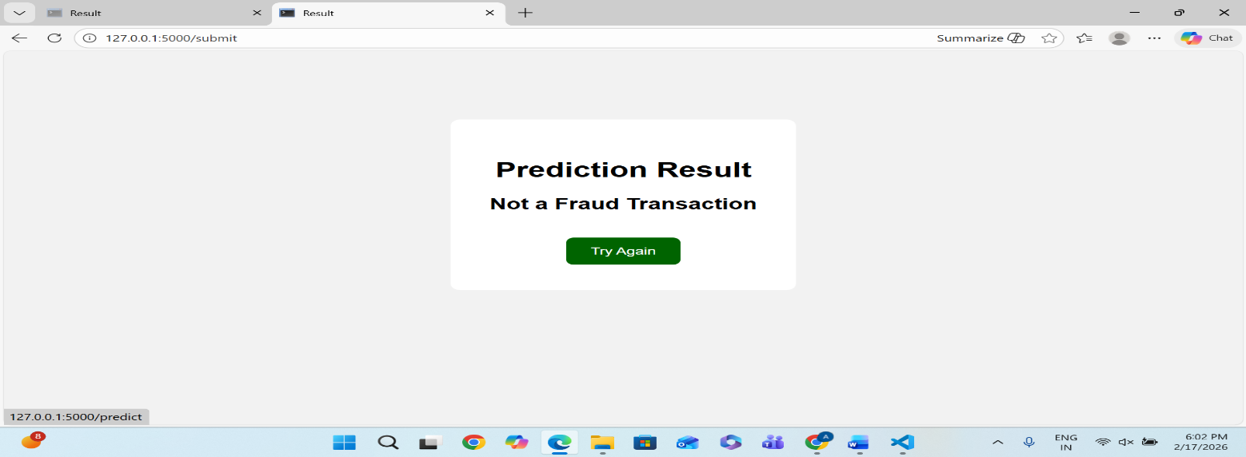
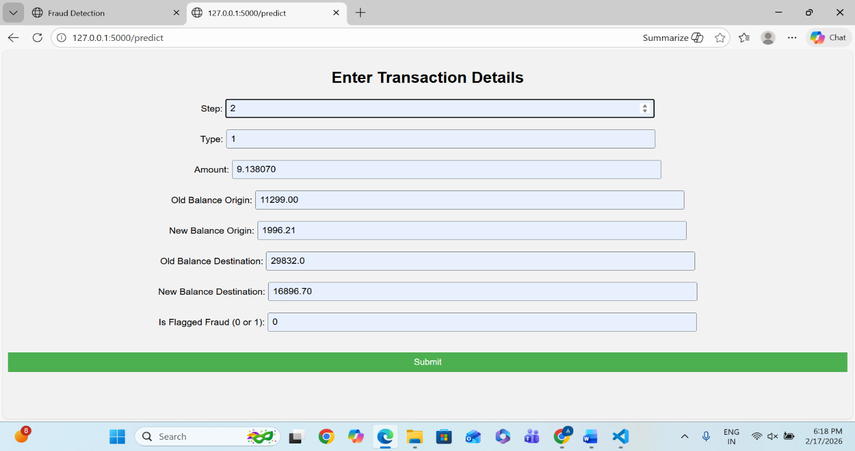
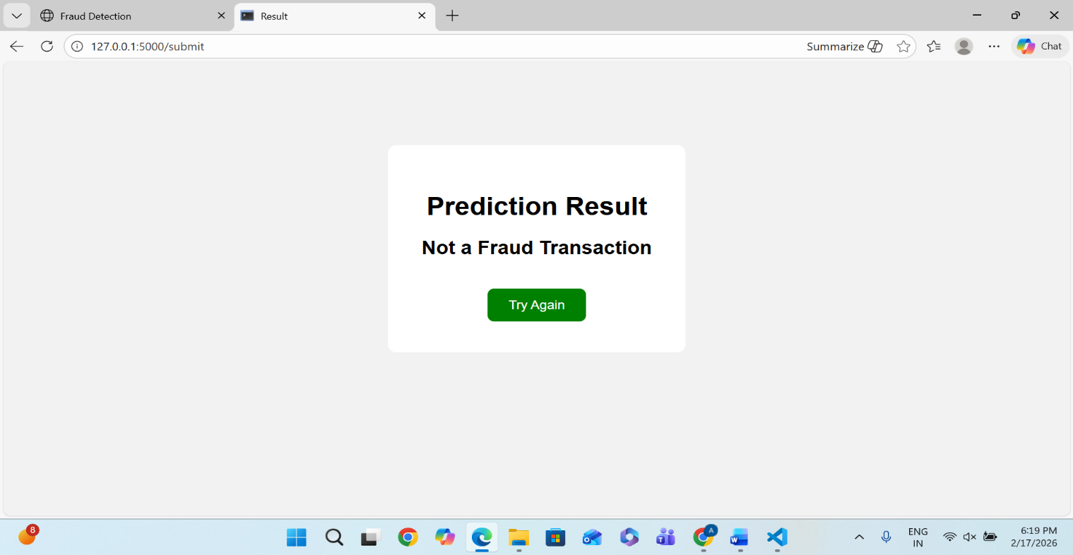

11.CONCLUSION
This project focused on developing a Machine Learning model to detect fraudulent online payment transactions. With the rapid growth of digital payments, financial fraud has become a significant concern for individuals and organizations. The objective of this project was to build an intelligent system capable of identifying fraudulent transactions accurately and efficiently.
The dataset was carefully preprocessed by removing irrelevant features, encoding categorical variables, and handling missing values. Proper data preparation ensured better model performance and reliability. The dataset was then divided into training and testing sets to evaluate the model effectively.
A Random Forest Classifier was implemented to classify transactions as either fraudulent or legitimate. The model demonstrated strong predictive performance and achieved high accuracy on the test data. The results indicate that machine learning algorithms can successfully detect patterns and anomalies associated with fraud.
This project highlights the importance of data preprocessing, feature engineering, and model evaluation in building effective predictive systems. The developed model can assist financial institutions and online platforms in minimizing financial losses and enhancing security.
In conclusion, the implementation of Machine Learning for Fraud Detection proves to be a powerful and practical solution for real-world financial security challenges.

