User Manual

Salvador Orozco
Andres Reynoso
Ricardo Rodiles
Jesus Coles
Raul Barranco
18/10/2018

USER'S MANUAL
TABLE OF CONTENTS
Page #

1.0 GENERAL INFORMATION 2
1.1 SYSTEM OVERVIEW 2
1.2 PROJECT REFERENCES 2
2.0 SYSTEM SUMMARY 3
2.1 SYSTEM CONFIGURATION 3

3.0 GETTING STARTED 4
3.1 Login Page 4
3.2 Register Page 4
3.3 Main Page 5
3.4 New Experiment 6
3.5 Existing Experiment 6
3.6 Log out 7

GENERAL INFORMATION
1.1 System Overview
The system is designed to allow the researcher to generate experiments about certain body parts (Such as head, hands, elbows, etc.) with the benefit of only needing the software to make the research. The only thing that the researcher needs it’s to generate the questionaries’ to conduct an experiment

The system is designed to be run with Angular 6 and Nodejs. It was developed in the fall 2018 semester by Corpus Web team at ITESM campus Puebla.

1.2 Project References

The following is a list of the references that were used during development of the system:

- Angular 6
- NodeJs

SYSTEM SUMMARY

2.1 System Configuration

Users are provided with a webpage to create new experiments and add new participants and see other people results.

3.0 GETTING STARTED

3.1 Login page

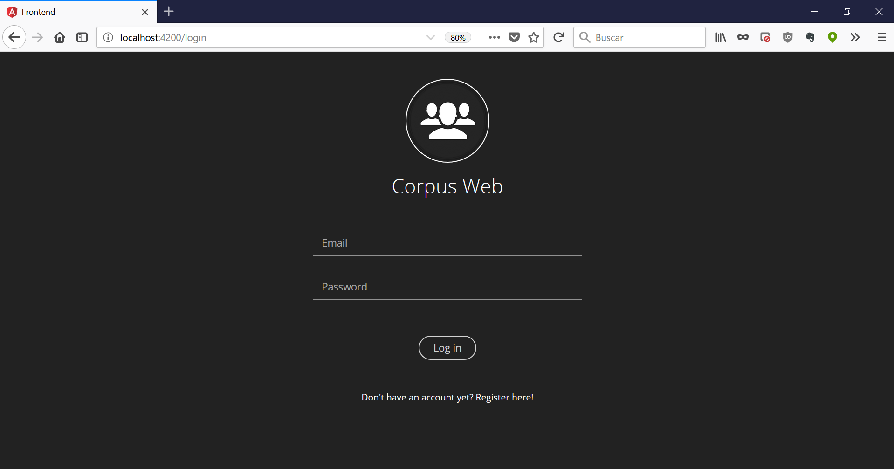

When first accessing to the page, you will be asked for your login credentials, if you don’t have, don’t worry, just click register!

3.2 Register Page

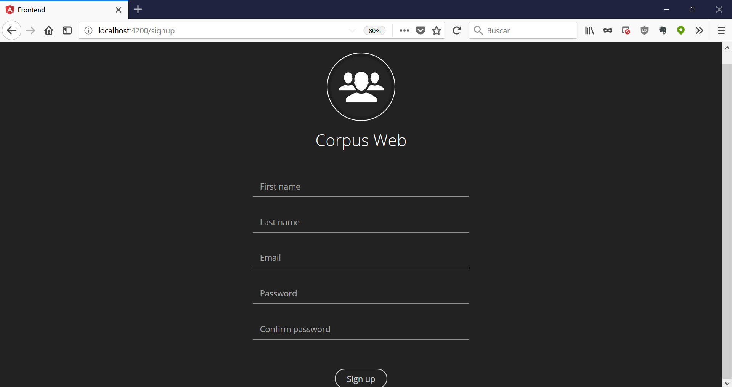

If it’s the case that you don’t have credentials, you just have to provide us with some basic information like:
- First name
- Last name
- Email
- Password
With that we will give you those as your credentials to log in!

3.3 Main Page
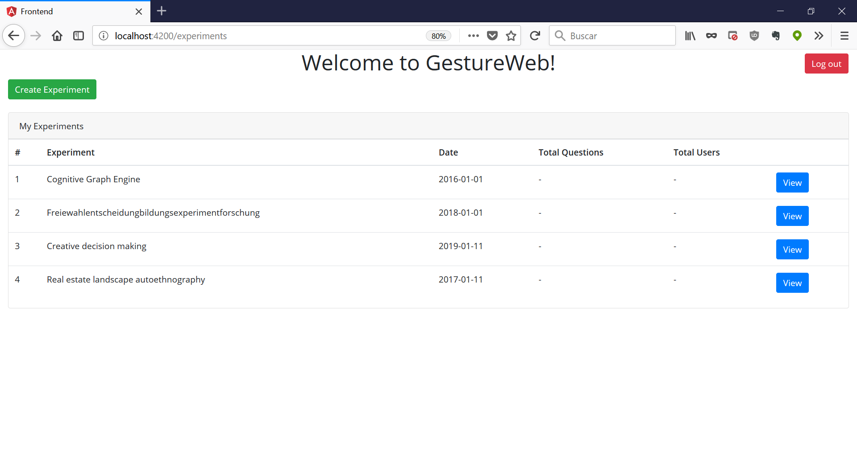
Here in the Main page now that you have log in, we show you your projects, and from here you can create a new experiment or see your existing ones!

3.4 New experiment

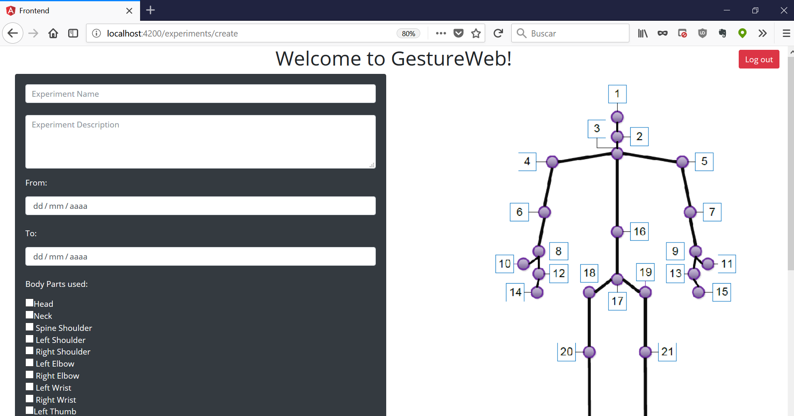

Here you can create your new experiments with everything you need!

3.5 Existing Experiments
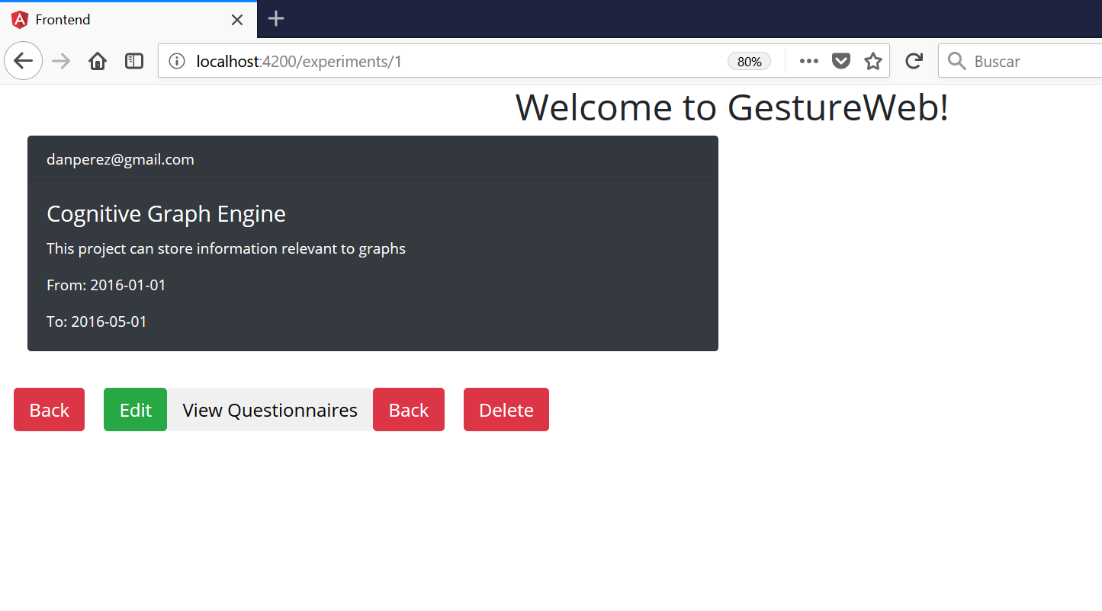

3.6 Log out

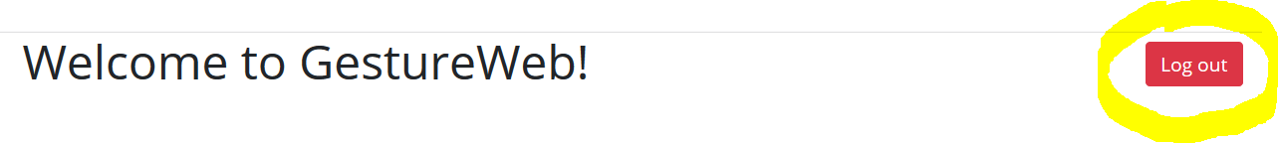
Now if you are done with everything in the webpage, you could just simply Log out.

