**SP-6 Blue — Time Mileage Location Tracker**

**CS 4850 - Section 02 – Spring 2024**

**January 19, 2024**

|  |  |  |
| --- | --- | --- |
| **Armando Ortiz** | **Jacob Carrington** | **David Huu Nguyen** |
| **Andrew Millsap** | **Ethan Strickland** | **KSU Spirit** |

**Team Members:**

|  |  |  |
| --- | --- | --- |
| Name (Project Owner) | Role | Cell Phone / Alt Email |
| Ethan Strickland (Team Lead) | QA | 770-355-6603 - [ethanstrickland@startup-rescue.com](mailto:ethanstrickland@startup-rescue.com) |
| David Nguyen | Developer | 678-519-7884 - [davnguy00@gmail.com](mailto:davnguy00@gmail.com) |
| Armando Ortiz | Documentation | 404-980-3848 - [14angel007@gmail.com](mailto:14angel007@gmail.com) |
| Jacob Carrington | Developer | 404-825-5391 - [JacobCarrington101@gmail.com](mailto:JacobCarrington101@gmail.com) |
| Andrew Millsap | Documentation | 706-521-1989 - [amillsap72@gmail.com](mailto:amillsap72@gmail.com) |
| Sharon Perry | Advisor | 770-329-3895 - [Sperry46@kennesaw.edu](mailto:Sperry46@kennesaw.edu) |

**Project SP-6 Blue Time Mileage Location Tracker**

### Enhanced Overview

We are designing an app that will track a person's location from two points. While the app is running there will be data post-processed based on the information retrieved from google maps API that will provide data such as how far they went, their average speed, and route taken on the trip. The app will be available on all platforms and will have a two-tier system.

The base tier will provide basic information about trips such as the distance, average speed, time, start location, and stop location. This base version will also contain the ability to view the history of trips but will contain ads located both on the home page and history page.

The second tier will be a paid version of the app that will contain no ads across any page of the app. This tier will also contain more features such as more detail for trips taken such as gps tagging and the ability to view up to the past 5 years of trips taken.

Both tiers will contain features that will allow the user to track the location between two points, download a excel file for tax purposes around tax season, see information about previous trips, change basic information about account (contact email, password, etc...).

**Deliverables**

Deliverables include:

* Application Design Mock-up (Figma)
* Working Application Prototype (Figma)
* User Flow Documentation (Admin/User)
* Tutorial Documentation (In-App or Separate)
* Testing Reports
* Database (User Information)
* Database Design Document
* Requirements Documentation
* Project Plan Documents
* Source code files (zip file)

### Milestone Events

**Milestone #1:**

Requirements Documentation | Date: 2/13/2024

* List of features that will be added to the application (With priority in case not all features can be added in time)
* Software/Hardware requirements to build/use the system (Emulators, languages, database systems, APIs, Device hardware, etc.)
* Permissions Requirements

Design Documentation | Date: 2/13/2024

* Outline platforms used for application development
* Provide technical documents specifying database design
* User interface design visual mockup and flow chart
* Outline of plan for monetization

**Milestone #2:**

Working Application Prototype | Date: 3/10/2024

* User will be able to interact with the application and experience the base level features offered within the application
* Advertisements will be displayed, or Advertising spaces will be indicated
* User will be able to create an account and sign in and out of the application
* User will be able to see basic travel statistics for a set period of time (distance, time, speed, etc.)

Database System | Date: 2/13/2024

* Database will hold user information as well as mileage tracking history
* Tables that must be implemented:
  + USERS table which holds UserName, Password, Email, Status (Standard, Premium), etc.
  + TRIPS table which stores trip information such as Distance, Time, Speed, Location Set, etc.
  + Username field will be the key linking TRIPS to USERS

**Milestone #3:**

Finished Project w/ Monetization| Date: 4/29/2024

* Documentation used throughout project
* Final Working Application
* Source Code
* Descriptions outlining the system design
* Video Demonstration of Application

### Meeting Schedule Date/Time

Meetings are from 5:00-6:00 M/W in person if class is taking place, otherwise we will meet in Microsoft Teams. We also plan to meet on Fridays between 3:30-4:45 on Teams if necessary.

### Collaboration and Communication Plan

For our project we are planning on using GroupMe for our main source of communication, but can also communicate by phone, email, or Microsoft teams. If we are unable to meet, we will join an online video call through Microsoft teams or discuss another day that works for the group besides Monday, Wednesday, or Friday. When it comes to sharing files, we will use Teams. For version control we will be using GitHub. Armando will take meeting notes and distribute them to us through Teams. We will give weekly status updates every Monday saying what we worked on last week, what we are planning on working on this week, and if we had any issues with anything. ￼

### Project Schedule and Task Planning (GANTT CHART)

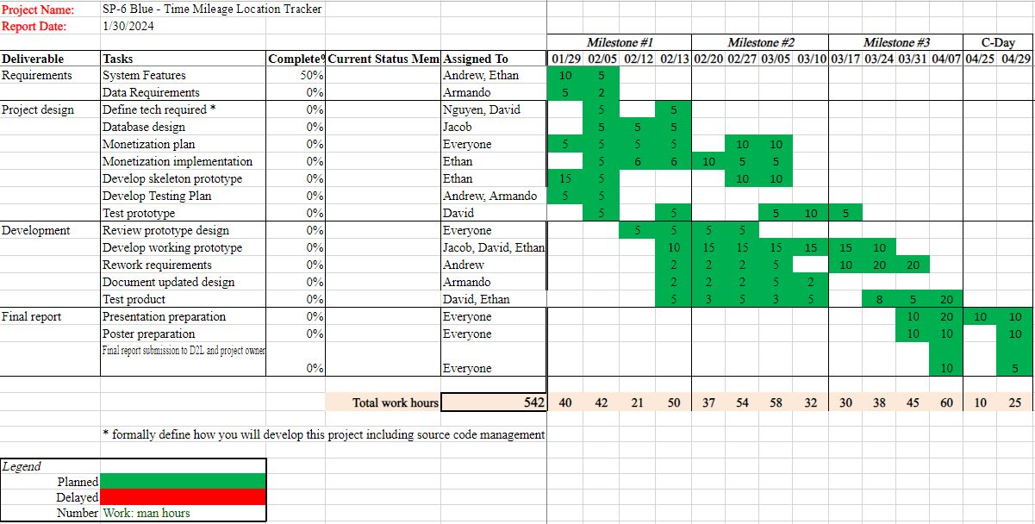

### Security:

Here are a few things that will be considered for security when developing this app

* Have MFA setup when logging into the app
* Encrypt user's passwords when stored in the database

**Version Control Plan:**

We are planning on using a GitHub Actions organization to help with version control and make sure everyone is on the same page when working on this project.

You can view the project here <https://github.com/SP-6-Blue-TimeMileageApp>