**SQL EXERCISE – STORED PROCEDURE**

Exercise 1: Create a Stored Procedure

Code :

-- Create a new database named 'EmployeeManagementDB'

CREATE DATABASE EmployeeManagementDB;

GO

USE EmployeeManagementDB;

GO

-- Create the Departments table

CREATE TABLE Departments (

DepartmentID INT PRIMARY KEY,

DepartmentName VARCHAR(100)

);

GO

-- Create the Employees table

CREATE TABLE Employees (

EmployeeID INT PRIMARY KEY IDENTITY(1,1),

FirstName VARCHAR(50),

LastName VARCHAR(50),

DepartmentID INT,

Salary DECIMAL(10,2),

JoinDate DATE,

FOREIGN KEY (DepartmentID) REFERENCES Departments(DepartmentID)

);

GO

-- Insert data into the Departments & Employees table

INSERT INTO Departments (DepartmentID, DepartmentName) VALUES

(1, 'HR'),

(2, 'Finance'),

(3, 'IT'),

(4, 'Marketing');

INSERT INTO Employees (FirstName, LastName, DepartmentID, Salary, JoinDate) VALUES

('John', 'Doe', 1, 5000.00, '2020-01-15'),

('Jane', 'Smith', 2, 6000.00, '2019-03-22'),

('Michael', 'Johnson', 3, 7000.00, '2018-07-30'),

('Emily', 'Davis', 4, 5500.00, '2021-11-05');

GO

-- Retrieve employee details along with their department name

SELECT

E.EmployeeID,

E.FirstName,

E.LastName,

E.Salary,

E.JoinDate,

D.DepartmentName

FROM

Employees E

INNER JOIN

Departments D ON E.DepartmentID = D.DepartmentID

WHERE

E.DepartmentID = 2;

GO

-- Insert a new employee into the Employees table

-- The EmployeeID will be automatically generated because it uses IDENTITY

INSERT INTO Employees (FirstName, LastName, DepartmentID, Salary, JoinDate)

VALUES ('Alice', 'Walker', 3, 7500.00, '2023-06-01');

GO

-- EXAMPLE: Retrieve employee details for those in Department 3

SELECT

E.EmployeeID,

E.FirstName,

E.LastName,

E.Salary,

E.JoinDate,

D.DepartmentName

FROM

Employees E

JOIN

Departments D ON E.DepartmentID = D.DepartmentID

WHERE

E.DepartmentID = 3;

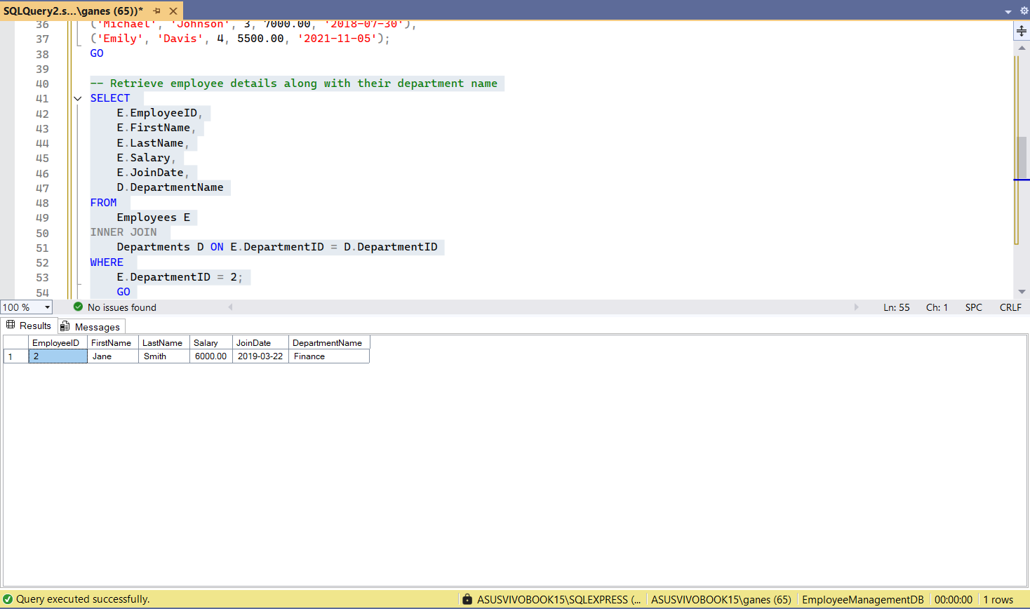OUTPUT :

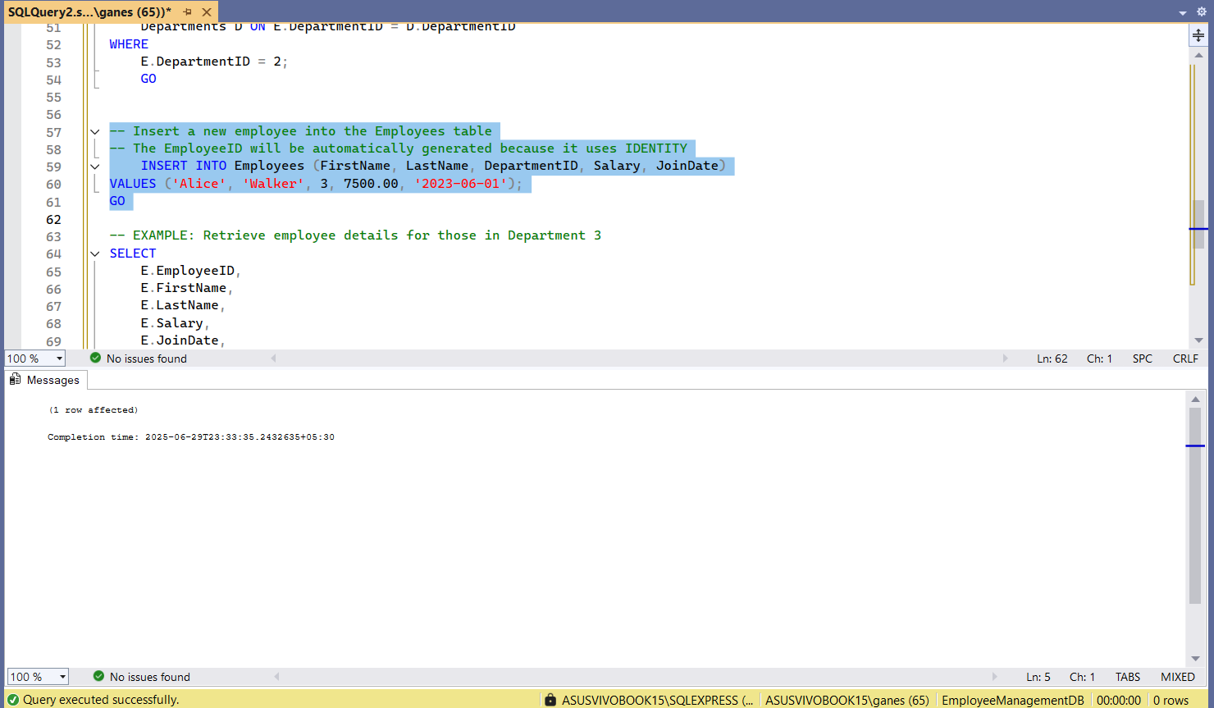

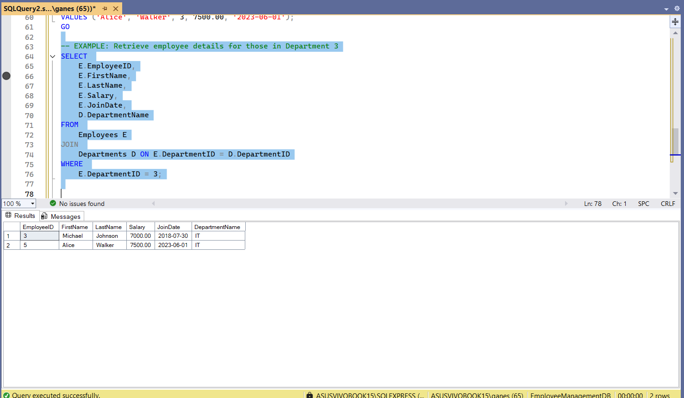

**Exercise 5: Return Data from a Stored Procedure**

Code :

-- Create Database

CREATE DATABASE OrgDB_StaffCounter;

GO

USE OrgDB_StaffCounter;

GO

-- Create Division Table

CREATE TABLE Divisions (

DivisionID INT PRIMARY KEY IDENTITY(1,1),

DivisionName VARCHAR(100) NOT NULL

);

GO

-- Create Staff Table

CREATE TABLE Staff (

StaffID INT PRIMARY KEY IDENTITY(1,1),

First_Name VARCHAR(50) NOT NULL,

Last_Name VARCHAR(50) NOT NULL,

DivisionID INT NOT NULL,

Pay DECIMAL(10,2),

HireDate DATE,

FOREIGN KEY (DivisionID) REFERENCES Divisions(DivisionID)

);

GO

-- Insert Sample Divisions

INSERT INTO Divisions (DivisionName) VALUES

('Operations'),

('Accounts'),

('Technology'),

('Sales');

GO

-- Insert Sample Staff

INSERT INTO Staff (First_Name, Last_Name, DivisionID, Pay, HireDate) VALUES

('Ananya', 'Iyer', 3, 85000, '2024-03-05'), -- Technology

('Rahul', 'Verma', 3, 74000, '2023-08-10'), -- Technology

('Meera', 'Nair', 1, 91000, '2022-06-22'), -- Operations

('Arjun', 'Patel', 2, 77000, '2024-02-15'); -- Accounts

GO

-- Create Stored Procedure to Return Staff Count by Division

CREATE PROCEDURE sp_GetStaffCountByDivision

@DivisionID INT

AS

BEGIN

SELECT

COUNT(*) AS TotalStaff

FROM

Staff

WHERE

DivisionID = @DivisionID;

END;

GO

-- Example Query: Get Staff Count for Technology Division (DivisionID = 3)

EXEC sp_GetStaffCountByDivision @DivisionID = 3;

GO

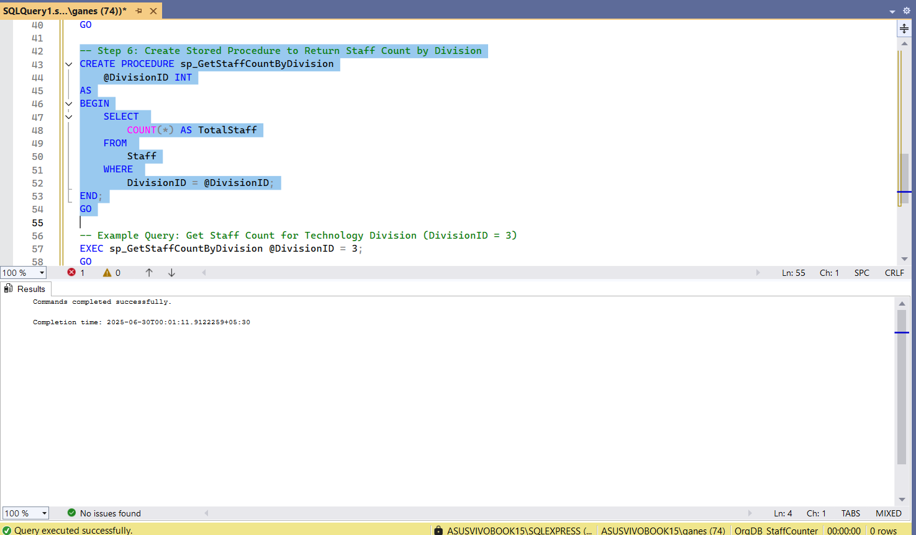OUTPUT :

