**Kafka Integration with C#:**

Code:

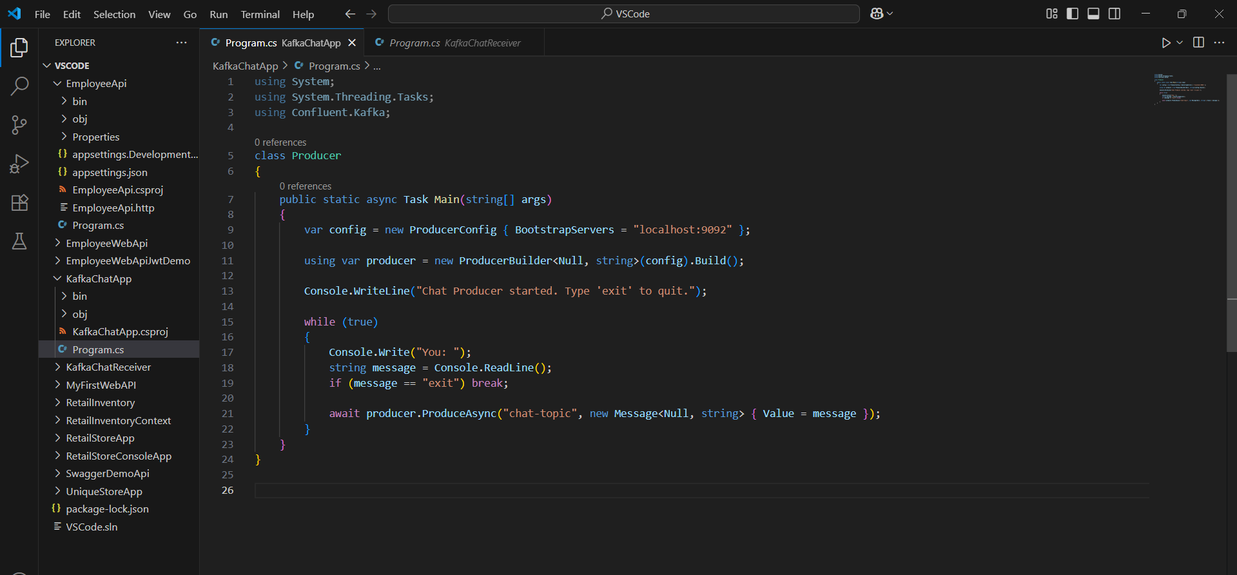Producer Code -

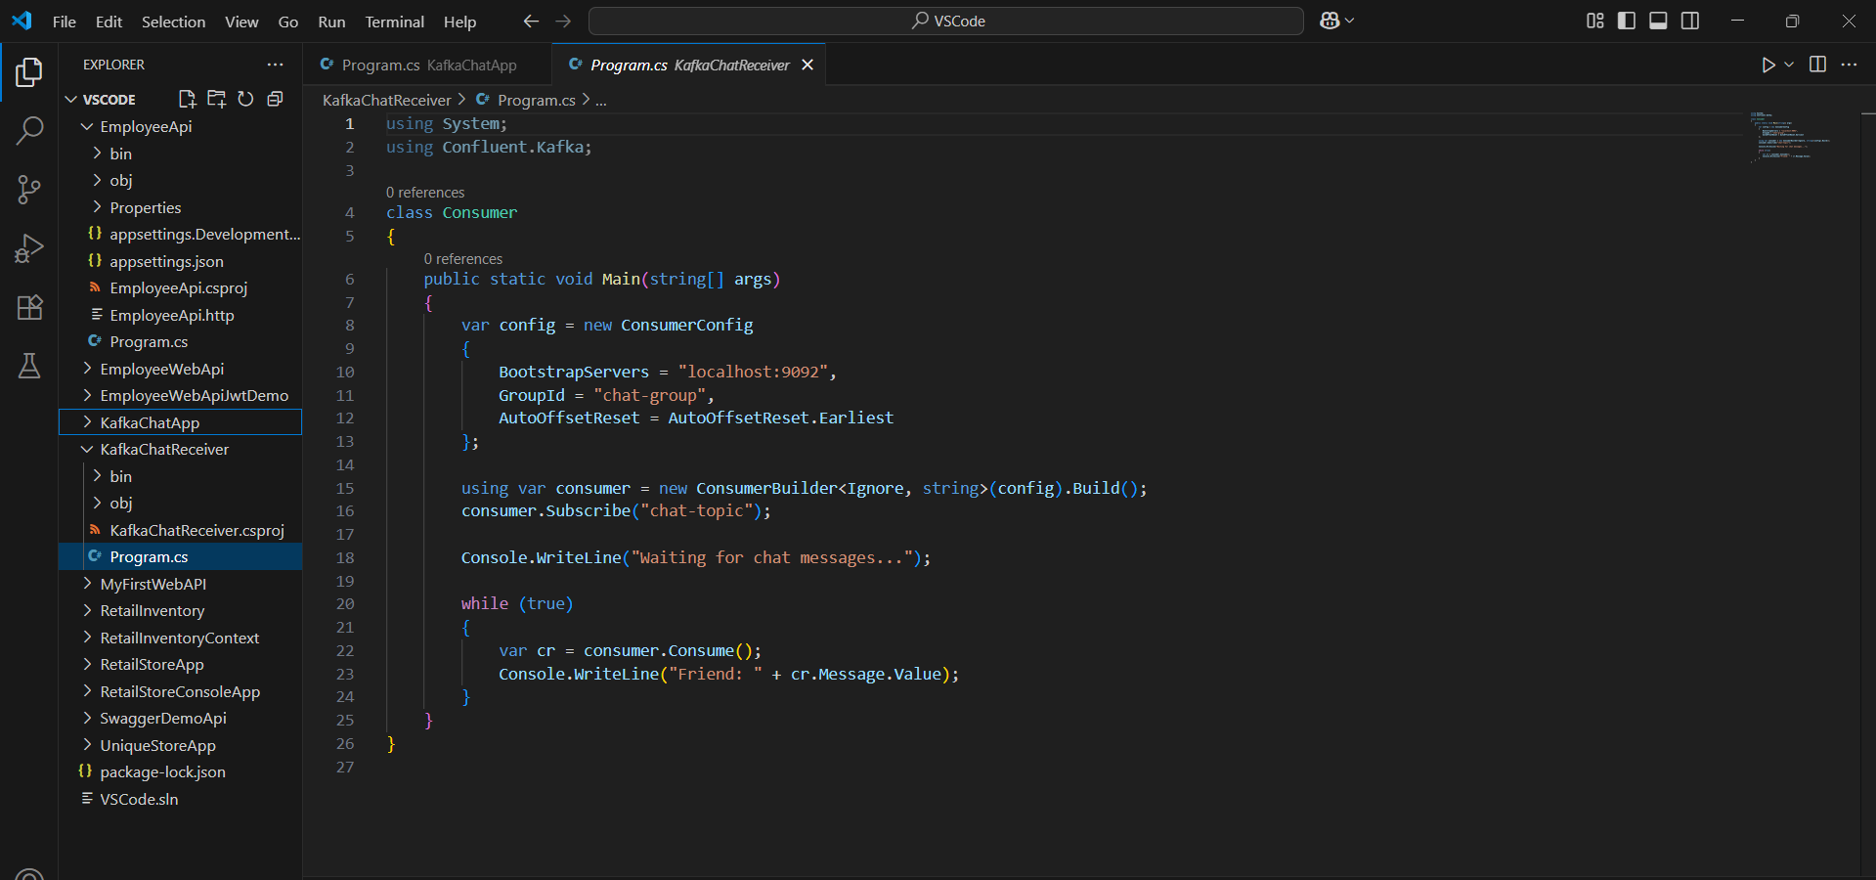Consumer Code:

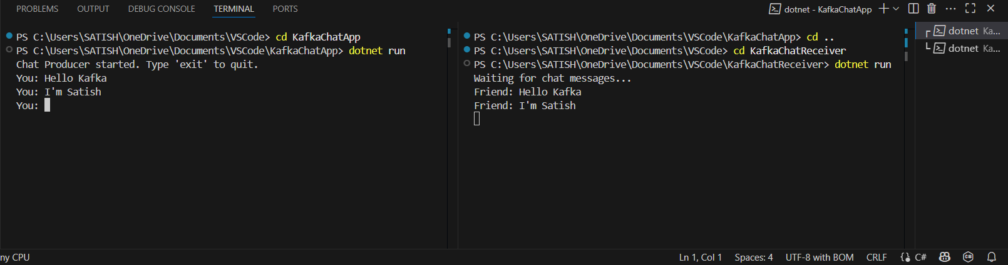OUTPUT: