REACTJS – HANDSON LEARNING

Exercise - 1

**CODE & OUTPUT :**

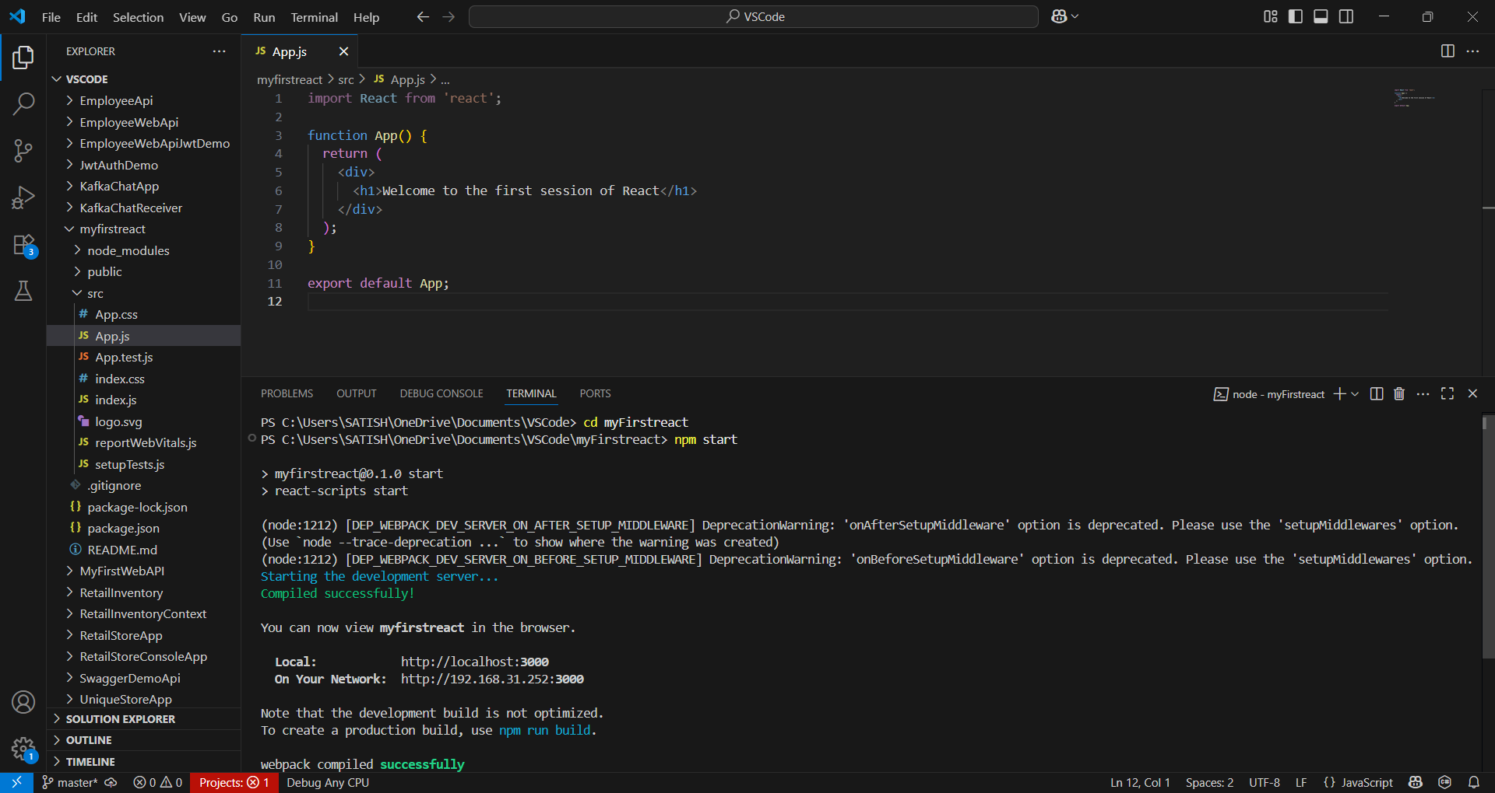

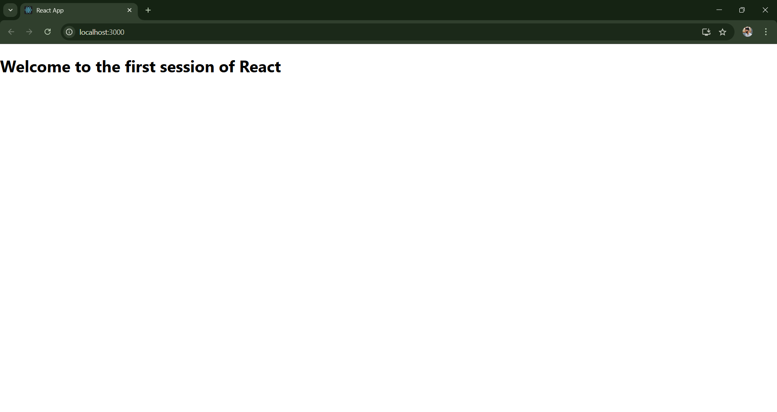

App.js :

import React from 'react';

function App() {

  return (

    <div>

      <h1>Welcome to the first session of React</h1>

    </div>

  );

}

export default App;