**REACTJS – HANDSON LEARNING**

**Exercise - 2**

**CODE:**

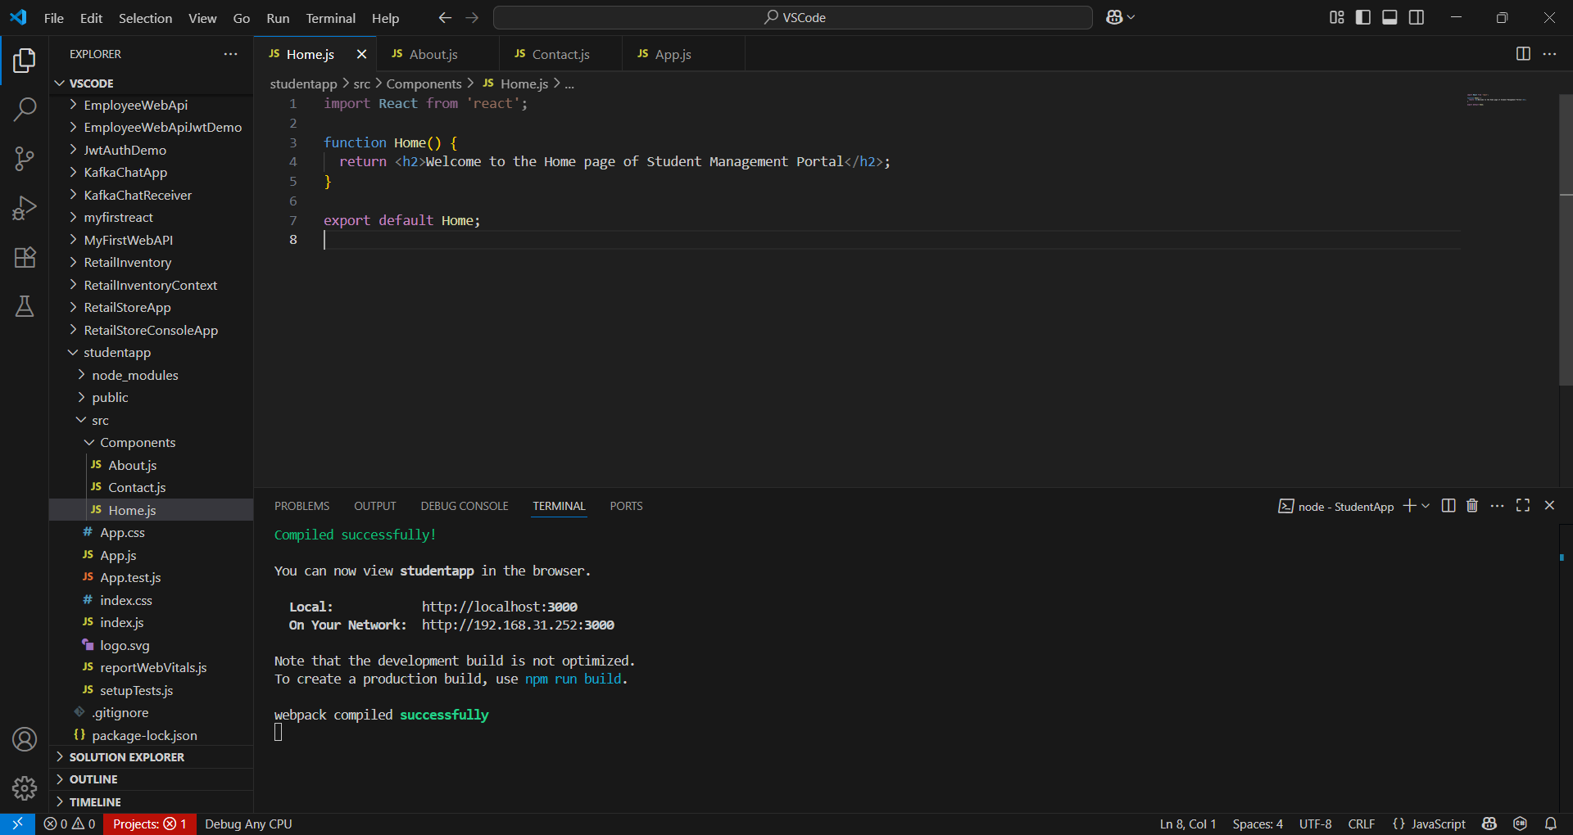

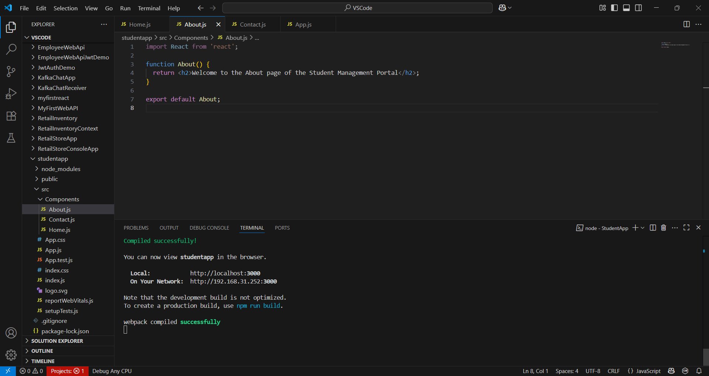

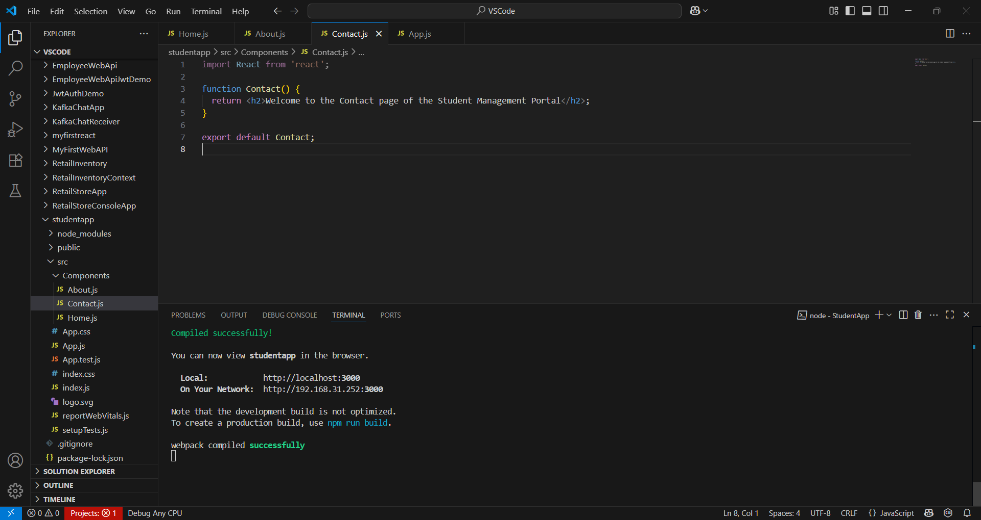

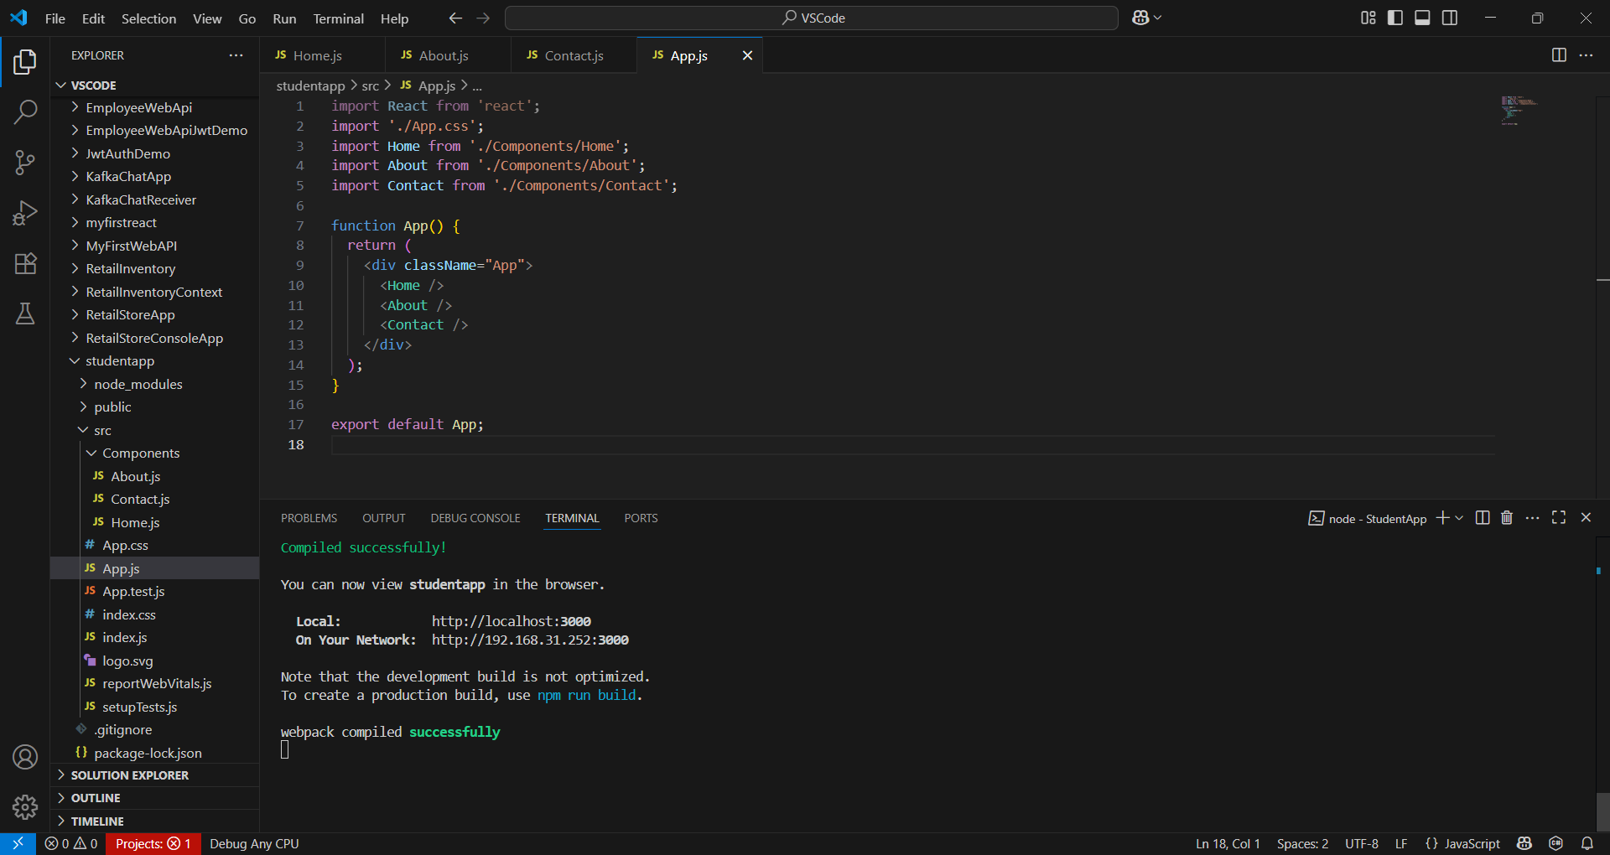

**OUTPUT:**

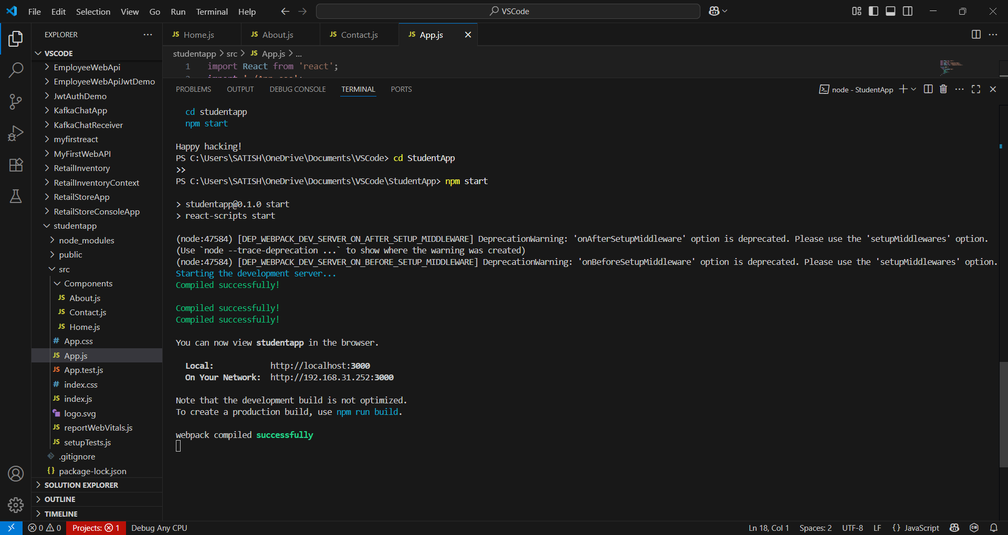

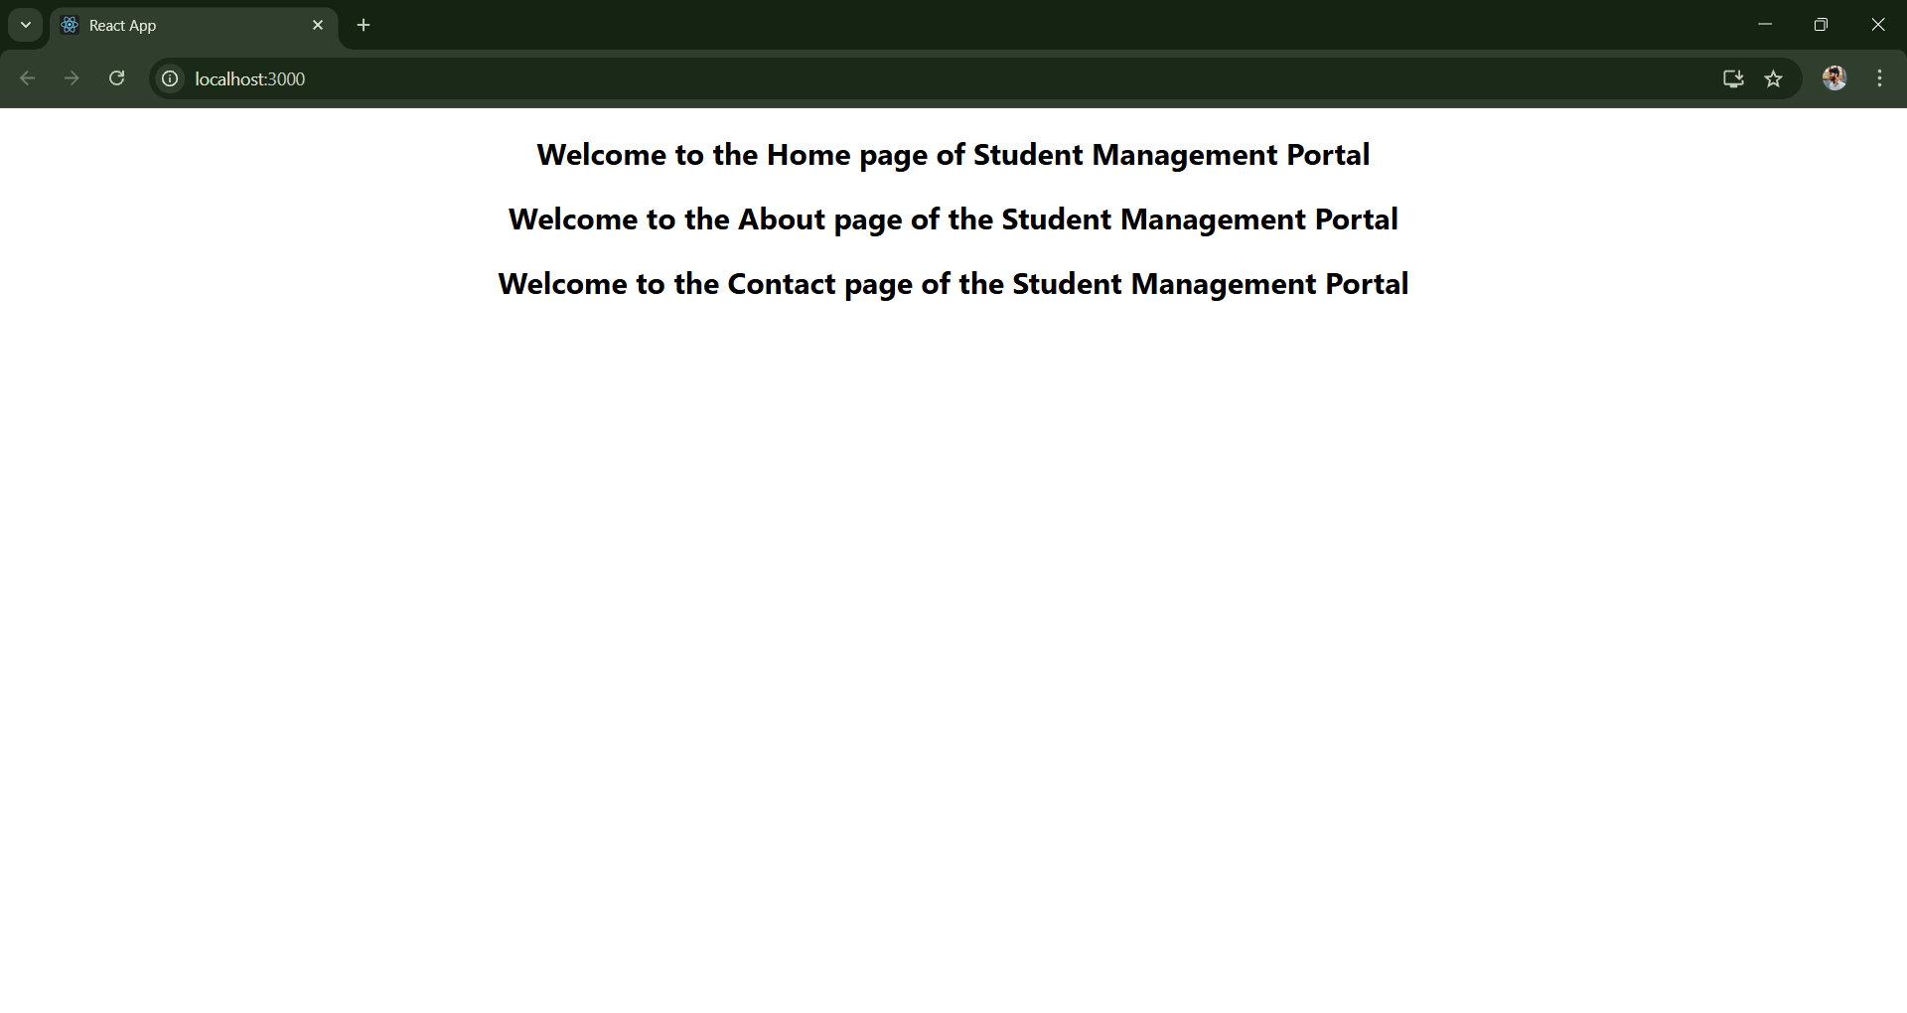

**Home.js :**

import React from 'react';

function Home() {

  return <h2>Welcome to the Home page of Student Management Portal</h2>;

}

export default Home;

**About.js :**

import React from 'react';

function About() {

  return <h2>Welcome to the About page of the Student Management Portal</h2>;

}

export default About;

**Contact.js :**

import React from 'react';

function Contact() {

  return <h2>Welcome to the Contact page of the Student Management Portal</h2>;

}

export default Contact;

**App.js** :

import React from 'react';

import './App.css';

import Home from './Components/Home';

import About from './Components/About';

import Contact from './Components/Contact';

function App() {

  return (

    <div className="App">

      <Home />

      <About />

      <Contact />

    </div>

  );

}

export default App;