**REACTJS – HANDSON LEARNING**

**Exercise - 3**

**CODE:**

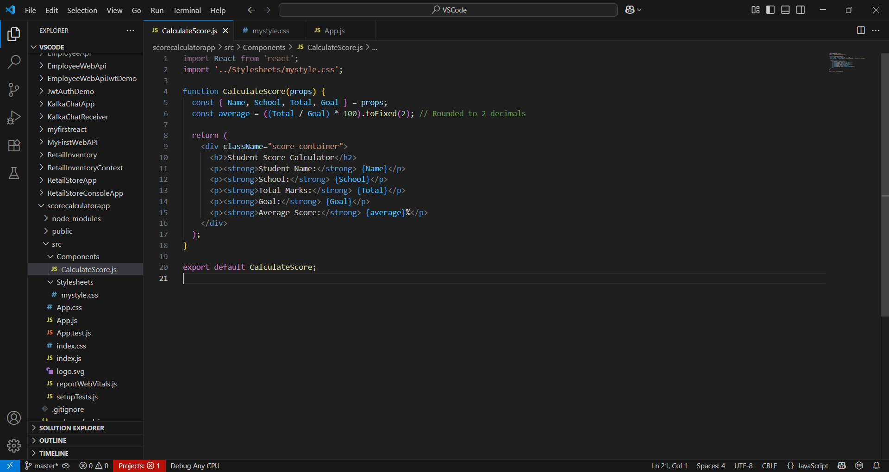

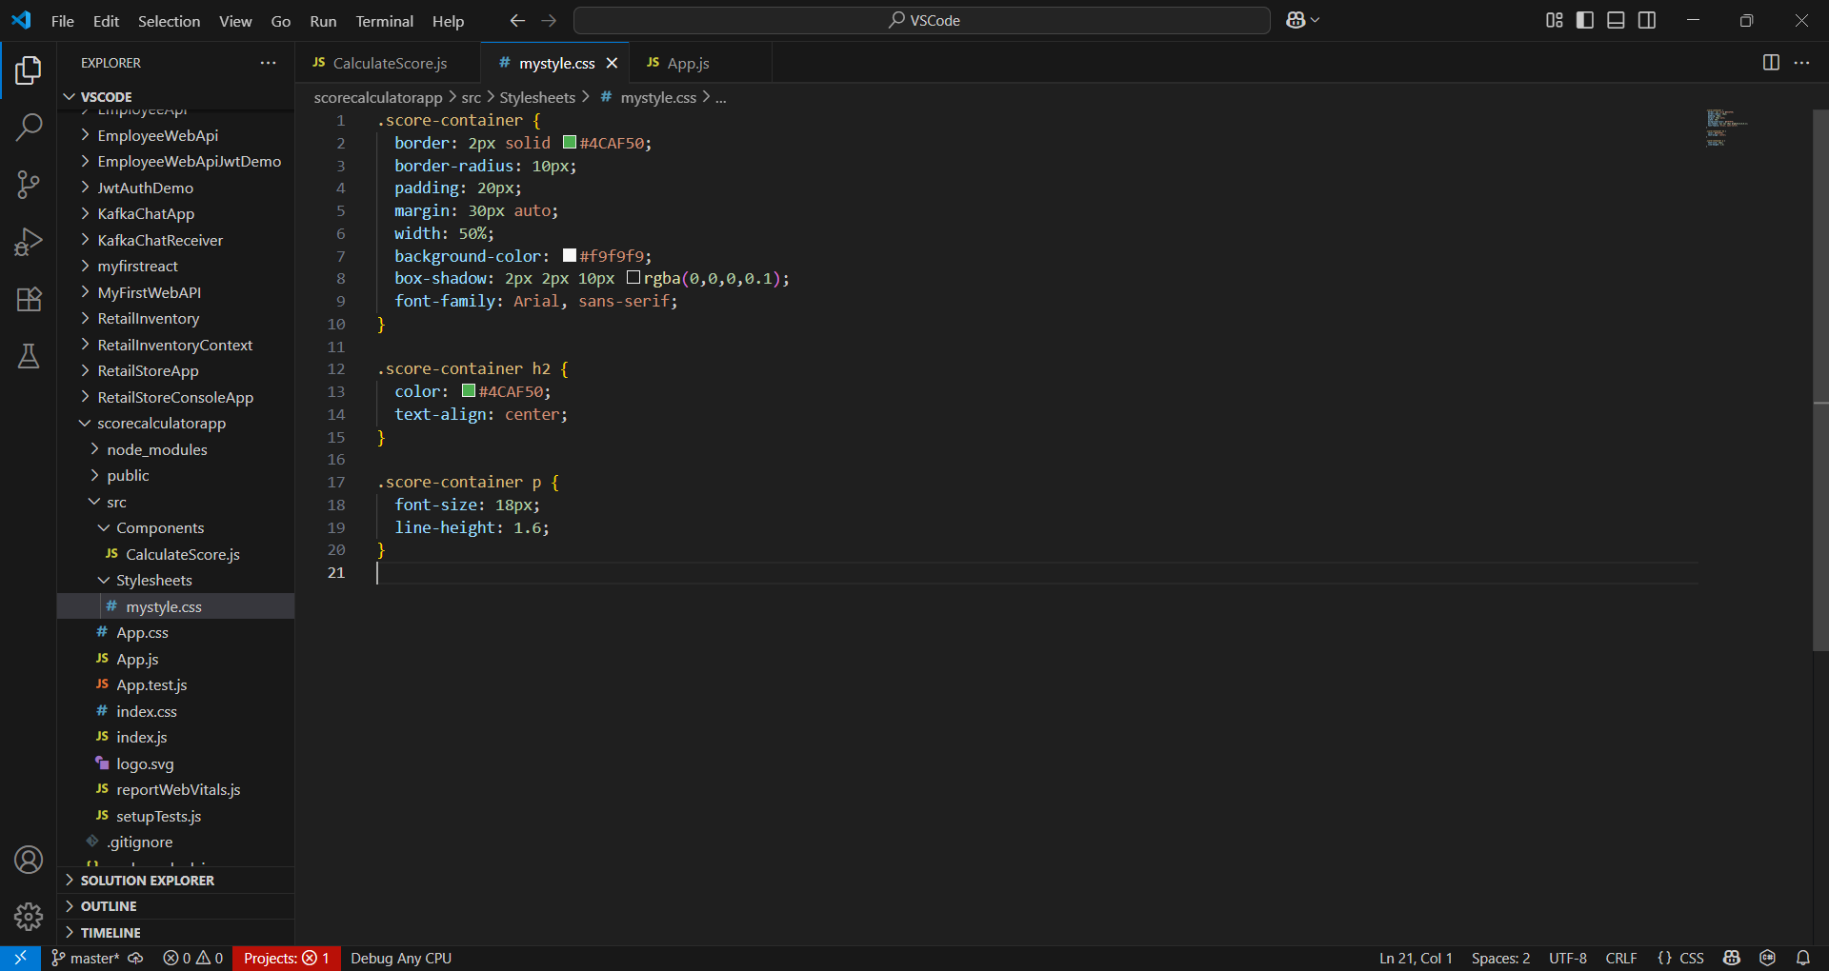

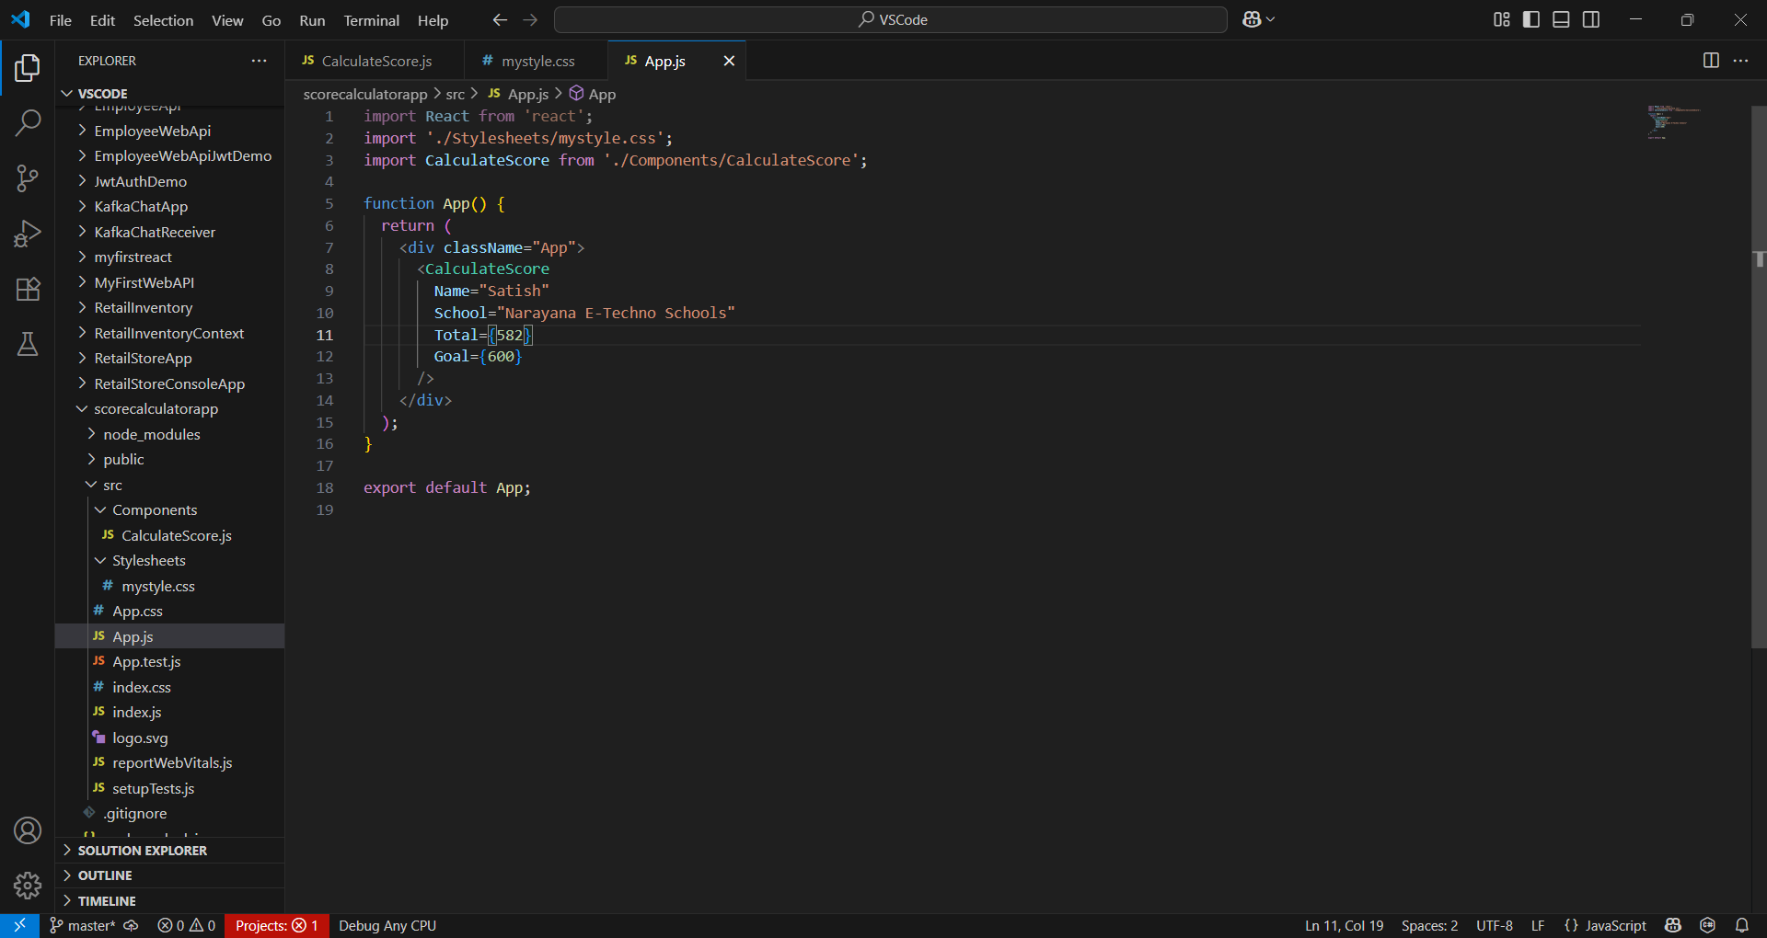

**OUTPUT:**

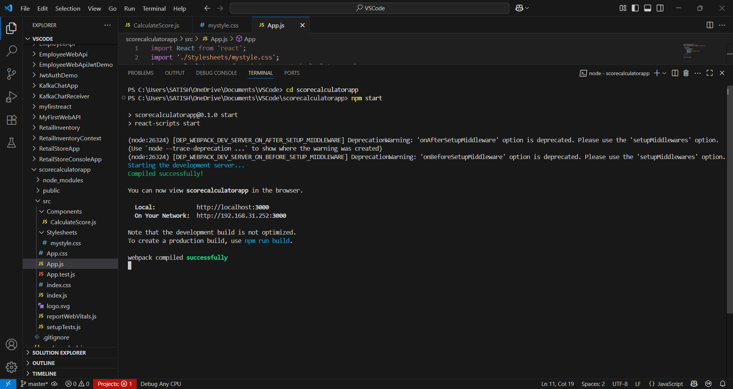

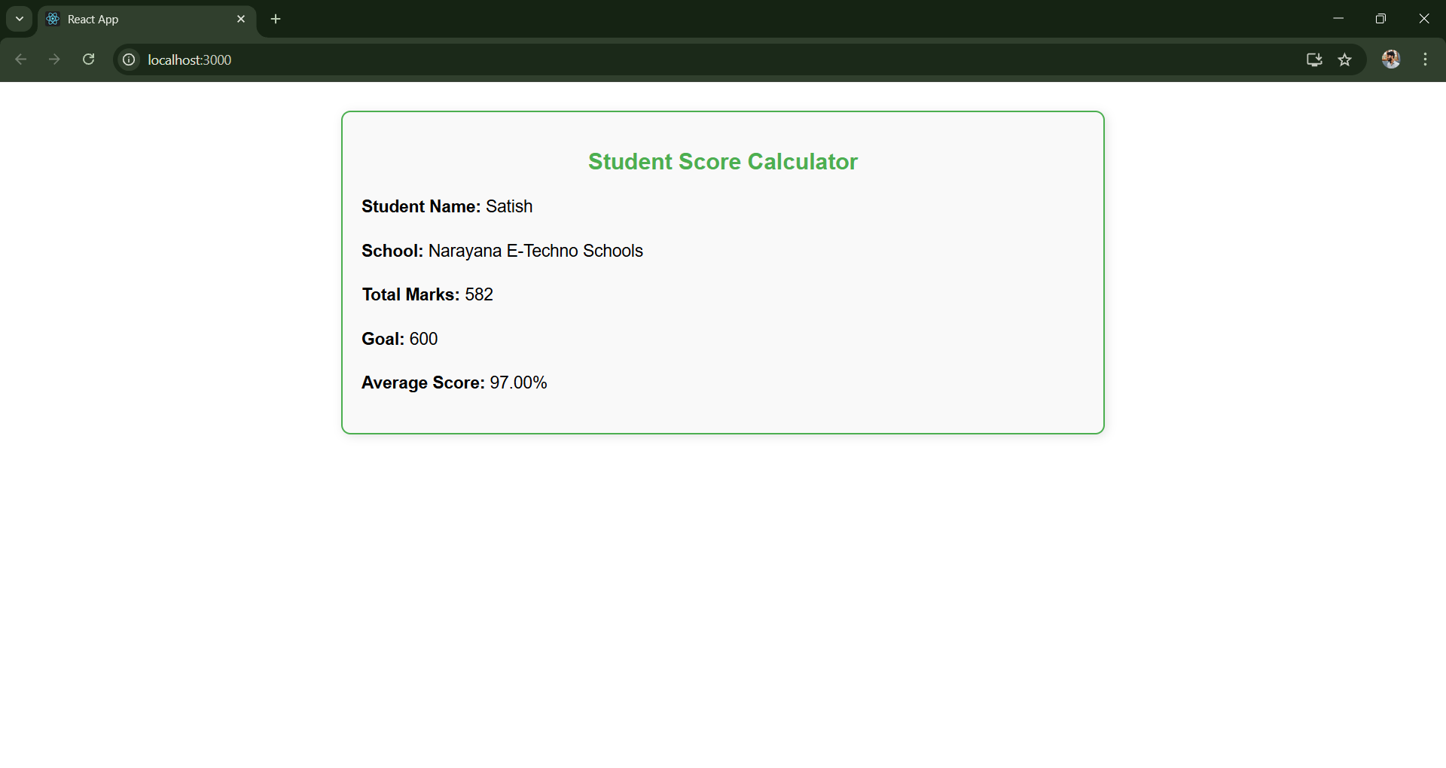

**CalculateScore.js :**

import React from 'react';

import '../Stylesheets/mystyle.css';

function CalculateScore(props) {

  const { Name, School, Total, Goal } = props;

  const average = ((Total / Goal) * 100).toFixed(2); // Rounded to 2 decimals

  return (

    <div className="score-container">

      <h2>Student Score Calculator</h2>

      <p><strong>Student Name:</strong> {Name}</p>

      <p><strong>School:</strong> {School}</p>

      <p><strong>Total Marks:</strong> {Total}</p>

      <p><strong>Goal:</strong> {Goal}</p>

      <p><strong>Average Score:</strong> {average}%</p>

    </div>

  );

}

export default CalculateScore;

**mystyle.css :**

.score-container {

  border: 2px solid #4CAF50;

  border-radius: 10px;

  padding: 20px;

  margin: 30px auto;

  width: 50%;

  background-color: #f9f9f9;

  box-shadow: 2px 2px 10px rgba(0,0,0,0.1);

  font-family: Arial, sans-serif;

}

.score-container h2 {

  color: #4CAF50;

  text-align: center;

}

.score-container p {

  font-size: 18px;

  line-height: 1.6;

}

**App.js :**

import React from 'react';

import './Stylesheets/mystyle.css';

import CalculateScore from './Components/CalculateScore';

function App() {

  return (

    <div className="App">

      <CalculateScore

        Name="Satish"

        School="Narayana E-Techno Schools"

        Total={582}

        Goal={600}

      />

    </div>

  );

}

export default App;