**REACTJS – HANDSON LEARNING**

**Exercise – 4**

**CODE:**

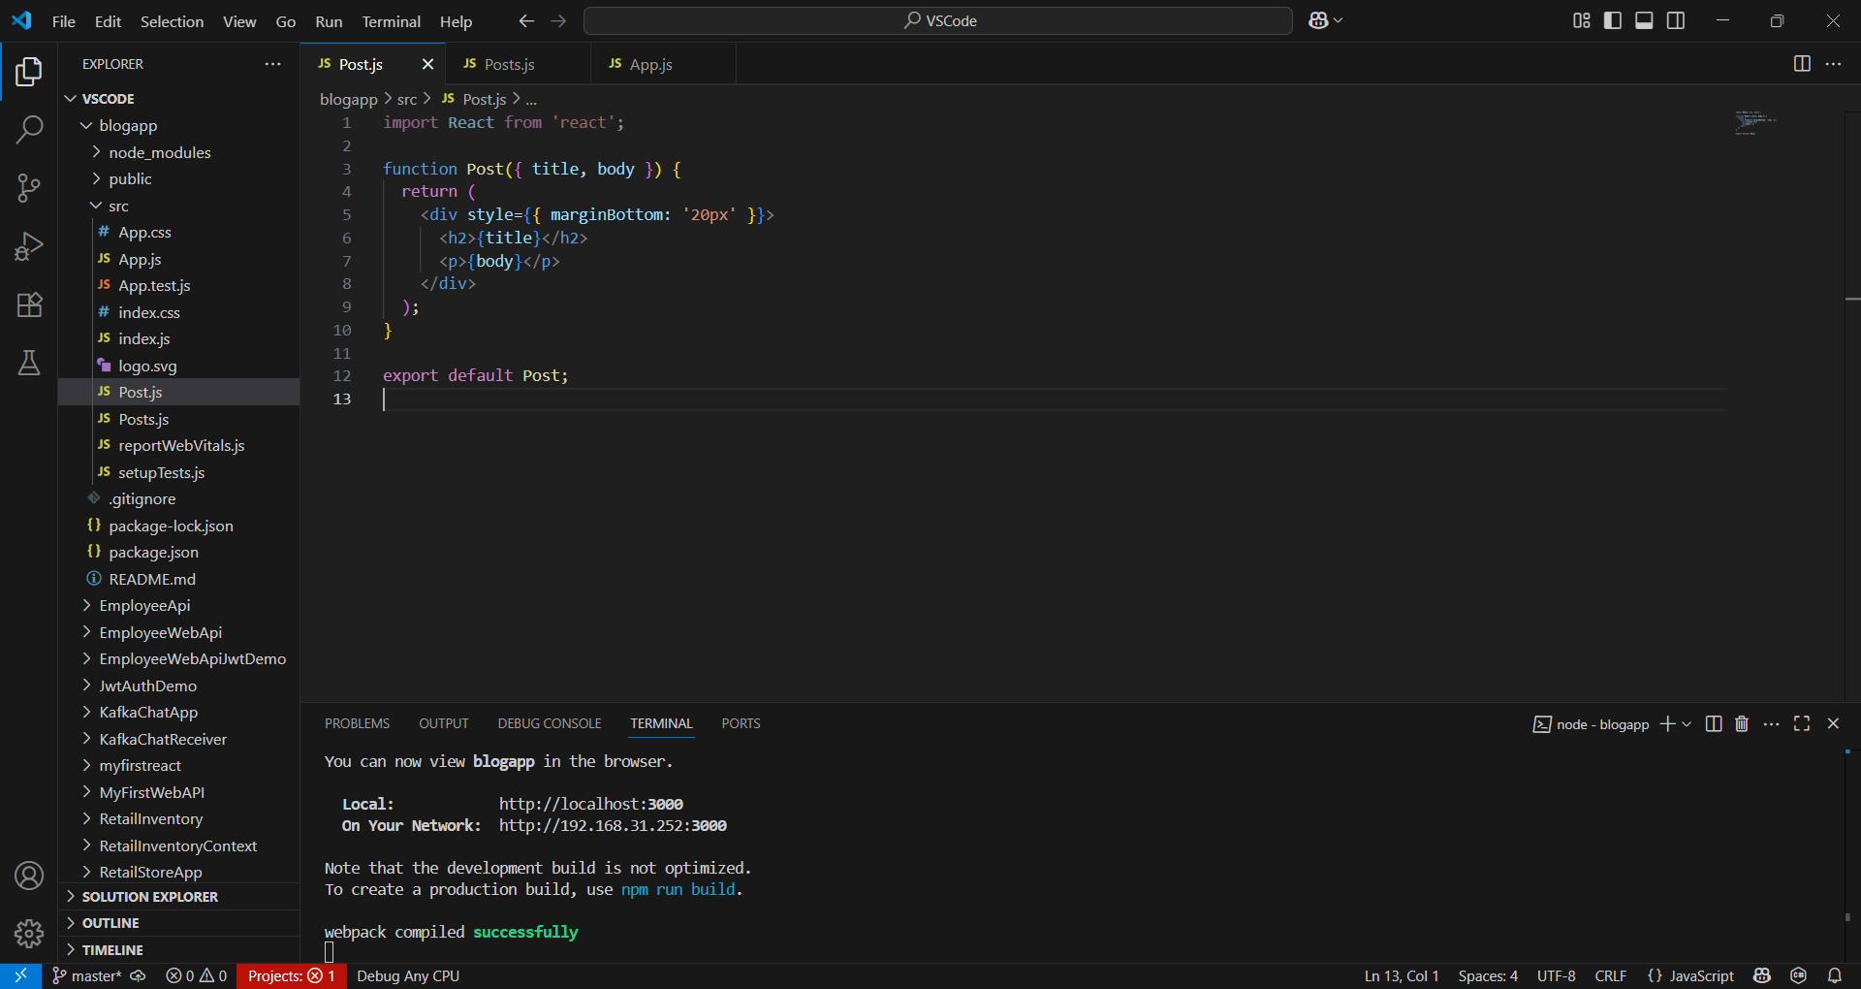

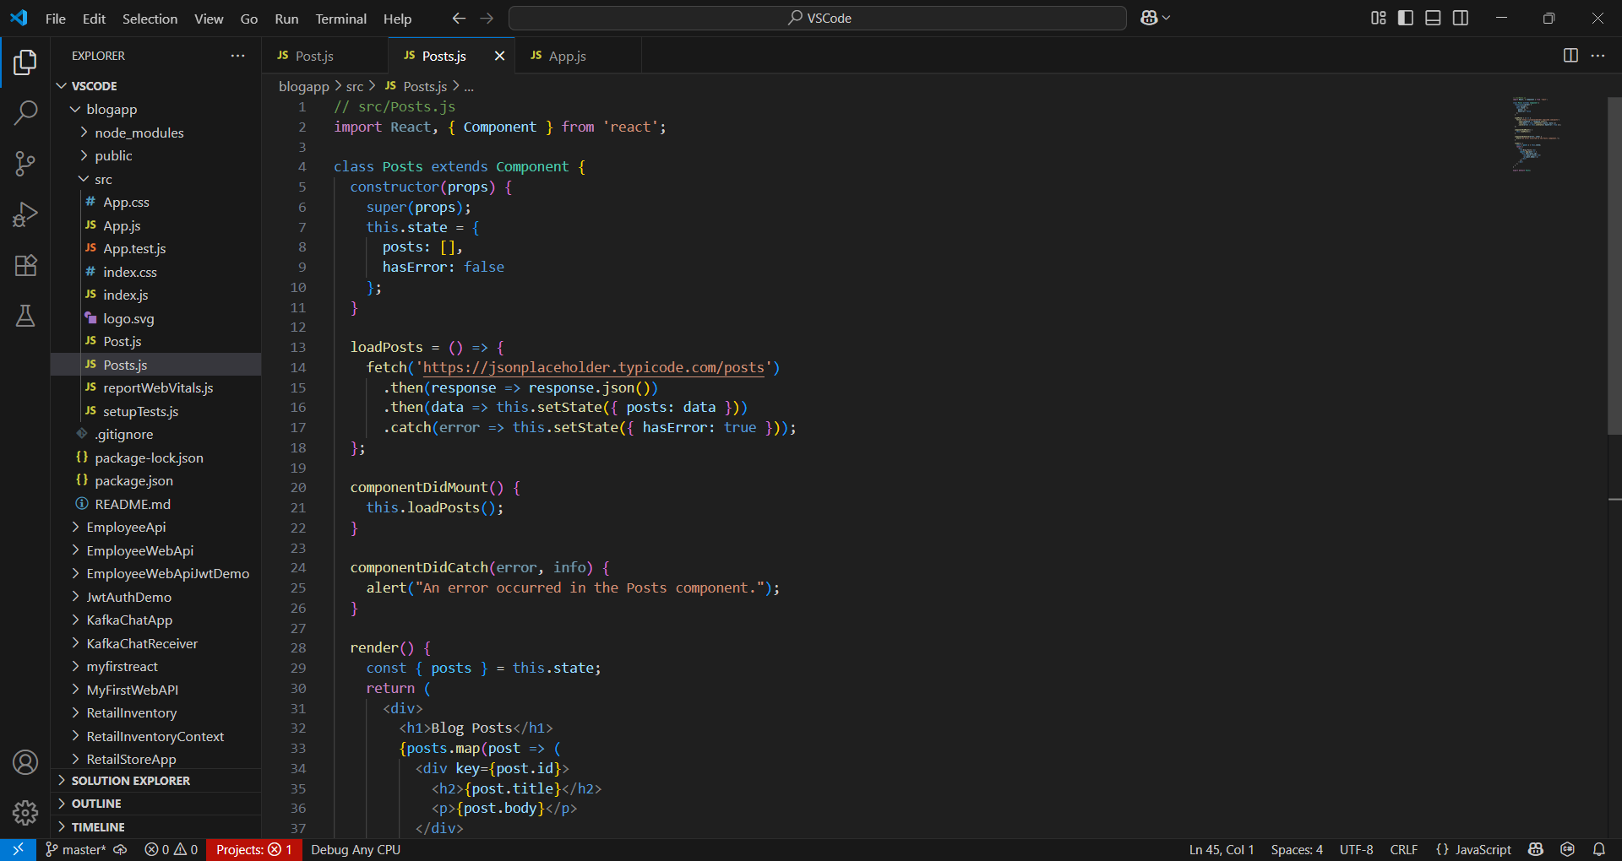

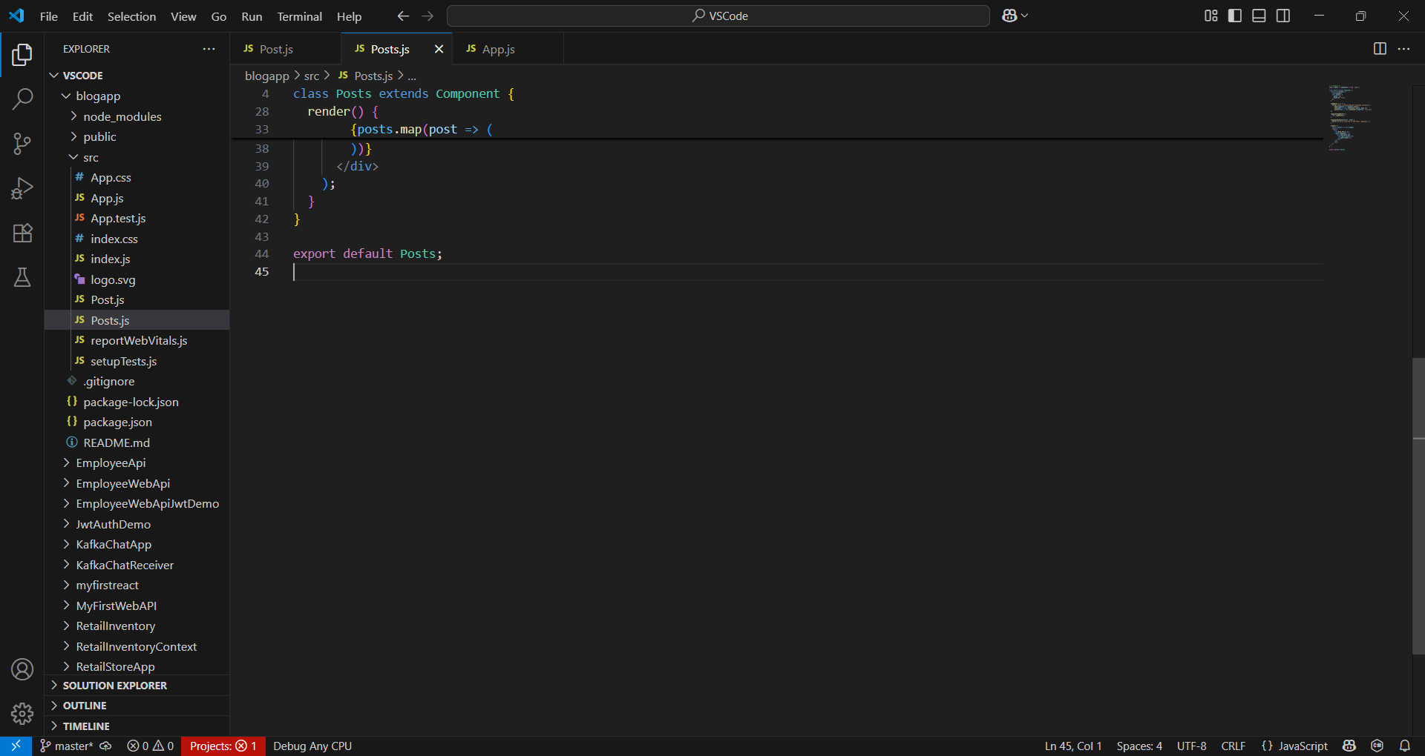

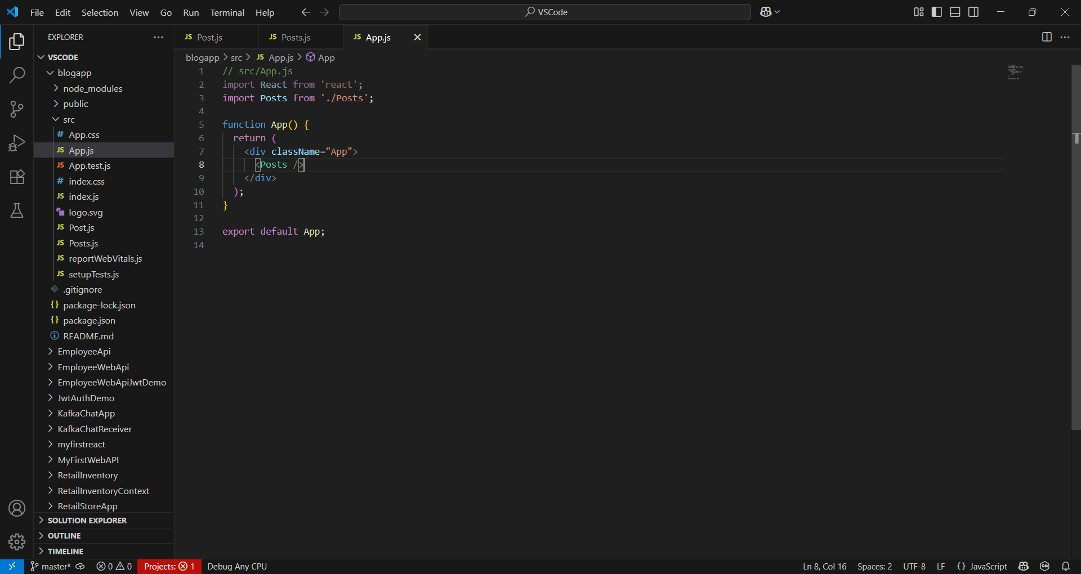

**OUTPUT:**

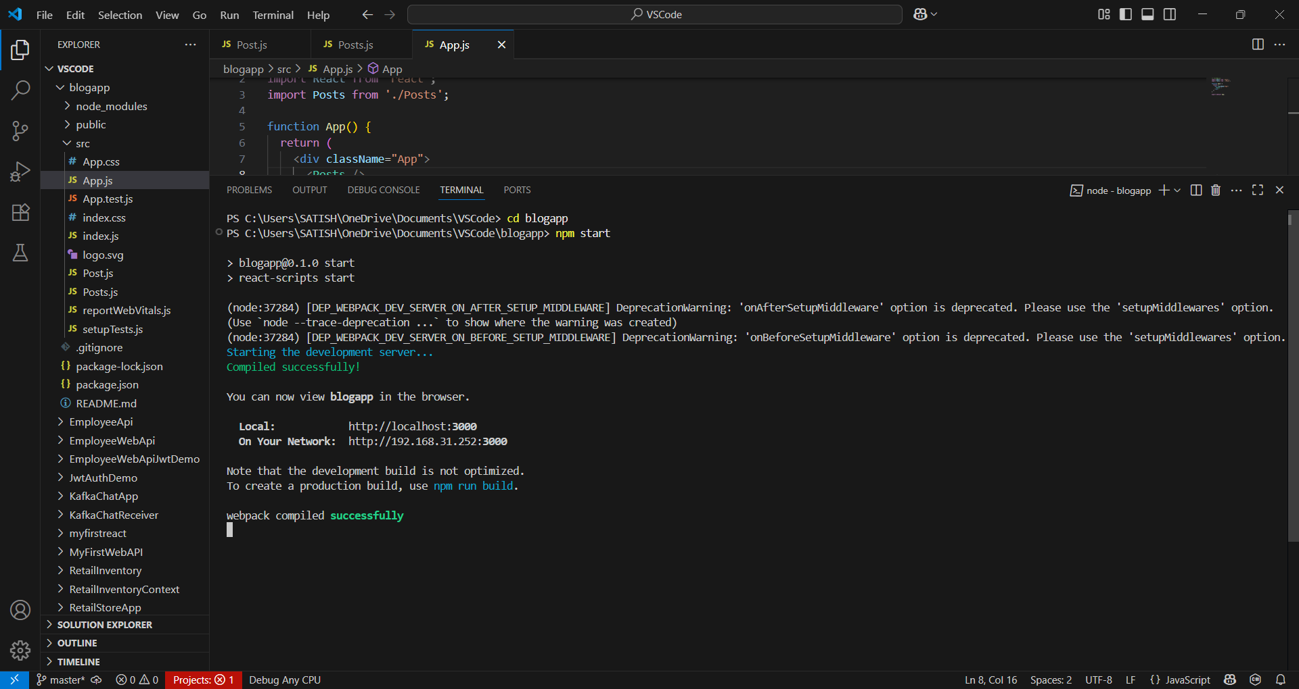

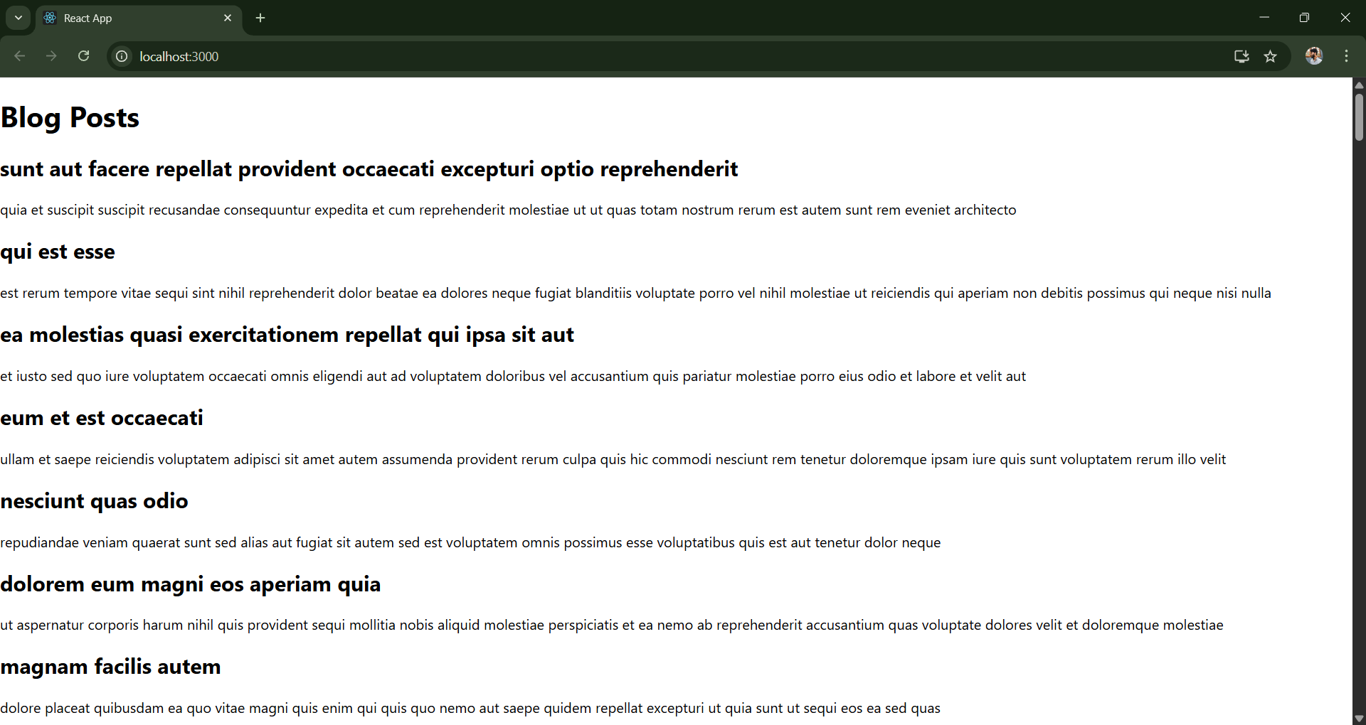

**Post.js :**

// src/App.js

import React from 'react';

import Posts from './Posts';

function App() {

  return (

    <div className="App">

      <Posts />

    </div>

  );

}

export default App;

**Posts.js :**

// src/Posts.js

import React, { Component } from 'react';

class Posts extends Component {

  constructor(props) {

    super(props);

    this.state = {

      posts: [],

      hasError: false

    };

  }

  loadPosts = () => {

    fetch('https://jsonplaceholder.typicode.com/posts')

      .then(response => response.json())

      .then(data => this.setState({ posts: data }))

      .catch(error => this.setState({ hasError: true }));

  };

  componentDidMount() {

    this.loadPosts();

  }

  componentDidCatch(error, info) {

    alert("An error occurred in the Posts component.");

  }

  render() {

    const { posts } = this.state;

    return (

      <div>

        <h1>Blog Posts</h1>

        {posts.map(post => (

          <div key={post.id}>

            <h2>{post.title}</h2>

            <p>{post.body}</p>

          </div>

        ))}

      </div>

    );

  }

}

export default Posts;

**App.js :**

// src/App.js

import React from 'react';

import Posts from './Posts';

function App() {

  return (

    <div className="App">

      <Posts />

    </div>

  );

}

export default App;