**REACTJS – HANDSON LEARNING**

**Exercise – 5**

CODE:

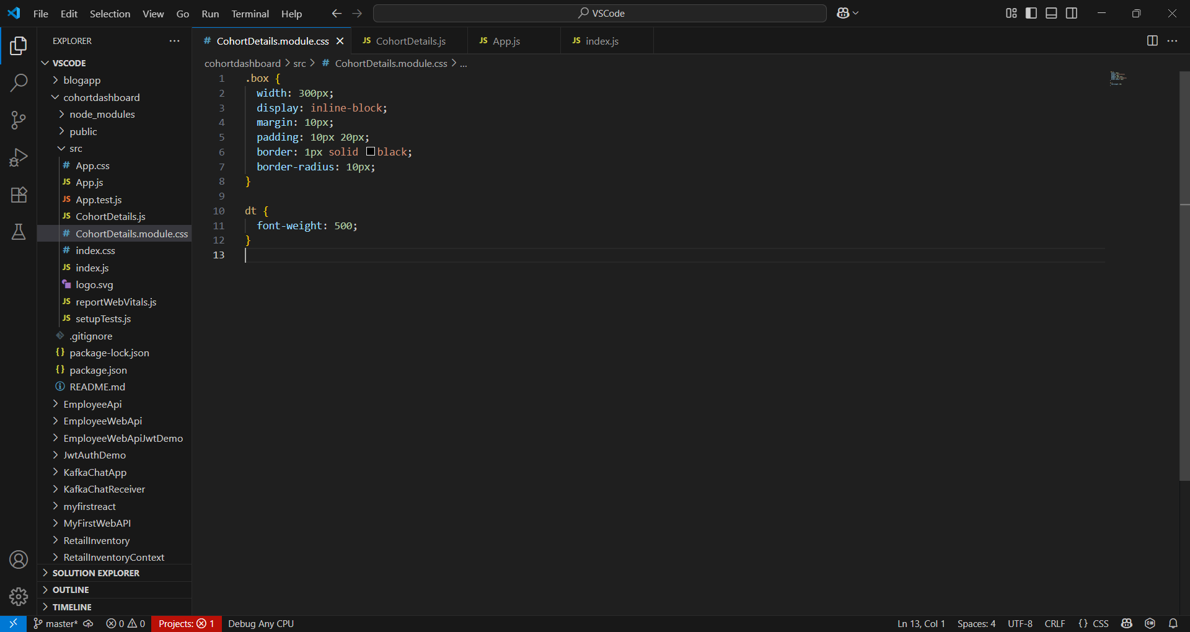

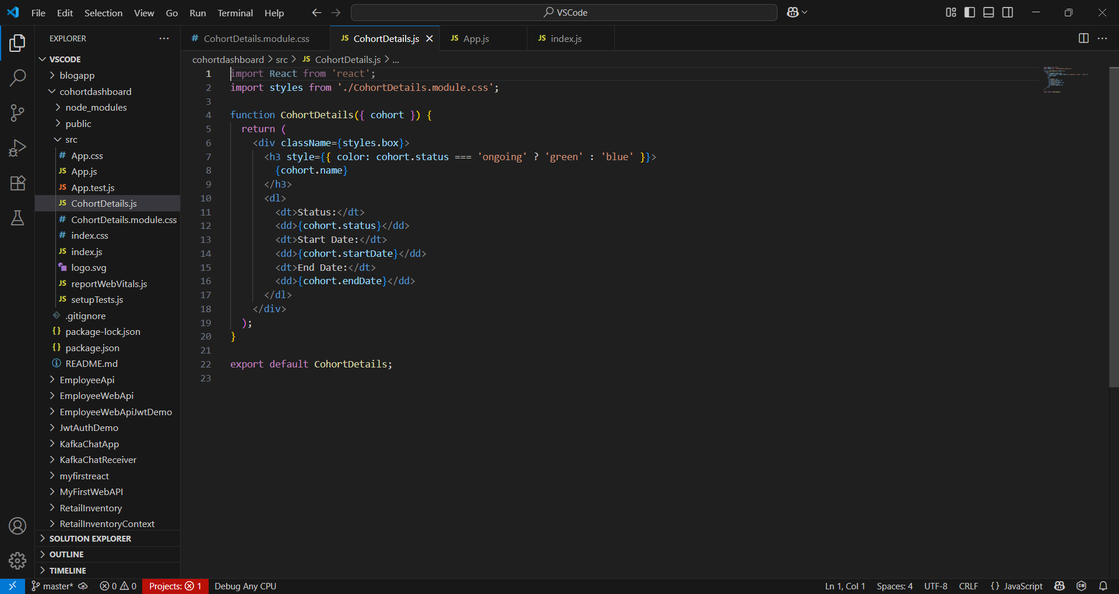

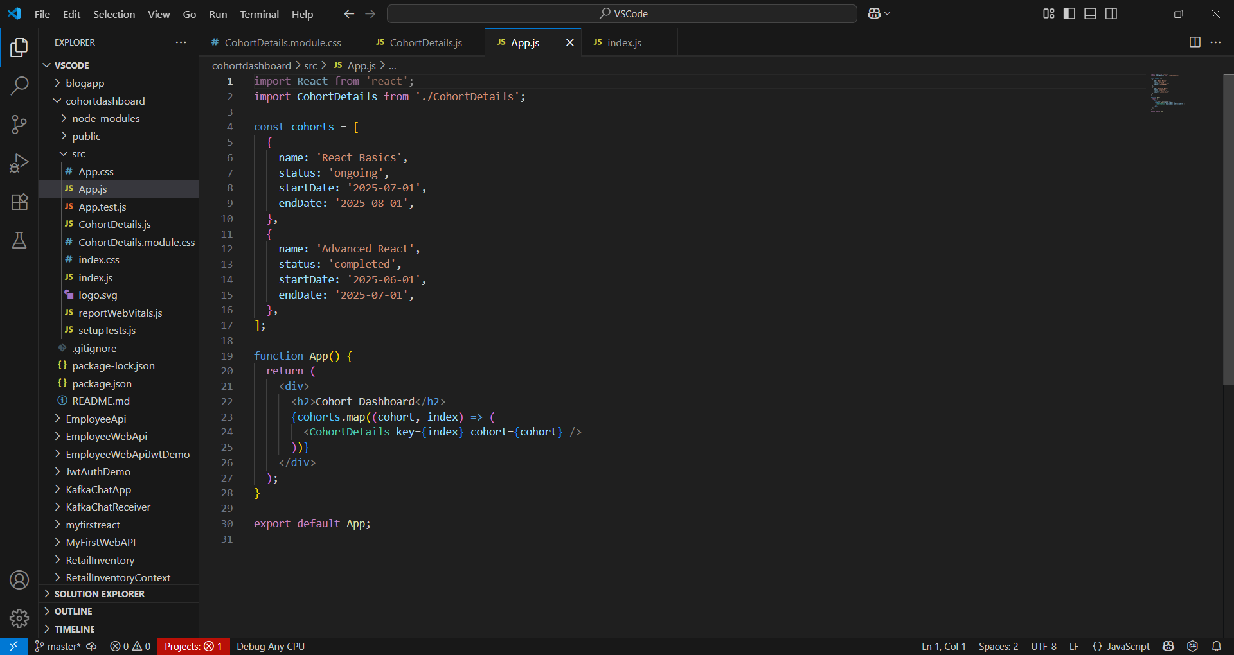

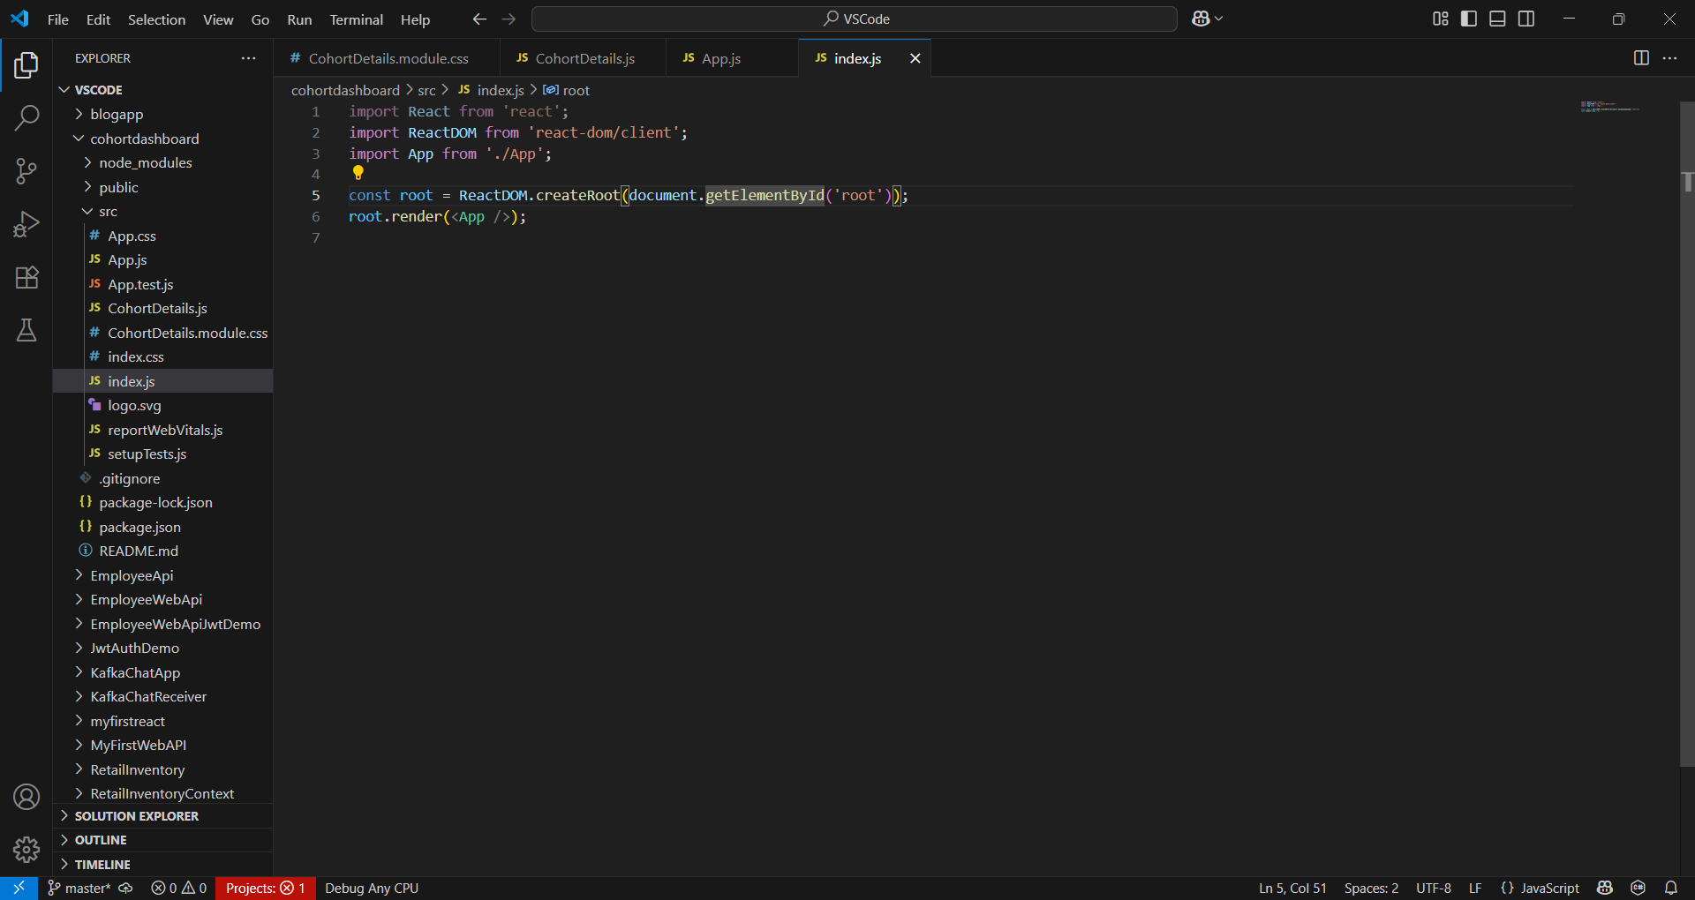

OUTPUT:

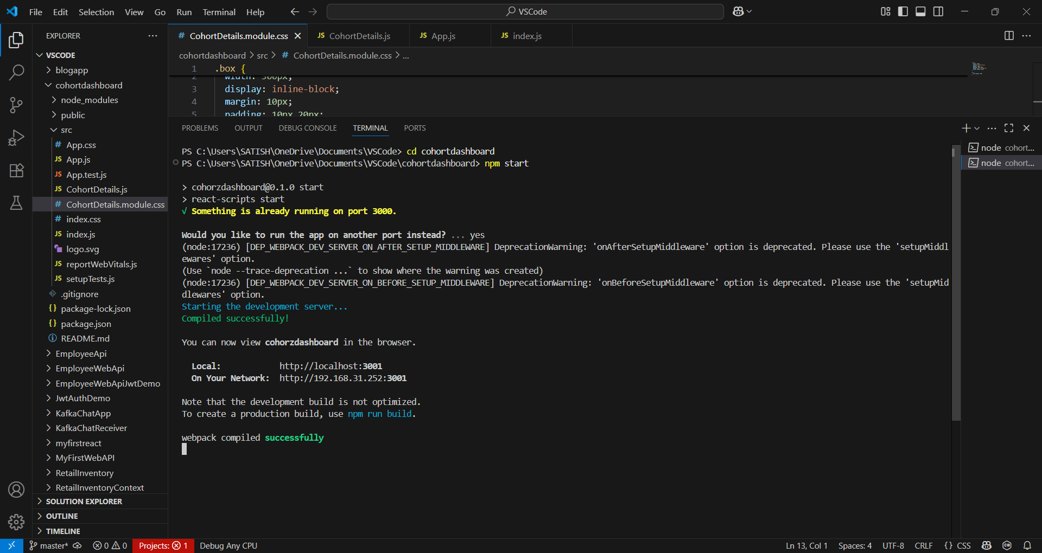

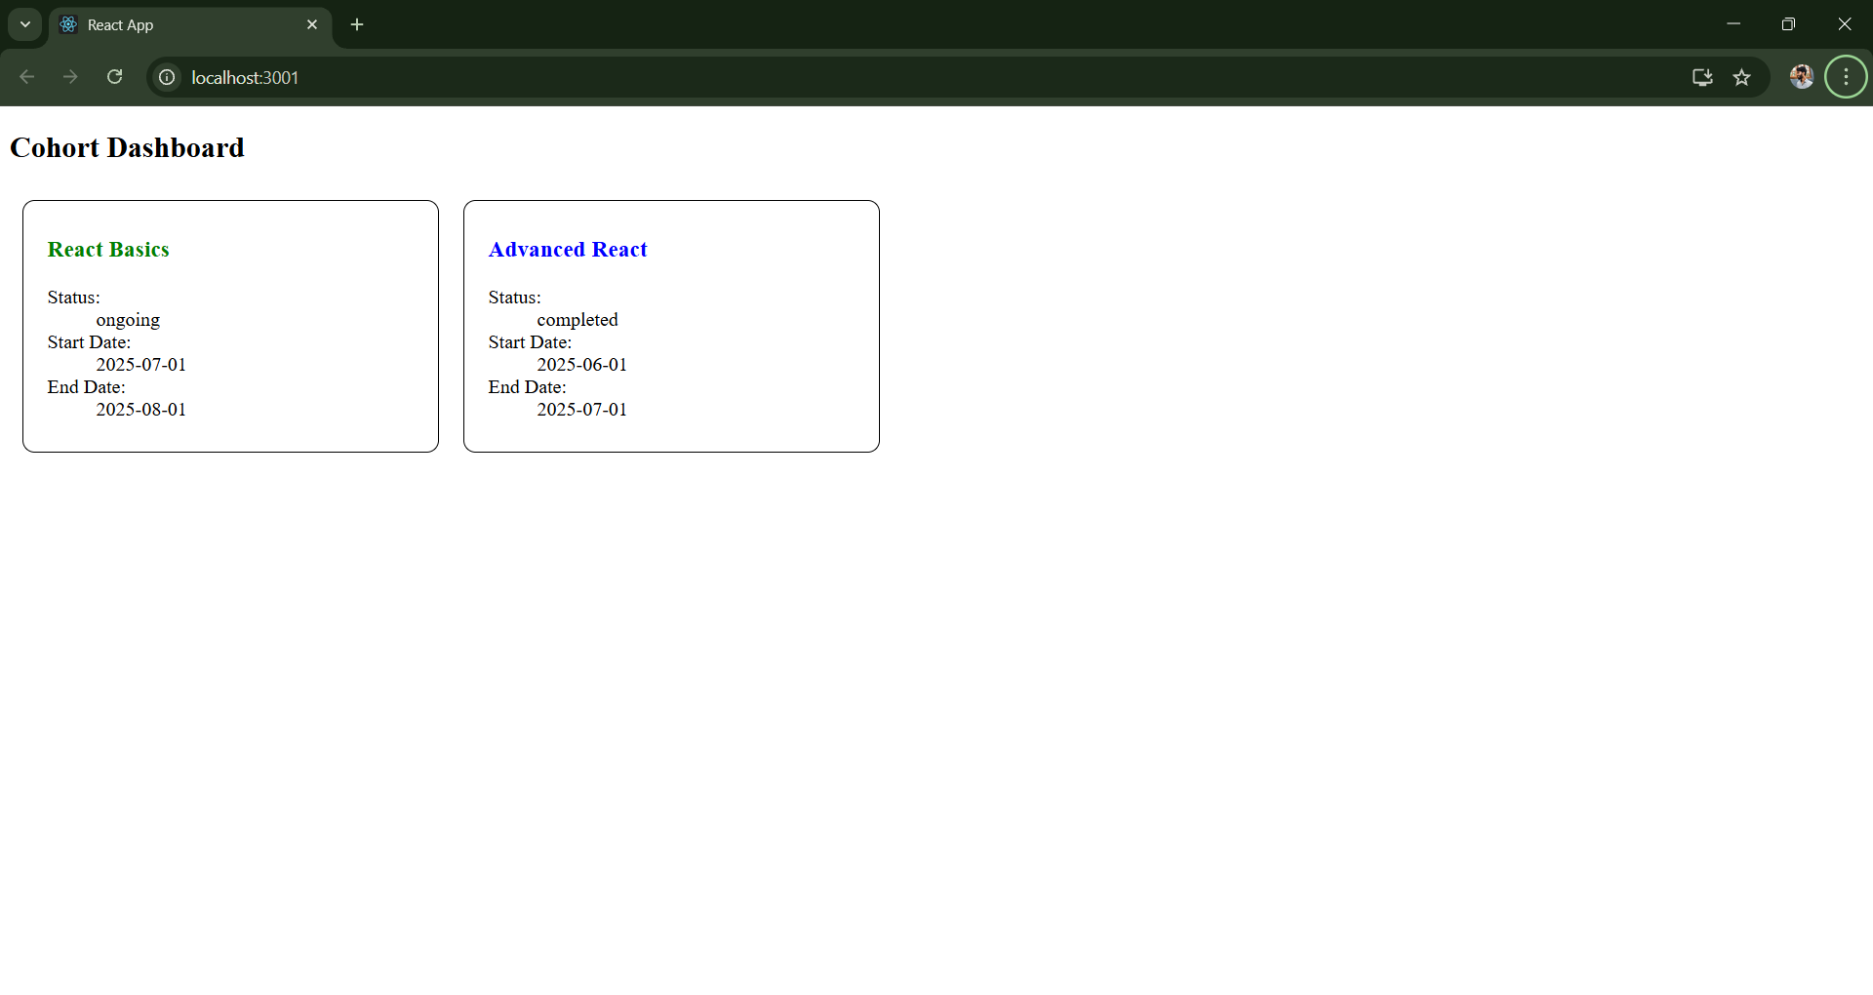

**CohortDetails.module.css :**

.box {

  width: 300px;

  display: inline-block;

  margin: 10px;

  padding: 10px 20px;

  border: 1px solid black;

  border-radius: 10px;

}

dt {

  font-weight: 500;

}

**CohortDetails.js :**

import React from 'react';

import styles from './CohortDetails.module.css';

function CohortDetails({ cohort }) {

  return (

    <div className={styles.box}>

      <h3 style={{ color: cohort.status === 'ongoing' ? 'green' : 'blue' }}>

        {cohort.name}

      </h3>

      <dl>

        <dt>Status:</dt>

        <dd>{cohort.status}</dd>

        <dt>Start Date:</dt>

        <dd>{cohort.startDate}</dd>

        <dt>End Date:</dt>

        <dd>{cohort.endDate}</dd>

      </dl>

    </div>

  );

}

export default CohortDetails;

**App.js :**

import React from 'react';

import CohortDetails from './CohortDetails';

const cohorts = [

  {

    name: 'React Basics',

    status: 'ongoing',

    startDate: '2025-07-01',

    endDate: '2025-08-01',

  },

  {

    name: 'Advanced React',

    status: 'completed',

    startDate: '2025-06-01',

    endDate: '2025-07-01',

  },

];

function App() {

  return (

    <div>

      <h2>Cohort Dashboard</h2>

      {cohorts.map((cohort, index) => (

        <CohortDetails key={index} cohort={cohort} />

      ))}

    </div>

  );

}

export default App;

**index.js :**

import React from 'react';

import ReactDOM from 'react-dom/client';

import App from './App';

const root = ReactDOM.createRoot(document.getElementById('root'));

root.render(<App />);