**Weather Forecast**

**Brief use case:**

**Actors: User, weather api**

**Type: secondary**

**Description:**

A user wants to check the weather, he clicks the check weather and a weather api will get the weather data from the weather system , the received data will be than display it to a user.

**Fully dressed use case :**

**Name:** Check weather

**Scope:** Prediction of weather.

**Level:** Notifying users about the weather information.

**Primary Actor:** User

**Secondary Actor:** Weather Api

**Pre-Condition:** Login

**Post-Condition:** Weather displayed.

**Stakeholders:** User, Developer

**Main Success Scenario:** User wants to check the weather; system will use the weather api for collecting the information form the weather station and displaying it to the user.

**Extensions:** Error saying server not available.

**Operation Contract:**

**Operation :** getData

**Cross References:** Use case: **Check weather**

**Pre-conditions:** User wants to check the weather.

**Post-Condition:**  check weather instance is created and an Api gets the data from the weather system and is displayed to the user.

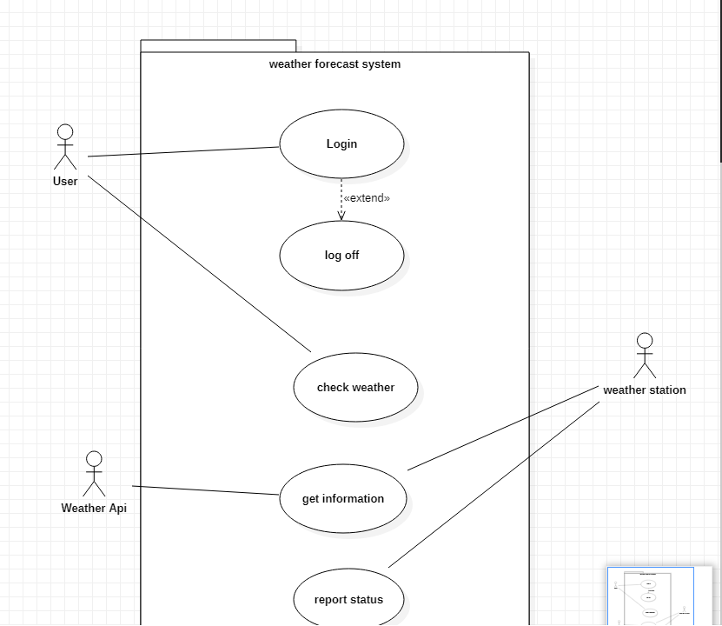

**Use case**

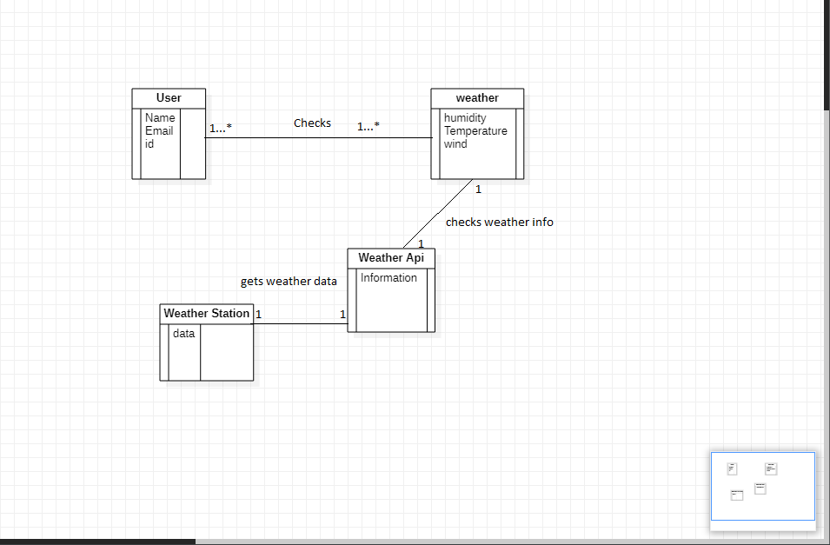

**Domain Model**

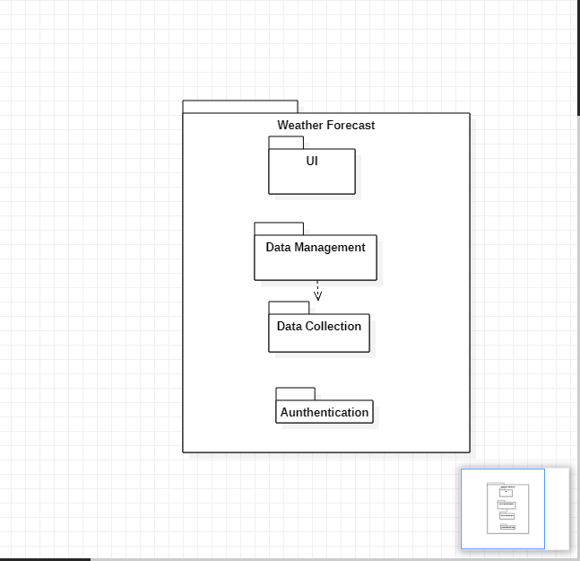

**Package Diagram**

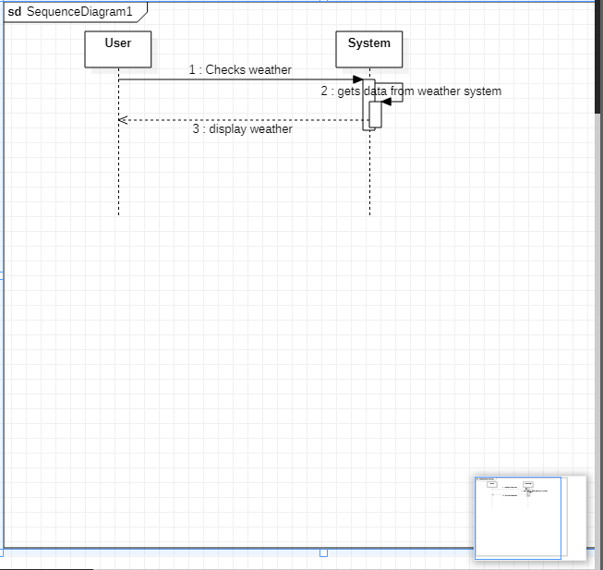

**System Sequence Diagram**

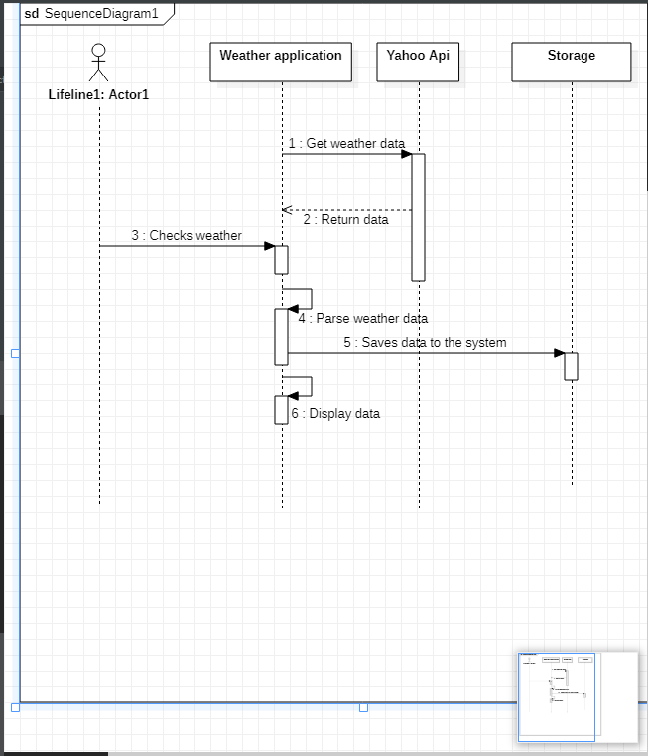

**Sequence Diagram**

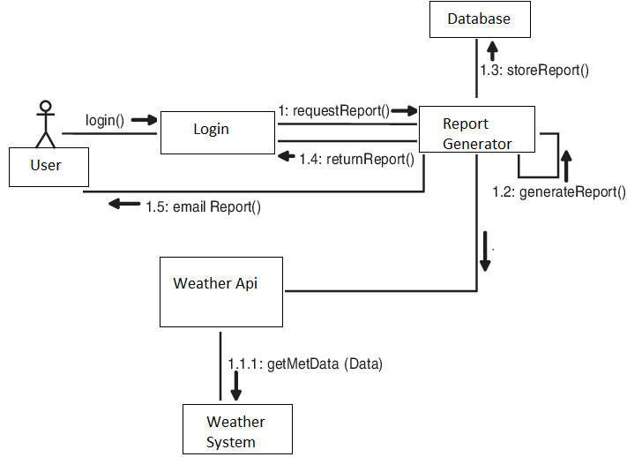

**Communication Diagram**