**SP-26 — Green Budgeting App**

***CS 4850 - Section 01 – Fall 2024***

***Sept 1, 2024****-*

## **Project Team**

| **Roles** | **Name** | **Major responsibilities** | **Contact (Cell Phone)** |
| --- | --- | --- | --- |
| Team leader | Kelly Erhunse | Documentation, arranging team meetings | 404-543-9346 |
| Team members | Kody Clark | Developer | 912-399-1360 |
| Tristan Stocks | Developer | 678-451-8739 |
| Katie Carlson | Developer, UI Design | 678-684-7915 |
|
| Advisor / Instructor | Sharon Perry | Facilitate project progress; advise on project planning and management | 770-329-3895 |

| A person smiling at the camera  Description automatically generated  Kelly Erhunse | Kody Clark |
| --- | --- |
| Tristan Stocks | Katie Carlson |

## **1.0 Project Overview / Abstract**

With this project, our objective is to develop an user-friendly budgeting app that will help individuals manage their personal finances. The app will feature tools for tracking income and expenses, providing insights into spending habits, and also allow the user to set savings goals for themselves. Additionally, the app will also allow the user to visualize their spending through interactive graphs, and will include debt tracking section and reminders for bill payments. The user will also be able to register for an account (with a secure login and two-factor authentication for security), and will have the option to connect their bank accounts with their accounts (via the Plaid API), so the user can save their data and monitor their progress. The project's scope includes developing a strong backend to safely store user data, and creating a visually appealing user interface that simplifies complex financial tasks for everyday users.

## **2.0 Project website**

<https://sp26-greenbudgetapp-2024.github.io/DontGoBroke-App/README.md>

## **3.0 Deliverables**

**Week 1:**

* **Team/Project Selection document (Individual Assignment)**: Select project, and assign roles to group members.

**Weeks 2-3:**

* **Project Plan (Group Assignment)**: Draft and finalize the project plan, including milestones and timelines.
* **SRS (Software Requirements Specification) – Group Assignment**: Begin working on the SRS document, detailing the functional and non-functional requirements of the project.
* **SDD (Software Design Document) – Group Assignment**: Develop the software architecture and design.

**Weeks 4- 5:**

* **STP (Software Test Plan) – Group Assignment**: Create a test plan outlining the testing strategies and cases.
* **Dev Doc (Development Document) – Group Assignment**: Document the development process and tools used.
* **Coding Tutorials:** Begin coding tutorials for Flutter and Dart, to familiarize ourselves with the language/frameworks.

**Weeks 6-9:**

* **Develop Screen Mockup for Group Review**: Develop a design mockup of the budget app, and present to group for feedback.
* **Develop Prototype for Group Review**: Develop and present a simple prototype of the app, and present to group for feedback.
* **Team Status Report (TSR – Group Assignment)**: Submit the team status report, including progress and any challenges faced.
* **Final Report Package (Group Assignment)**: Begin to compile all documents (SRS, SDD, STP, and others) into a final package.
* **Prototype Presentation:** Prepare presentation of the mockup and app prototypes for peer review.

**Weeks 10- 12:**

* **Prototype Presentations**: Present prototypes for peer review.
* **Final Report (Group Assignment)**: Begin writing the final project report.
* **Source Code (Group Assignment)**: Contine working on the source code, ensuring it is well-documented and functional.

**Weeks 13-14:**

* **Final Report (Group Assignment)**: Finalize the final project report.
* **Source Code (Group Assignment)**: Finish working on the source code, putting any last minute touches and testing its functionality to make sure it works properly.
* **iOS and Android Compatible Mobile Time Travel Apps**: Ensure that the app is compatible and tested on both iOS and Android platforms.

**Weeks 15-16:**

* **C-Day Application/Submission**: Prepare for the final project submission on C-Day, ensuring all documentation, source code, and deliverables are complete and submitted.
* **Launch App (Group Assignment)**: Develop and launch the project on Github.
* **Video Demo (Group Assignment)**: Create and edit a video demo showcasing the app’s features and functionalities.
* **Final Report Package (Group Assignment)**: Compile all the deliverables of the project (Final Report, Github Link, Final Video Presentation) and submit to the instructor.

***\*\*Weekly:***

* ***Weekly Activity Reports (WARs – Individual Assignment)****: Start from Week 4, and continue with these every week until the project is done.*

## **4.0 Milestone Events**

**#1: Planning —** Finish all test plans, requirements specifications, design documents, and other documentation meant for planning.

***Date****: September 15*

**#2: Prototypes —** Complete design mockup and a prototype of our code, and prepare them for a presentation to peers.

***Date:*** *October 14*

**#3: Final Report Draft—** Draft the final report, so that we are prepared to go on Teams with the instructor for feedback.

***Date:*** *November 4*

**#4: Completion of Source Code —**  Finish writing the source code, and upload it to Github. Test multiple times to be sure of functionality.

***Date:*** *November 24*

**#5: Completion of Project —**  Finish preparing all completed versions of documents, add any last minute touches to the code, and prepare a final presentation that explains the app and how it works.

***Date:*** *December 2*

**5.0 Meeting Schedule Date/Time**

Every Tuesday and Thursday at 5:15 pm. Additional meetings are scheduled at the group’s discretion.

## **6.0 Collaboration and Communication Plan**

We will meet on Teams to discuss the project with the instructor, and on Discord to discuss the project amongst ourselves. We created a Discord server just for this purpose, and we share documentation, code links, and more there.

## **7.0 Project Schedule and Task Planning**

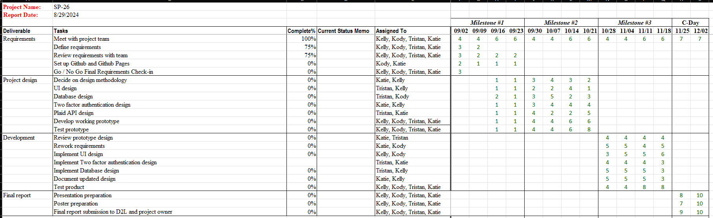

## **8.0 Version Control Plan**

We are planning to use Git for version control. We made a group Github account for the repository (with all of our individual accounts having the privileges to commit to it), and we will be uploading all our code there.

**Our repository:**

<https://github.com/SP26-GreenBudgetApp-2024/DontGoBroke-App>