Example

3.1 Management of Vehicle Models (Admin)

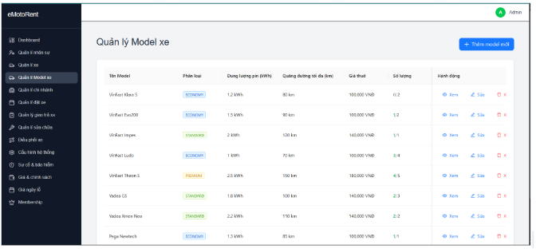

3.16.1 View vehicle Model List

- Function Trigger
  - From sidebar → Click "Quản lý Model xe"
- Function Description
  - Actors: Admin, Manager
  - Purpose: Display and search vehicle models in the system
  - Interface: Model table with search, filter, and action buttons
- Function Details
  - Data Displayed: Model name, brand, type, battery capacity, range, rental price
  - Actions: Xem chi tiết, Sửa, Xóa buttons
  - Features: Search bar, brand filter, type filter, pagination
- Normal Flow
  - User clicks "Quản lý Model xe" from sidebar
  - System displays vehicle model list table
  - System shows search and filter options
  - User can search by model name/brand
  - User can filter by type (Economy/Standard/Premium)
  - User can click action buttons for each model
- Abnormal Cases
  - No models found: "Không tìm thấy model xe nào"
  - Loading failed: "Không thể tải danh sách model. Vui lòng thử lại"

Do it here

3.2 Student Portal

3.2.1 <Function Name 1.1>

3.3 Lecturer Portal

3.3.1 <Function Name 2.1>

3.3 Expert Portal

3.3.1 Case Review

3.3.2 Medical Case

3.4 AdminPortal

3.4.1 <Function Name 2.1>

