Experiment 1

Aim: Case Study Framing & Dataset Preparation

Objective: Define a real-world domain problem, benchmark existing solutions, acquire data (API/scraping/open portals). Document versioning plan with DVC.

Detailed Steps
Problem statement
Airbnb is one of the largest online platforms that connects property owners with travelers seeking short-term accommodation. One of the biggest challenges faced by Airbnb hosts is determining the appropriate nightly rental price for their properties. The price of a listing depends on several factors such as location, room type, number of bedrooms, amenities, availability, host reputation, customer reviews, and seasonal demand. Setting a price that is too high may reduce bookings, while setting a price that is too low decreases the host's revenue.
The objective of this project is to develop an Explainable Machine Learning System for Airbnb Listing Price Prediction and Fair Pricing Analysis. The system will analyze property characteristics, host information, calendar availability, and guest review information to predict an appropriate nightly price. The model will also provide explanations for its predictions using Explainable AI techniques and evaluate fairness across different neighbourhoods and property types. The final solution will help hosts make data-driven pricing decisions while ensuring transparency and fairness.

Key Challenges
- Determining an optimal nightly rental price based on multiple influencing factors.
- Handling large and heterogeneous datasets collected from multiple sources.
- Integrating listing, calendar, and review datasets into a unified dataset.
- Ensuring prediction accuracy while avoiding overfitting and data leakage.
- Providing transparent and interpretable predictions instead of black-box recommendations.
- Maintaining fairness across different neighbourhoods, property types, and room categories.

Proposed Solution
- Collect Airbnb datasets from the Inside Airbnb Open Data Portal.
- Perform data profiling, cleaning, and feature engineering.
- Merge multiple datasets (Listings, Calendar, and Reviews) using the common listing_id.
- Train regression models to predict Airbnb listing prices.
- Apply Explainable AI (SHAP) to understand feature importance and prediction reasoning.
- Evaluate fairness across different groups to ensure responsible AI practices.
- Deploy the trained model using FastAPI and create an interactive Streamlit dashboard for end users.

Expected Benefits
- Helps Airbnb hosts determine competitive and profitable listing prices.
- Reduces manual effort in pricing decisions.
- Improves revenue generation through data-driven pricing.
- Provides transparent explanations for every price prediction.
- Supports fair and unbiased pricing recommendations across different locations and property categories.
- Demonstrates a complete end-to-end applied data science solution from data collection to deployment.
- Benchmark existing solutions;
Existing Solution | Description | Limitations | Improvements in Proposed System
Manual Pricing | Hosts manually decide the listing price based on experience, nearby listings, and seasonal demand. | Time-consuming, subjective, and inconsistent pricing decisions. | Uses machine learning to generate objective and data-driven price predictions.
Airbnb Smart Pricing | Automatically adjusts listing prices using internal Airbnb algorithms and market demand. | Proprietary algorithm with limited transparency and explainability. | Provides an explainable machine learning model using SHAP to understand prediction factors.
Commercial Pricing Platforms (e.g., AirDNA) | Provides pricing recommendations and market analytics for Airbnb listings. | Commercial service with limited access to underlying models and datasets. | Uses openly available datasets, making the project reproducible and suitable for academic research.
Basic Machine Learning Models | Predict listing prices using listing attributes such as location, room type, and amenities. | Often rely on a single dataset and focus only on prediction accuracy. | Integrates multiple Airbnb datasets, performs feature engineering, explainability, fairness evaluation, API deployment, and dashboard development.
Airbnb provides a built-in Smart Pricing feature that automatically recommends a nightly price for listings based on factors such as demand, seasonality, nearby listings, booking trends, and market conditions.
Advantages
- Automatically adjusts listing prices.
- Easy to use for Airbnb hosts.
- Considers market demand and seasonal trends.
- Helps increase booking opportunities.
Limitations
- Recommendation process is not transparent.
- Hosts cannot understand why a particular price is suggested.
- Limited user control over pricing decisions.
- Does not provide Explainable AI-based insights.
- Fairness across different neighbourhoods is not evaluated
- Set success metrics (e.g., recall >= 95%)
Success metrics are measurable performance indicators used to evaluate whether the machine learning model achieves its intended objective. Since the proposed system predicts the nightly rental price of Airbnb listings, the problem is categorized as a regression problem. Therefore, regression evaluation metrics are used to measure the accuracy and effectiveness of the model.
The following success metrics have been defined for the proposed system:

1. Mean Absolute Error (MAE)
Mean Absolute Error measures the average absolute difference between the actual listing price and the predicted listing price.
- Lower MAE indicates better prediction accuracy.
- It provides an easy-to-understand measure of prediction error.
Target: MAE should be as low as possible.

2. Mean Squared Error (MSE)
Mean Squared Error calculates the average squared difference between the predicted and actual prices.
- Penalizes large prediction errors.
- Lower MSE indicates better model performance.
Target: Minimize MSE.

3. Root Mean Squared Error (RMSE)
RMSE is the square root of the Mean Squared Error and represents the prediction error in the same unit as the target variable (price).
- Easier to interpret than MSE.
- Lower RMSE indicates higher prediction accuracy.
Target: RMSE should be as low as possible.

4. R² Score (Coefficient of Determination)
The R² Score measures how well the model explains the variation in Airbnb listing prices.
- Values range between 0 and 1.
- A value closer to 1 indicates better predictive performance.
Target: R² Score ≥ 0.85

5. Model Explainability
In addition to prediction accuracy, the system should provide explanations for every prediction using SHAP (SHapley Additive Explanations).
Target:
- Every prediction should include feature importance.
- Users should understand which features contributed most to the predicted price.

6. Fairness Evaluation
The model should provide consistent performance across different property types and neighbourhoods without introducing significant bias.
Target:
- Similar prediction accuracy across different neighbourhoods.
- No significant bias toward any room type or property category.
- Acquire dataset from open data portals or scrape using BeautifulSoup/APIs
datasets are collected from the Inside Airbnb Open Data Portal, which provides publicly available Airbnb datasets for research and educational purposes.
Three datasets are downloaded:
- Listings Dataset
- Calendar Dataset
- Reviews Dataset
These datasets are stored in compressed CSV format (.csv) and loaded into Google Colab using the Pandas library. Since all datasets share a common identifier (listing_id), they can be integrated after appropriate preprocessing.
-Description of dataset

Dataset 1: Listings Dataset
The Listings dataset serves as the primary dataset and contains one record for each Airbnb property.
Important attributes include:
- Listing ID
- Host ID
- Property Type
- Room Type
- Number of Bedrooms
- Number of Bathrooms
- Number of Beds
- Amenities
- Location
- Price
- Availability
- Review Scores
This dataset will act as the master dataset during integration.

Dataset 2: Calendar Dataset
The Calendar dataset stores daily availability information for every Airbnb listing.
Important attributes include:
- Listing ID
- Date
- Available
- Price
- Minimum Nights
- Maximum Nights
Each listing contains multiple calendar records.
Therefore, aggregation will be performed before merging

Dataset 3: Reviews Dataset
The Reviews dataset contains customer review information.
Important attributes include:
- Listing ID
- Review ID
- Review Date
- Reviewer ID
- Review Text
The review data will later be aggregated to derive review-based features.
- Initialize Git repo and DVC: version raw dataset
- Commit `.dvc` files and push to remote
Github Link
Calendar.csv
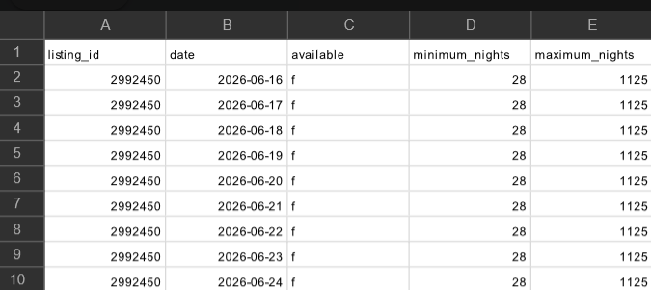

listing.csv
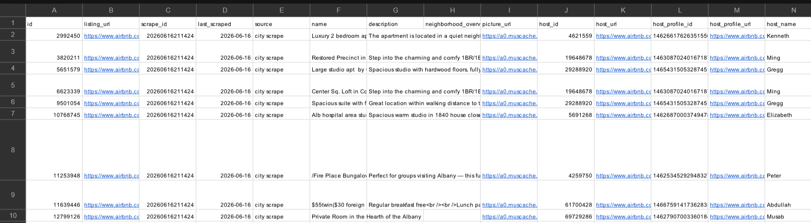
Reviews.csv
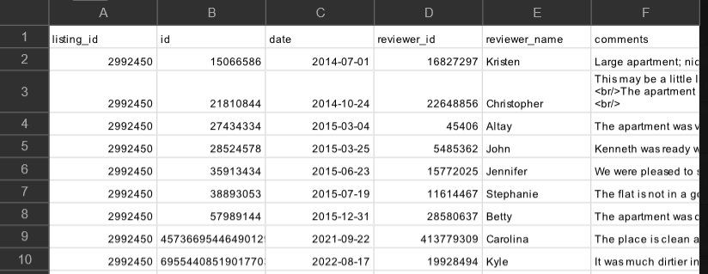

Open-Source Tools
Jupyter Notebook, Python (Requests, BeautifulSoup), DVC, GitHub/GitLab

Conclusion
This experiment successfully defined the Airbnb listing price prediction problem and established a clear business objective. Multiple datasets were acquired from the Inside Airbnb Open Data Portal and their structure, quality, and relationships were examined. Appropriate success metrics were identified, and existing solutions were benchmarked to highlight the proposed improvements. Git and DVC were introduced to enable version control and reproducible dataset management. The prepared datasets and project framework provide a strong foundation for data cleaning, feature engineering, exploratory data analysis, and machine learning in the subsequent experiments.

