Experiment 2

Aim: Data Profiling, Cleaning & Feature Engineering

Objective: Perform profiling, clean issues, engineer new features, validate, and version cleaned dataset.

Detailed Steps
- Run Pandas Profiling to detect missing/outliers
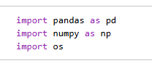
- Clean missing values, duplicates
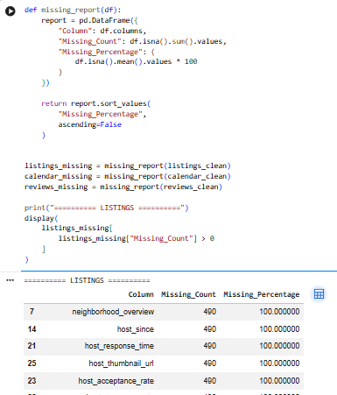
- Engineer new features (e.g., time-of-day flags)
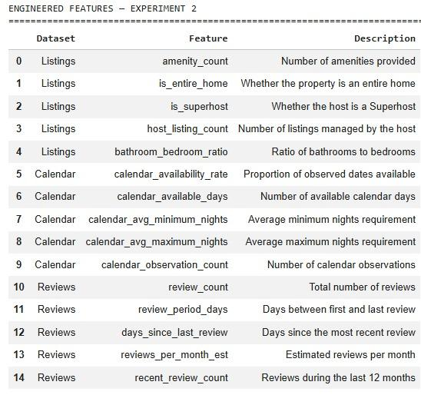
- Validate schema (with Great Expectations library)
- Version cleaned dataset with DVC
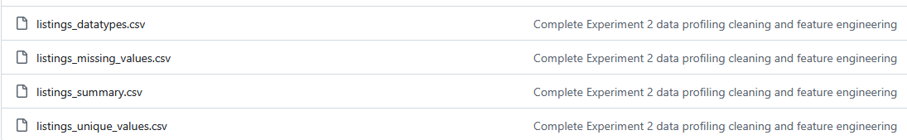
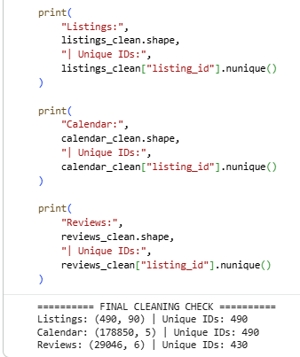

Open-Source Tools
Pandas, PyJanitor, Pandas Profiling, Great Expectations, DVC

Deliverables
- Profiling report
A data profiling report was generated for the Airbnb Listings, Calendar, and Reviews datasets. The report provides information about dataset structure, data types, missing values, unique values, statistical summaries, and potential data-quality issues. The profiling results were used to identify problems that required cleaning and preprocessing.
- Cleaned dataset
The Listings, Calendar, and Reviews datasets were cleaned by handling missing values, checking duplicate records, converting columns to appropriate data types, and ensuring consistency in the data. The cleaned datasets were subsequently used for feature engineering. The processed datasets were saved as:
- listings_feature_engineered.csv
- calendar_feature_engineered.csv
- reviews_feature_engineered.csv
- Validation suite
A data validation suite was prepared using Great Expectations to verify the quality and structure of the processed datasets. The validation checks ensure that required columns are present, numerical features contain valid values, missing values are controlled, and important features satisfy their expected constraints. The validation results confirm that the processed datasets are suitable for further analysis and machine-learning tasks.

Conclusion
The Airbnb Listings, Calendar, and Reviews datasets were successfully profiled, cleaned, and prepared for further analysis. Missing values, duplicates, data types, and other data-quality issues were examined and handled appropriately. Feature engineering was performed to create meaningful features related to property characteristics, host information, availability, and review activity. The processed datasets were validated for consistency and prepared for subsequent analysis and machine-learning tasks. Thus, the objectives of Data Profiling, Cleaning, and Feature Engineering were successfully achieved.
https://colab.research.google.com/drive/19mytHpcocNILhcEq1Ea4RMvw3QTUFI5I?usp=sharing

