Experiment No. 4

Aim: ML Modeling & Experiment Tracking

Objective: Build ML pipeline, tune hyperparameters, track experiments with MLflow.

Detailed Steps
- Dataset Preparation
The prepared dataset was divided into training and testing subsets using an 80:20 split.
The train_test_split() function from Scikit-learn was used with random_state=42 to ensure reproducibility.
The resulting datasets were:
Training set 366
Testing set 92
- Baseline Model TraininG
A Scikit-learn preprocessing pipeline was created to handle numerical and categorical features separately.

Numerical Features
For numerical attributes:
- Missing values were replaced using the median.
- Features were standardized using StandardScaler.

Categorical Features
For categorical attributes:
- Missing values were replaced using the most frequent value.
- Categorical variables were converted into numerical representation using OneHotEncoder.
- handle_unknown="ignore" was used to avoid errors caused by unseen categories in the test data.
A ColumnTransformer was used to combine both preprocessing pipelines.
This preprocessing was integrated with the machine learning models using Scikit-learn Pipeline.

Hyperparameter Tuning
For the selected machine learning model(s), hyperparameter optimization was performed using GridSearchCV / RandomizedSearchCV.
The purpose of hyperparameter tuning was to identify parameter combinations that improve predictive performance compared with the baseline configuration.
The tuning process involved:
- Defining a parameter grid.
- Applying cross-validation.
- Training the model for different parameter combinations.
- Selecting the configuration with the best cross-validation performance.
- Evaluating the tuned model on the test dataset.
- Comparing tuned performance with the baseline model..
- Experiment Tracking with MLflow
MLflow was incorporated into the machine learning workflow to track model experiments.
The notebook installed and imported MLflow and MLflow's Scikit-learn integration.
For each experiment, MLflow can record:

Parameters
MLflow was incorporated into the machine learning workflow to track model experiments.
The notebook installed and imported MLflow and MLflow's Scikit-learn integration.
For each experiment, MLflow can record:
For the verified baseline experiments, the results were:
Model | RMSE | MAE | R²
Linear Regression | 102.01 | 70.79 | 0.5392
Random Forest | 85.52 | 51.15 | 0.6761
Gradient Boosting | 80.26 | 49.38 | 0.7147

Open-Source Tools

Deliverables

1. Trained ML Models
The following baseline regression models were trained:
- Linear Regression
- Random Forest Regressor
- Gradient Boosting Regressor

2. Comparative Analysis
The baseline models were compared using:
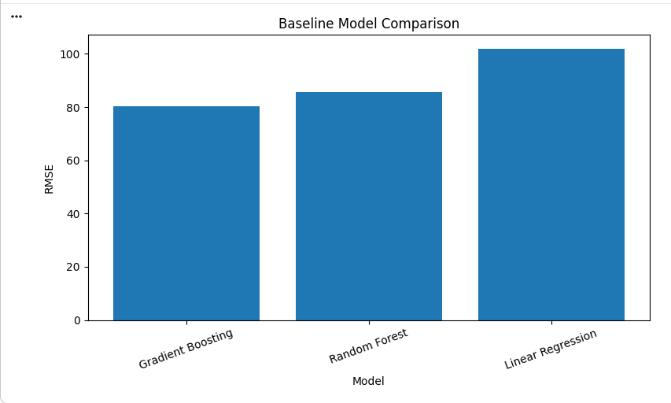
The baseline comparison was recorded in a Pandas DataFrame.

3. Hyperparameter-Tuned Model
The selected model was optimized using cross-validation and hyperparameter search.

4. MLflow Tracking
MLflow was incorporated for recording:
- Parameters
- Metrics
- Model artifacts
- Experiment runs

5. Serialized Model
The final model was saved under the project's outputs/models directory.

Conclusion
The Airbnb price prediction problem was formulated as a supervised regression task using the prepared merged Airbnb dataset. The dataset was divided into training and testing subsets using an 80:20 split, resulting in 366 training samples and 92 testing samples. Appropriate preprocessing pipelines were created for numerical and categorical features.
Three baseline regression models—Linear Regression, Random Forest Regression, and Gradient Boosting Regression—were trained and evaluated using RMSE, MAE, and R². The executed baseline experiments produced RMSE values of 102.01, 85.52, and 80.26 respectively, while the corresponding R² values were 0.5392, 0.6761, and 0.7147.
Hyperparameter tuning was performed on the selected model(s) to investigate whether optimized model configurations could improve predictive performance. MLflow was incorporated to provide systematic experiment tracking through logging of model parameters, evaluation metrics, and model artifacts. The final trained model was saved as a reusable serialized artifact for subsequent deployment and prediction tasks
https://colab.research.google.com/drive/1egoRVvRzamfUyYN7f4IKUefJL16qwC-N?usp=sharing.

