EXPERIMENT 6

Containerization & API Deployment

1. Aim
To containerize the trained Airbnb Price Prediction machine learning model using Docker and deploy it as a REST API using FastAPI for real-time Airbnb price prediction.

2. Objective
The objectives of this experiment are:
- To deploy the trained Airbnb Price Prediction model using FastAPI.
- To create a /predict API endpoint for making predictions.
- To accept property-related information through a JSON request.
- To load the trained Gradient Boosting Regressor model into the API.
- To test the API using a sample JSON POST request.
- To create a Dockerfile for containerizing the application.
- To build a Docker image containing the API, trained model, and required dependencies.
- To run the application inside a Docker container.
- To test the locally deployed containerized API.
- To verify that the deployed model successfully returns an Airbnb price prediction.

3. Problem Statement
In the previous experiments, a machine learning model was developed and trained to predict Airbnb listing prices using property-related features. The trained model was saved as a .pkl file.
However, a trained machine learning model cannot be directly accessed by external applications or users. Therefore, the model needs to be deployed through an API that can accept input data and return predictions.
In this experiment, the trained Gradient Boosting Regressor model is deployed using FastAPI. Docker is then used to package the FastAPI application, trained model, dependencies, and configuration files into a portable container.
The final system accepts property information in JSON format through the /predict endpoint and returns the predicted Airbnb price.

4. Model Used
The best-performing model obtained during the machine learning modeling experiment was:
Gradient Boosting Regressor
The trained model was saved as:
best_airbnb_price_model.pkl
The saved model contains the preprocessing pipeline and trained Gradient Boosting Regressor.
The model uses 80 input features, consisting of:
- 66 numerical features
- 14 categorical features
The model was loaded into the FastAPI application and used to generate predictions.

5. System Architecture
The overall deployment architecture is:
Airbnb Dataset
|
↓
Data Preprocessing
|
↓
Feature Engineering
|
↓
ML Model Training
|
↓
Gradient Boosting Regressor
|
↓
best_airbnb_price_model.pkl
|
↓
FastAPI
|
↓
Dockerfile
|
↓
Docker Image
airbnb-price-api
|
↓
Docker Container
airbnb-api
|
↓
localhost:8001
|
↓
POST /predict
|
↓
Predicted Price
Figure 1: Architecture of the Containerized Airbnb Price Prediction System

6. Deployment Folder Structure
The deployment files used for the experiment were organized as follows:
deployment/
│
├── app.py
├── best_airbnb_price_model.pkl
├── feature_columns.json
├── requirements.txt
├── sample_request.json
└── Dockerfile

Description of files
File | Description
app.py | FastAPI application containing the API endpoints
best_airbnb_price_model.pkl | Trained Gradient Boosting Regressor model
feature_columns.json | Contains the feature information required by the model
requirements.txt | Contains the Python dependencies required for deployment
sample_request.json | Sample JSON input used for API testing
Dockerfile | Instructions used to build the Docker image

7. Detailed Steps

Step 1: Prepare the Trained Model
The trained Gradient Boosting Regressor model from the previous experiment was saved in Pickle format.
The model file used for deployment was:
best_airbnb_price_model.pkl
The model was loaded in the FastAPI application using Python's pickle module.
The saved model includes the preprocessing pipeline, which allows the API to process the input features before generating the prediction.

Step 2: Create the FastAPI Application
A FastAPI application was created using Python.
The application provides two main endpoints:
GET /
and
POST /predict
The root endpoint is used to verify that the API is running.
The /predict endpoint accepts the input property information in JSON format and returns the predicted Airbnb price.

Step 3: FastAPI /predict Endpoint
The /predict endpoint performs the following operations:
- Receives the input JSON request.
- Extracts the input data.
- Converts the input into the required format.
- Passes the input to the trained machine learning pipeline.
- Generates the predicted Airbnb price.
- Returns the prediction as a JSON response.
The endpoint is accessed using:
POST /predict

Step 4: Requirements File
The required Python dependencies were specified in requirements.txt.
The final deployment requirements were:
fastapi
uvicorn[standard]
pandas
numpy
scikit-learn==1.6.1
pydantic
The version of Scikit-learn was specifically fixed to:
scikit-learn==1.6.1
This was done to maintain compatibility with the version used while creating the trained .pkl model.

Step 5: Create the Dockerfile
A Dockerfile was created to package the FastAPI application and machine learning model.
The Dockerfile used was:
FROM python:3.11-slim

WORKDIR /app

COPY requirements.txt .

RUN pip install --no-cache-dir -r requirements.txt

COPY app.py .
COPY best_airbnb_price_model.pkl .
COPY feature_columns.json .
COPY sample_request.json .

EXPOSE 8000

CMD ["uvicorn", "app:app", "--host", "0.0.0.0", "--port", "8000"]

Step 6: Explanation of Dockerfile

6.1 Base Image
FROM python:3.11-slim
A lightweight Python 3.11 image is used as the base image.

6.2 Working Directory
WORKDIR /app
The /app directory is used as the working directory inside the Docker container.

6.3 Copy Requirements
COPY requirements.txt .
The dependency file is copied into the container.

6.4 Install Dependencies
RUN pip install --no-cache-dir -r requirements.txt
All required Python libraries are installed inside the container.

6.5 Copy Application and Model Files
COPY app.py .
COPY best_airbnb_price_model.pkl .
COPY feature_columns.json .
COPY sample_request.json .
These commands copy the FastAPI application, trained model, feature configuration, and sample request into the container.

6.6 Expose Port
EXPOSE 8000
Port 8000 is used by the FastAPI application inside the container.

6.7 Start the API
CMD ["uvicorn", "app:app", "--host", "0.0.0.0", "--port", "8000"]
Uvicorn is used to start and serve the FastAPI application.

Step 7: Build the Docker Image
The Docker image was built using the following command:
docker build --no-cache -t airbnb-price-api .

Explanation
- docker build — builds a Docker image.
- --no-cache — ensures that the image is rebuilt using the latest configuration and dependencies.
- -t airbnb-price-api — assigns the name airbnb-price-api to the image.
- . — specifies the current directory as the build context.
The Docker image was successfully created with the name:
airbnb-price-api:latest
Figure 2: Successful Docker Image Build
Insert your screenshot of the successful docker build command here.

Step 8: Run the Docker Container
The Docker container was started using:
docker run -d -p 8001:8000 --name airbnb-api airbnb-price-api

Explanation
-d
Runs the container in detached/background mode.
-p 8001:8000
Maps port 8001 of the host machine to port 8000 of the Docker container.
--name airbnb-api
Assigns the name airbnb-api to the container.
airbnb-price-api
Specifies the Docker image used to create the container.

Step 9: Port Mapping
The application runs on port 8000 inside the Docker container.
The host machine uses port 8001.
Therefore, the port mapping is:
Host Machine Docker Container

localhost:8001 ───────────→ port 8000
|
↓
FastAPI
The API can therefore be accessed using:
http://localhost:8001

Step 10: Verify the Running Container
The running Docker containers were checked using:
docker ps
The deployed container was:
Container Name: airbnb-api
Image: airbnb-price-api
Port Mapping: 8001:8000
The container was successfully running and serving the FastAPI application.
Figure 3: Running Docker Container
Insert your docker ps screenshot here.

Step 11: Test the Root API
The root API was tested using a web browser.
The following URL was opened:
http://localhost:8001
The API returned:
{
"message": "Airbnb Price Prediction API is running",
"endpoint": "/predict",
"model": "Gradient Boosting Regressor"
}
This confirms that:
- The Docker container is running.
- The FastAPI application started successfully.
- The Uvicorn server is active.
- The trained model is available.
- The /predict endpoint is available.
Figure 4: Successful Root API Response
Insert your screenshot of http://localhost:8001 here.

Step 12: Test Using Swagger UI
FastAPI provides an interactive Swagger UI for testing API endpoints.
The Swagger interface was accessed using:
http://localhost:8001/docs
The interface displayed the available endpoints:
GET /
POST /predict
The /predict endpoint was selected for testing.
Figure 5: FastAPI Swagger UI
Insert your screenshot of http://localhost:8001/docs here.

Step 13: Prepare Sample JSON Request
A sample JSON request was prepared in:
sample_request.json
The sample request contains the required input features expected by the trained model.
The JSON request was used to simulate a real API request from a client application.

Step 14: Test the /predict Endpoint
The /predict endpoint was tested using the Swagger UI.
The request was sent to:
http://localhost:8001/predict
The sample JSON data was provided as the request body.
The request was successfully processed by the FastAPI application.

Step 15: API Response
The API returned the following response:
{
"predicted_price": 150.15
}
The HTTP status code was:
200
The Swagger UI displayed:
Code: 200
Successful Response
The predicted price obtained for the supplied sample input was:
150.15
Figure 6: Successful Airbnb Price Prediction
Insert the screenshot you just captured showing 200 and predicted_price: 150.15 here.

8. Result
The trained Airbnb Price Prediction model was successfully deployed as a FastAPI REST API and containerized using Docker.
The Docker image:
airbnb-price-api
was successfully built and the Docker container:
airbnb-api
was successfully executed.
The /predict endpoint was tested using a sample JSON request through Swagger UI.
The API returned:
HTTP Status Code: 200
Predicted Price: 150.15
Therefore, the containerized machine learning API successfully generated an Airbnb price prediction.

9. Deliverables
The following deliverables were completed for the experiment:

1. API Code
app.py
Contains the FastAPI application and /predict endpoint.

2. Dockerfile
Dockerfile
Contains instructions for building the Docker image.

3. Trained Model
best_airbnb_price_model.pkl
Contains the trained Gradient Boosting Regressor model.

4. Feature Configuration
feature_columns.json
Contains the input feature configuration.

5. Sample Request
sample_request.json
Contains the JSON data used for testing the API.

6. Local Test Evidence
The following evidence was obtained:
- Successful Docker image build.
- Running Docker container.
- Successful root API response.
- Swagger UI.
- Successful /predict request.
- HTTP 200 response.
- Predicted Airbnb price of 150.15.

10. Final Workflow
The complete workflow of the experiment is:
Trained Airbnb ML Model
↓
best_airbnb_price_model.pkl
↓
FastAPI Application
↓
/predict Endpoint
↓
Dockerfile
↓
Docker Image
airbnb-price-api
↓
Docker Container
airbnb-api
↓
localhost:8001
↓
POST /predict
↓
Sample JSON Input
↓
Gradient Boosting Regressor
↓
Predicted Airbnb Price
150.15

11. Advantages of the Deployment
- Portability: Docker packages the application and dependencies into a portable container.
- Reproducibility: The same environment can be recreated using the Dockerfile.
- Easy Deployment: The API can be deployed on systems supporting Docker.
- API Accessibility: Other applications can communicate with the model through the REST API.
- Dependency Management: Required Python libraries are defined in requirements.txt.
- Model Reusability: The trained model can be loaded and used without retraining.
- Scalability: Containerized APIs can later be deployed and scaled using cloud or container orchestration platforms.

12. Conclusion
The Airbnb Price Prediction model was successfully deployed as a REST API using FastAPI and containerized using Docker. A Dockerfile was created to package the FastAPI application, trained Gradient Boosting Regressor model, configuration files, and required dependencies. The Docker image was successfully built and executed as a container.
The deployed API was tested using Swagger UI with a sample JSON POST request. The /predict endpoint successfully processed the request and returned an HTTP 200 response with a predicted Airbnb price of 150.15. Thus, the experiment successfully demonstrated containerization and local API deployment of a machine learning model
13. Screenshots
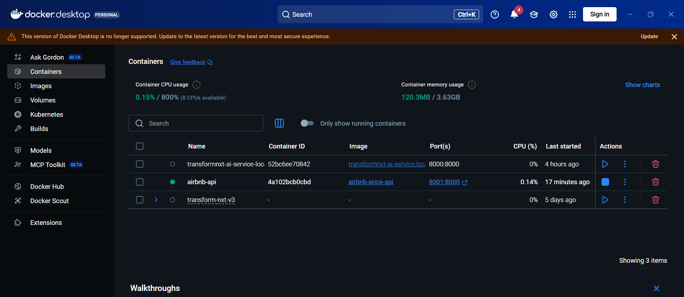

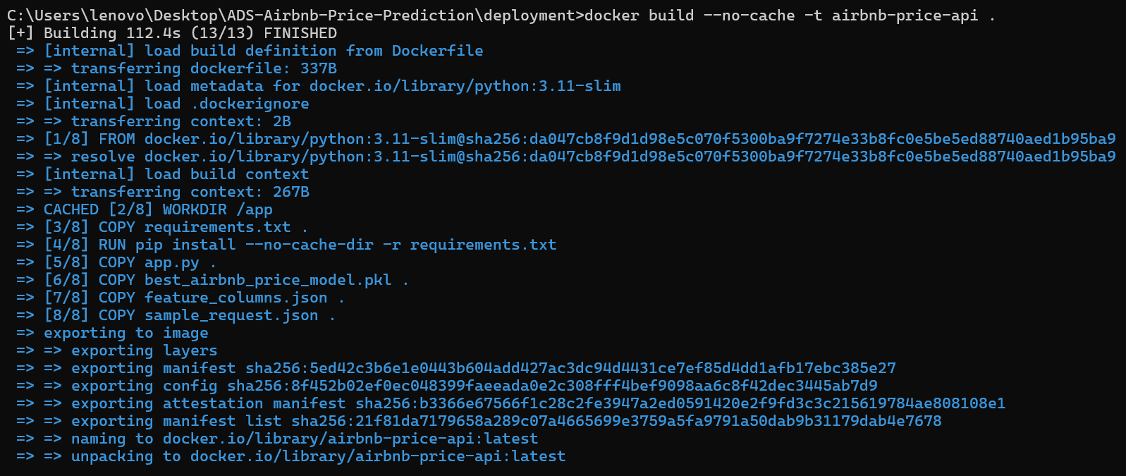
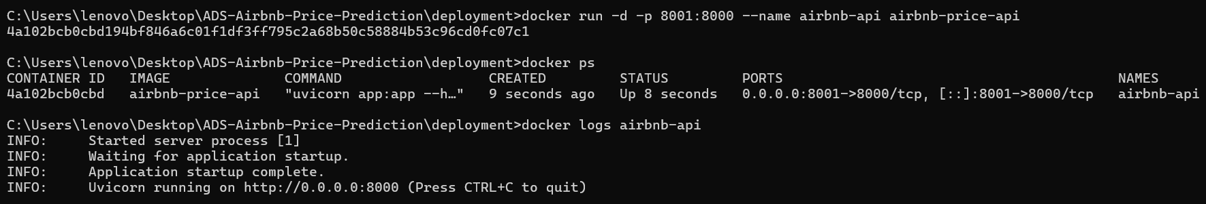

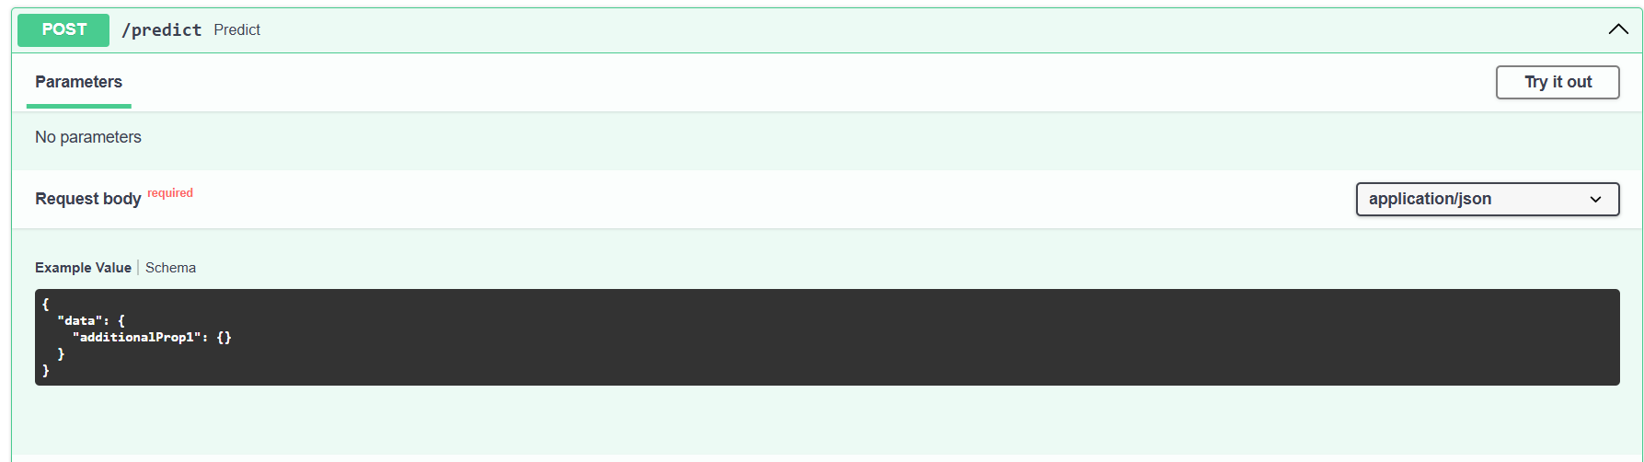

Output
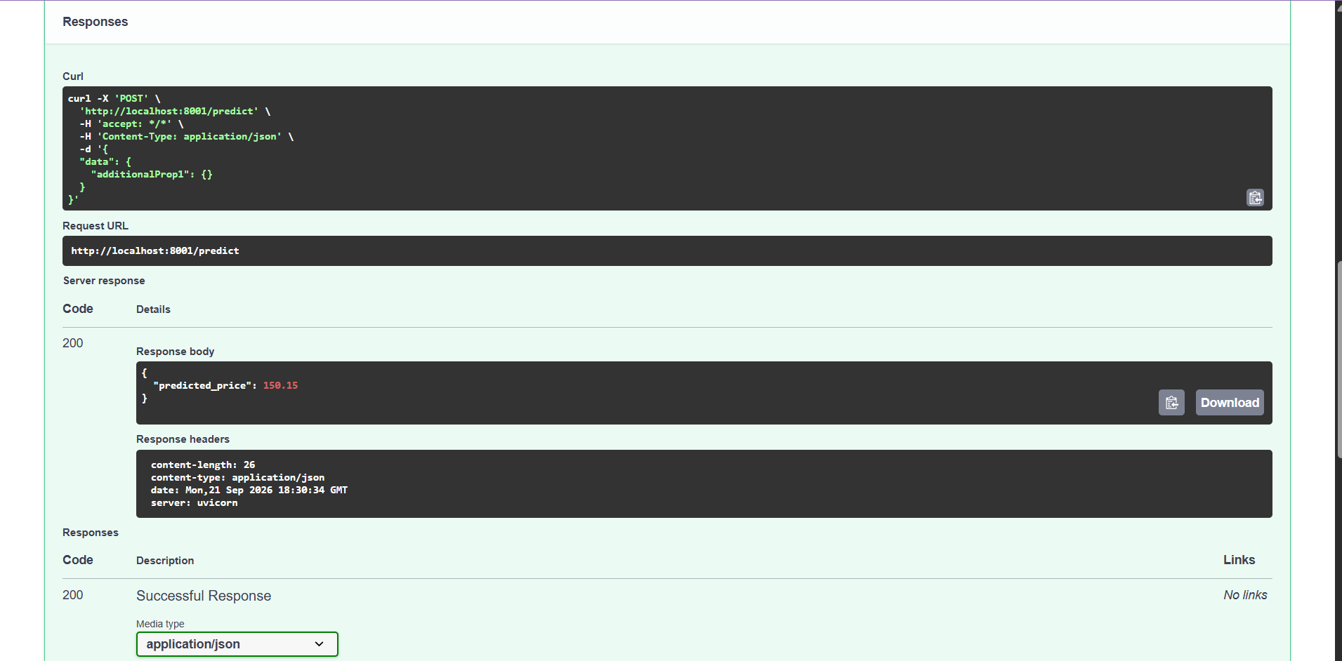
This directly satisfies the experiment requirement to test the API using a sample JSON POST and provide local test evidence.

Colab Link - Link

