Experiment 5

Aim: To apply explainable AI (XAI) methods (SHAP & LIME) for interpreting model predictions and evaluate fairness using Fairlearn.
Project: Explainable Machine Learning System for Airbnb Listing Price Prediction and Fair Pricing Analysis (Inside Airbnb, Albany, New York). GitHub: github.com/CloudyPatil/ADS-Airbnb-Price-Prediction. Colab notebook: ADS_Exp5_XAI_SHAP_LIME_Fairness.ipynb.

Objective
- Generate global (SHAP feature importance) and local (LIME) explanations of the price model built in Experiment 4.
- Audit bias in the model across sensitive groups. Airbnb data has no gender or race, so the groups are the two fairness goals set in Experiment 1: room type and ward (neighbourhood).
- Propose and compare fairness mitigation strategies for the bias that is detected.

Detailed Steps

Dataset & Model Selection
  - Dataset. The listings, calendar and reviews tables (Experiment 1) were profiled, cleaned and feature-engineered in Experiment 2, then merged on listing_id into merged_dataset.csv (490 listings; 458 have a price). The data covers Albany, NY, and contains the fairness aspects chosen in Experiment 1: room type (322 entire homes, 127 private rooms, 8 hotel rooms, 1 shared room among priced listings) and 15 wards.
  - Model. The Experiment 4 winner, a Gradient Boosting Regressor inside a scikit-learn pipeline (median imputation and scaling for 66 numeric features; most-frequent imputation and one-hot encoding for 14 categorical features). Price-derived columns (price_quote_*, estimated_revenue_l365d) are excluded to avoid target leakage; the split is 80/20 with random_state=42 (366 train, 92 test).
  - Reproduced result. Re-running the pipeline gives exactly the Experiment 4 figures, so the explanations below describe that model.

Model (Experiment 4) | RMSE | MAE | R² (92 test listings)
Linear Regression | 102.01 | 70.79 | 0.5392
Random Forest | 85.52 | 51.15 | 0.6761
Gradient Boosting (used here) | 80.26 | 49.38 | 0.7147
The Experiment 1 target of RZ ≥ 0.85 is not reached. Because 92 test listings is a small sample, the model was also scored with 5-fold out-of-fold predictions over all 458 listings: RZ = 0.534, MAE =
$45.82, RMSE = $107.34. The test-split RZ of 0.715 is therefore on the optimistic side, and the fairness audit below uses the out-of-fold predictions.

Explainability with SHAP
shap.TreeExplainer computes exact Shapley values for the tree ensemble on the 92 test listings. The base value (average prediction) is $172.17 per night, and for every listing base value plus the sum of SHAP values equals the model prediction (maximum difference below 1e-12). One-hot columns are added back to their original feature so that importance is reported per real feature.
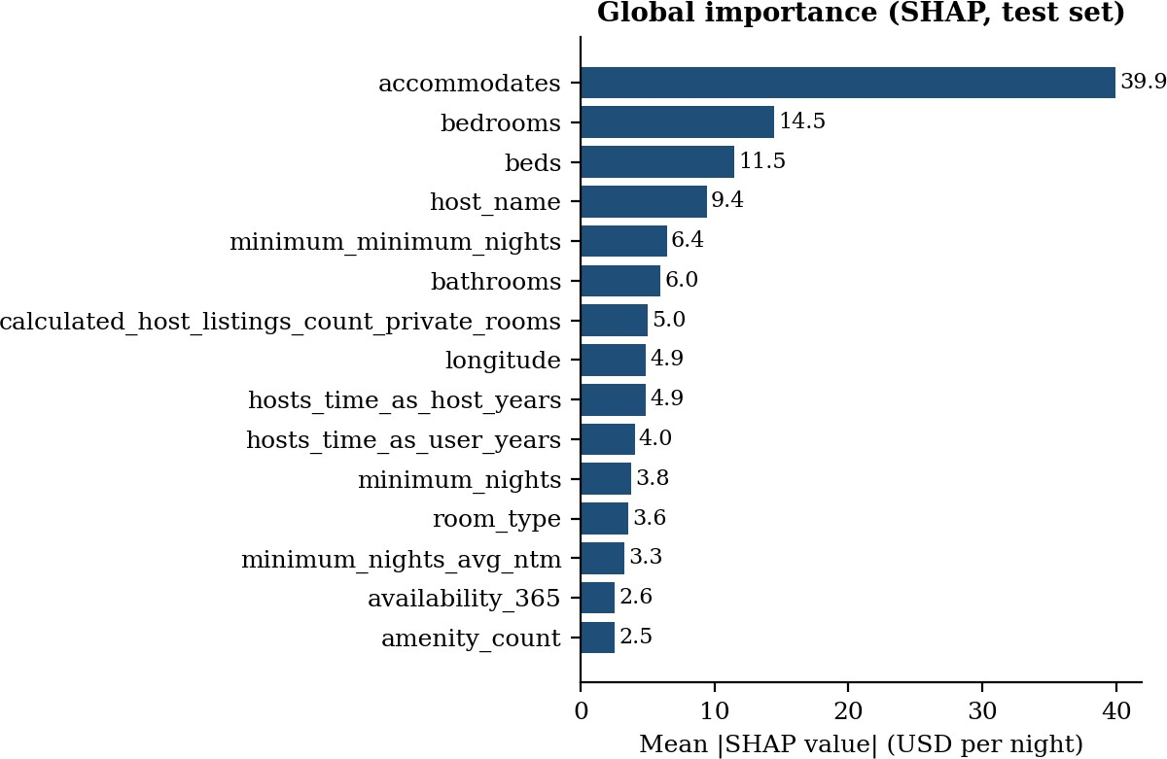
Figure 1. Global feature importance: mean |SHAP value| per feature (USD per night).
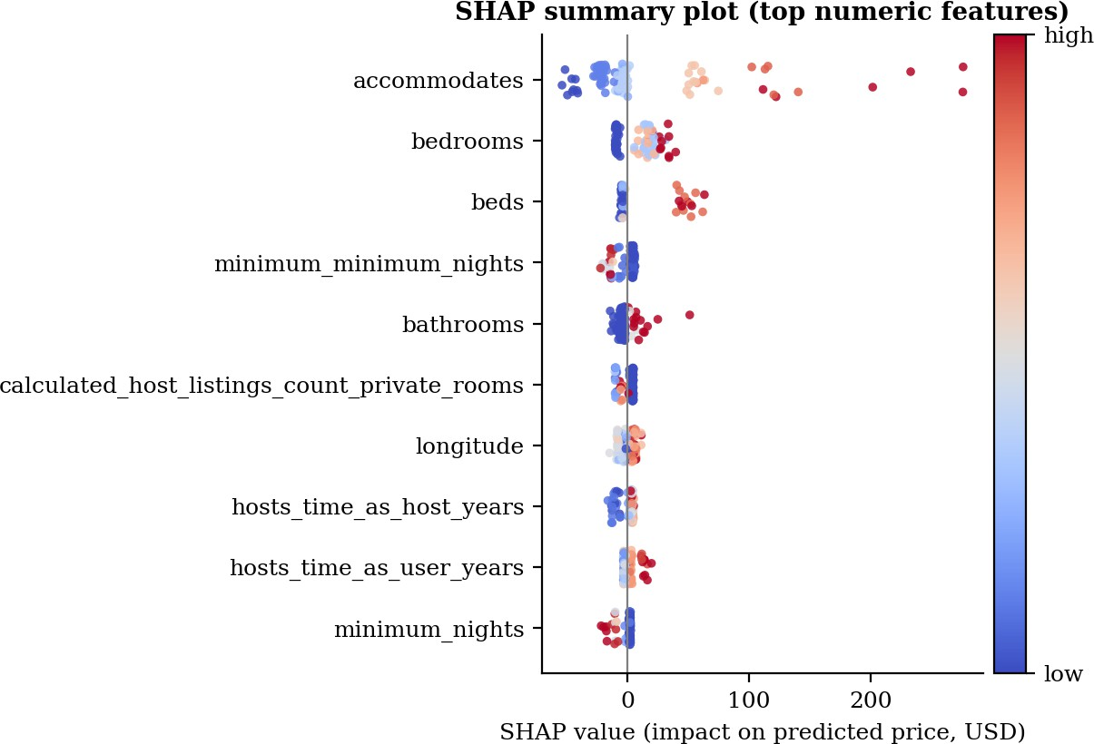
Figure 2. SHAP summary plot for the top numeric features. Each dot is a listing; colour is the feature value, position is its effect on the predicted price.

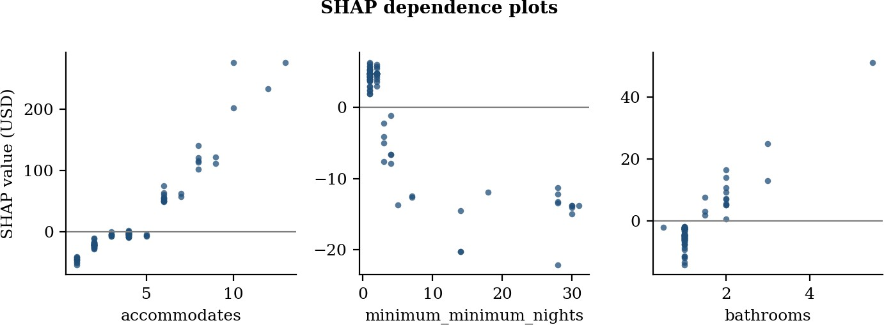

Figure 3. SHAP dependence plots for accommodates, minimum_minimum_nights and bathrooms.

Interpretation.
  - Size and capacity drive price. accommodates is by far the most influential feature (mean |SHAP|
$39.9), followed by bedrooms ($14.5) and beds ($11.5). Together with host_name and minimum_minimum_nights the top five features carry about 52% of total importance.
  - Direction of effects. Listings for 1–2 guests are pushed down by $27 on average, while those for 8 or more guests are pushed up by $165. Listings with a minimum stay of 7 nights or more lose about
$15 relative to short-stay listings. Homes with 3 or more bathrooms gain about $30 (only 3 test listings).
  - Room type has a small direct effect. room_type averages +$2.8 for entire homes and −$6.0 for private rooms; the entire-home price premium is mostly explained by capacity (guests, bedrooms, beds).
  - A feature to question: host_name. It ranks fourth (mean |SHAP| $9.4). It is a personal name (153 distinct values in 458 listings, 73 of them shared by several listings), so the model partly memorises which hosts charge more. Dropping it lowers out-of-fold RZ only from 0.534 to 0.514, so it adds little real signal and is best removed in the final system.

Explainability with LIME
lime.lime_tabular explains one listing at a time by fitting a weighted local linear model to 5,000 perturbed copies of it. Three test listings were explained: the most accurately predicted, one with median error, and the one with the largest error. Blue bars raise and orange bars lower the predicted price.

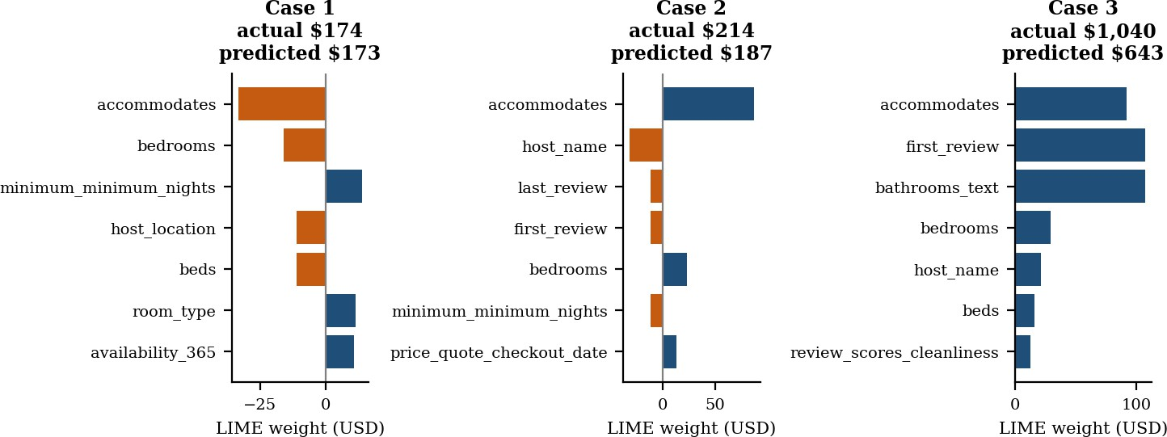
Figure 4. LIME local explanations (top 7 features) for three test listings.

Listing | Actual | Predicted | Top LIME features | SHAP top 5 overlap | LIME  local R²
Case 1: 3 guests, 1 bedroom, Fourth Ward | $173.70 | $172.68 | accommodates, bedrooms, minimum_minimum_nights | 3 of 5 | 0.05
Case 2: 4 guests, 4 bedrooms, First Ward | $213.80 | $187.05 | accommodates, host_name, last/first_review | 2 of 5 | 0.26
Case 3: 13 guests, 6 bedrooms, Thirteenth Ward | $1,040.50 | $642.66 | accommodates, first_review, bathrooms_text | 2 of 5 | 0.29
Interpretation. LIME and SHAP agree on the main story: accommodates and bedrooms lead the explanation in every case. The agreement is partial rather than complete (2–3 of the top five features), and the local linear fit is weak (RZ of 0.05–0.29), so LIME weights for a single listing should be read as rough guidance. In Case 3, a large entire home listed at $1,040 was predicted at $643: SHAP credits
+$276 to accommodates, +$63 to beds and +$51 to bathrooms, so the model recognises a very large property but under-predicts the extreme upper tail of the price range. LIME also gives large weights to rare text-valued columns (first_review, bathrooms_text), which are high-cardinality strings that the model can only memorise, and it is a reason to drop or re-encode them.

Fairness Audit with Fairlearn
  - Sensitive attributes: room type (Entire home/apt vs other room types) and ward (neighbourhood_cleansed; wards with at least 10 listings).
  - Decision framing. Demographic parity and equalized odds need a binary decision. A listing is premium when its price is above the dataset median ($145.67); the model “selects” a listing as premium when its predicted price is above the same value.
  - Data. 5-fold out-of-fold predictions for all 458 listings, because 92 test rows leave too few listings per group.
  - Metrics. Fairlearn’s demographic parity difference (largest gap in selection rate between groups) and equalized odds difference (largest gap in true-positive or false-positive rate), plus group-wise error. A difference above 0.10 is treated as a flag for bias.

Room type | n | Mean price | MAE | Relative error | Actual premium rate | Predicted premium rate | TPR | FPR
Entire home/apt | 322 | $208.47 | $52.25 | 25.1% | 63.7% | 73.3% | 0.932 | 0.385
Other room types | 136 | $102.93 | $30.60 | 29.7% | 17.6% | 21.3% | 0.917 | 0.062
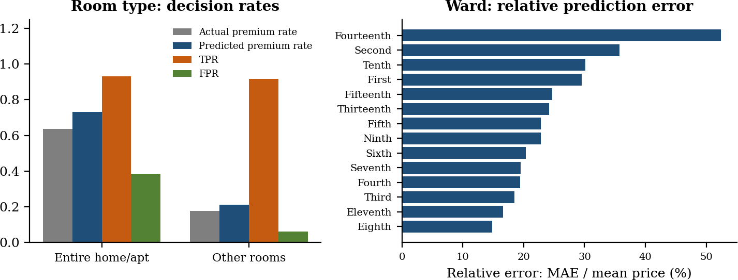
Figure 5. Fairness audit: decision rates by room type (left) and relative prediction error by ward (right).

Fairness report.
  - Room type: demographic parity difference = 0.520, equalized odds difference = 0.322. Of the
0.520 parity gap, 0.460 is a real difference in how often each group is expensive (63.7% vs 17.6% of listings are premium), so only about 0.06 is added by the model. The equalized-odds gap comes from false positives: an entire home that is actually below the median price is wrongly flagged premium 38.5% of the time, against 6.2% for other rooms, while true-positive rates are almost equal (0.932 vs 0.917). The model over-predicts other room types by $11.17 on average and under-predicts entire homes by $8.36. This exceeds the 0.10 flag level, so bias is detected.
  - Ward: relative error ranges from 14.8% (Eighth Ward) to 52.4% (Fourteenth Ward), with Eleventh Ward (16.6%) among the best predicted. The ward parity difference (0.895) and equalized odds difference (0.558) are large, but wards genuinely differ in price (actual premium rate from 3.3% in Eleventh Ward to 100% in Fourth Ward) and several wards have only 10–14 listings, so ward-level decision metrics are unstable and are read as a warning, not as proof of bias.

Bias Mitigation
Because bias was detected for room type, three strategies were compared using 3 repeats of 5-fold cross-validation. Thresholds are always tuned on the training part of each fold only. The baseline row is averaged over these three fold seeds, so its equalized-odds value (0.354) differs slightly from the single audit above (0.322).
  - Pre-processing (reweighing): each (room group, premium label) pair is weighted by P(group) P(label) / P(group, label) when training the regressor. A simpler baseline, dropping room_type and is_entire_home, is also shown.

  - Post-processing (threshold adjustment): a separate premium cut-off for each room group, chosen either to reduce the equalized-odds difference plus the error rate, or to force equal selection rates (demographic parity).
  - In-processing (fairness constraints in training): Fairlearn’s ExponentiatedGradient with an equalized-odds constraint is included as an optional extra cell in the notebook; it is not part of the comparison table.

Strategy | Accuracy | Equalized-odds diff. | Demographic-parity diff. | MAE ($)
Baseline (no mitigation) | 0.846 | 0.354 | 0.536 | 45.75
Drop sensitive features | 0.854 | 0.340 | 0.526 | 45.77
Reweighing (pre-processing) | 0.852 | 0.268 | 0.475 | 46.52
Group thresholds, equalized odds (post) | 0.771 | 0.118 | 0.274 | 45.75
Group thresholds, demographic parity (post) | 0.719 | 0.266 | 0.020 | 45.75
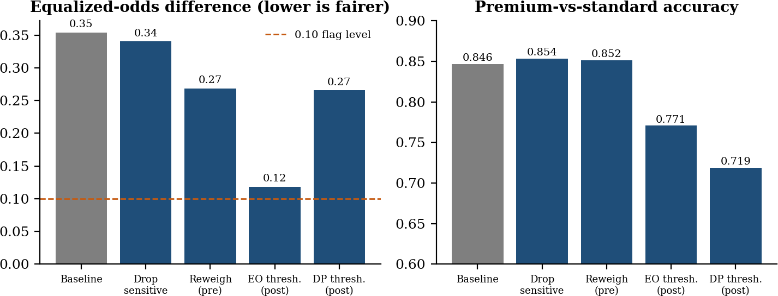
Figure 6. Effect of each mitigation strategy on the equalized-odds difference (left) and on accuracy (right).

  - Reweighing lowers the equalized-odds difference from 0.354 to 0.268 with no loss of accuracy (0.852) and only $0.77 more MAE. It helps but stays above the 0.10 flag level.
  - Equalized-odds thresholds bring the difference down to 0.118, close to the flag level, but cost 7.5 points of accuracy (0.846 to 0.771).
  - Forcing demographic parity reaches a parity difference of 0.020 but accuracy falls to 0.719 and the equalized-odds difference is 0.266. Because entire homes really are more often premium, equal selection rates are the wrong target here.
  - Dropping the sensitive feature barely helps (0.340), because capacity features and host information still carry room-type information.

Open-Source Tools
  - SHAP – Global feature importance and dependence plots (exact TreeExplainer values).
  - LIME – Local explanation of individual predictions (lime_tabular).

  - Fairlearn – Fairness metrics (demographic parity and equalized odds difference, MetricFrame) and mitigation methods.
  - scikit-learn, pandas, matplotlib – modelling, data handling and plots (as in Experiment 4).

Deliverables
  - SHAP plots (summary, dependence): Figures 1–3.
  - LIME local explanation visualizations: Figure 4.
  - Fairness audit report (metrics, visualizations): the room-type table, the ward findings and Figure 5; mitigation comparison: Figure 6.
  - Google Colab notebook ADS_Exp5_XAI_SHAP_LIME_Fairness.ipynb, which regenerates all plots and tables, and the project repository (GitHub: CloudyPatil/ADS-Airbnb-Price-Prediction).

Conclusion
SHAP and LIME show that the Gradient Boosting model prices Airbnb listings mainly by capacity and size: the number of guests accommodated, bedrooms, beds and bathrooms dominate, and long minimum stays lower the price.. The explanations also exposed two weaknesses: the model leans on host_name, a personal identifier that adds little signal, and it under-predicts the most expensive properties. The fairness audit with Fairlearn found that room type is treated unevenly: most of the demographic-parity gap reflects real price differences, but the model wrongly flags cheaper entire homes as premium far more often than cheaper private rooms (false-positive rate 0.385 vs 0.062, equalized-odds difference 0.322). Ward-level errors also vary widely (14.8% to 52.4%), although the small groups make those figures uncertain. Among the mitigation strategies, reweighing is the best default because it reduces the gap without hurting accuracy, while group thresholds reduce it further at a real accuracy cost, and demographic parity is the wrong goal when groups truly differ. None of the methods brings the equalized-odds difference reliably below 0.10, and the model still misses the Experiment 1 target of RZ ≥ 0.85 (out-of-fold RZ = 0.53). Future work is to remove host_name and the high-cardinality date-string columns, collect more listings for the smaller room types and wards, and re-run the audit on the improved model.

