Source: Build a 75 ohm 1/4 Wave Matching Transformer – Q82.uk – Antenna Resources by Steve G0UIH – ex Vortex Antenna Systems

Build a 75ohm 1/4 wave Matching Transformer
We’ve already covered on the site how to match a single element Delta Loop by using a quarter-wavelength of 75 ohm coax coupled to your main 50 ohm feed back to the shack. If you have an antenna that exhibits a natural impedance of around 100-200 ohms, then a 75 ohm quarter wave stub will help you lower the SWR without the need of an ATU.
In essence, the far end of 75 ohm stub connects directly to the antenna and then the start of the stub connects to your main 50 ohm feed. You can see below basically how the setup works.
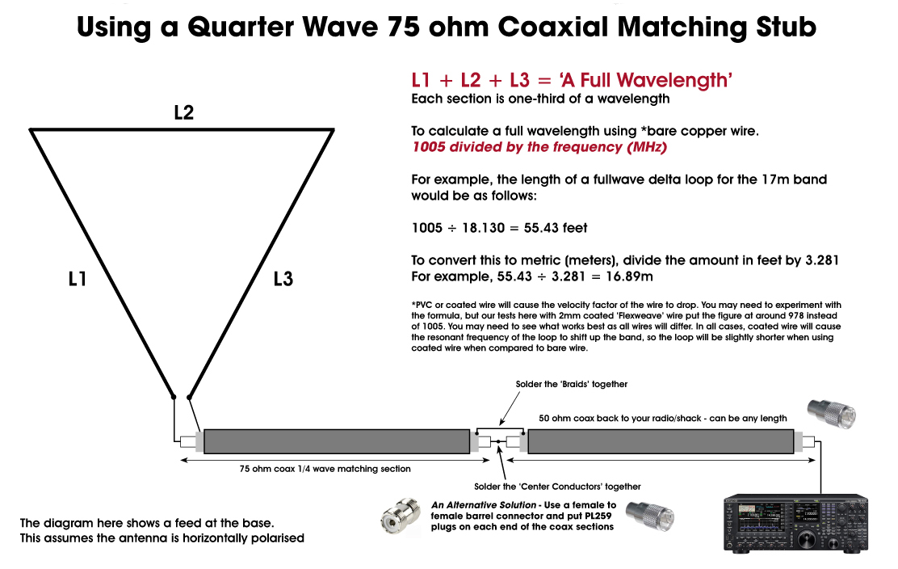

So – what’s going on and how does it work. Certainly with loop antennas, the natural unmatched impedance is in the region of 100-200 ohms. This does vary with the shape of the loop and the height above ground. However, the 1/4 wave 75 ohm stub can be used to match any antenna that exhibits an impedance with these sort of figures.
What needs to happen is that your transceiver wants to see ’50 ohms’ [or close to that figure] in order to have the least amount of standing waves on the feeder. The higher the SWR, the more power is reflected back to the radio. If you connect a loop or say a 150 ohm antenna directly to your 50 ohm coax, the SWR will be high – maybe over 3 to 1. A 100 ohms antenna will read about 2 to 1. So the 75 ohm coaxial quarter wave stub helps to reduce the impedance [called ‘Z’] to a lower and much more acceptable level that your radio will be happy with.
When making a stub, you MUST take into account the velocity factor [called the ‘VF’] of the coaxial stub.
One important factor of a coax cable in some applications is the wavelength of the signals travelling in it. In the same way that the wavelength of a signal is the speed of light divided by the frequency for free space, the same is also true in any other medium. As the speed of the wave has been reduced, so too the wavelength is reduced by the same factor. Travelling at a slower speed the signal cannot travel as far in the same time.
Thus, if the velocity factor of the coax cable is for example 0.66 [common for many cheaper types of coax], then the wavelength is 0.66 times the wavelength in free space. Premium coaxial cables that use PTFE or foam as their dielectric often have a higher VF [0.80 or more].
In constructing a stub, the length of coax cable is cut to a specific length to act as an impedance transformer, then this needs to be taken into consideration when determining the required length of coax cable.
Here’s a table with some sample velocity factors – although it best to confirm the coax data first. Owners of antenna analysers can of course create their own stubs easily without knowing what the VF is.
DIELECTRIC CONSTANTS & VELOCITY FACTORS
OF COMMONLY USED COAX CABLE DIELECTRIC MATERIALS
COAX CABLE DIELECTRIC MATERIAL | DIELECTRIC  CONSTANT | VELOCITY  FACTOR
Polyethylene (PE) – Normally budget coaxial cables | 2.3 | 0.659
Foam polyethylene – Normally premium coaxial cable | 1.3 – 1.6 | 0.88 – 0.79
Air spaced polythene – Normally premium coaxial cable |  | 0.84 – 0.88
Foam polystyrene – Normally premium coaxial cable |  | 0.910
Solid PTFE – High-end professional grade coaxial cable | 2.07 | 0.695
Air spaced PTFE – High-end professional grade coaxial cable |  | 0.85 – 0.90
The velocity factor is determined by the dielectric of the coaxial cable. As the dielectric constant will not vary too much from the standard values, it is often sufficient to take the datasheet figures and then cut the cable accordingly. It is obviously best to cut your stub slightly long at first and then trim back a bit once in situ. In this way any stray effects from cable ends and the like can be accommodated.

