29 MHz 4W input
Input to 2nd mixer 100 TX power: -42 dBm (IF amp off), -21 dBm (IF amp on)
54 TX power: -56 dBm (IF amp off), -35 dBm (IF amp ON)

2.4 GHz Input -30 dBm

From 2nd mixer outpput to TX BPF input
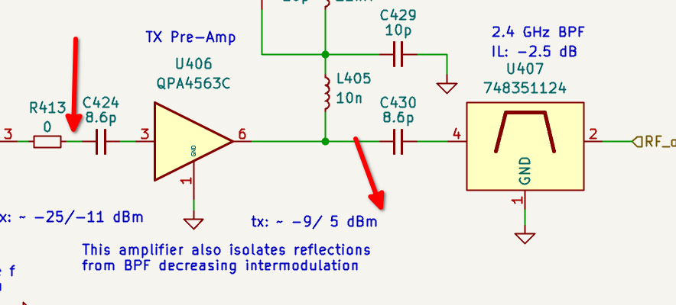
Output -14 dBm, Gain ~ 16 dB. Datasheet specs 14.5 dB gain so no problem here.
Flat characteristic

From 1st preamplifier output to PA output.
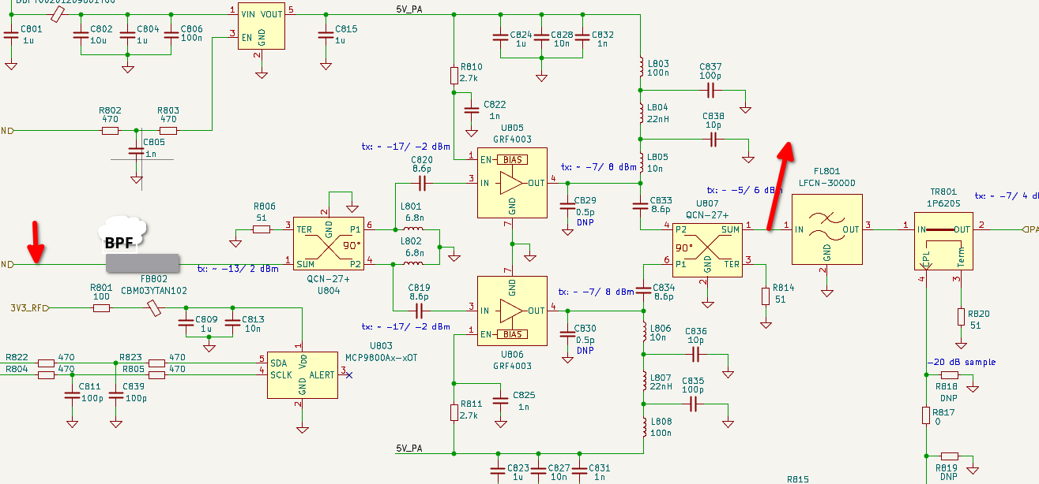
Output -22 dBm, Gain ~ 8 dB (rather low) characteristics ok.

2nd Mixer test:
Input -30 dBm 434 MHz, LO module driving mixer directly

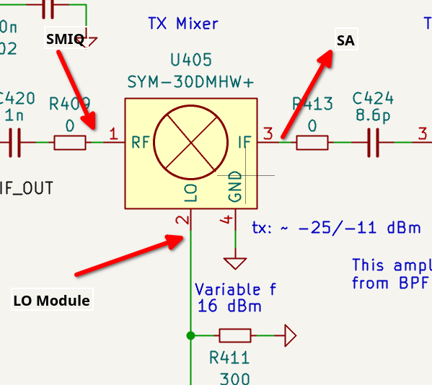

Output: 2.4 GHz -43 dBm. Datasheet loss ~7.5 dB. This is ok.
RF Isolation: 34 dB
LO isolation: 45 dB

4 W 29 MHz in, 2nd mixer output:
-55 dBm (IF amp off), -40 dBm (IF amp on), for tx power 50.
-42 dBm (IF amp off), -25 dBm (IF amp on), for tx power 100.

4 W 29 MHz in, 1st preamp output:
-27 dBm output (IF amp off), tx power 100.
-11 dBm (IF amp on) tx power 100. some spurs 50 dBc, 29 MHz offset

Testing Each GRF4003 path individually:
-LNB side: ~10 dB gain at 2.4 GHz
-PSU/IO side: ~10 dB gain at 2.4 GHz
both have comparable characteristics. Datasheet specifies ~13 dB.

