With stock LO2 module output power is about 46 dBm
Note: on startup without LO2 the EUT correctly detects LO2 lock error, then I n main manu displays LO1 lock?

LO2 @ 2.4 GHz Uplink
narrow

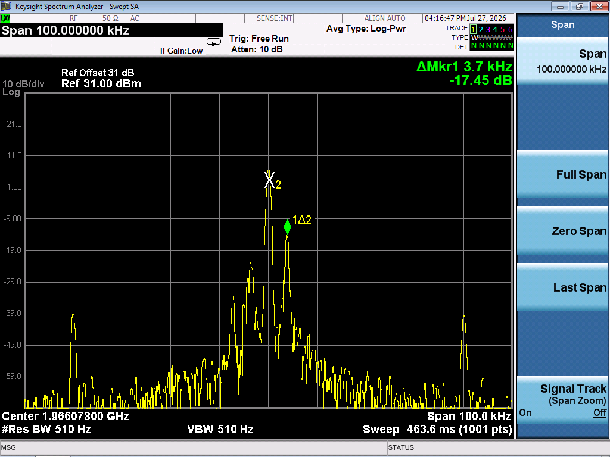
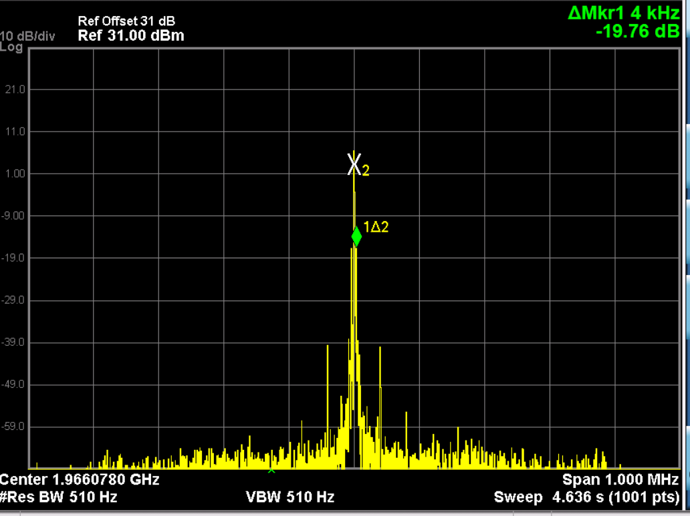

wide

With extenal LO2 singnal:

13 dBm at mixer, IF amp off
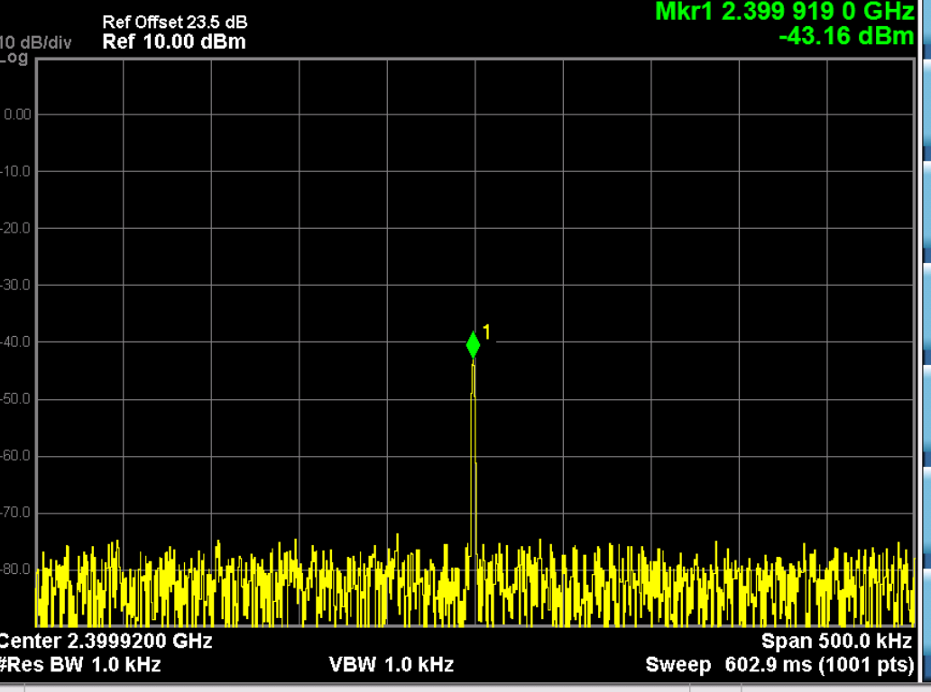

13 dBm at mixer, IF amp on
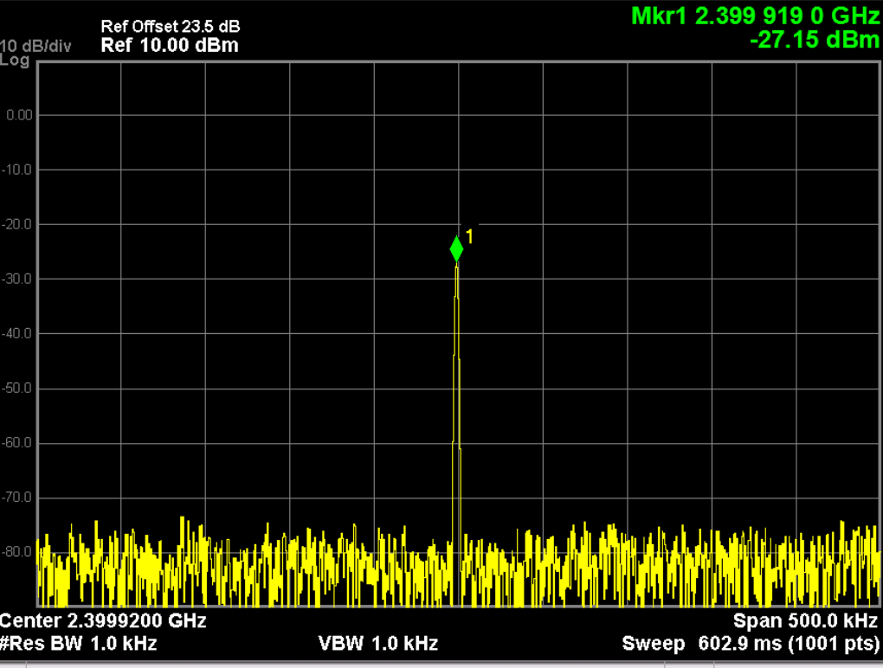

Stronger LO does not yield a significant improvement

Tests of PLL on 002399 board:
2nd LO with Abracom VCTCXO. 24 MHz because 48 MHz is divided by 2 by flip flop.
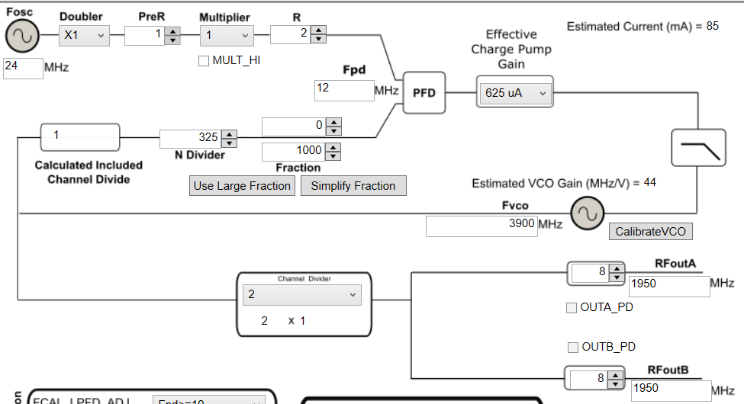

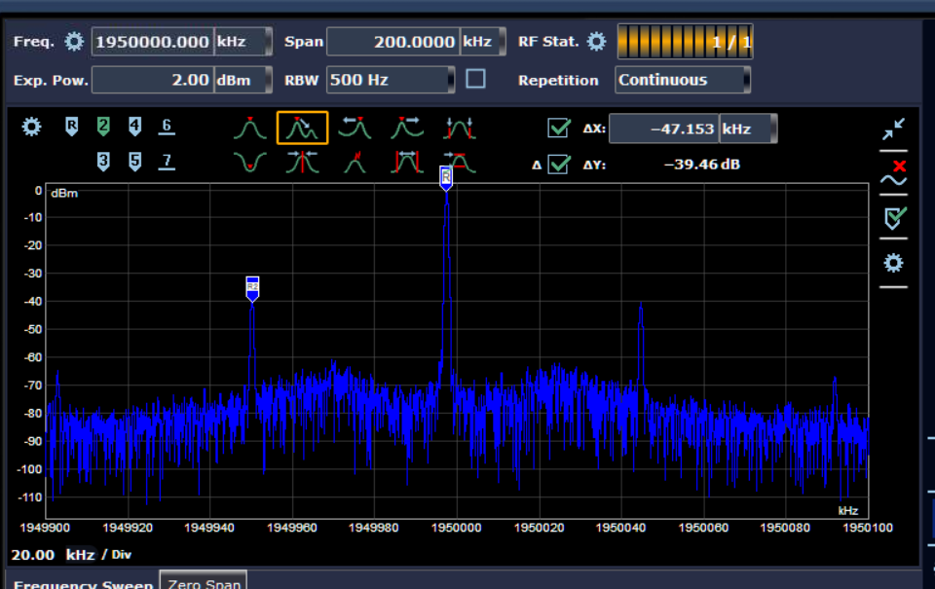
Solution is to limit the Fpd to 0.2 MHz (48 Khz spurs are minimized)
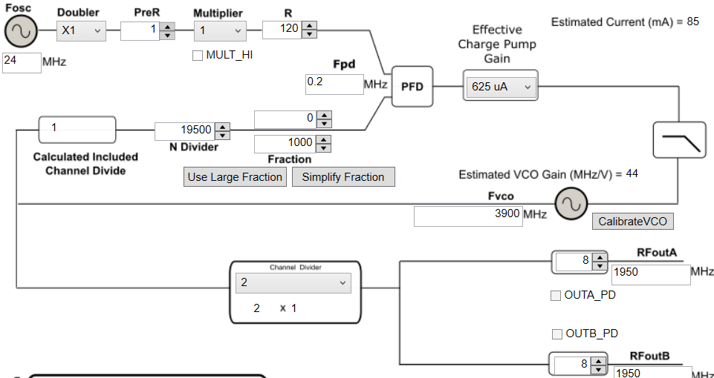
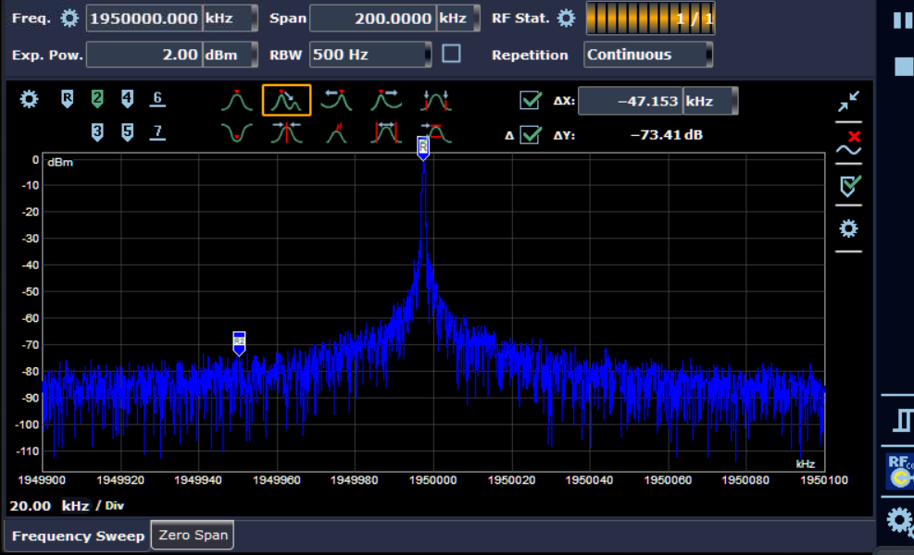

Using external 24 MHz source the spurs at 48 KHz offset were not present

$8 MHz seems to be clean
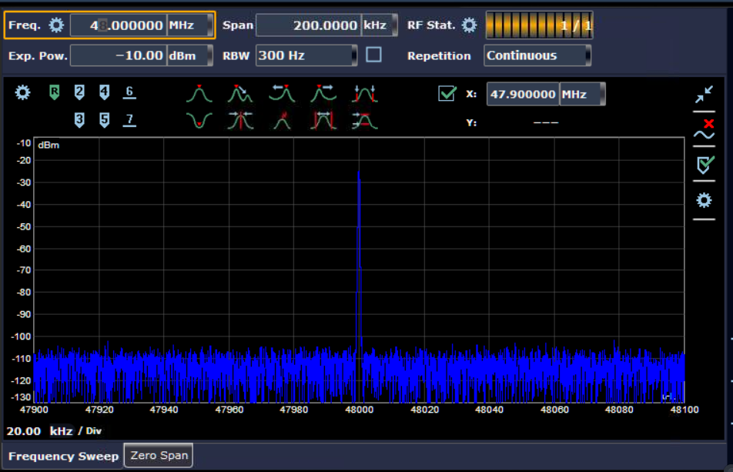
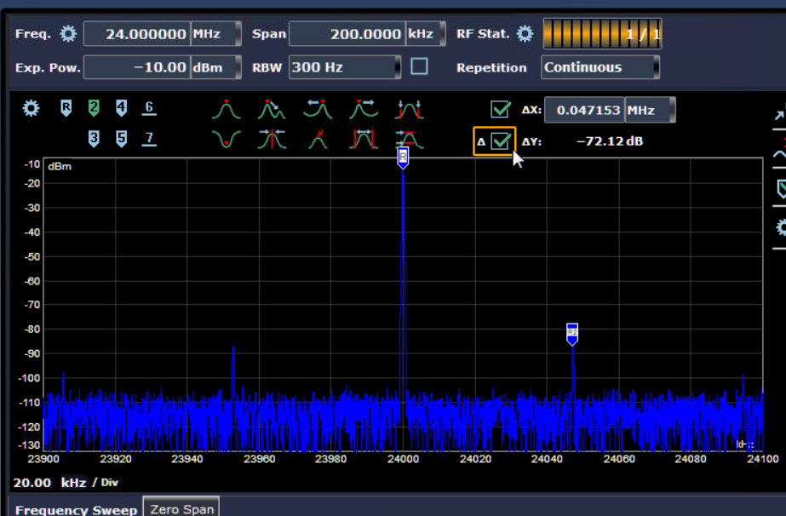
Measurements of Fref on CXA:
divided (24 MHz):
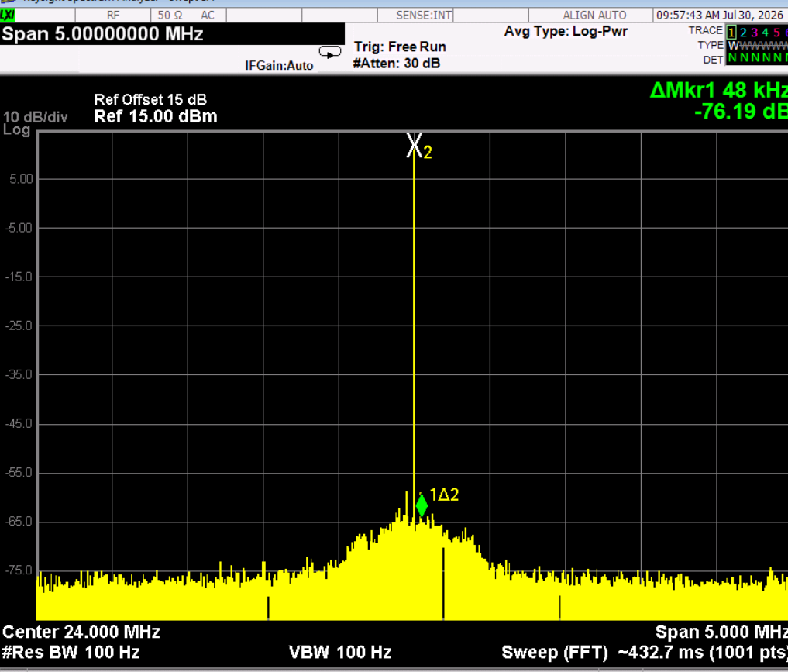
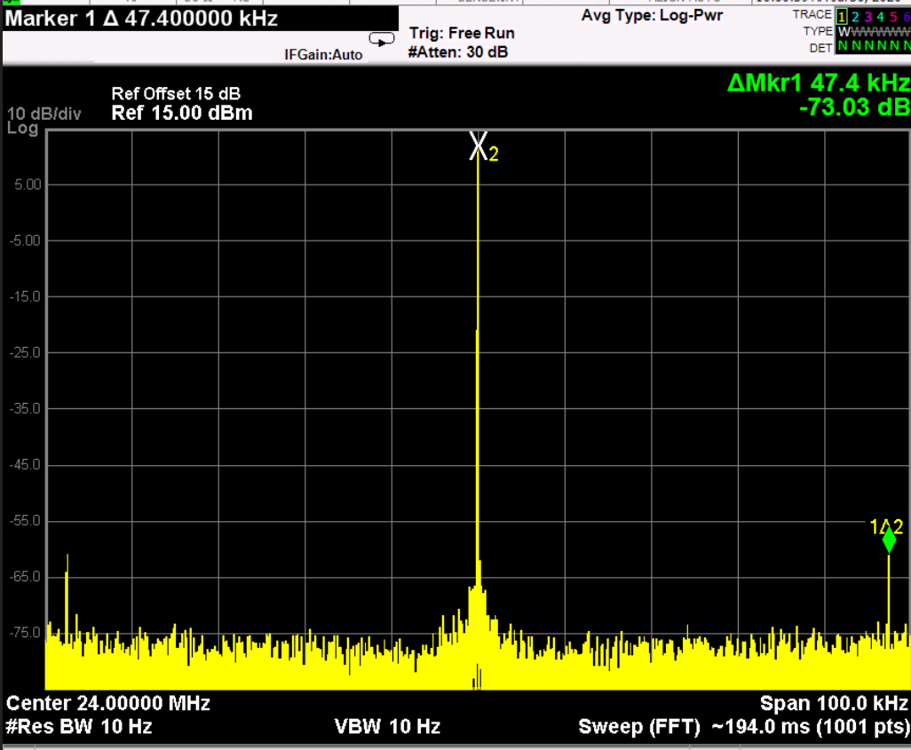

TCXO output:
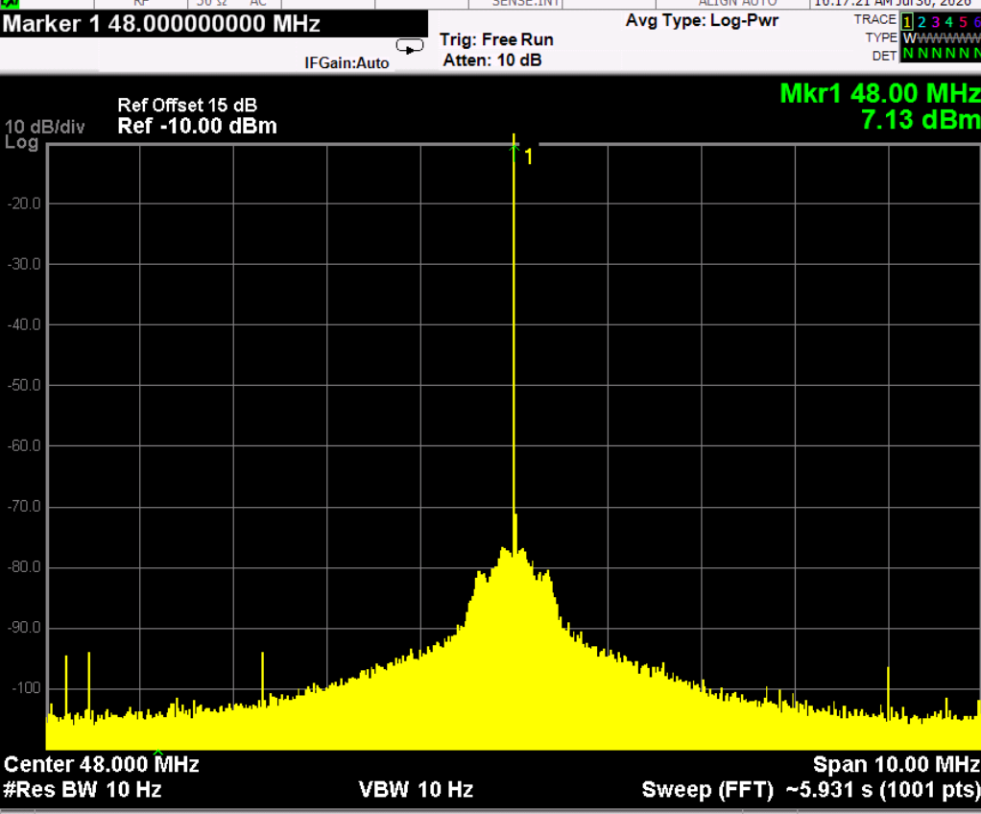
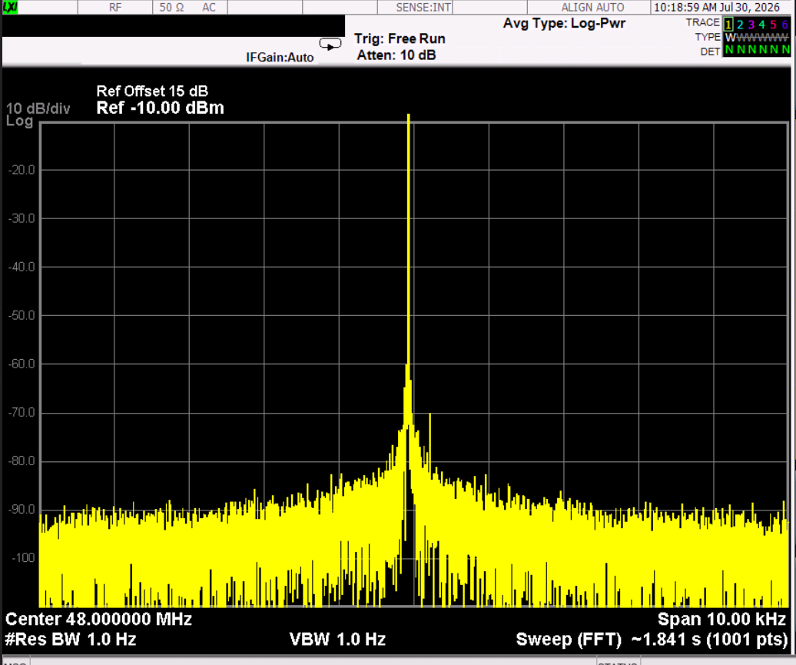
Presto 2nd LO driven by embedded SW(yellow)
00299 driven with 24 MHz from Agileng AWG (blue)
The same PLL settings (for presto read from debug, then enterd into TICS to program 002399)

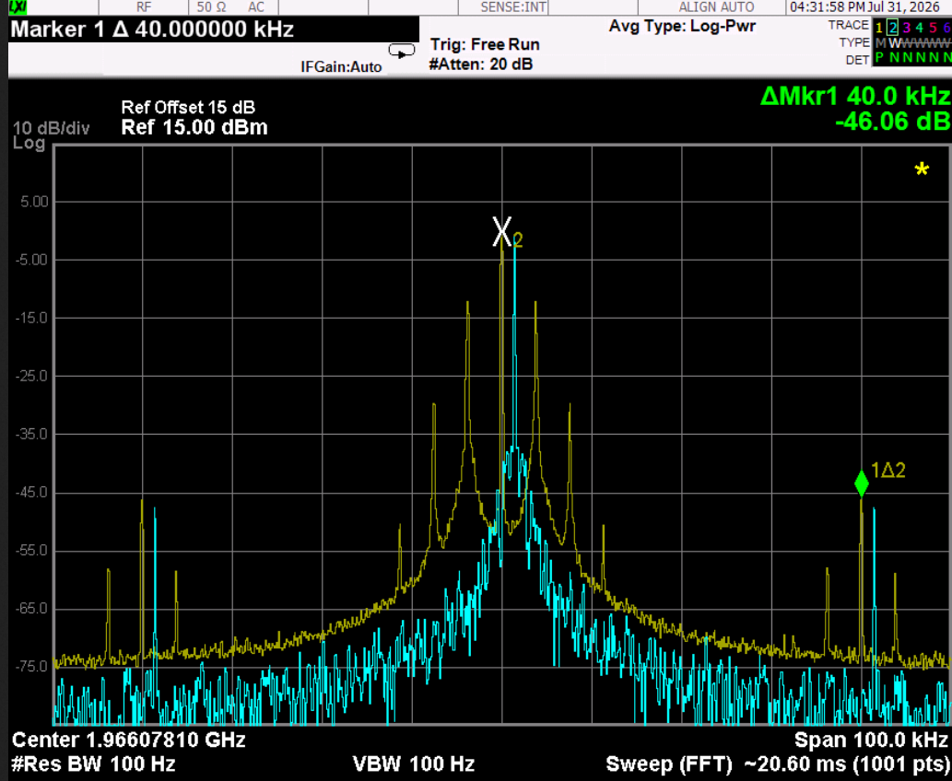
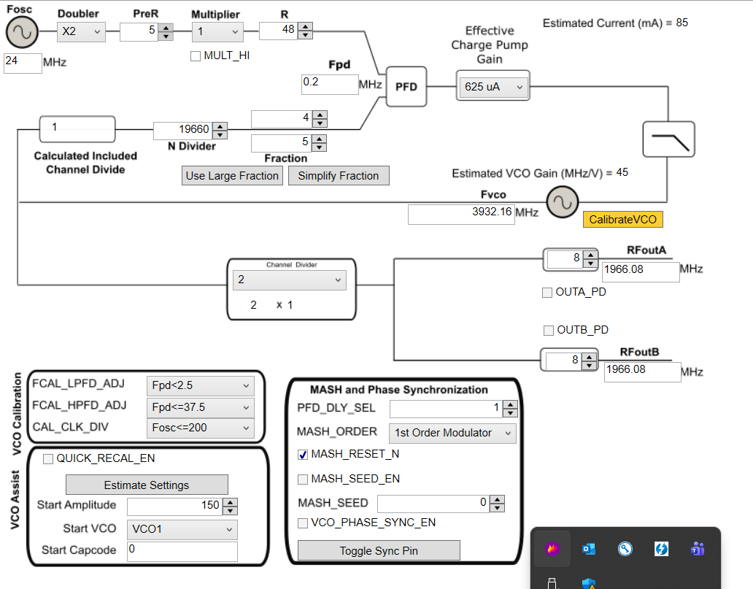
‘

Observed degradation with higher order modulator

