Your order

Item |  | Name | Quantity | Net price | Net value
1 | 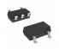 | 74LVC1G06GW,125 Nexperia Micros part number: UT006lvc1g gw Manufacturer: NXP Manufacturer part number: 74LVC1G06GW RoHS Case style: SC70-5 t/r
  5 |  | 0,8100 PLN | 4,05 PLN
  Total:: | 5 |  | 4,05 PLN
2 | 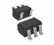 | 74LVC1G06 SOT23-5 Micros part number: UT006lvc1g dbv Manufacturer: Texas Instruments Manufacturer part number: SN74LVC1G06DBVR RoHS Case style: SOT23-5/t/r
  5 |  | 1,0500 PLN | 5,25 PLN
  Total:: | 5 |  | 5,25 PLN
3 | 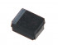 | TAJB106K020RNJ AVX/ 293D106X9020B2TE3 VISHAY Capacitor Micros part number: KTSB 10.00/20k Manufacturer: AVX Manufacturer part number: TAJB106K020RNJ RoHS Case style: smdB
  3 |  | 1,6300 PLN | 4,89 PLN
  Total:: | 3 |  | 4,89 PLN
4 |  | TAJB226K020RNJ AVX/ 293D226X9020B2TE3 VISHAY Capacitor Micros part number: KTSB 22.00/20k Manufacturer: AVX Manufacturer part number: TAJB226K020RNJ RoHS Case style: smdB
  6 |  | 1,3200 PLN | 7,92 PLN
  Total:: | 6 |  | 7,92 PLN
5 | 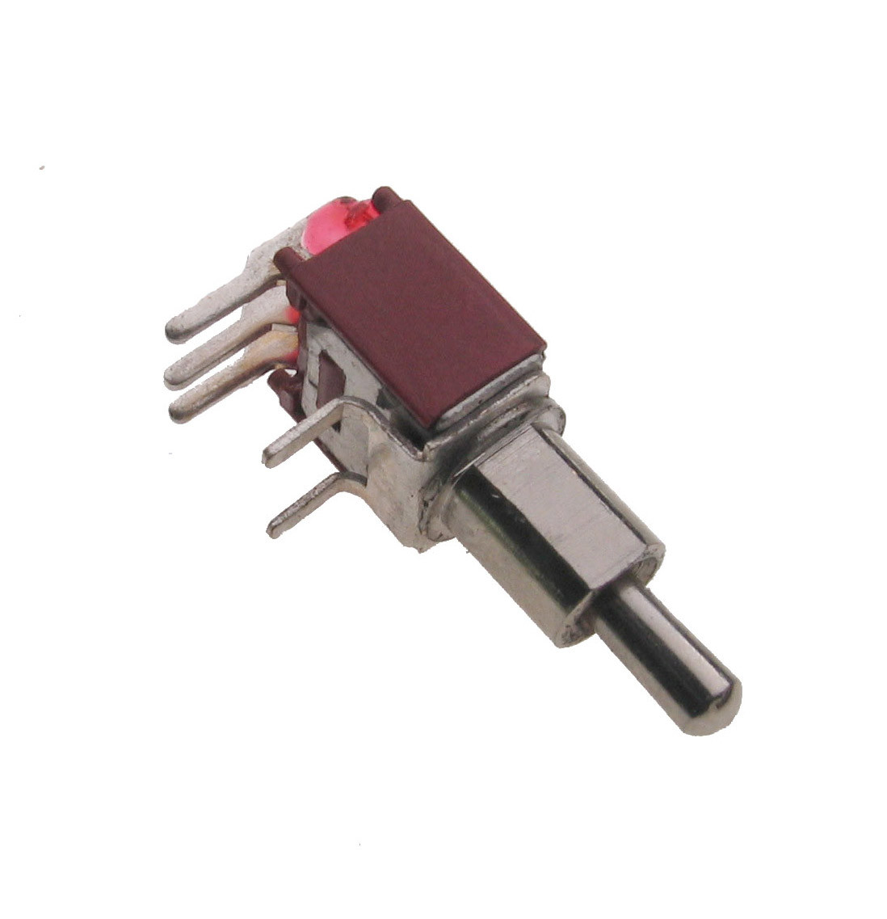 | SMTS103-2C3; toggle switch; Micros part number: PRZ Smts103-2c3 Manufacturer: SWI Manufacturer part number: SMTS103-2C3 RoHS Case style: Rys.SMTS103-2C3
  3 |  | 3,4300 PLN | 10,29 PLN
  Total:: | 3 |  | 10,29 PLN
6 | 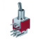 | SMTS202-2C3; toggle switch; Micros part number: PRZ Smts202-2c3 Manufacturer: SWI Manufacturer part number: SMTS202-2C3 RoHS Case style: Rys.SMTS202-2C3
  2 |  | 3,9300 PLN | 7,86 PLN
  Total:: | 2 |  | 7,86 PLN
7 | 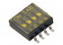 | SOP04E SAB dip-switch IC type, 4 contacts, SMD montage p. 1.27mm Micros part number: PRZ DipICns04 Manufacturer: SAB Manufacturer part number: SOP04E RoHS Case style: Rys.dswICns4
  1 |  | 5,6600 PLN | 5,66 PLN
  Total:: | 1 |  | 5,66 PLN
8 | 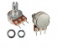 | Single turn shaft potentiometer; 10K Micros part number: PO R16148-1A-2-A10K Manufacturer: BOCHEN Manufacturer part number: WH148-1A-2-A 10kR RoHS Case style: Rys.R16148-1A-2
  5 |  | 1,5400 PLN | 7,70 PLN
  Total:: | 5 |  | 7,70 PLN
Net products | Net delivery cost | Net amount | VAT 23 % | Total cost
53,62 PLN | 24,02 PLN | 77,64 PLN | 17,86 PLN | 95,50 PLN

