2015 AFRL University and Service Academy Design Challenge

Auburn University

Weagle Water Cooling



Pictured from left to right, front then back: Rob Galland, Devin Trowbridge, Shane Tucker, Jackson Montgomery, Nicholas Bowman, Adam Wypyski, Michael Hizny, William Crubaugh, Josh Jablonowski

# Executive Summary

This design uses thermoelectric cooling technology to cool the airman’s water supply. A cooling chamber is fed by the hydration pack (camelbak) already carried by the airman. The water inside the cooling chamber is cooled to a temperature ideal for decreasing the core body temperature. Inside the cooling chamber, thermoelectric plates are used to cool the water. Heat is drawn through the thermoelectric plates from the water into the heatsinks. Two battery packs power the design. The capacity of this cooling chamber supports a 1 quart/hr drinking rate. Approximately 15W of cooling is provided by the water when it is cooled to 75°C. The chamber is also well insulated to prevent other losses. The device has operability in many different environments due to few moving parts and a simple on-off switch. Dead batteries can easily be switched at base and the device is ready to use again. The system is very durable due to the casing and materials used. The strength of this design is that, once the water enters the body, the entire temperature difference is used to cool the core body temperature with no losses to the environment.

**Introduction**

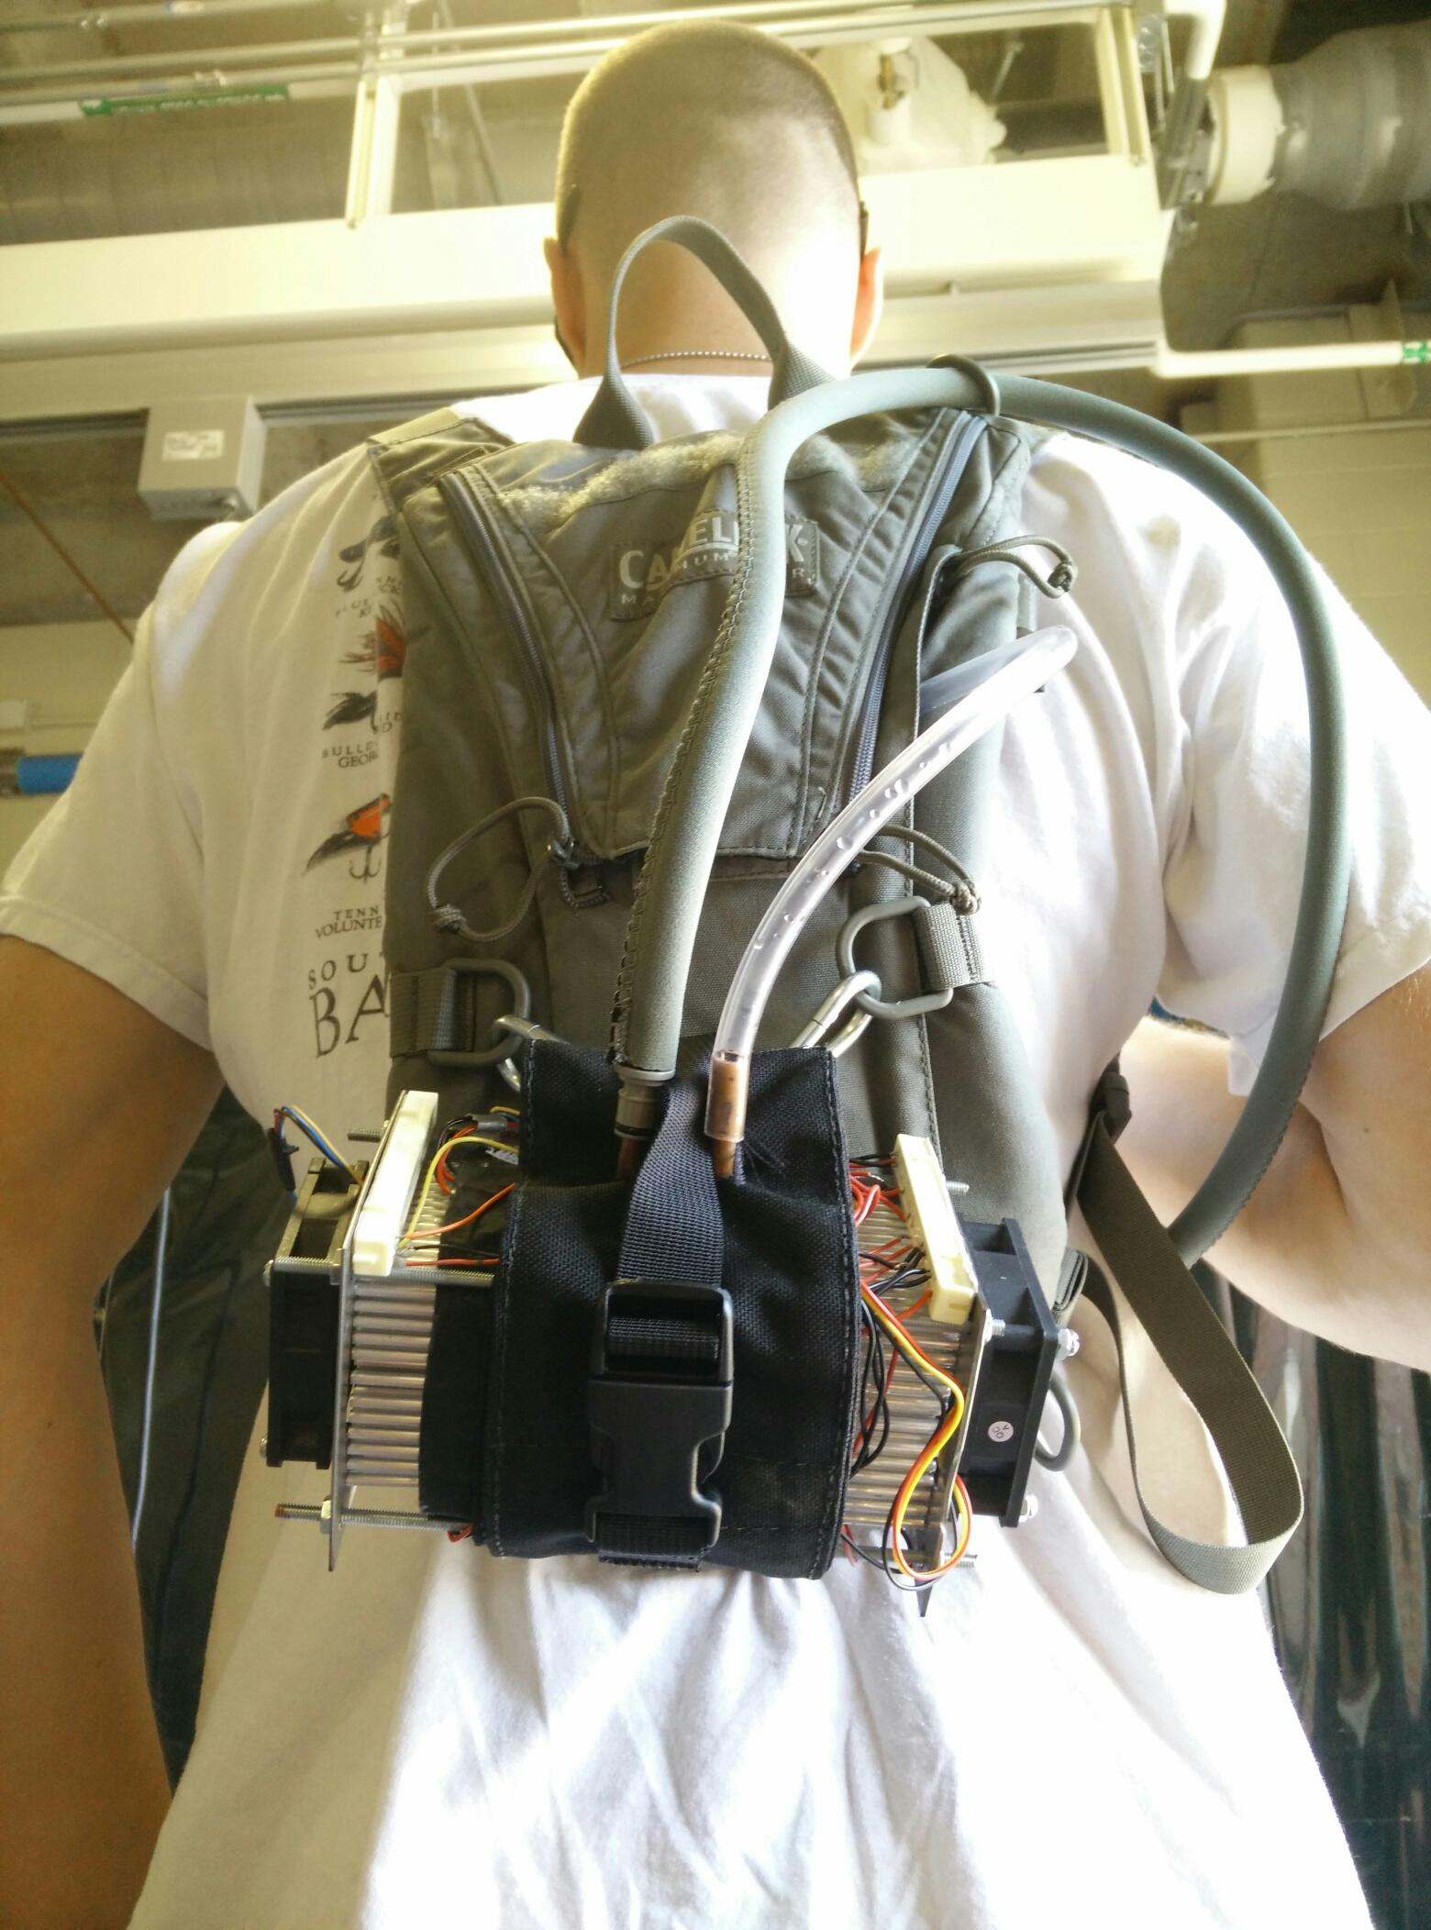

Figure 1: Device (excluding batteries) integrated into camelback

The device shown in Figure 1uses 75° F drinking water to cool the user’s core temperature. Water is stored in an existing reservoir, such as the camelback shown in the picture. The water is then drawn into an 8 oz cylindrical cooling chamber, attached at the bottom of the camelback in the figure.

The water is cooled in this chamber before the user drinks it through their straw. The cooling chamber has a custom sleeve that connects it to the camelback, and is insulated by both the sleeve and a layer of insulation.

In order to cool the chamber, two large thermoelectric coolers are attached to the chamber by thermal grease; one on each end of the cylinder. The other side of the thermoelectrics are attached by thermal grease to aluminum heat sinks. When a voltage is applied to the thermoelectrics, heat is pumped from the side facing the chamber to the side attached to heat sinks. This removes heat from the water in the chamber and dissipates that heat to the environment through the heatsink and fan system. The fins of these heat sinks can be seen in Figure 1on either end of the sleeve, with the fans screwed on top of them. The fans help to dissipate the heat from the heat sink. The container, heatsinks, and fans are held together by four tension rods located on each corner of the design.

The thermoelectrics are powered by a battery pack and power is regulated to them by a microcontroller. The controller, battery pack, and cooling chamber will all be located on the camelback shown in Figure 1.

|  |  |  |  |
| --- | --- | --- | --- |
| **Metric** | **Description** | **Quantity** | **University Team’s Opinion**  **(Grade yourself on a scale of 1-10)** |
| Total Weight (lbs) | All equipment that will be on test subject the day of the competition | 9 |  |
| Size (in3) | All equipment combined | 156.90 |  |
| Time (hrs) | Time device works with only above equipment | 3.5 |  |
| Device Performance | Does it help solve the problem? |  | 5 |
| Usability | Does it hinder movements? |  | 7 |
| Reusability | Can I just swap out power source and continue? Or do I have to wait a long time? Or do I need special equipment to recharge? |  | 8 |
| Innovation and Creativity | How creative do you feel your design is? |  | 8 |

# 

# Functional Overview

The main cooling medium in this design is water. Drinking the cold water absorbs some of the core body heat, keeping body temperature down. The water is cooled in an 8 oz. cylindrical chamber by 2 TECs, one on either end. These TECs dissipate heat to the environment via aluminum fin heat sinks and are powered by a voltage source. The voltage is regulated by a microcontroller.

## Water

Water is used as the thermal medium to get the cooling directly to the core of the body. Using water will not add any excess weight to the final design, as the soldiers are already carrying the water. Water also has a very high specific heat, making it ideal for absorbing heat.

The initial temperature of the water will be assumed to be 100° F, and the drinking rate is assumed to be 1 quart per hour (averages out to 0.2629 g/s). This rate of water consumption is recommended as the maximum amount from an Air Force guidance memorandum on thermal injury, #AFPAM 48-151.

Cooling water from 100° F to 75° F (37.8° C to 23.9° C) at this flow rate requires the following average heat removal:



Where:

Q̇ is the average amount of heat removed from the water

ṁ is the average mass flow rate of the water

Cp is the specific heat of water

ΔT is the change of temperature of the water

Due to the fact that the water is removing heat directly from the body, it is assumed that any heat removed from the water by the thermoelectrics is also removed from the body by the chilled water. Using a similar equation as above, the water removes about 11 watts directly from the core of the body.

## Cooling Container

The primary function of the cooling chamber is to quickly cool the water from the reservoir and maintain it at approximately 75° F. It is made out of a 3 inch diameter copper cylinder that is 2 inches in length and holds approximately 8 oz. of water. 1 thermoelectric is attached to each circular base as described in the introduction. This design relies on constant agitation from body movement to properly mix; although, some mixing will still occur through free convection even when the device is stationary. The side of the cylindrical chamber is insulated with Armaflex. Armaflex was chosen because of its light weight and low thermal conductivity.

**Thermoelectric Cooler**

The thermoelectric chip is a solid-state active heat pump which consists of a layer of semi conductive material between two ceramic plates. Operating by what is known as the Peltier effect, heat is transferred from one side of a semiconductor chip to the other due to an applied DC current. This device is used to cool the chamber because it is extremely durable, lightweight, compact, and can operate in almost any condition.

One of the main variables that define the performance of this device is the ∆T, which is the temperature difference between the two plates of the thermoelectric module. The ∆T is controlled by the heat removal from the hot side and the percent of input voltage relative to the maximum input voltage at which the device is designed to operate. As the ∆T decreases, the efficiency increases. Therefore, an appropriately sized heatsink with fan combination and carefully designed input voltage are imperative to the operation of this device.

The thermoelectric device is selected based off empirical data collected by the supplier to meet our requirements and provide the most optimum cooling. A thermoelectric that could pump 288W at a ∆T of 0 was chosen. The selection is shown in Table 2 in the appendix.

**Heatsink and Fan**

The heatsink and fan combination selection is based on trying to minimize the thermal resistance of the heatsink/fan system. This thermal resistance is calculated using the following equation:

Where:

TR is the Thermal Resistance of Fan and Heatsink Combination

I is the Input current for the thermoelectric

V is the Voltage drop across the thermoelectric

is the Temperature at the hot side of the thermoelectric

is the Temperature of the ambient air

By plugging in the known values discussed previously into the above equation, a thermal resistance of approximately 0.21° C/W is obtainable with the fans and heatsink used. The heatsink is required to have a certain volumetric flow rate of air to achieve the thermal resistance specified. The fan was then selected based on the required flow rate.

**Control Board**

In order to give the design an automated ability to control the temperature of the water, a printed circuit board (PCB) is used which can measure the temperature of the water and adjust the number of TECs running accordingly. The control loop uses a thermistor as a temperature sensor and alters the voltage sent to the TECs. This ensures that the water is not cooled to an unnecessarily low temperature. The printed board design was created in a program called Utiliboard.

Surface-mount devices (SMDs) were used for as many parts as possible to allow for easy placement on one side of the board. The primary components that help in controlling the board are the 12 A Transistors and the RFduino Module. Other components are used to regulate current and voltage to the primary components. The RFduino module reads a temperature using a voltage divider hooked up to a thermistor, shown below the board in Figure 2. Using these readings, the RFduino determines the number of TECs to activate by sending a signal to the transistors, allowing current from the battery to flow to the TECs. If the thermistor reads a temperature above 70° the TECs will be powered.The final product is shown in Figure 3 below, with final dimensions of 43.4mm x 52.8mm.

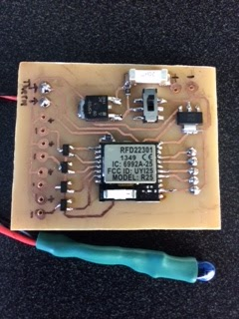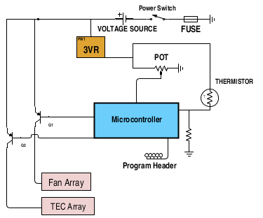

Figure 3: Circuit board and electrical diagram for the board.

**Batteries**

Projected lifetime of the unit under continuous operation is approximately two and a half hours. This is based on a continuous draw from eight thermoelectric cooling devices and two fans assuming two battery packs. Each lithium ion battery pack is rated for 7.4V and 26Ah and weighs 2lb. A single pack, however, cannot supply the amperage needed. For this reason, two of these packs must be placed in parallel to power the system, bringing the weight to 4 pounds. Using the onboard controller to regulate the cooling of the water the battery life may be prolonged if environmental factors improve. The battery case is water proof, fire proof, and will withstand most minor impacts. The protection circuit board installed within the battery pack protects the cells from overcharging, over discharging, and also prevents excessive current draw. This significantly reduces potential dangers associated with the use of the lithium ion battery packs.

# Possible Future Improvements

The more turbulent the water flow, the higher the heat removal rate from the water. The current design relies on the user to constantly agitate the water by walking or running. Idealy, a constant turbulent flow system could greatly increase the efficiency of this system.

The largest source of inefficiency in the design is the water that is in the drinking tube. This water heats up quickly once it exits the cooling chamber resulting in the first gulps of water being much hotter than desired. The current design utilizes a three port ball valve that allows for the water to be evacuated from the straw. A system that automates the valve system by just the pressing of a button on the straw would improve on this design.

Another improvement that can be done in the future is to waterproof the device so that it works in rainy environments. Right now the wires are not protected from the elements such as rain. In the future, the electrical wiring should be made waterproof.

One of the downsides of the design is that, in order to obtain the best heat transfer, more powerful fans need to be used. These fans are loud, and would not be good for missions in which stealth was necessary. An improvement to this would be to reduce the noise of the fans, by either using quieter fans that would achieve the same amount of heat transfer, or encasing a fan in such a way to reduce the noise.

Currently the heatsinks are the second heaviest component next to the batteries. Improving on heatsink design, and optimizing batteries could reduce the overall weight greatly and increase the efficiency of the thermoelectrics.

Changing the chamber design could also improve on the efficiency of the design. A water block design would optimize the cooling surface area.

Changing the overall design of the device in order to be handheld could also be a benefit. This would allow the device to be more versatile. In addition, the attachment method could be modified to further increase versatility.

**Appendix**

**Test Data**

The figure below demonstrates the effectiveness of drinking cold water in order to keep core body temperature down. The test subject was in a controlled environment room at 100° F and 50% relative humidity. For the first 30 minutes the subject sat in a chair, and for the last 30 minutes the subject cycled at 100 W on a stationary cycle.

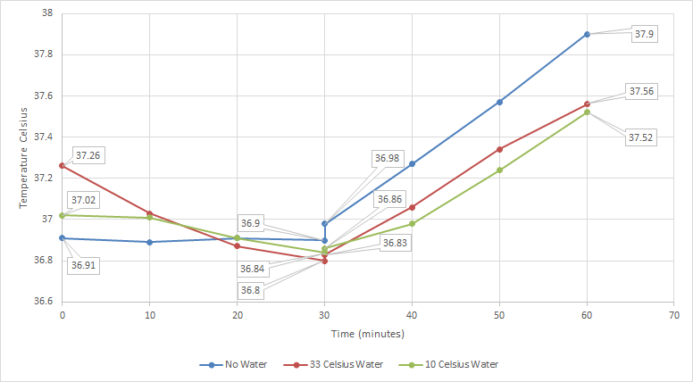

Figure 4: Core body temperature with various tests

The blue “No Water” data indicates that the subject did not drink water for the duration of testing. The red “33 Celsius Water” indicates that the subject was drinking 33o C for the duration of testing. The green “10 Celsius Water” indicates that the subject was drinking 10o C for the duration of testing. A rectal core body temperature, heart rate, and perceived intensity was recorded every 10 minutes.

Table 2: Main parts used in design

|  |  |  |
| --- | --- | --- |
| Quantity | Part | Part Number From Supplier |
| 1 | Insulated Tubing | Camelbak Part #  90765 |
| 2 | Battery | BatterySpace Part # BL-LCH4P10S2WCWP-2P2 |
| 2 | Heat Sink | Cool Innovations Part #  3-252514RSF |
| 2 | Fan | Digikey Part #  2410ML-04W-B89-E50 |
| 1 | 3” Copper Pipe | Grainger Part #  4WTN3 |
| 8 | Thermoelectric | Laird Part #  ZT1,7,F1,2020,TA,W6 |
| 1 | MOSFET Transistor | Mouser.com Part #  78-SUD45P03-09-GE3 |
| 1 | RFduino Module | Mouser.com Part #  975-RFD22301 |
| 4 | 12A Transistor | Mouser.com Part #  511-3STR1630 |
| 1 | Voltage Regulator | Mouser.com Part #  522-ZSR300GTA |
| 1 | Switch | Mouser.com Part #  611-JS20211SCQN |
| 1 | 20A Fuse | Mouser.com Part #  576-0463020.ER |