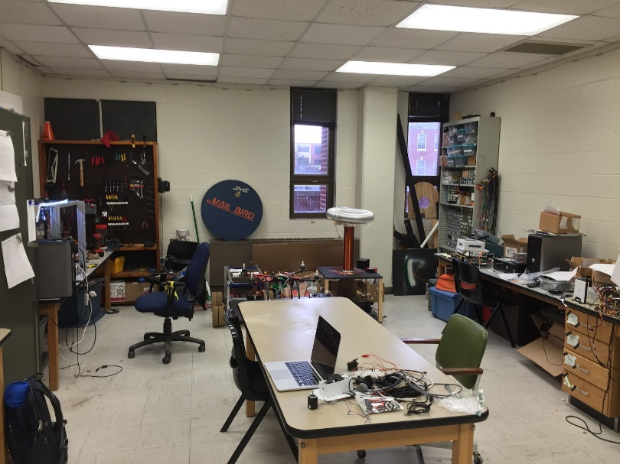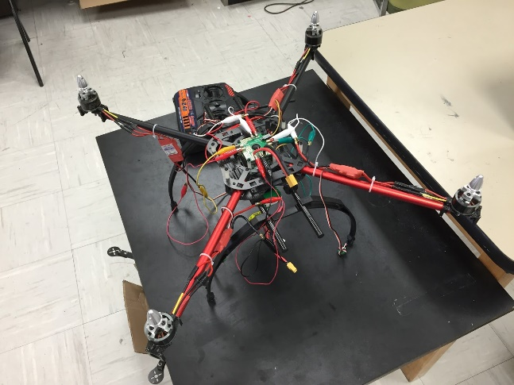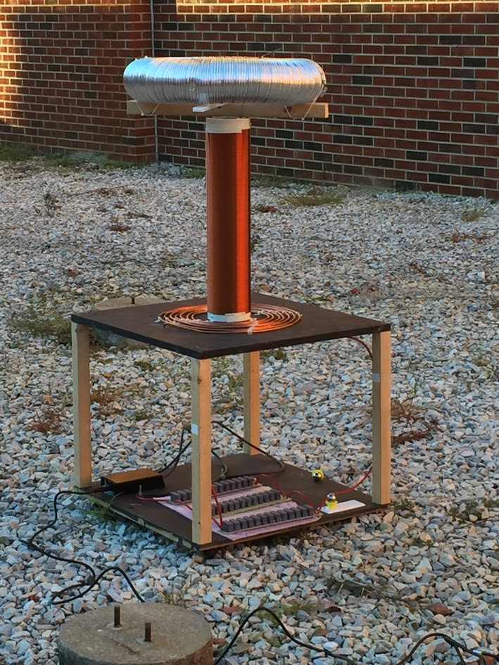2D2D2D

**For more information:** Visit our website: http://sparc-auburn.github.io/

Email our club president: [sbs0034@tigermail.auburn.edu](mailto:sbs0034@tigermail.auburn.edu)

Join our Facebook group: <https://www.facebook.com/groups/ausparc/>

**Who can join?**

* Any student regardless of major or year can join.
* No experience is required and there is no required commitment

**Do you want to?**

* Get hands on experience and apply the concepts you learn in your classes.
* Learn programming, soldering, fabricating, 3D design, and how to operate of a 3D printer.
* Build robots, quadcopters, or any other project you can come up with.

**What is SPaRC?**

* SPaRC stands for Student Project and Research Committee.
* It basically functions as Auburn’s own “makerspace.”
* SPaRC provides the resources and the funds for projects.

**Lab Location:**

Broun 368

**Spring 2016 Meeting Time:**

Tuesdays 6-7 in Broun 235

