

**YDLIDAR ROS**

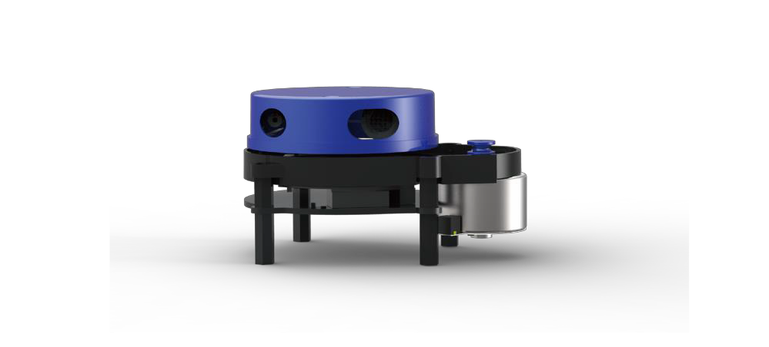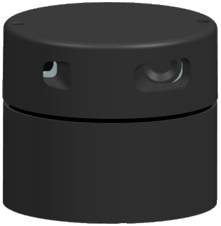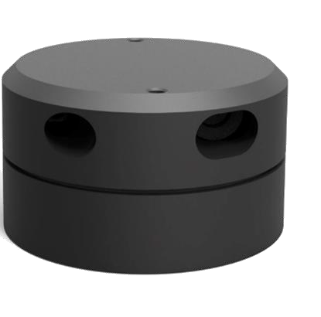

Manual

Doc#: 01.13.000019

Contents

Create YDLIDAR ROS driver package

Run YDLIDAR ROS driver package

YDLIDAR coordinate system

# Create YDLIDAR ROS driver package

（1）Switch your computer to the src directory of a ROS workspace and replace catkin_ws with your ROS workspace.

（2）Clone the ydlidar project into the src directory under your ROS workspace.

$cd ~/catkin_ws/src

$git clone <https://github.com/EAIBOT/ydlidar>

$cd ..

（3）The compiler generates ydlidar_node and ydlidar_client.

$catkin_make --pkg ydlidar

# Run YDLIDAR ROS driver package

（1）Create YDLIDAR Radar Serial Alias [/dev/ydlidar].

$roscd ydlidar/startup

$sudo chmod 0777 *

$sudo sh initenv.sh

（2） Open lidar.launch and change the baud rate for different models of lidar. The following is the configuration of X4.

$roscd ydlidar/launch

$vim lidar.launch

<param name="baudrate" type="int" value="128000"/>

<!--

G4:230400

X4:128000 F4:153600-->

***Note 1: Baud rate： G4：230400 X4：128000 F4：153600***

***Note 2：After creating an alias, please replug USB to effect***

There are two ways to run YDLIDAR ROS driver package:

（1） Run ydlidar_node and rviz

$roslaunch ydlidar lidar_view.launch

### see data in rviz

（2） Run ydlidar_node and ydlidar_client

$roslaunch ydlidar lidar.launch

$rosrun ydlidar ydlidar_client

###data output on computer

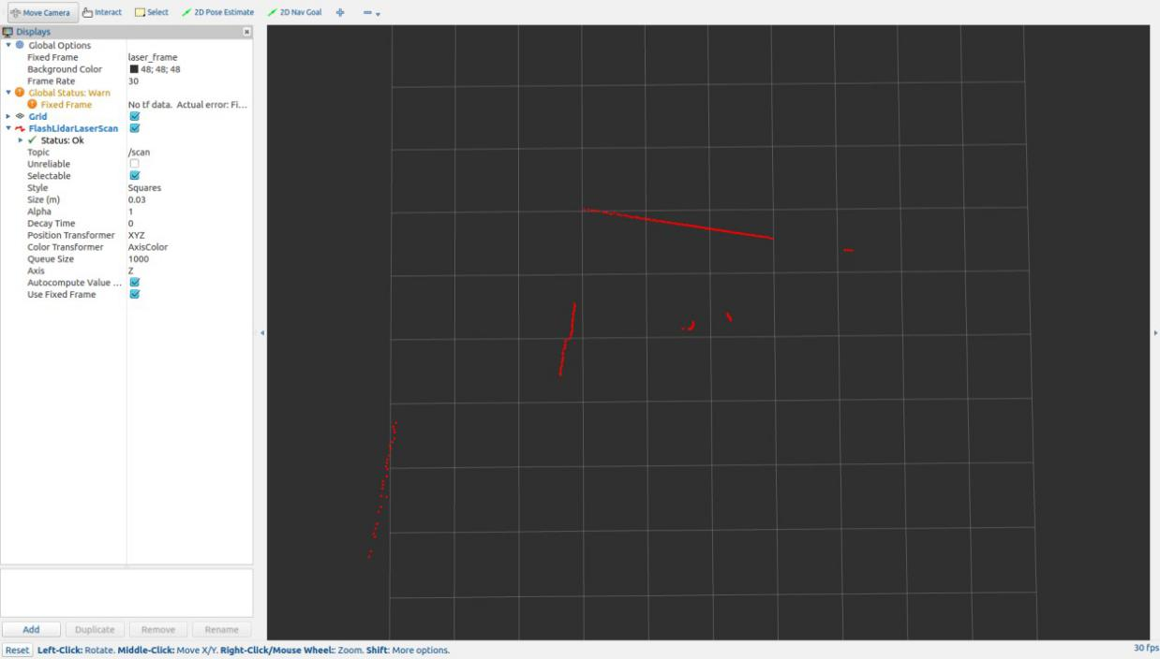

Fig 1 YDLIDAR RVIZ

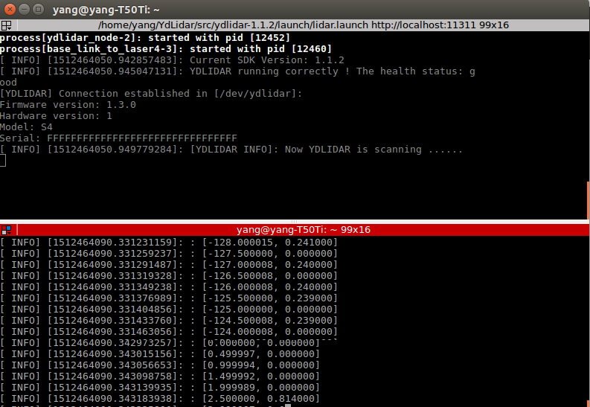

Fig 2 YDLIDAR

# YDLIDAR coordinate system

YDLIDAR rotates clockwise. SDK data output is left-handed data with distance and angle information. The ydlidar ROS driver package output has converted this to a right-handed coordinate system output, with the first measurement data from the front.

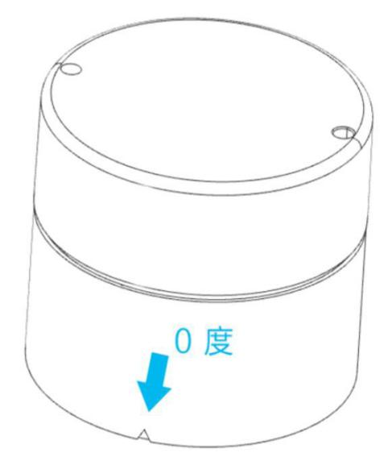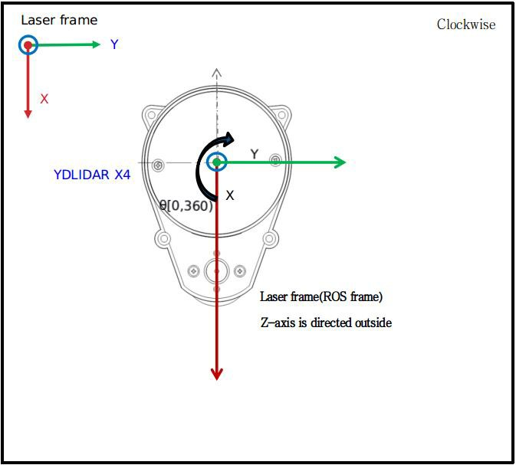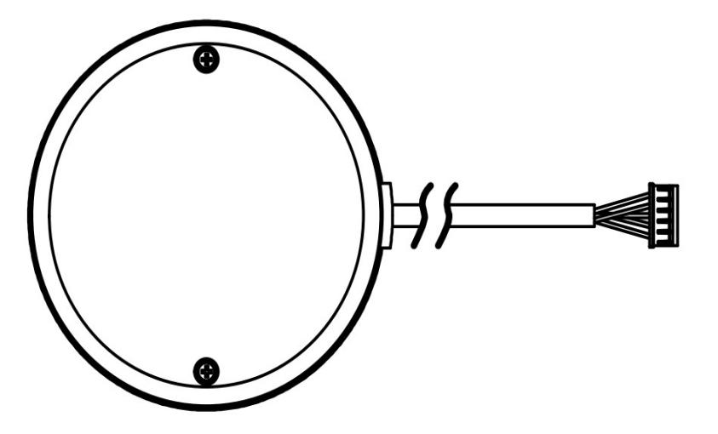

θ =[0,360)

Zero point点

Y

X

F4

Y

Zero

X

θ =[0,360)

G4

Zero 向

X4